AZ-900 Microsoft Azure Fundamentals

By Amir Mustafa. D.O.S – 15/10/2022

Private and Confidential

Type: Azure Cloud

[amirengg15@gmail.com](mailto:amirengg15@gmail.com) +91-8170954991 [LinkedIn](https://www.linkedin.com/in/amirmustafa1/) [Twitter](https://twitter.com/amir__mustafa) [GitHub](https://github.com/AmirMustafa) [YouTube](https://www.youtube.com/channel/UCiRv7SECTSF3-tXQM1IoMTw)

All requirements of this exam will be from one of the three:

Here we will ask three questions:

1. Describe Cloud Concepts
2. Describe Azure Architecture
3. Describe Azure Management and governance

What is a cloud?

🡪 There is no cloud it is just someone else’s computer

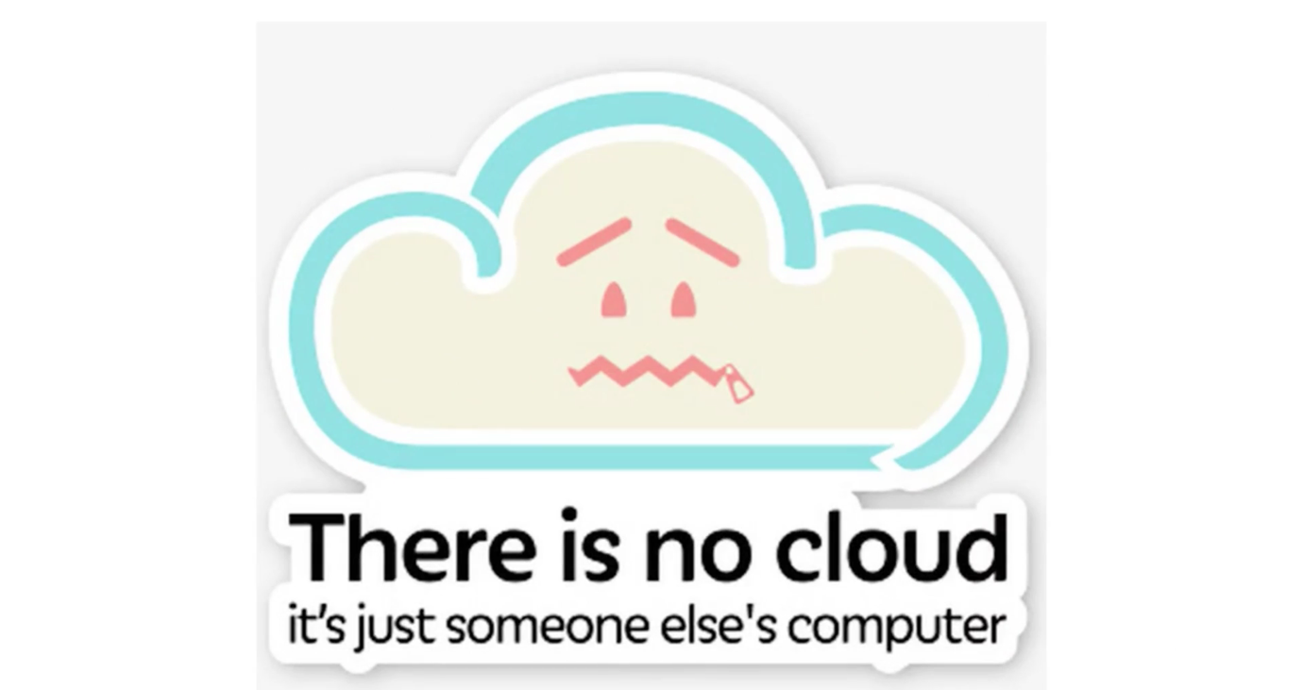

🡪 So basically renting computer services on demand

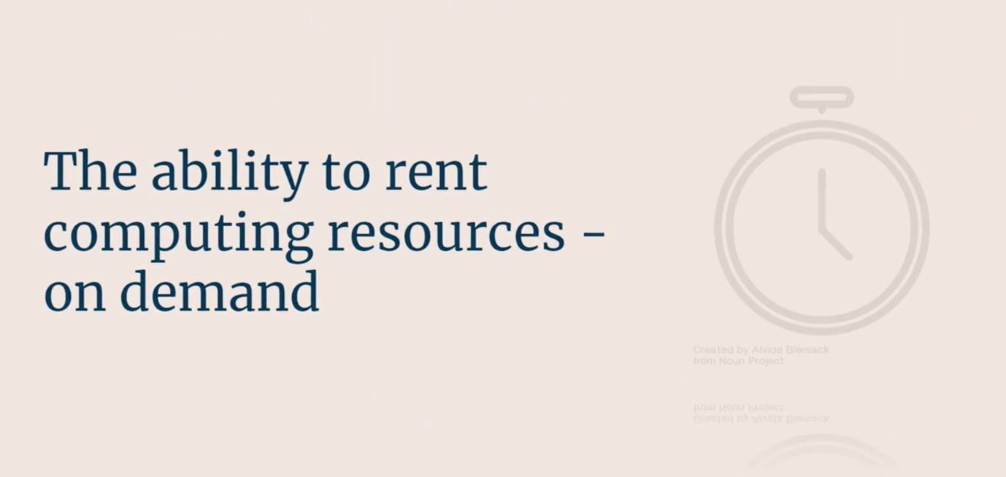

There are three main options when it comes to running servers:

1. We can run ourselves – on premises server

i.e. we have servers in offices that is locked

It takes lots of expertise + Even not using we still are paying for it

1. Hosting Model:

We can sign a contract with hosting company and they can host our services

1. Cloud Model:

Here we get not only servers but 100 and 100s of services – available on demand

We can rent them and when we stop using services, we stop paying for them

What does Computing Services Means?

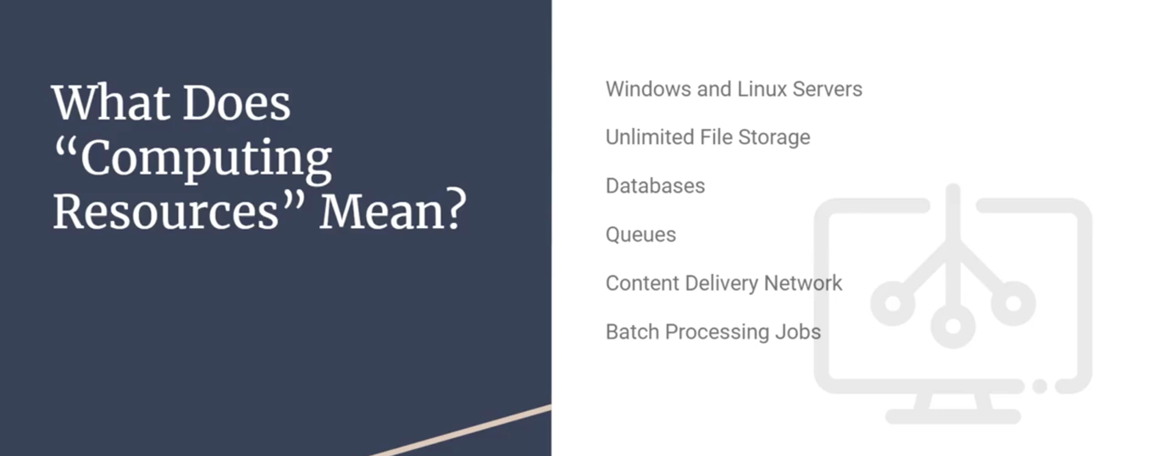

🡪 We even have pretty big services as well:

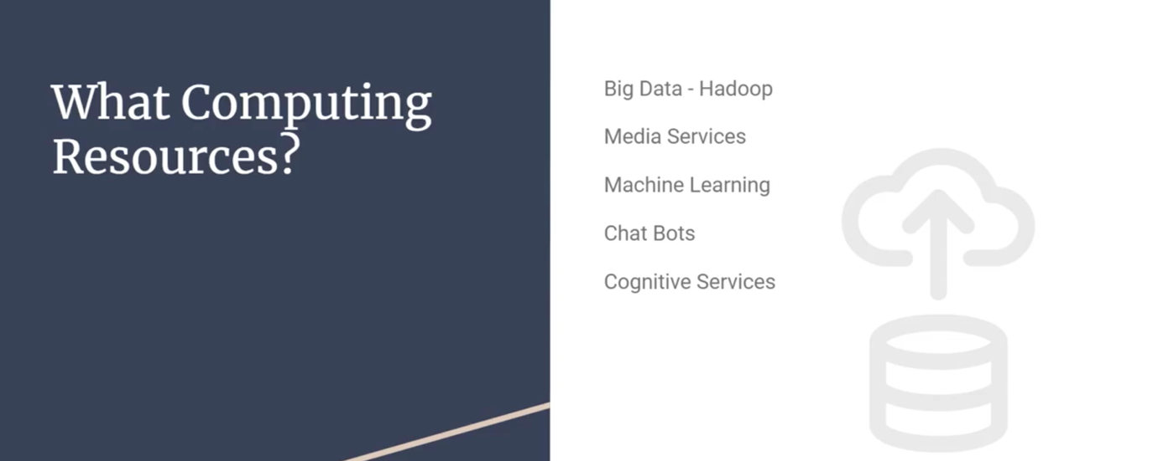

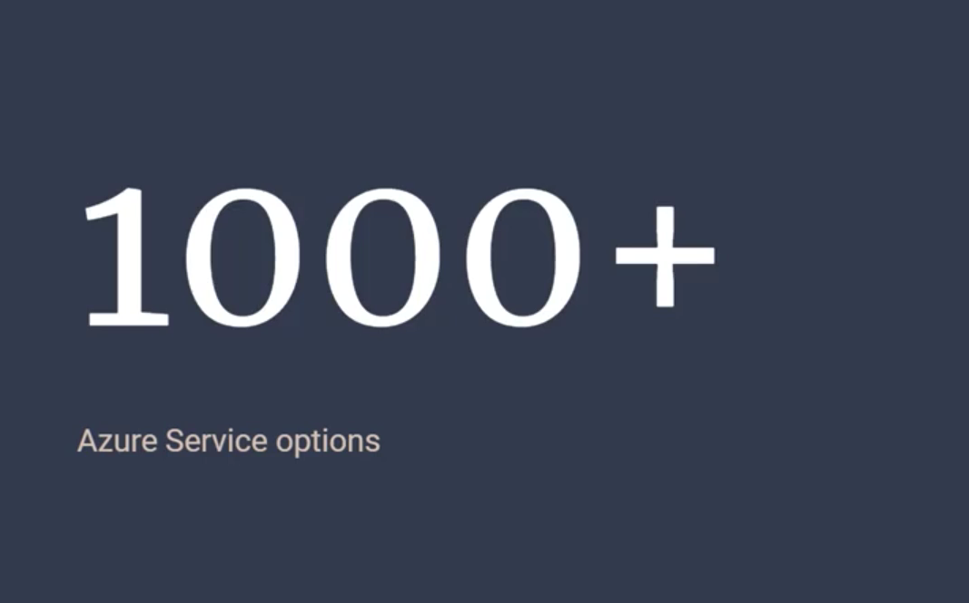

Read Here:

AZ-900 Exam:

<https://learn.microsoft.com/en-us/certifications/exams/az-900>

Live Demo Azure Cloud:

🡪 Here we have lots of options to create servers – compute, databases, networking, etc

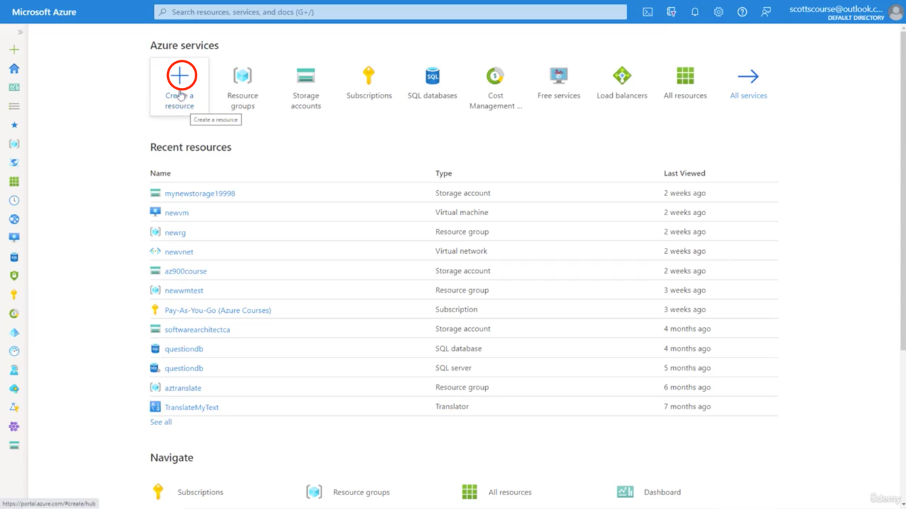

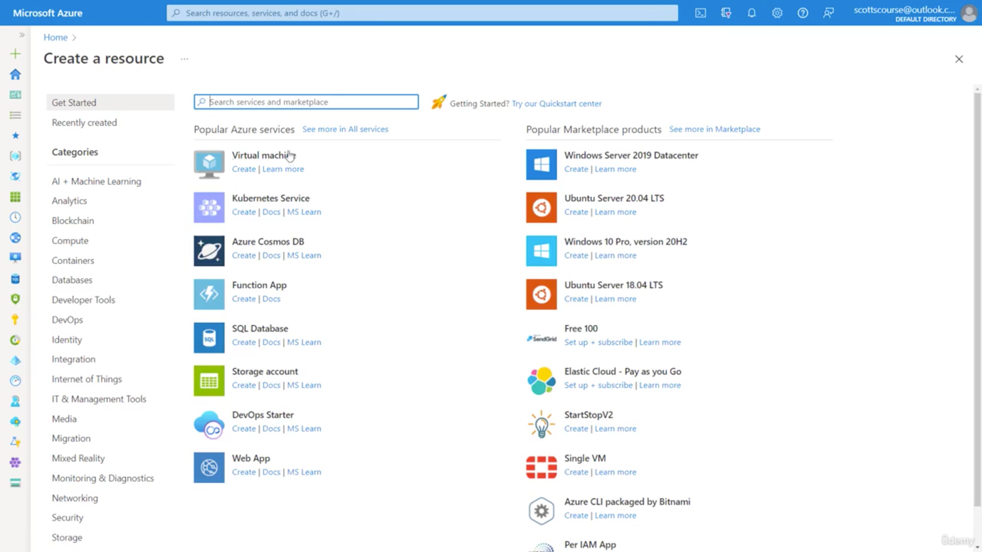

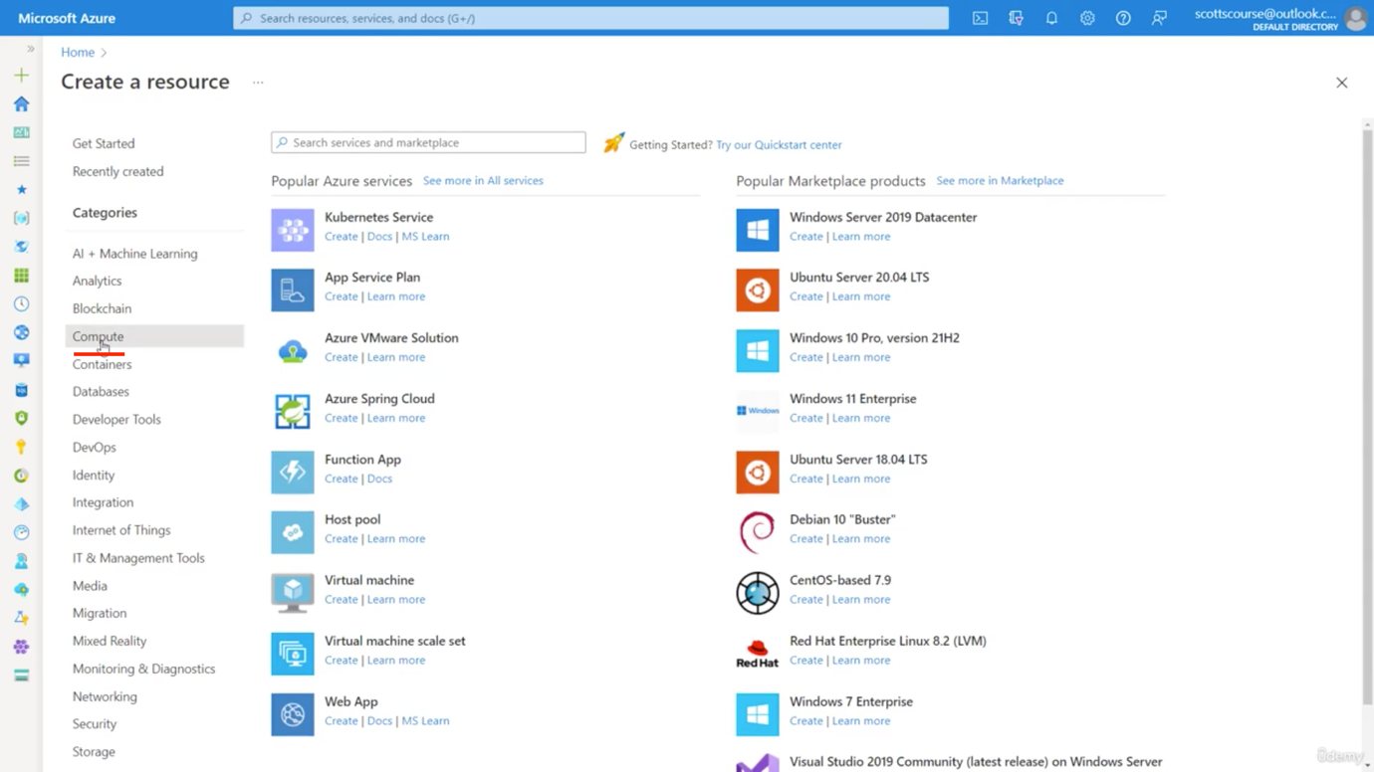

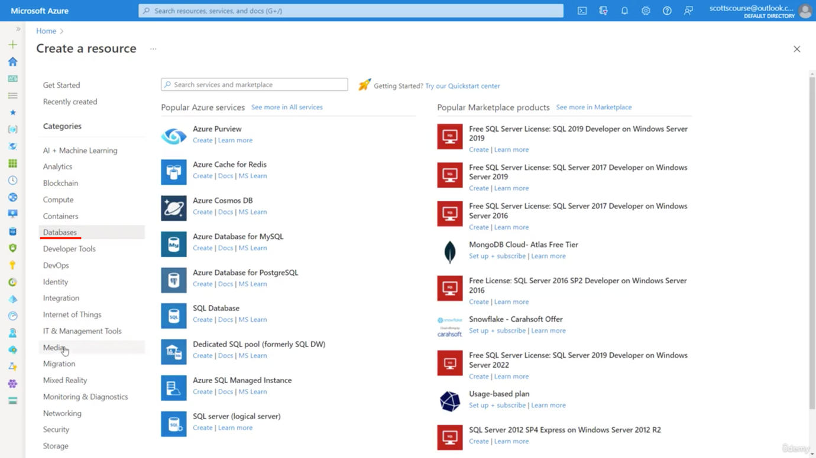



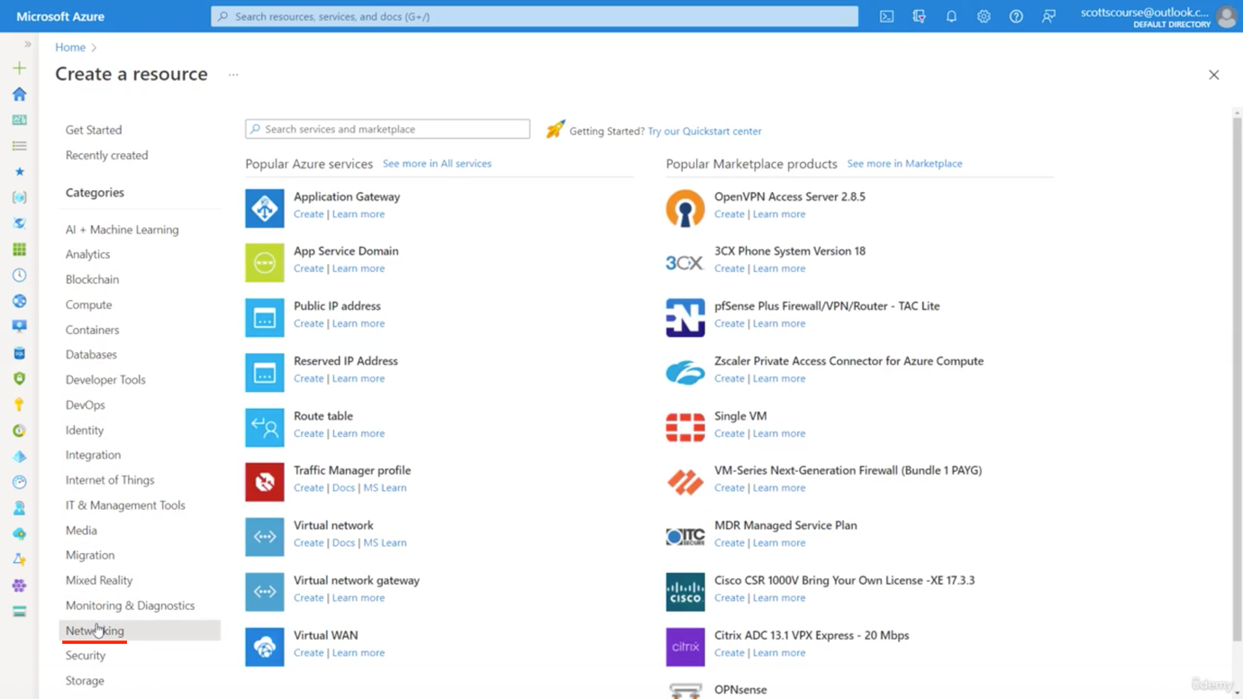

🡪 Let us now create a server:

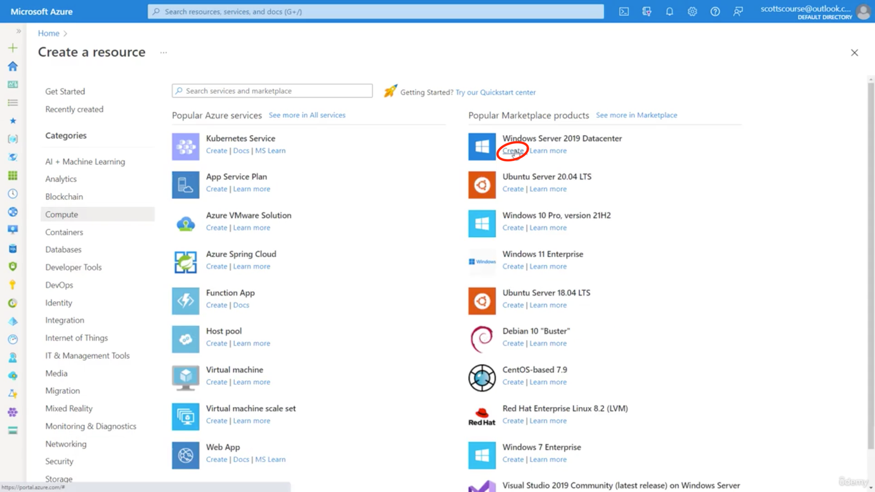

🡪 Click on Create New Resource group. Write some name

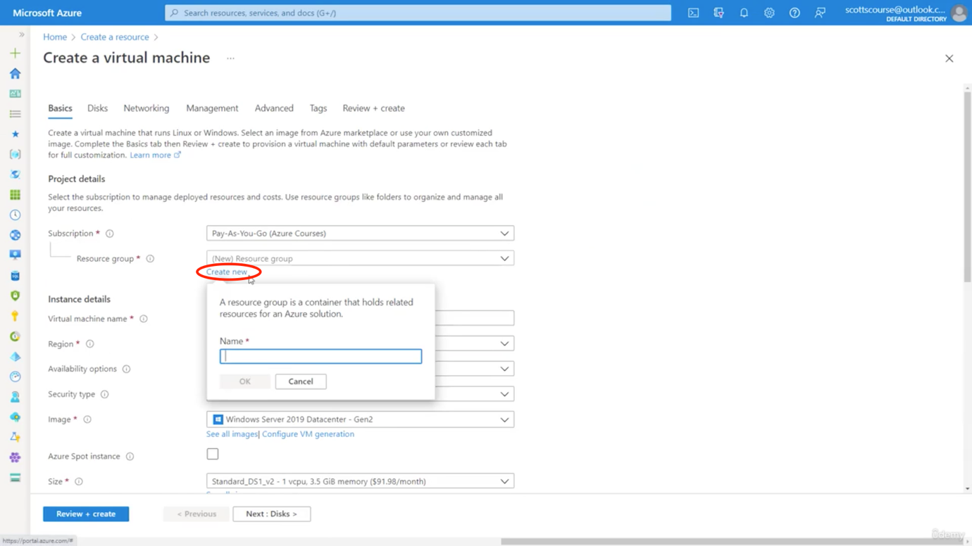

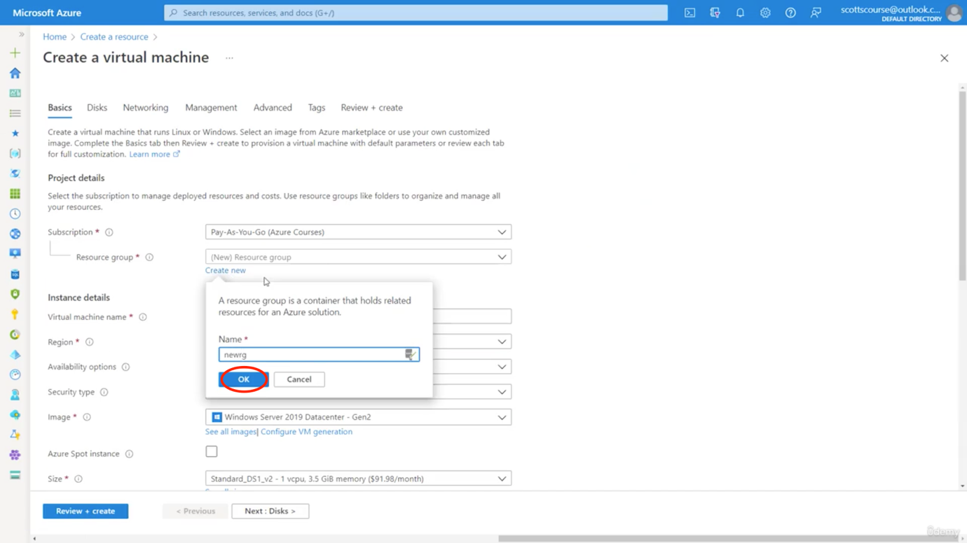

🡪 We also chose region, availability options, OS image, etc

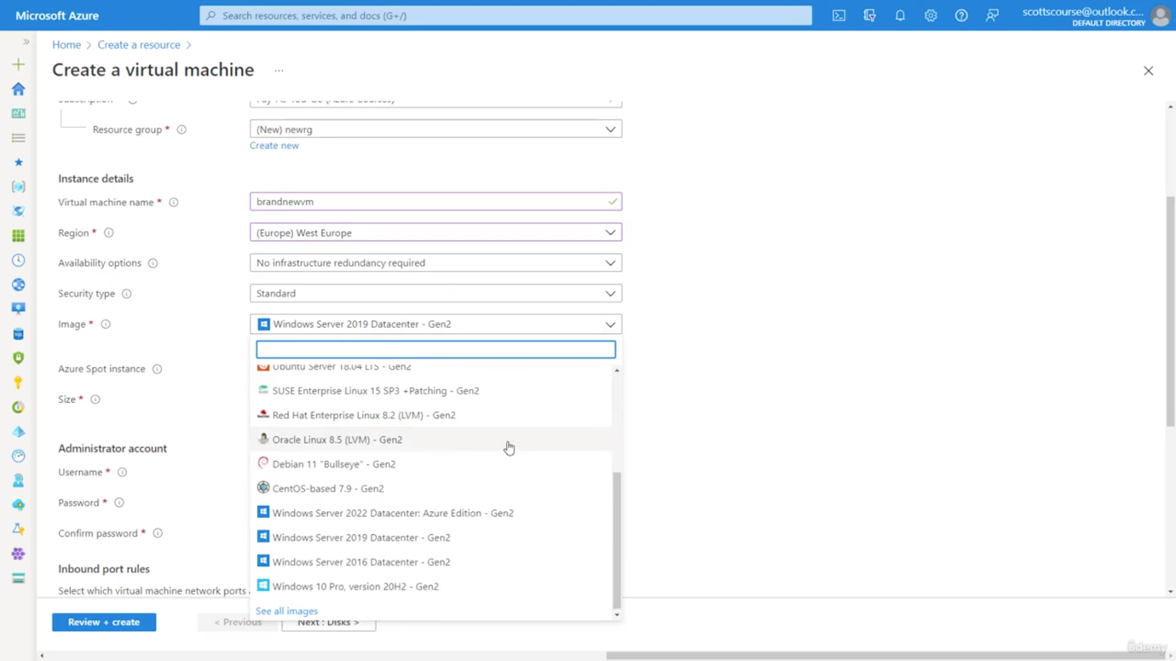

🡪 Now sometimes we get image and sometimes we get images with some softwares installed. We will install as per requirement

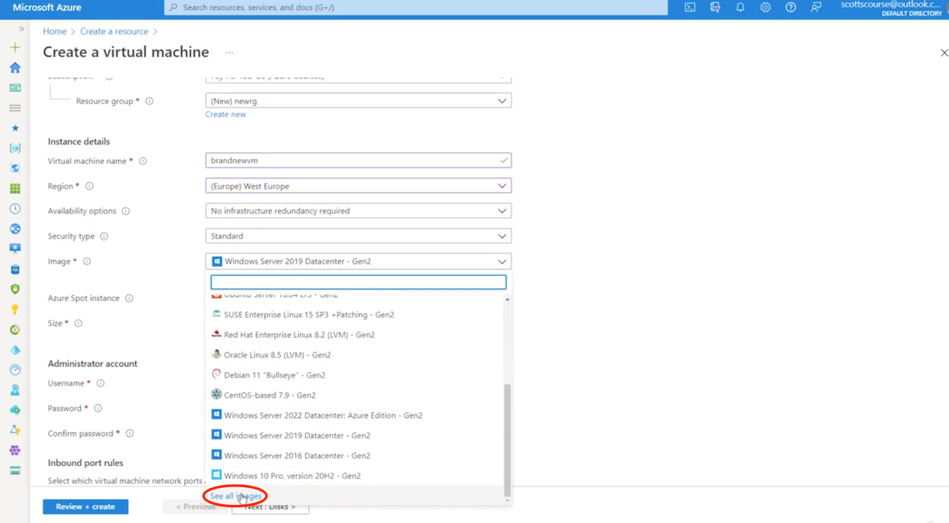

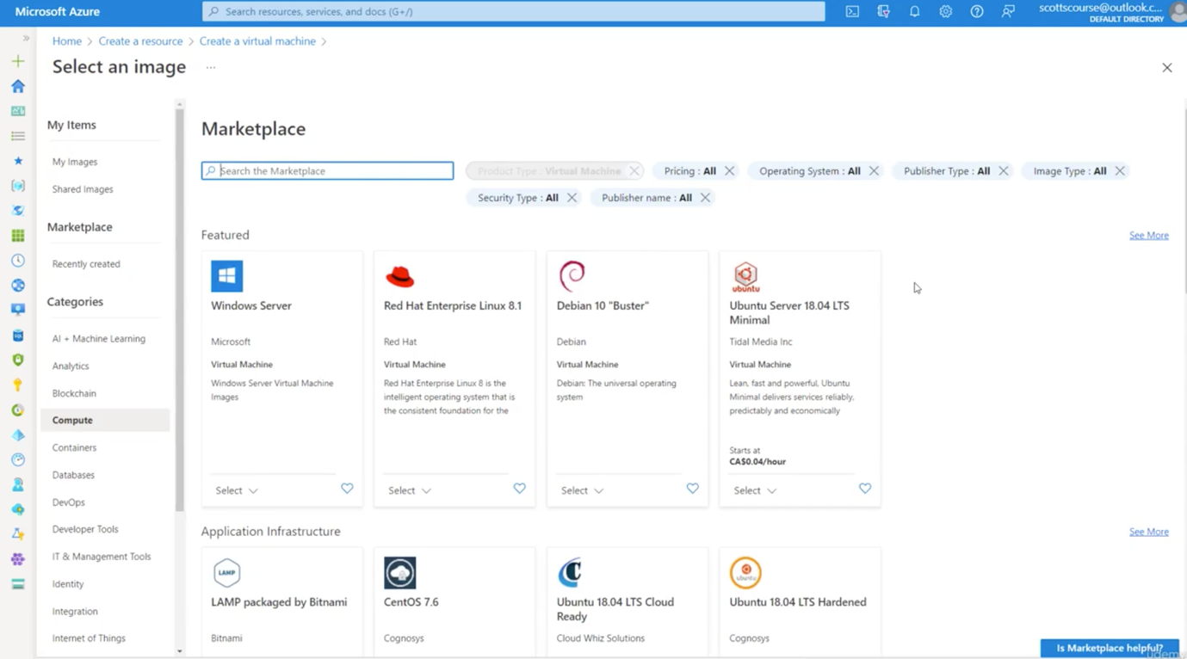

🡪 We also chose the hardware configurations for that server – RAM, CPU etc from size option

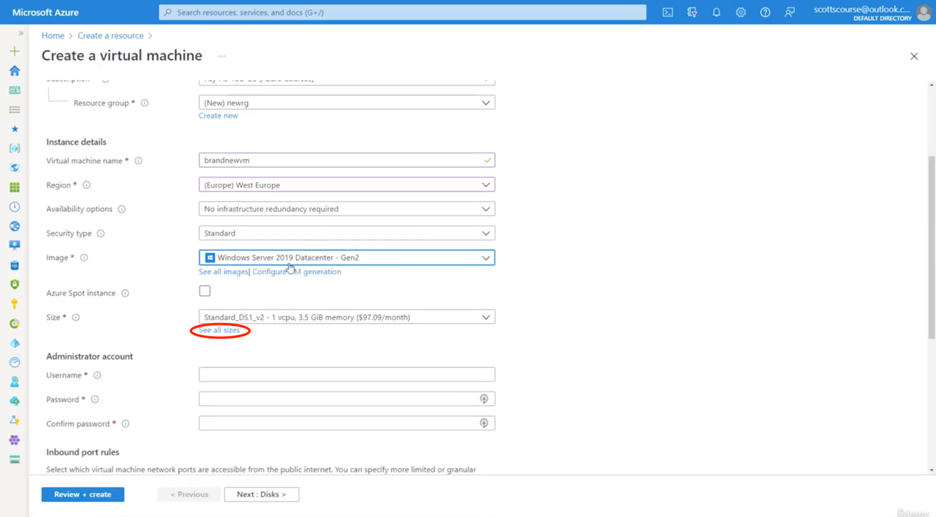

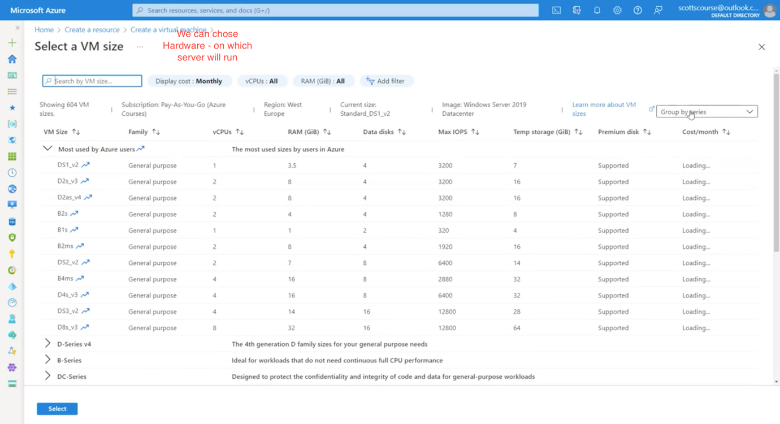

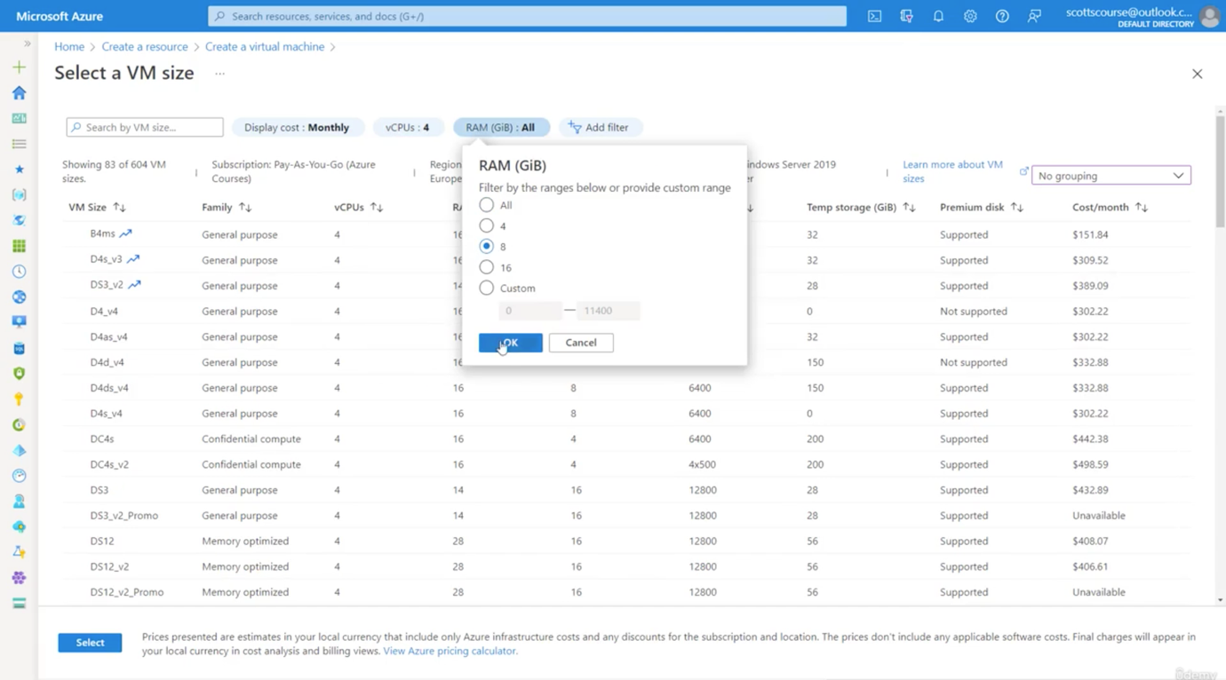

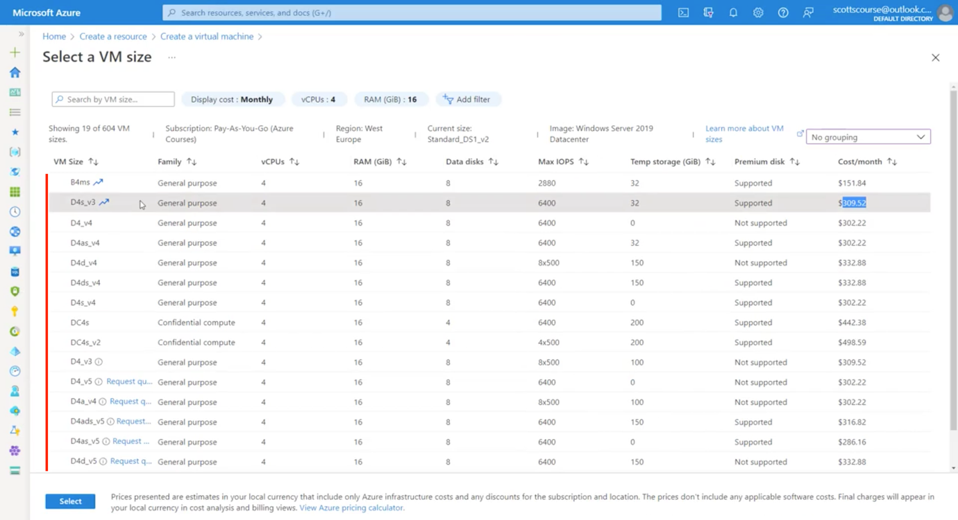

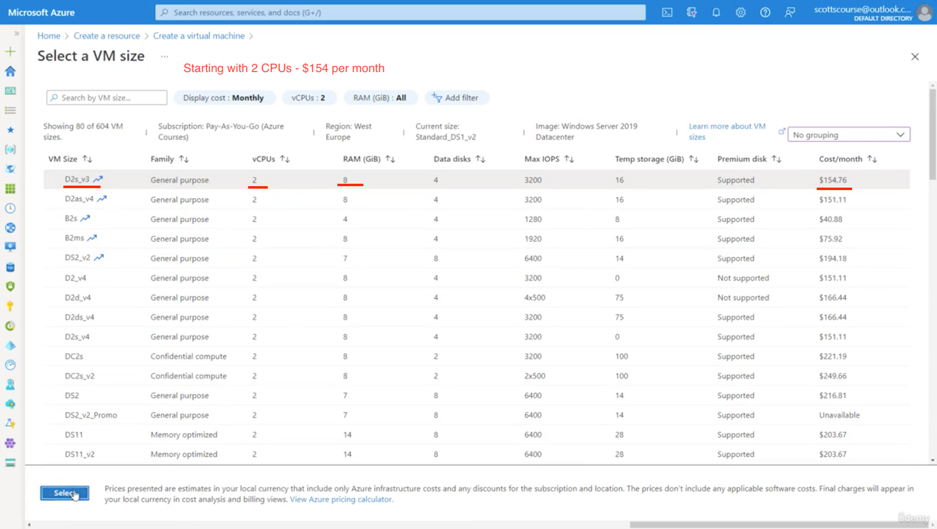

🡪 Once hardware size is chose, let us create – username & password for Cloud OS

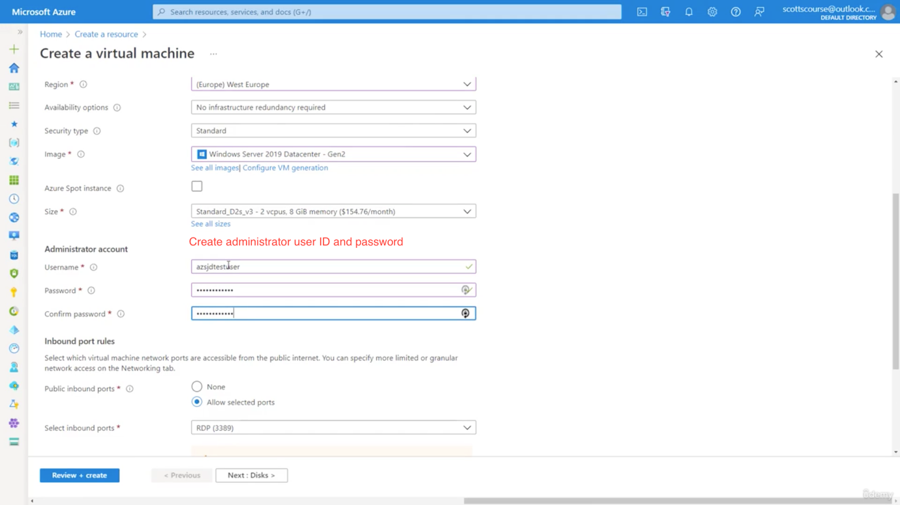

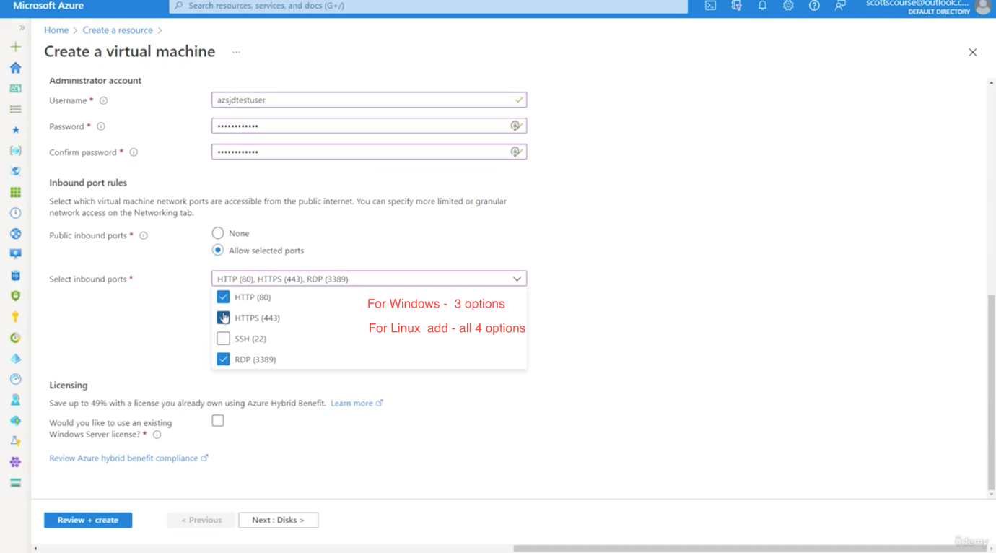

🡪 Chose all the inbound port as shown above

🡪 Click Next

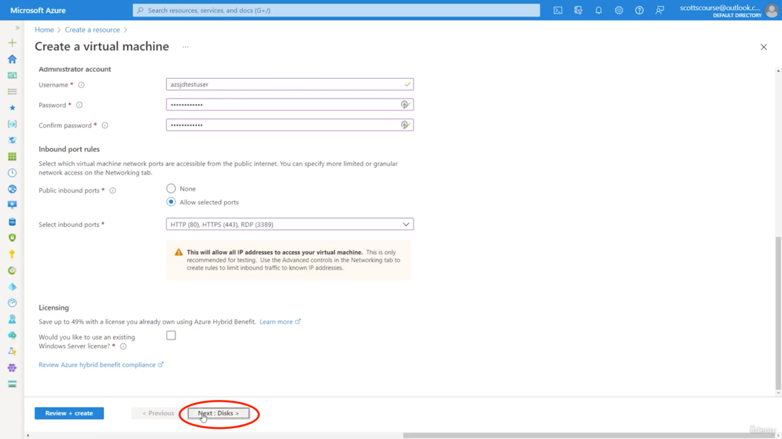

Page2: Here we add

🡪 In the next page we add Disk configurations – SSD, etc

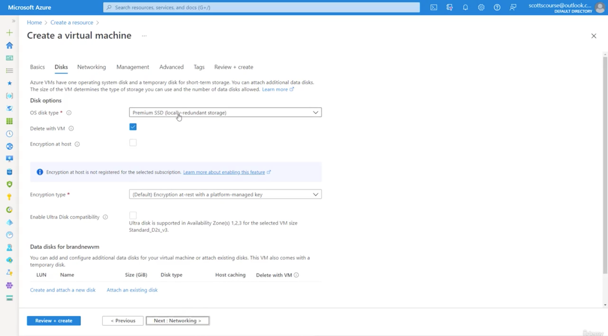

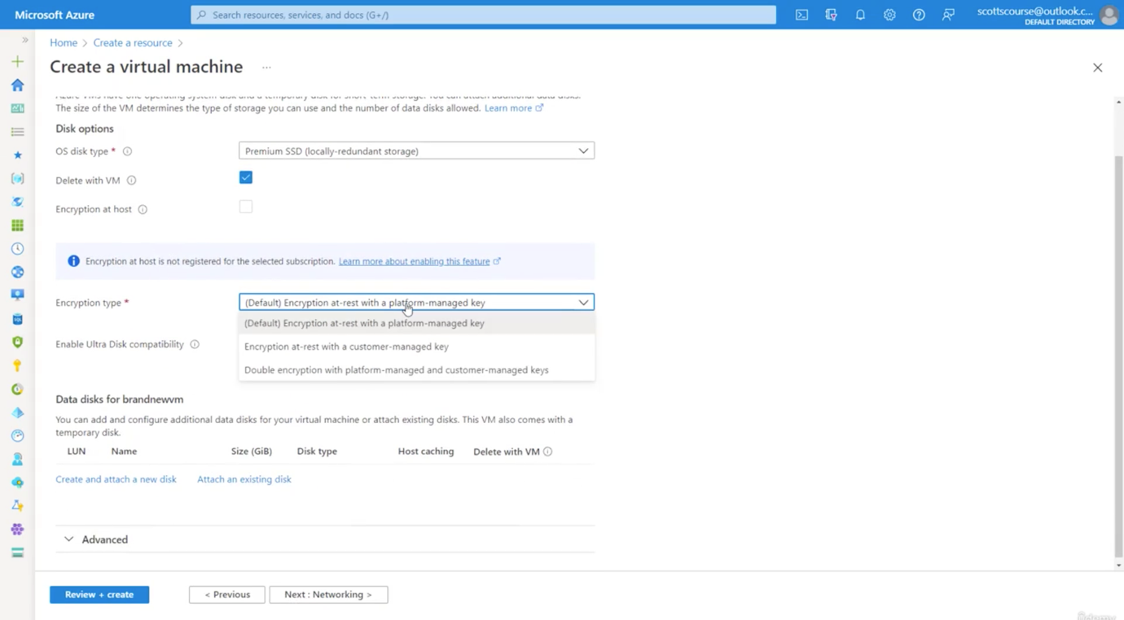

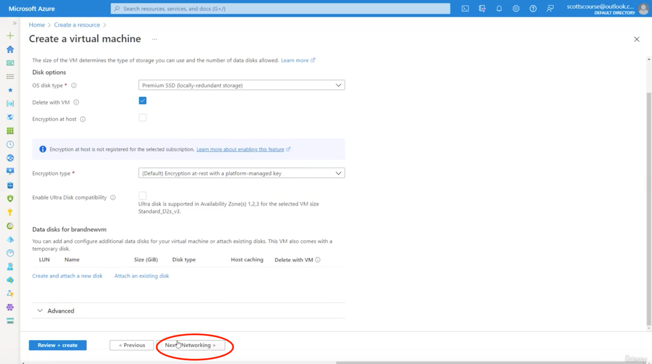

Page3: Here we add basic networking details:

By default options are selected and may be changed

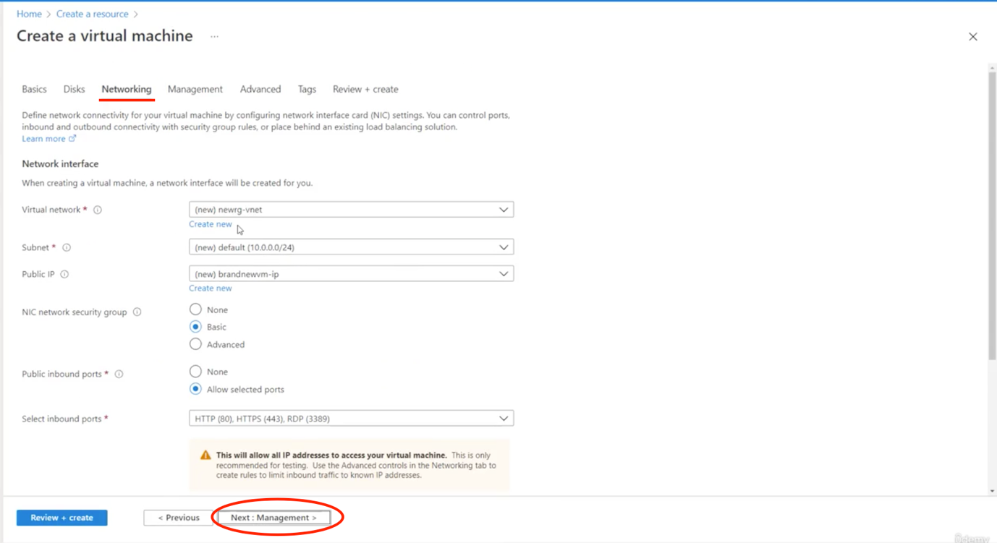

Page 4: Management:

Here have different facilities:

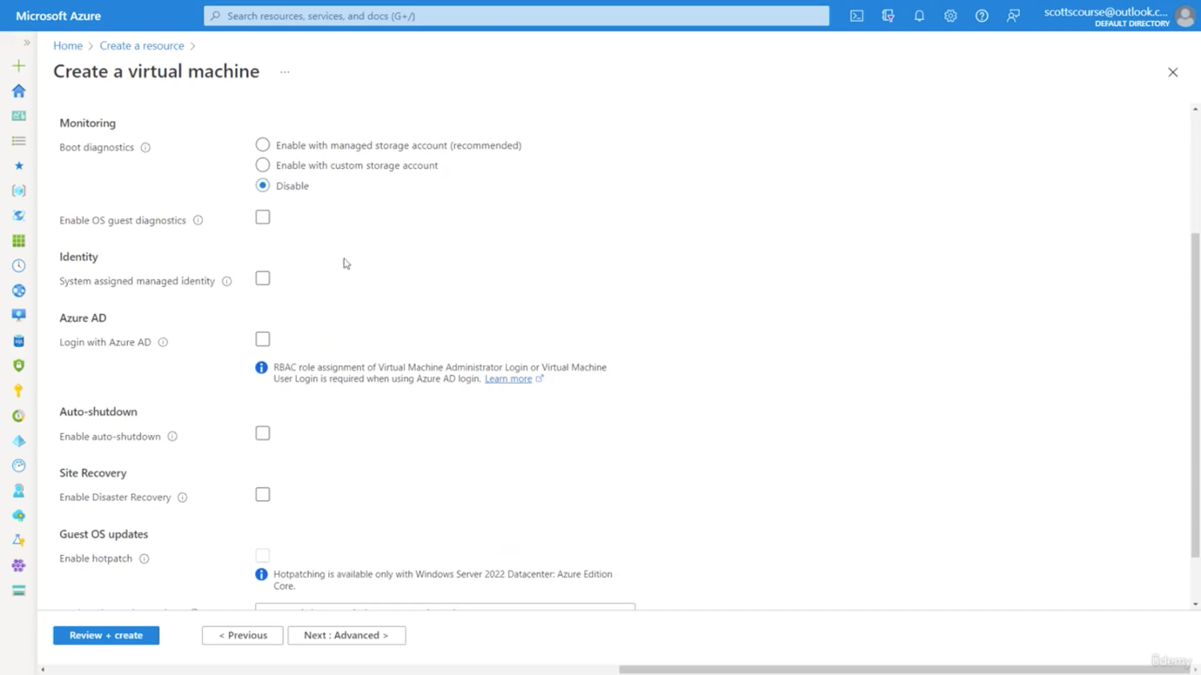

**Auto shutdown –** If we are not using most of the time we can set to auto shut down at some time

**Backup –** This is helpful when some issue happens in software level

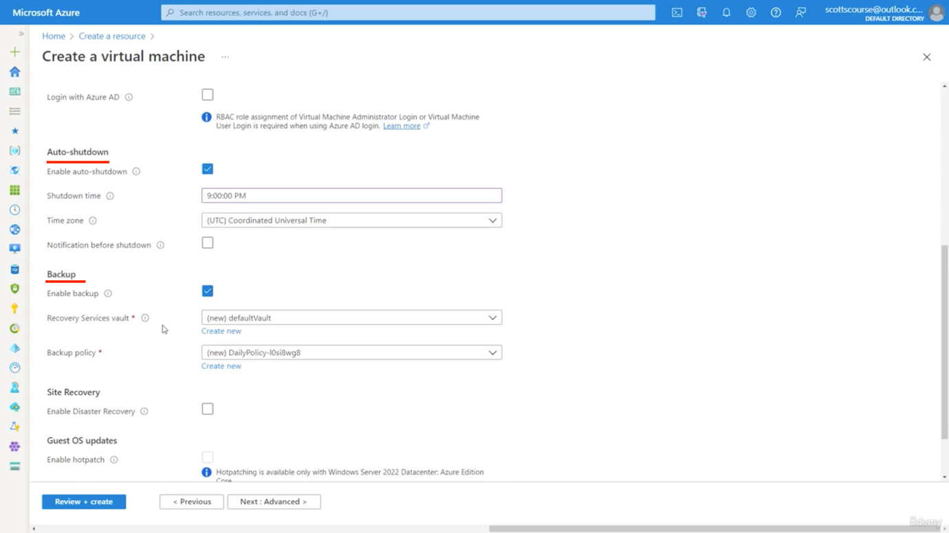

**Site Recovery –**

This is also powerful as we can get the recover data. If something happens in the west US server, then we can retrieve in east US server.

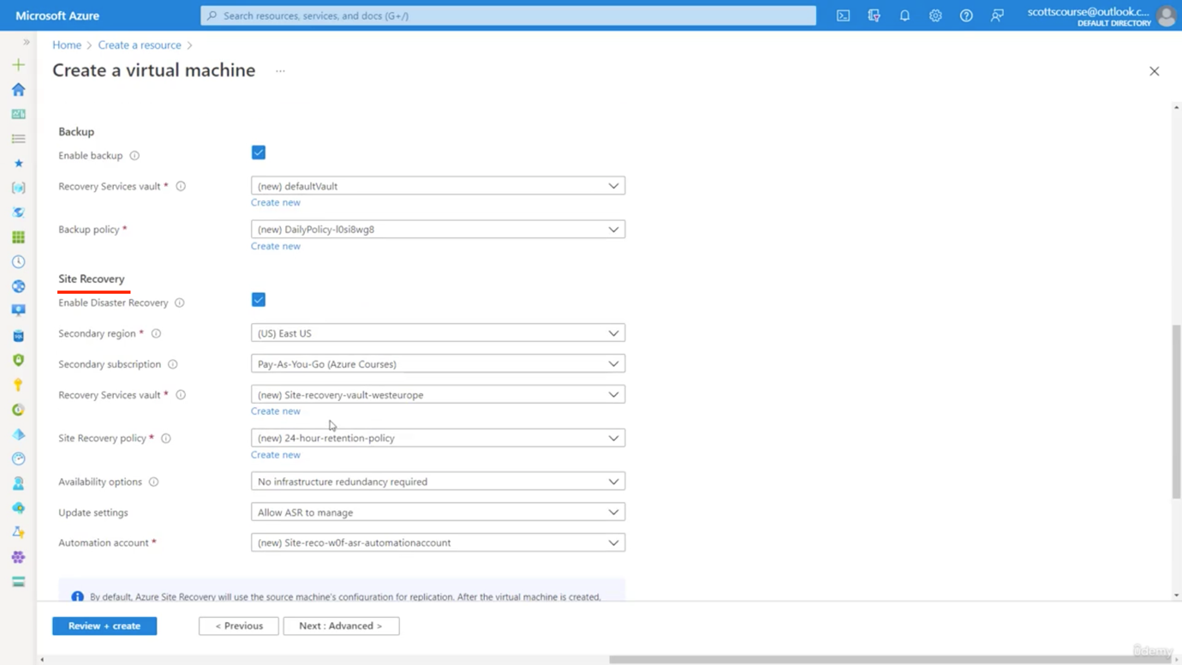

🡪 Page 5: Advanced - We can chose Advanced options – OS update, etc

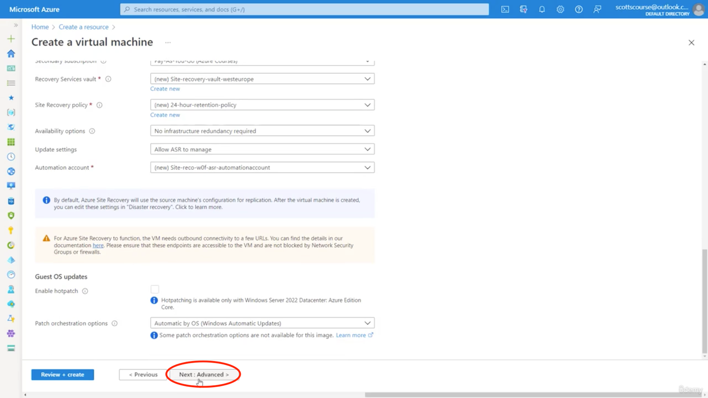

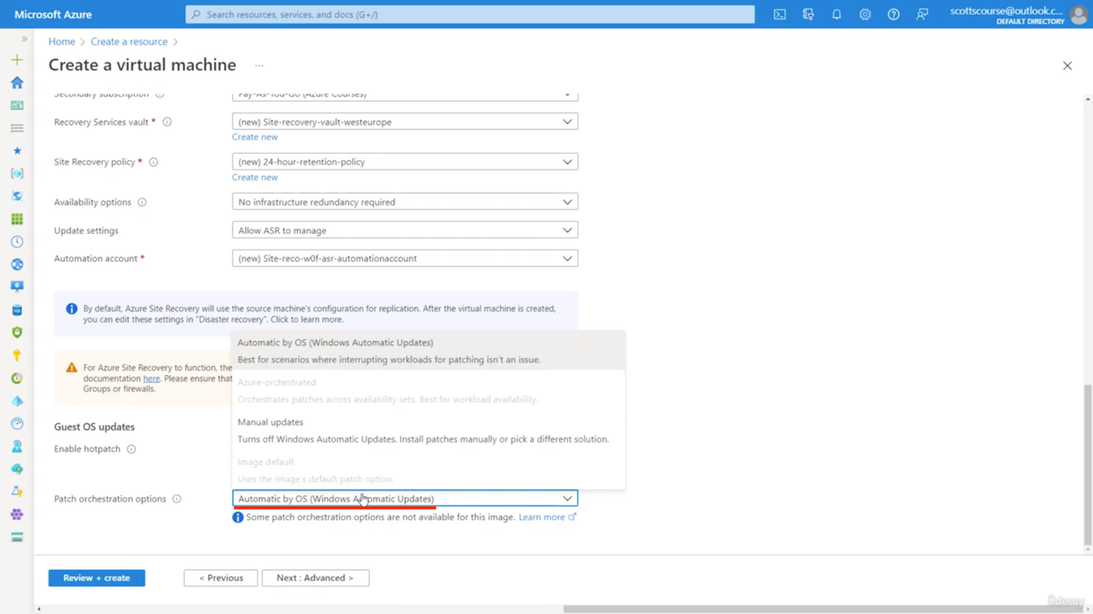

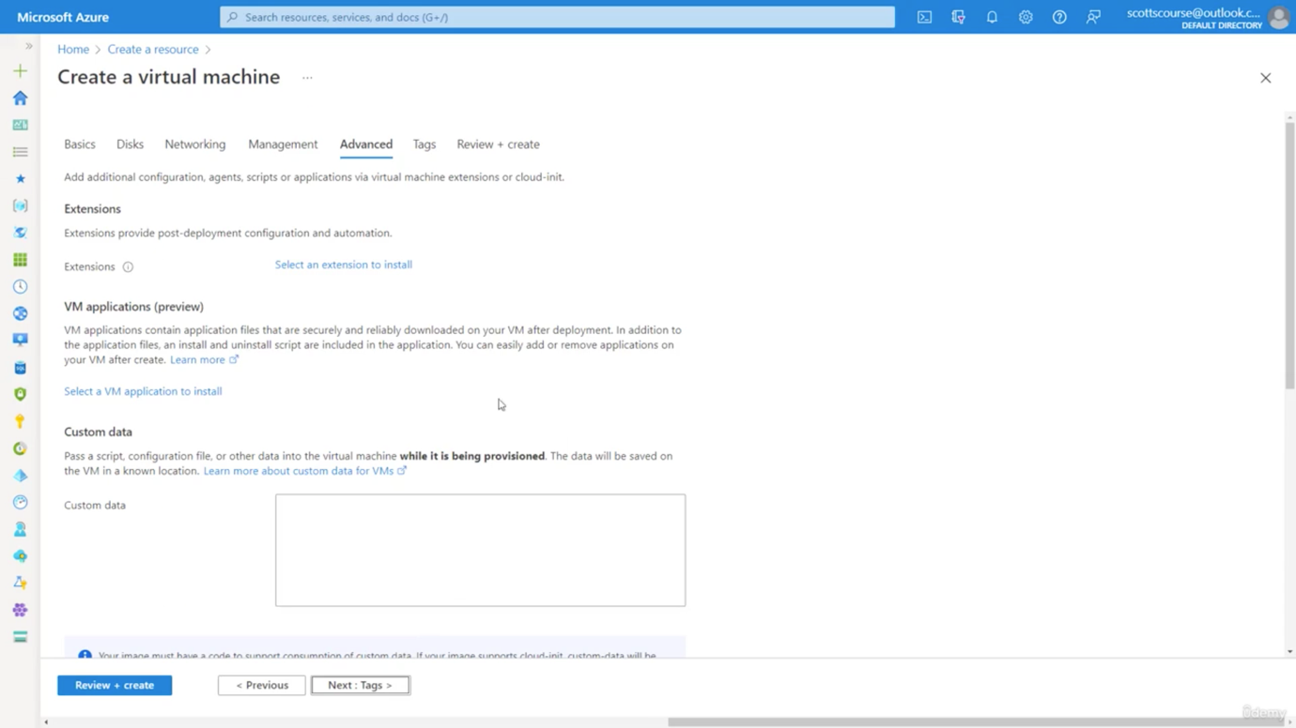

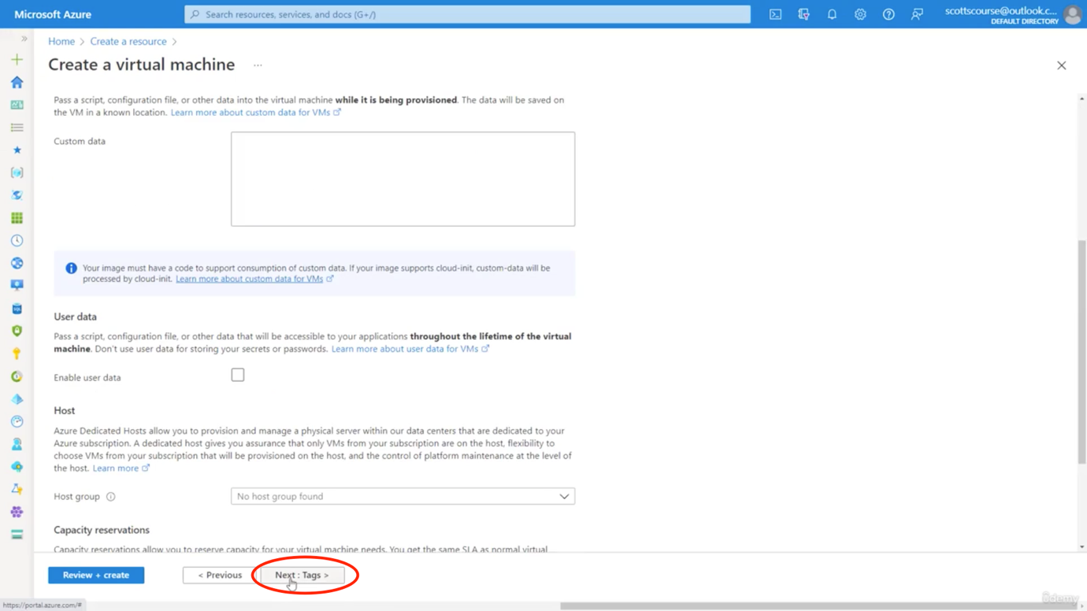

Page 6 – Tags

🡪 Here we may or may not add tag details

🡪 Click Review and Create button

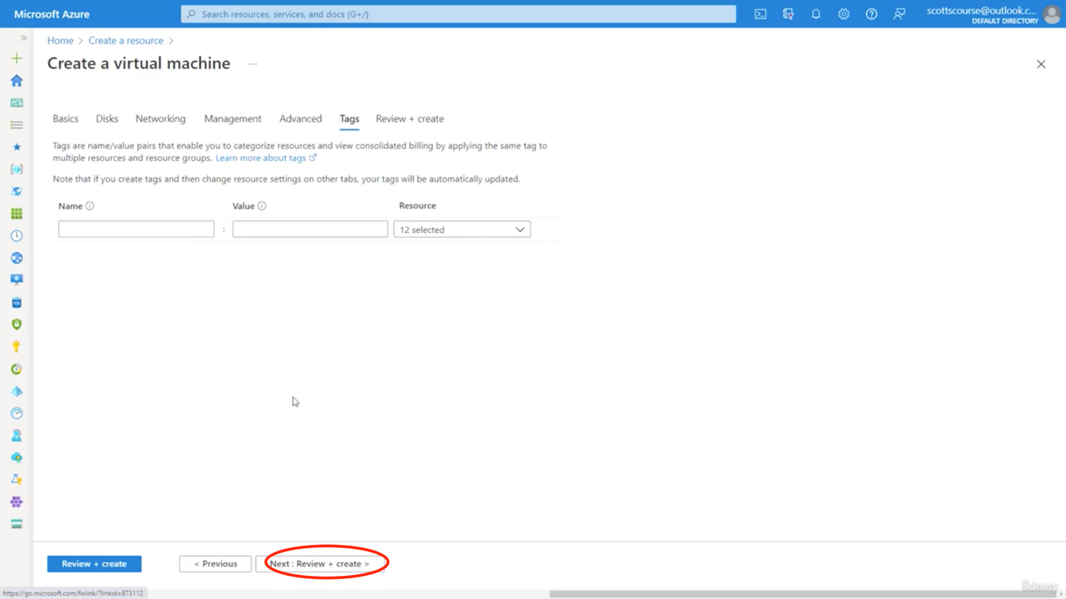

Page 7 – Review all details and click Create button

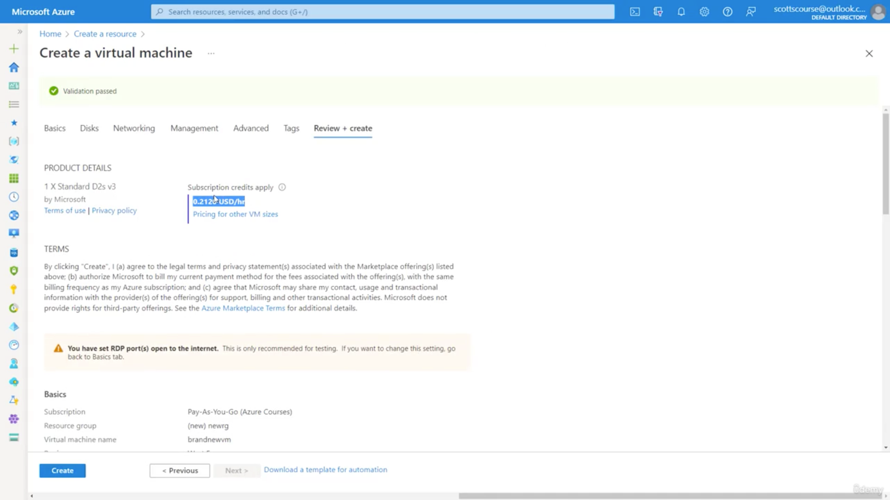

Review – Basics, Disks, Networking, Managements

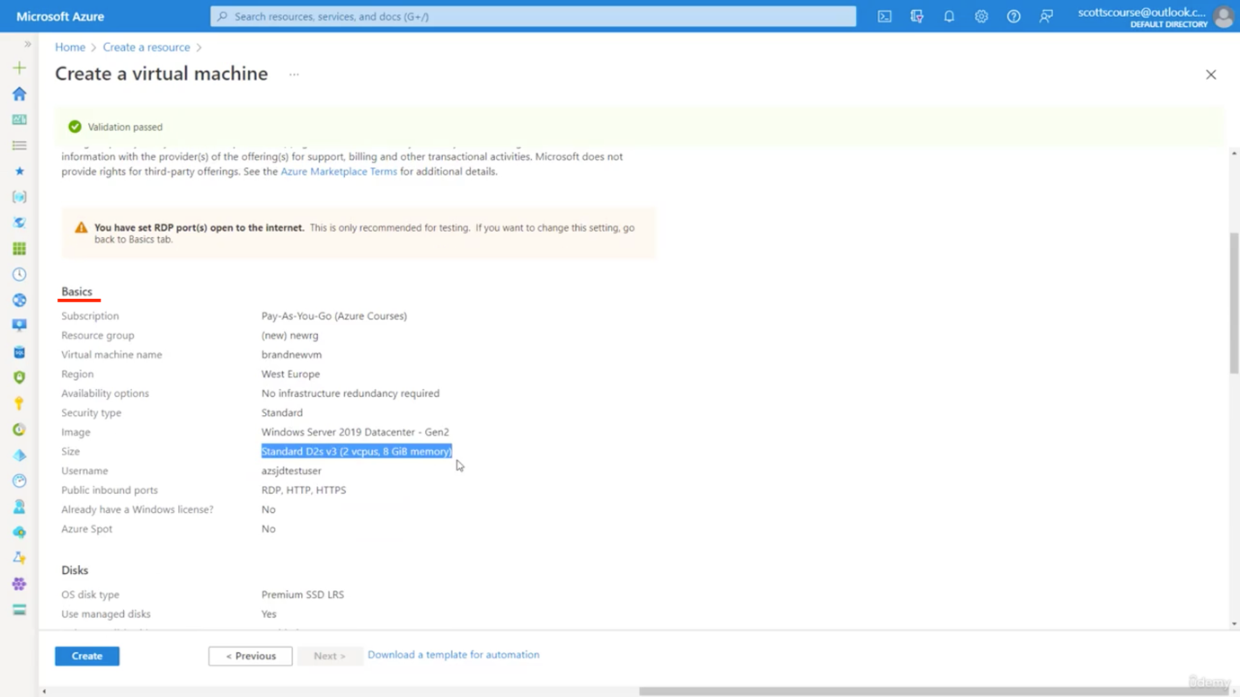

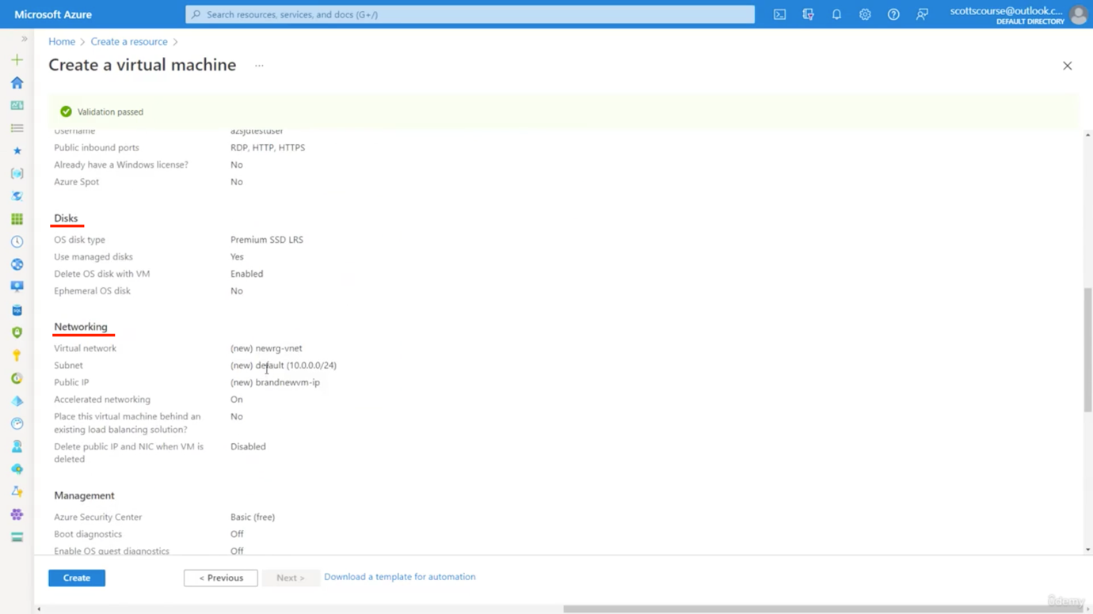

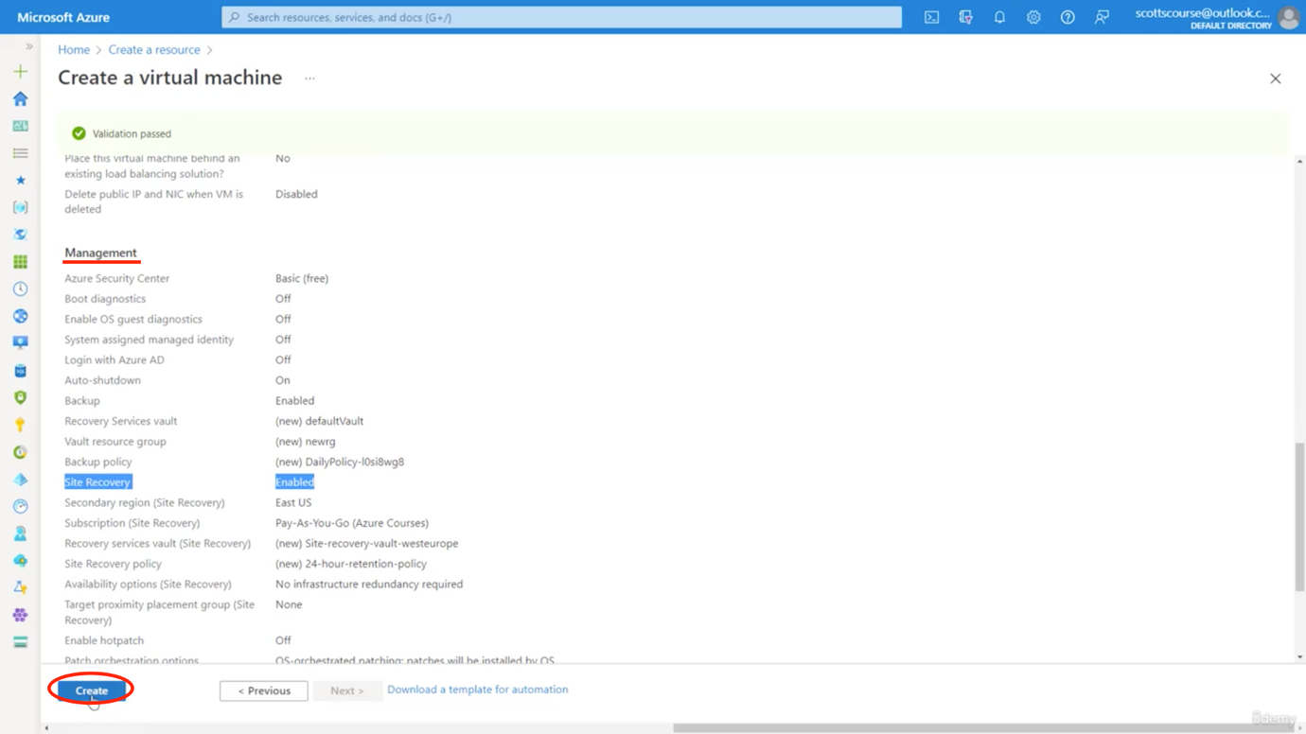

🡪 Now within a minute – Microsoft will create a compute for us

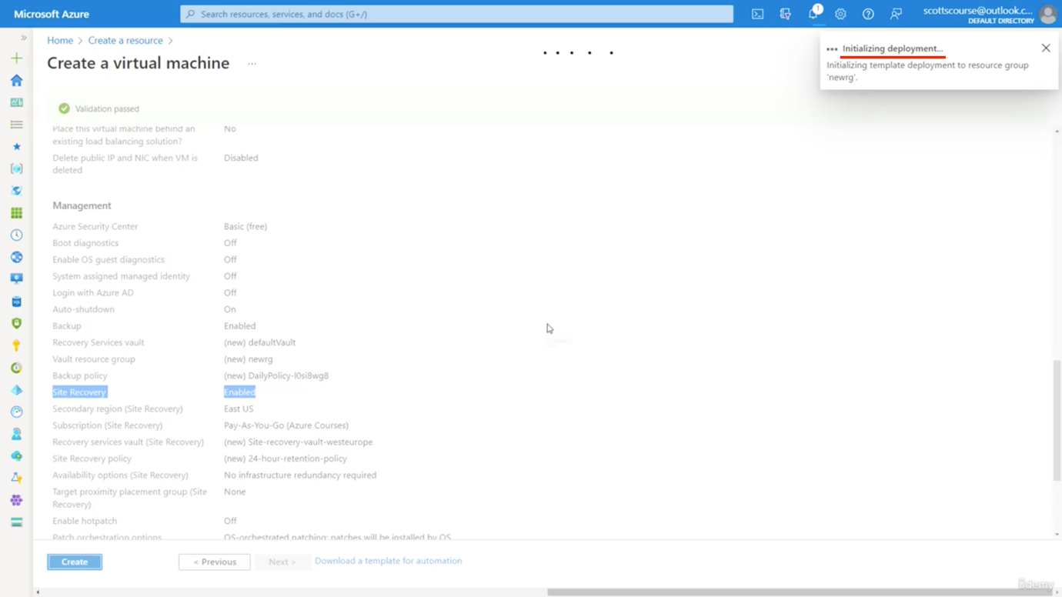

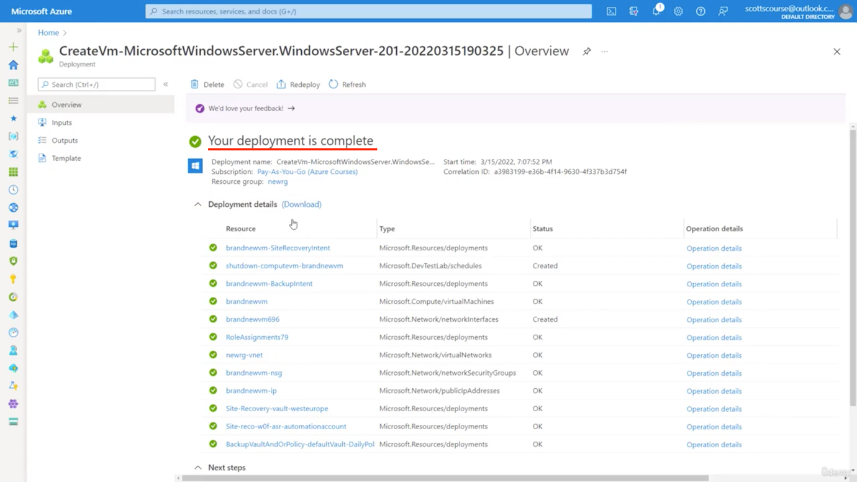

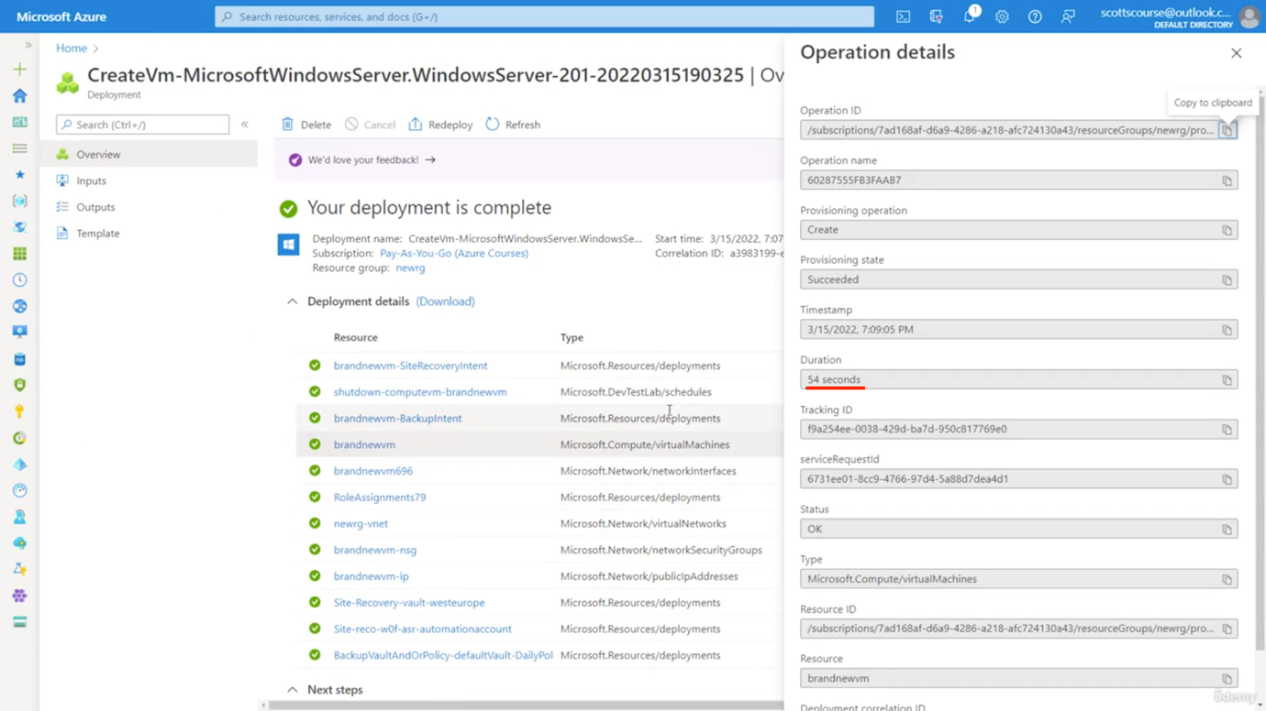

🡪 Click Go to Resource

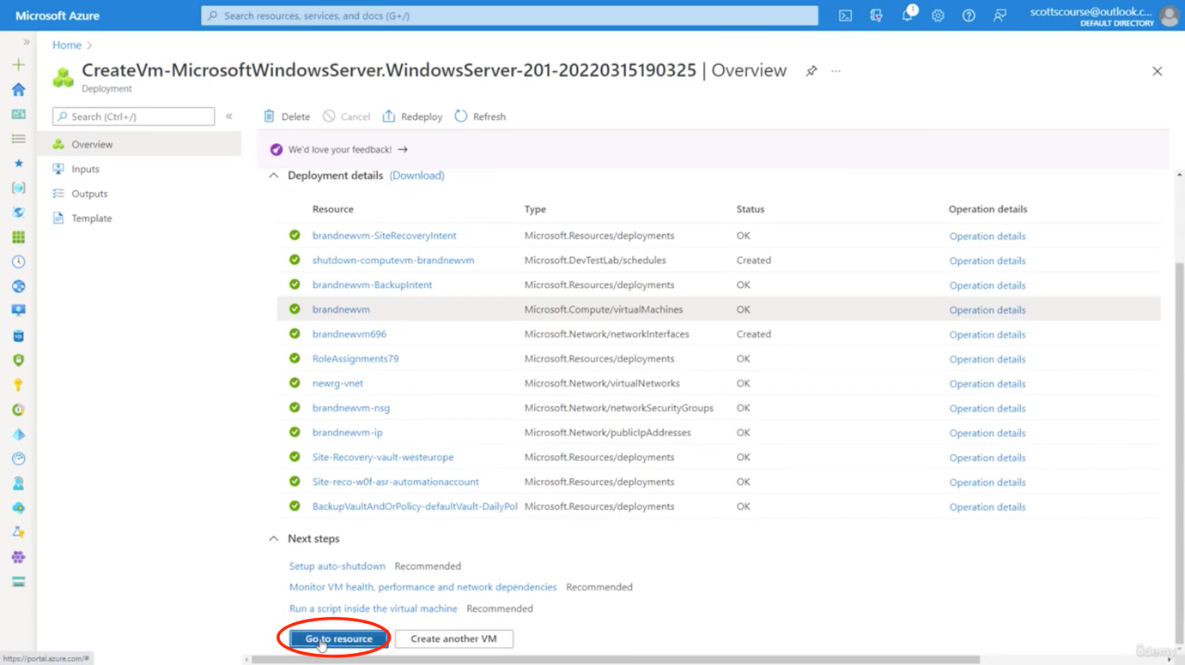

🡪 We now see our cloud computer is ready to be used

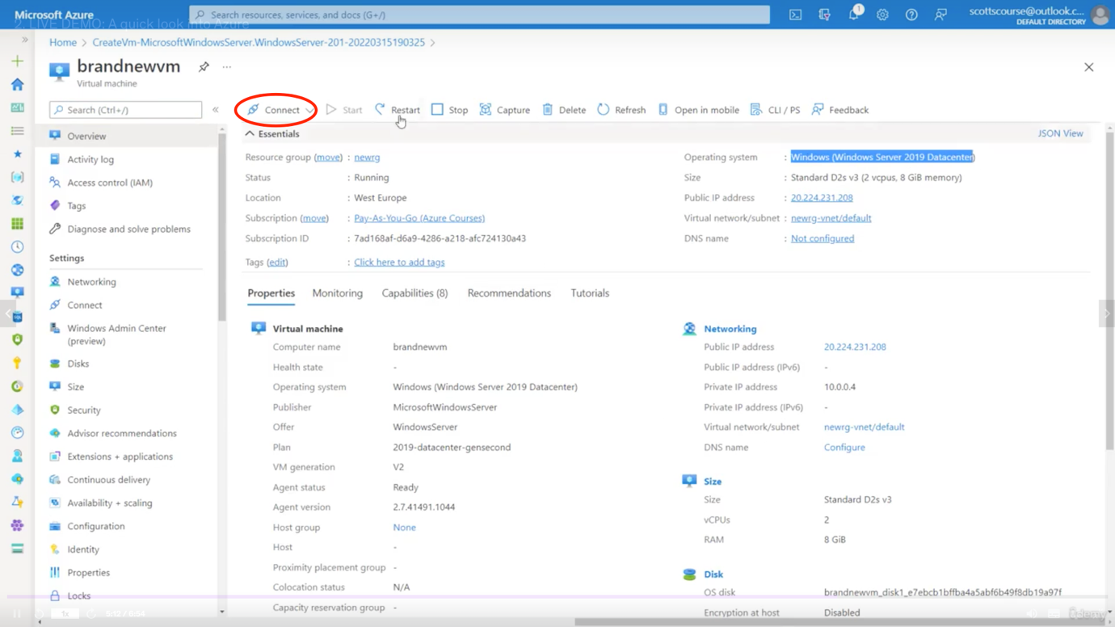

🡪 We can now use RDP to connect to it or install softwares to it.

🡪 We also have public IP address.

🡪 So likewise we can create 100s of resources and we have to pay small amount of money on a per hour basis.

🡪 When we are done with it, we can stop it or delete it – charging for this will stop

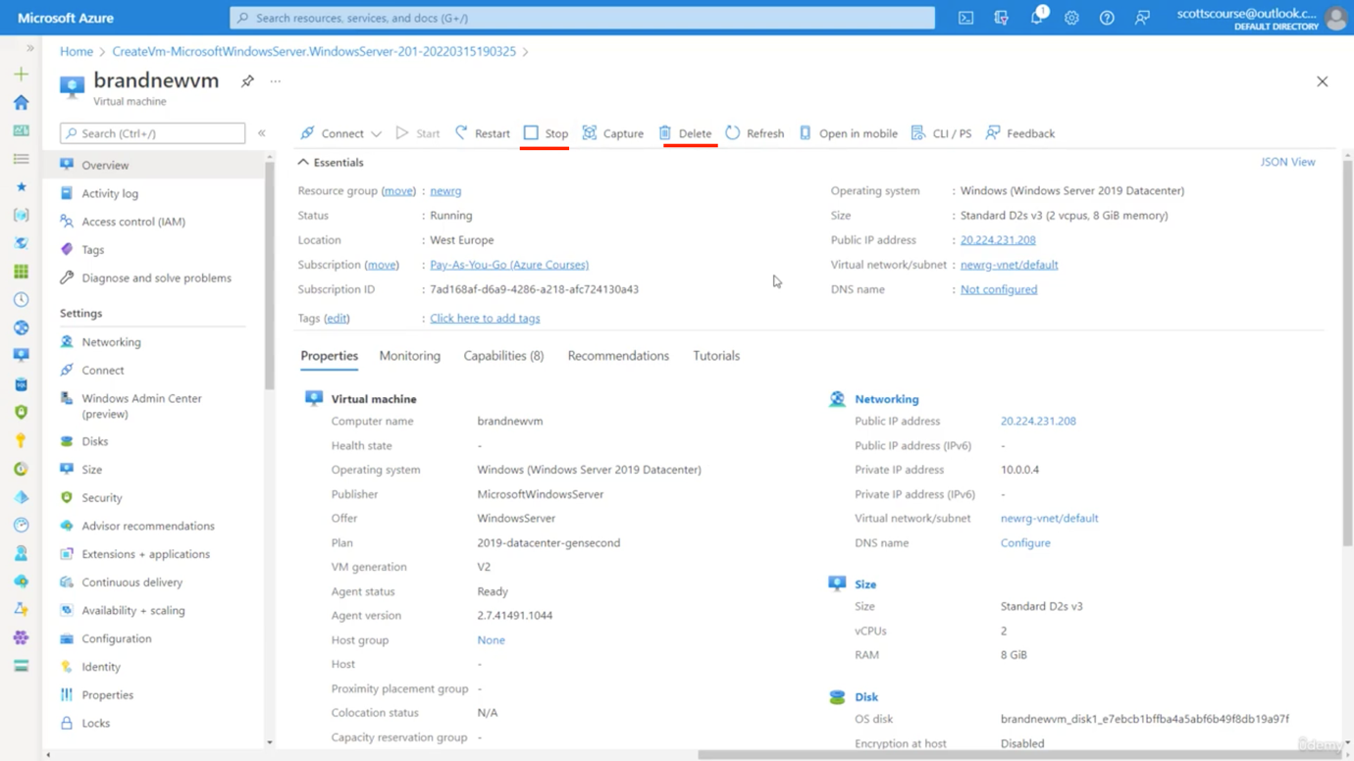

🡪 So basically if we have used traditional models – assembling hardwares and softwares, it would have taken weeks for that. It cloud it basically took minutes.

Check Dates of exam here:

<https://learn.microsoft.com/en-us/certifications/exams/az-900>

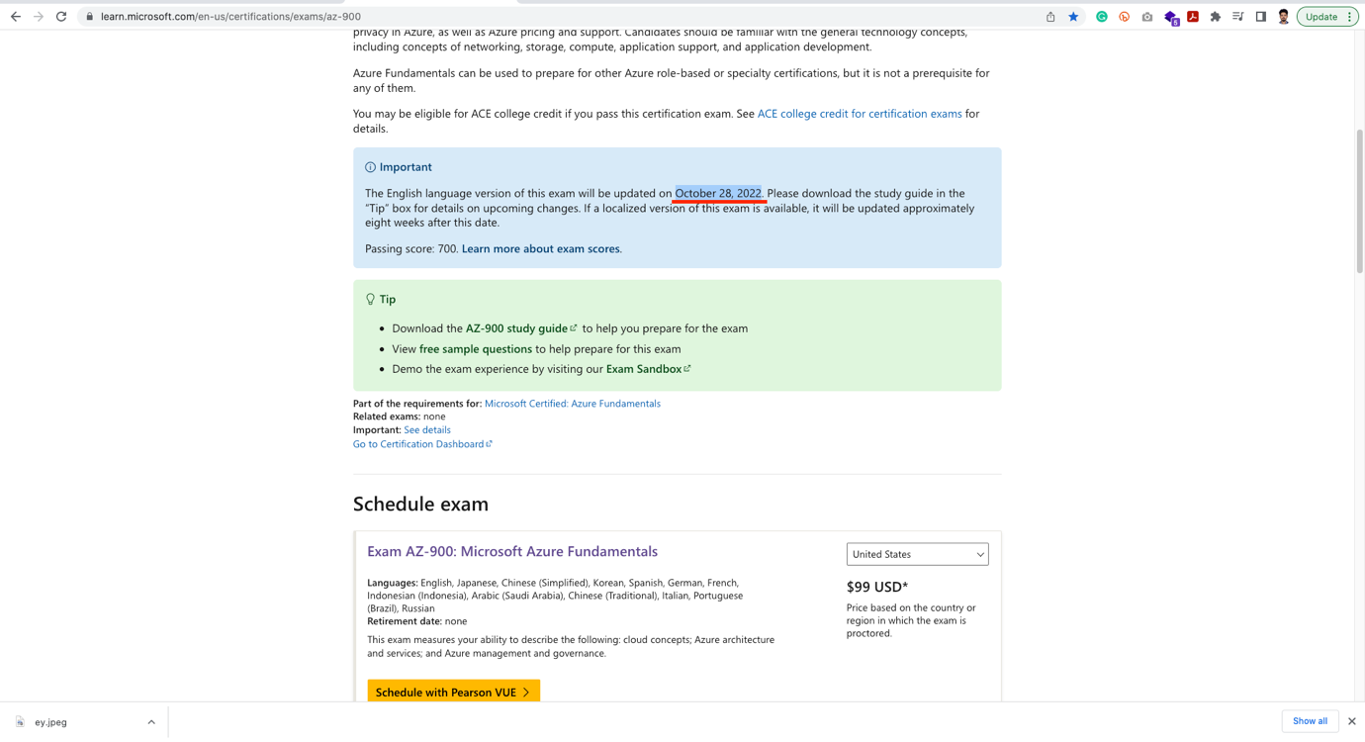

Cost of Exam: 3696 INR/-

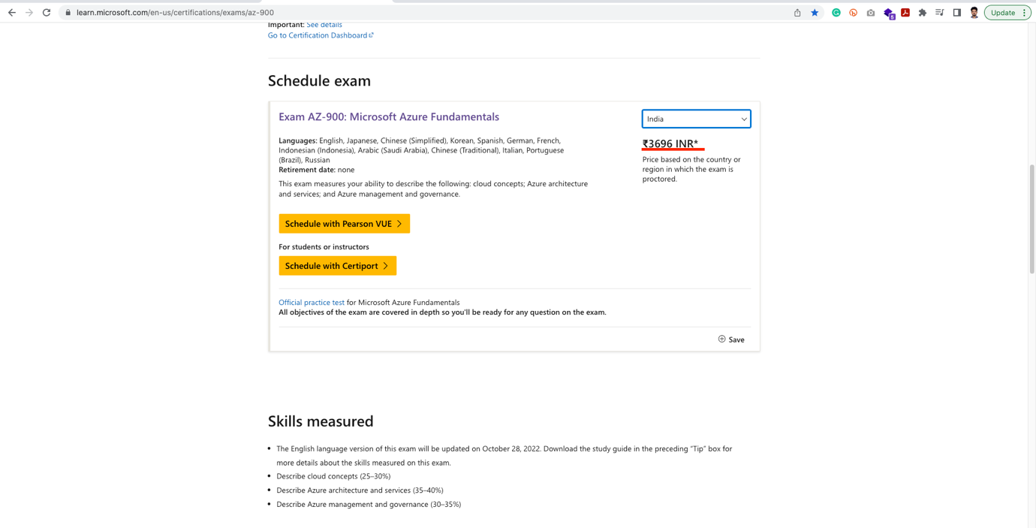

Skills measured:

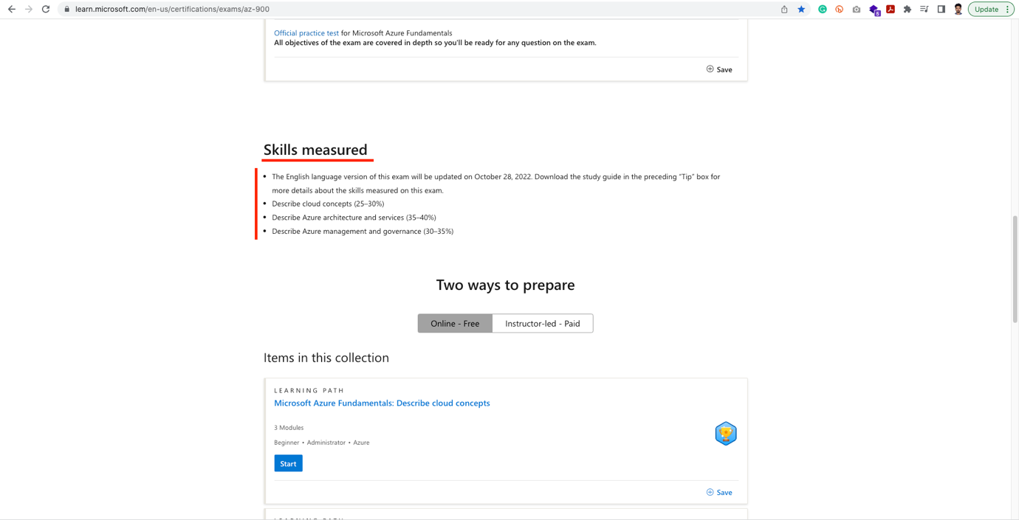

This certificate – does not expire unlike other Microsoft exams

SECTION 2 – DESCRIBE CLOUD COMPUTING

Shared Responsibility Model:

Cloud Computing –

🡪 Ability to rent cloud computing resources on demand.

🡪 We only pay for what we use

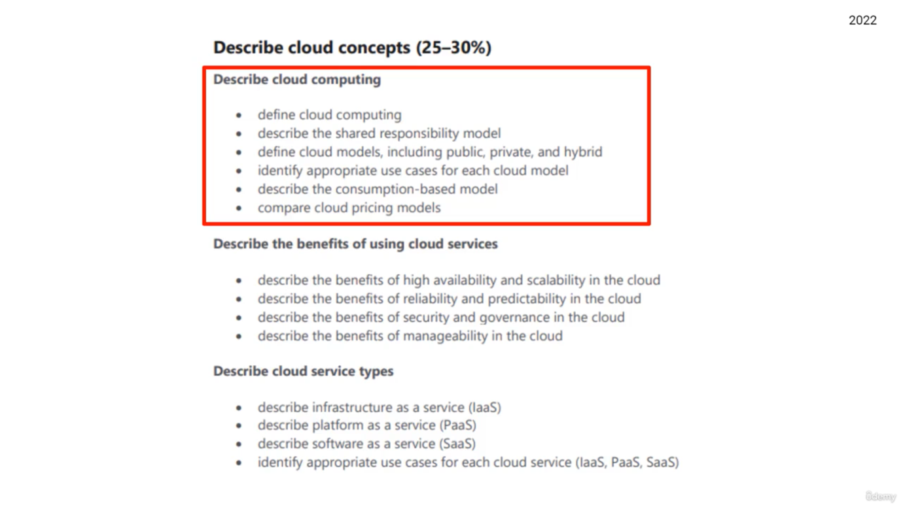

🡪 Normally when we run server in the office, we are responsible and payment for below tasks:

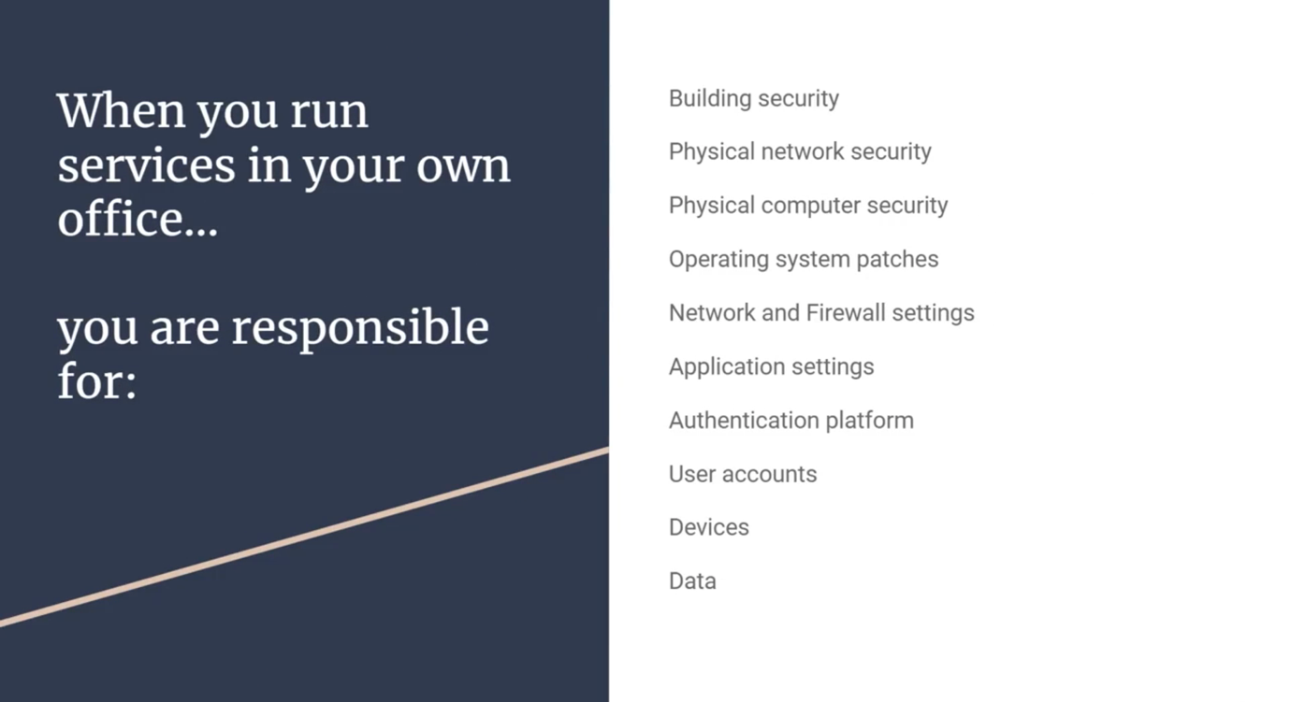

Cloud Model:

1. Virtual Model (VM): Responsible for below:

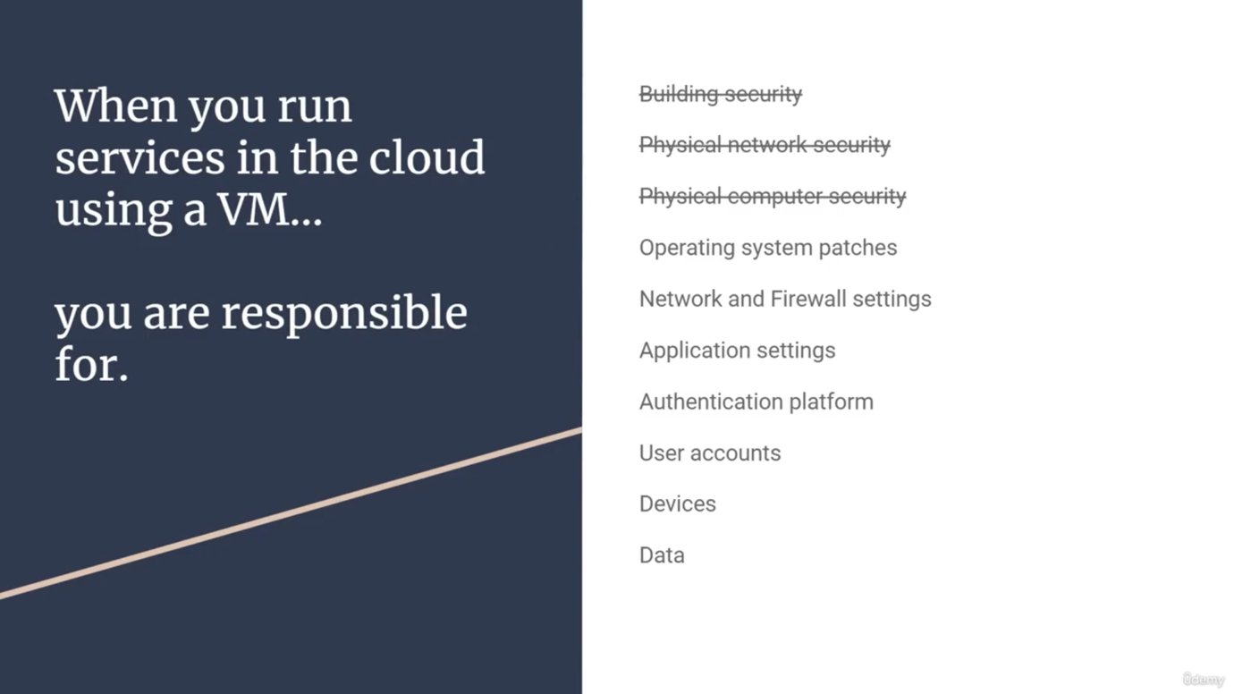

1. App Service Model:

🡪 This is a level higer than VM model

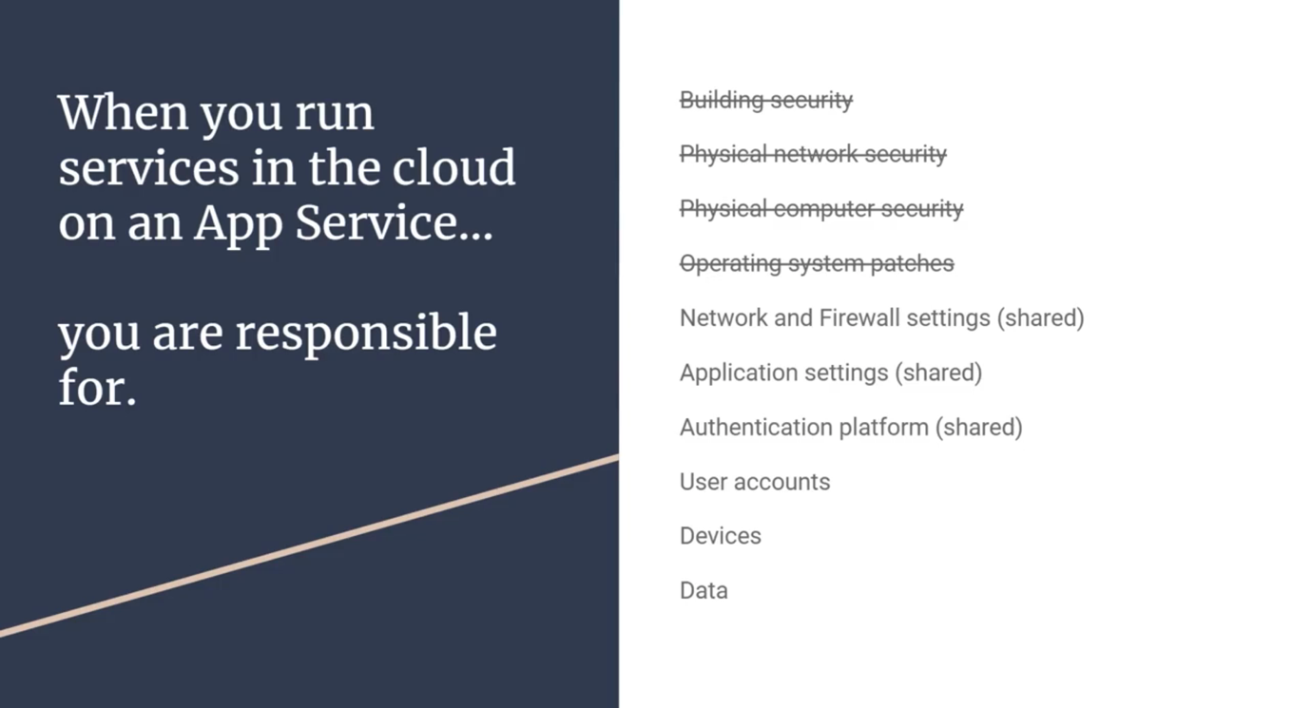

1. Software as a Service (SAAS):

🡪 Here this model has the highest level of Abstraction.

🡪 Normally here we rent software’s, that may have new features in future.

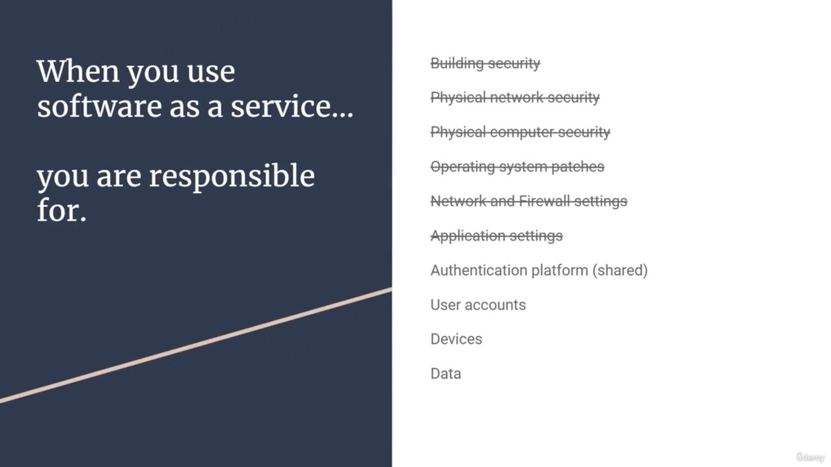

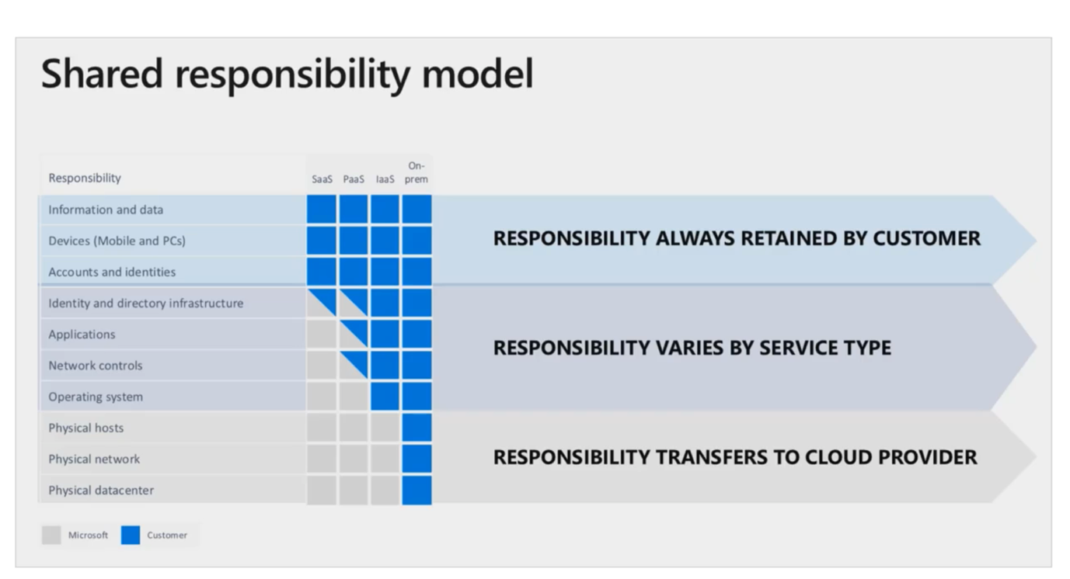  
  
___________________________________________________________________________

Public Cloud, Private Cloud, Hybrid Cloud:

1. Public Cloud:

🡪 Microsoft Azure has a public cloud version in which anyone with a credit card, sign up an account and start using the services right away.

🡪 So anyone can use it

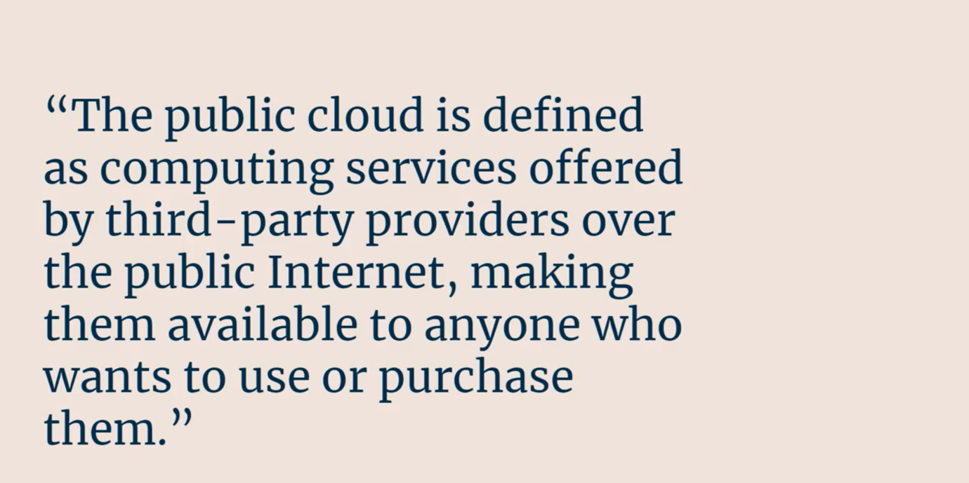

🡪 Azure basically owns the hardware and basically renting the services for which we will pay.

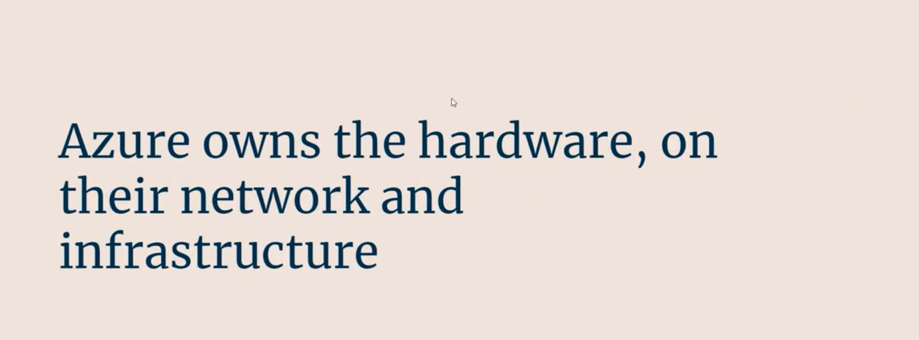

1. Private Cloud (or Azure Stack):

🡪 Microsoft Azure also has private cloud offering where only on a internal portal or some specific group of people in internet

🡪 It is also called Azure Stack

🡪 Here we can purchase the stack software and purchase on our own hardware, hence running a version of Azure privately.

🡪 There is also government specific cloud. It is available in the public domain but not anyone can start working on it.

🡪 Only approved government ID can allows for specific departments like ARMY

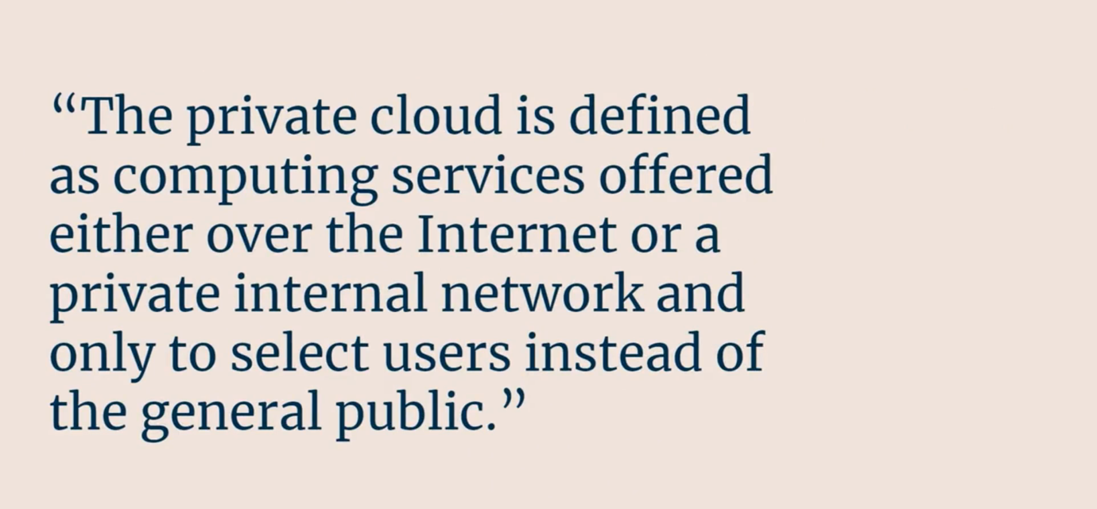

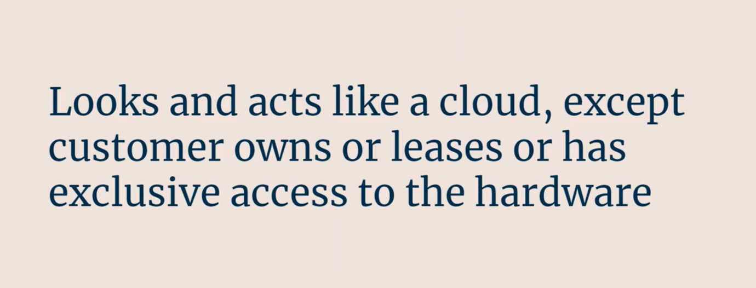

1. Hybrid Cloud:

🡪 It is a combination of public cloud and private applications

🡪 Private side does not necessarily means on the cloud softwares

🡪 If we are running application on our own hardware but we leverage cloud services for select things, then we are running hybrid model

Eg:

🡪 We have a SQL server installed locally and all of our data is running locally.

🡪 But then we have to archive data or backup data into the cloud.

🡪 Suppose we chose Azure Cloud to backup data.

🡪 So Automated data jobs runs every night – backups the data an dput those files into Azure storage account

🡪 So that’s a hybrid model that’s where use the public cloud and private applications

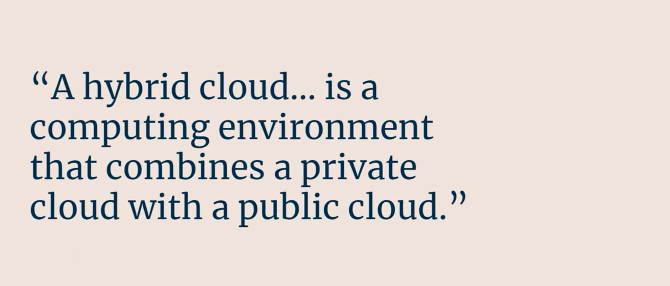

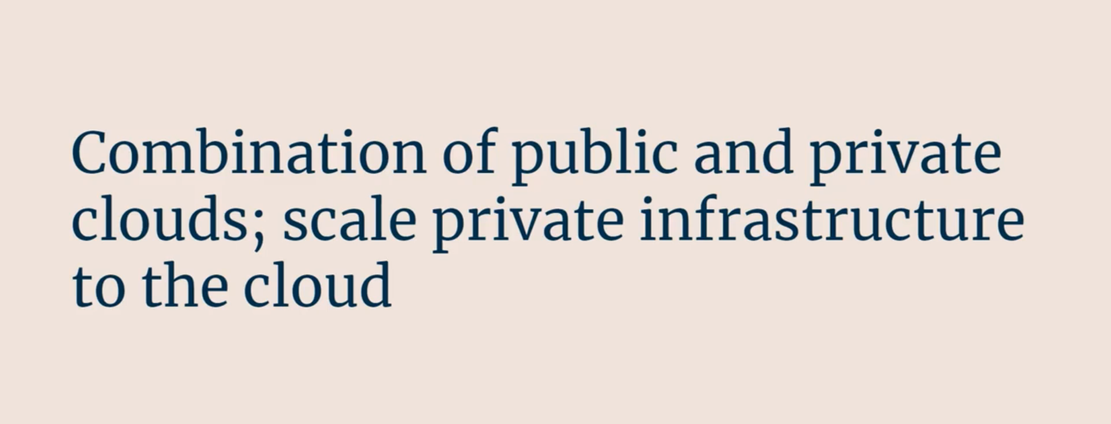

🡪 So it is a kind of scaling – we have app in our local servers and then we need additional computing power

🡪 It fires up a virtual machine and then send traffic to the clouds for performance reasons then that also a type of Hybrid cloud

**Q. Public vs Private vs Hybrid Cloud ?**

Public Model – Available for everyone, need to pay for it (may be dedicated hosting)

Private Model – Lease a software on hardware. There are many other companies

Eg, IBM Private cloud, HP has private cloud

Hybrid Model – Usually means combination of public and private cloud elements

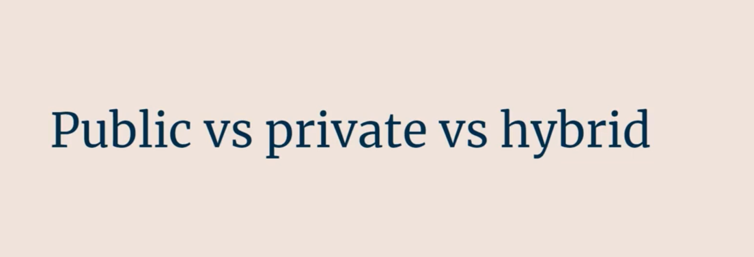

Cloud Pricing:

🡪 Cloud pricing is hard to predict based on the resource type (eg. on-premise, FAAS, PAAS, SAAS) it depends

🡪 If we are running services on-premises, cost 🡪 Easy to predict 🡪

We do not pay for the hardwares, mostly for the softwares we are using

Internet = fixed price

Cooling – fixed price

Cloud softwares = predicted price

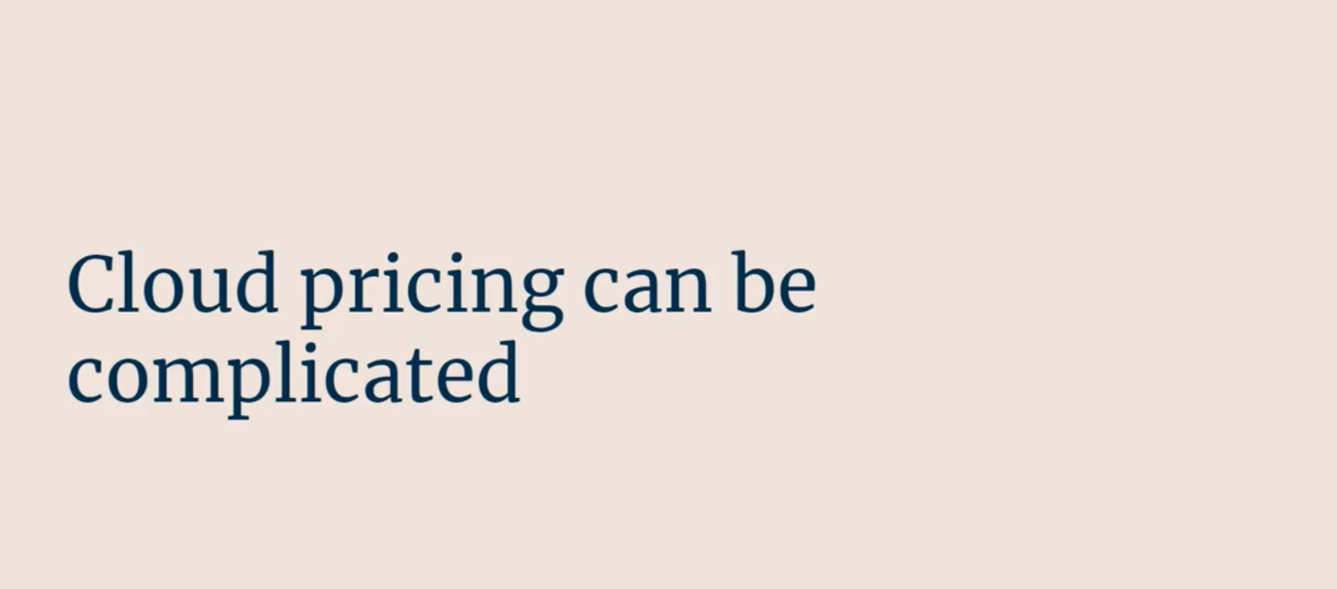



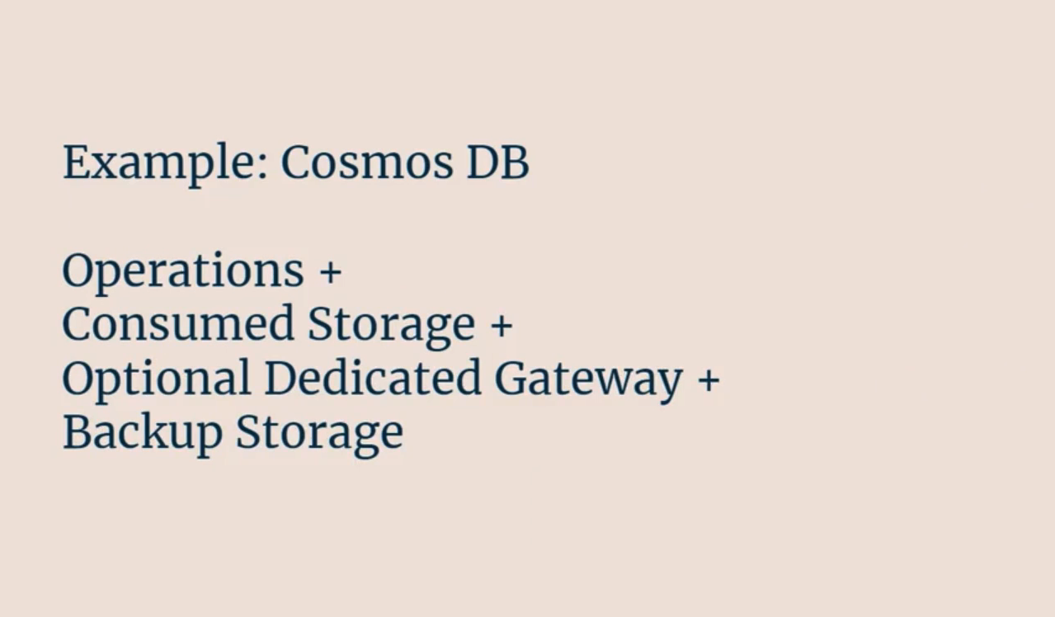

🡪 Suppose we are using databases say Cosmos DB – so there are multiple factors for cost for databases:

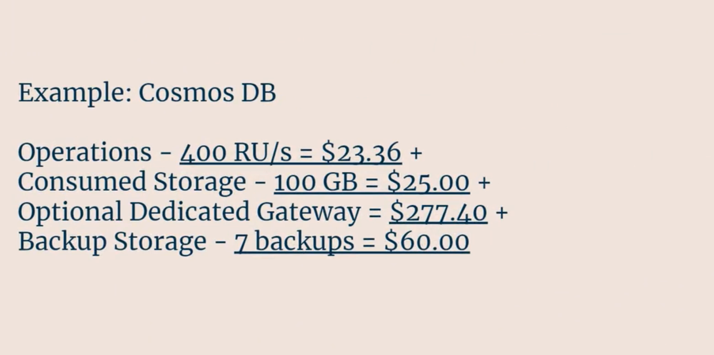

1. **Free Services:**

There are couple of free services in Microsoft Azure:

Azure Function (similar to AWS Lambda Function)

Azure AD (Active Directory)

Azure Policy (creating multiple policies for the Azure services),

Running a blog in Azure app service for free etc

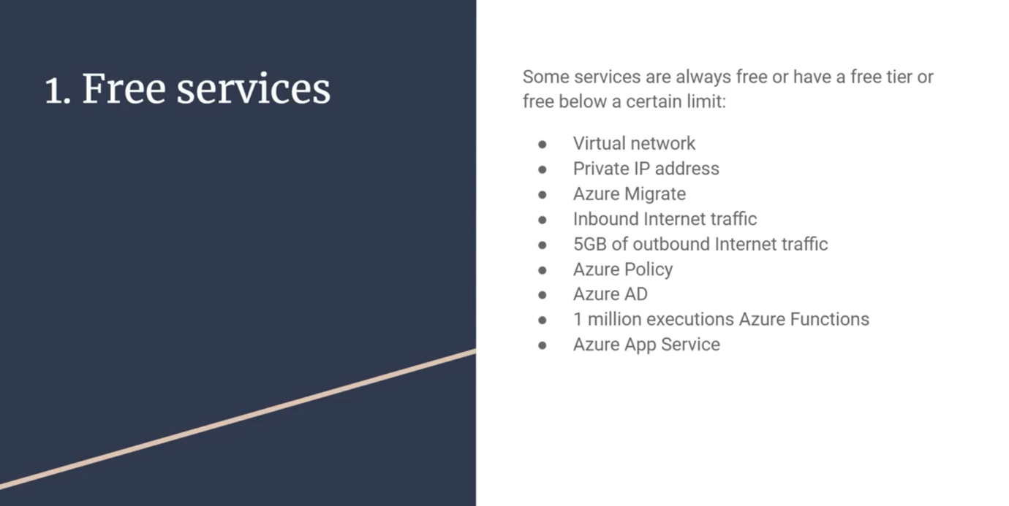

1. Pay for time:

🡪 There are several services that generates bills based on time we use it

Eg, Virtual Machine, App services, databases, load balancers, managed storages, public Ips

🡪 These services are above the free tier

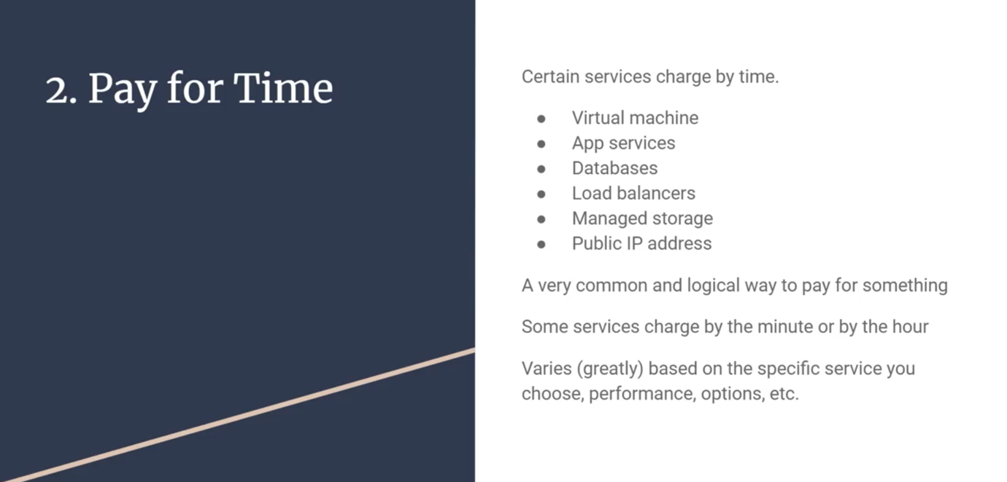

Virtual machines are used by hour and minutes.

Of course some of the charges are very small and some are large

1. Pay per GB:

🡪 This bill generates based on the quantity of storage

🡪 Anything to do with storage or traffic

Eg, sending traffic between regions. Sending traffic from Asia to America, doing regular backups, etc.

🡪 So we will pay for the GB for the traffic it travels

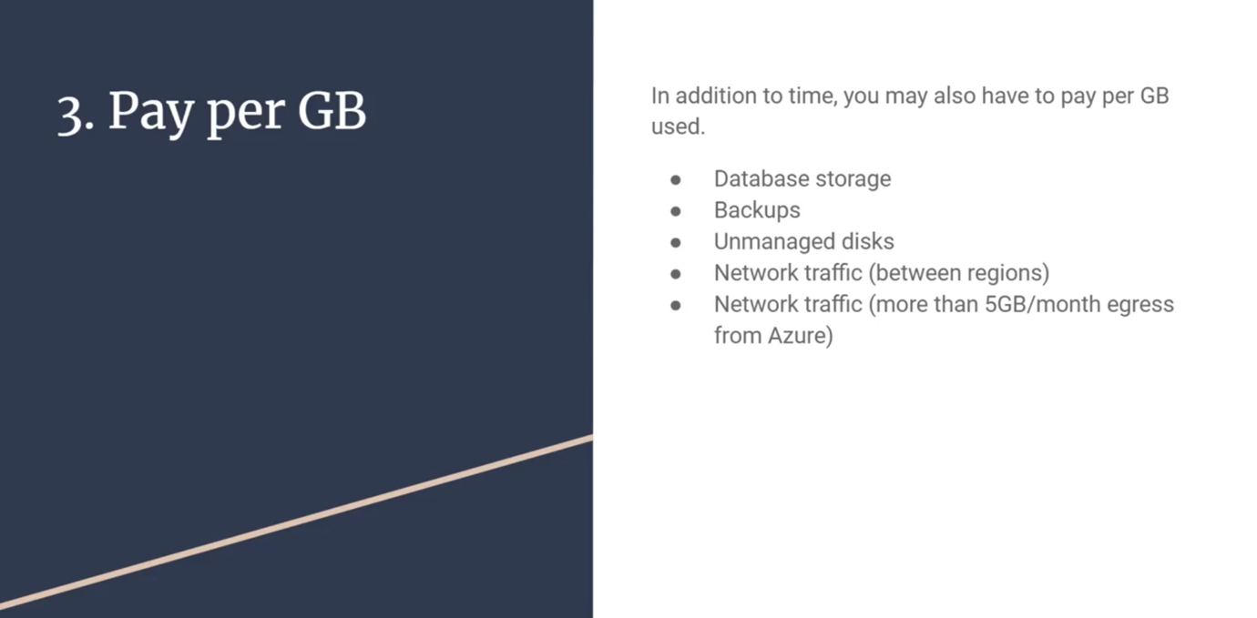

1. Pay for Operations:

🡪 In some cases we will be charged per operations

🡪 These are generally bulked together so we are paying for the operations –

Eg. 10,000 requests, per million requests etc.

🡪 In case of storage there will be charges for

1. Reads, writes and deletes for things like that.
2. Database queries
3. Messaging in Queues (similar to Amazon SQS service)

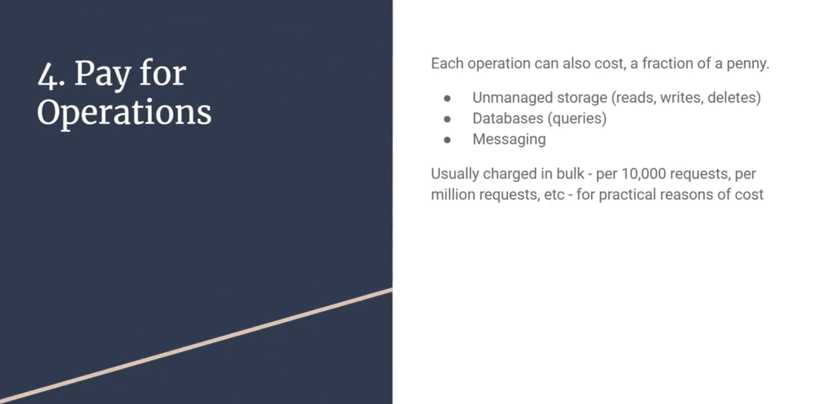

1. Pay per Execution:

🡪 There are several serverless operations that costs per executions

🡪 Some of them are –

1. Azure Functions (similar to AWS Lambda Functions) – first 1 million per month free

So even if we have a code that runs once a month then it is free.

1. Serverless Databases
2. Messaging Services
3. Logic Apps

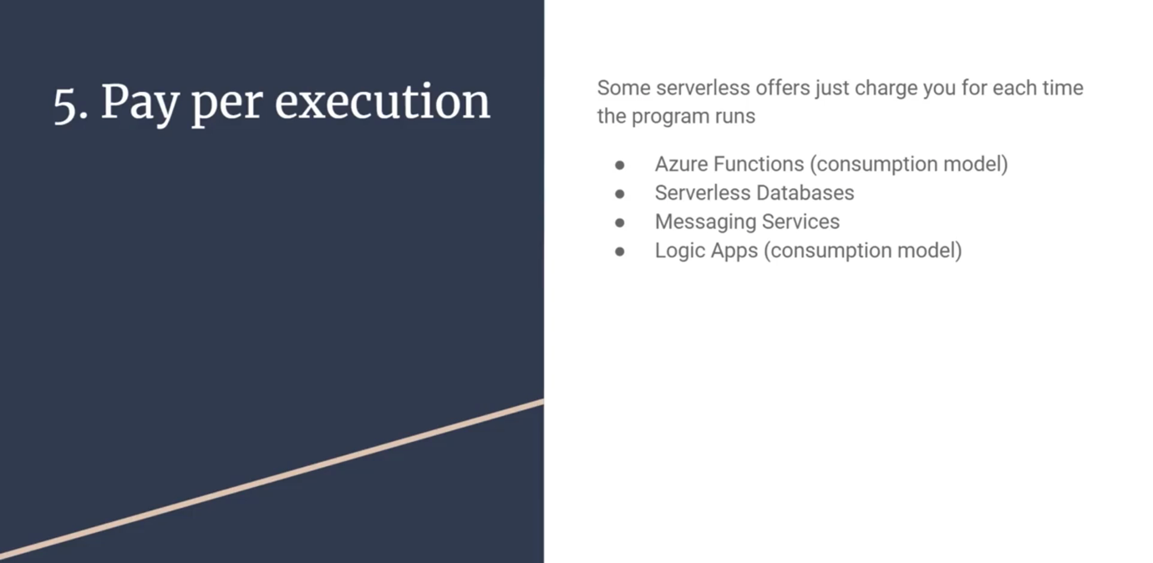

🡪 So what we are trying to understand here is there are many metrics based on which Microsoft charges in bills.

1. Other metrics:

Some are paid based on users,

It depends on geographical region of the services

Eg. Services running on North America can be cheaper based on South America or India

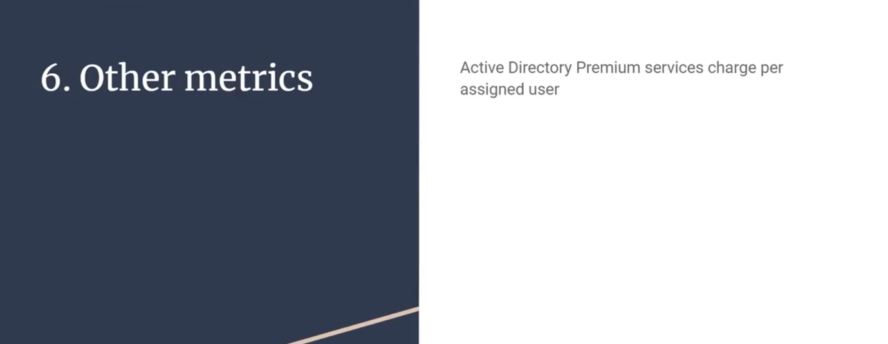

🡪 If saving money for Azure bill is the goal, then we can save in geographical data centers that are having cheap price.

Eg. storing a file in a some region.

Cost Saving Benefits of Cloud Computing:

🡪 There are multiple reasons why to use Azure Cloud.

🡪 Here are some of them, will discuss them one by one.

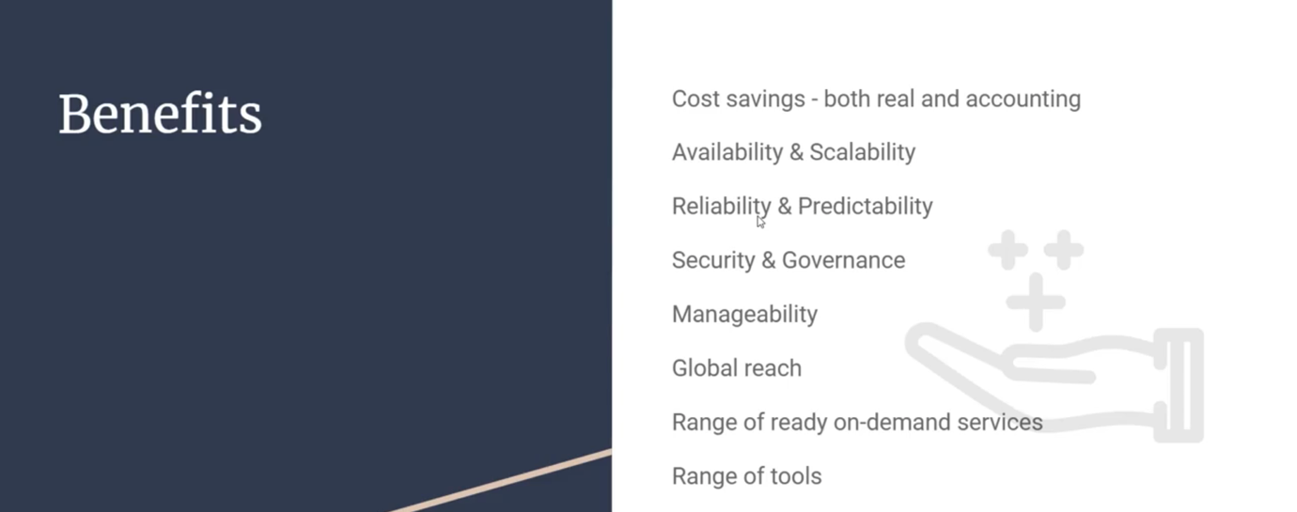

🡪 Azure Pricing vs Year graph

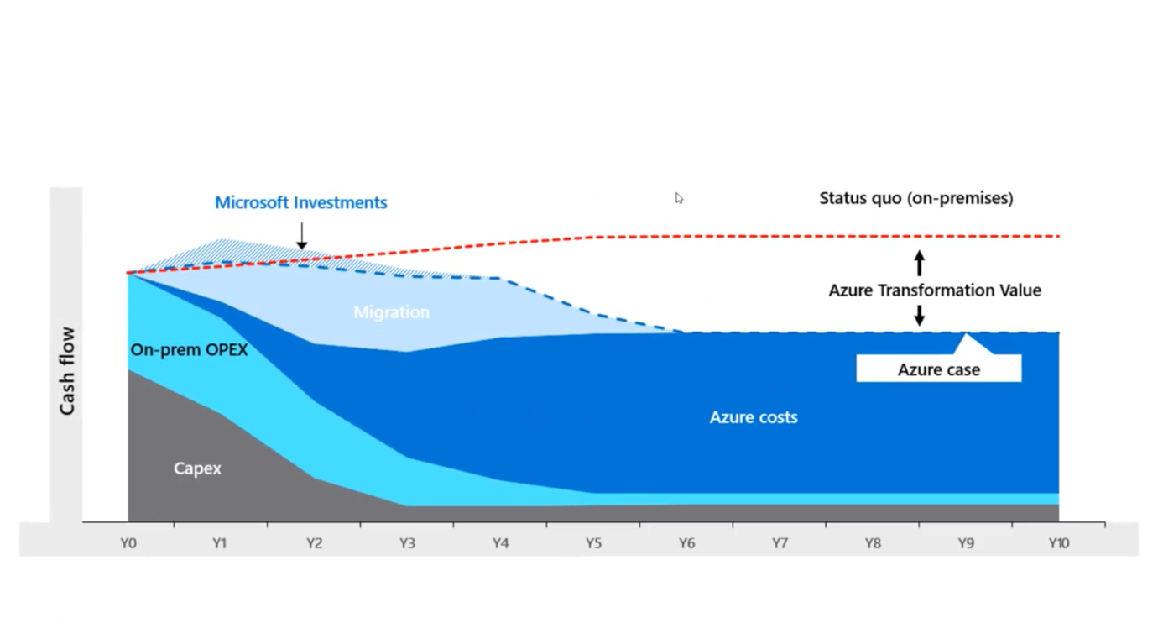

🡪 Why companies are using cloud instead of buying personal hardware’s.

🡪 This is because Microsoft buys hardware’s a lot cheaper then we can buy.

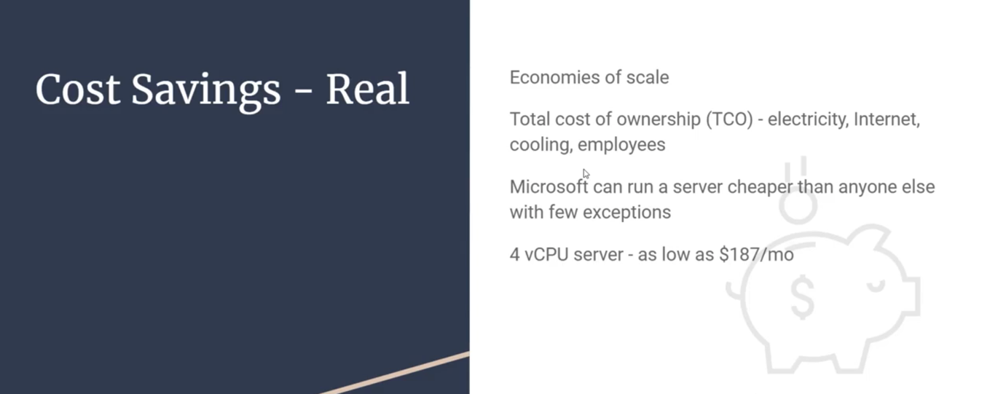



High Availability, Scalability, Elasticity:

1. High Availability:

🡪 The amount of time the system is operational

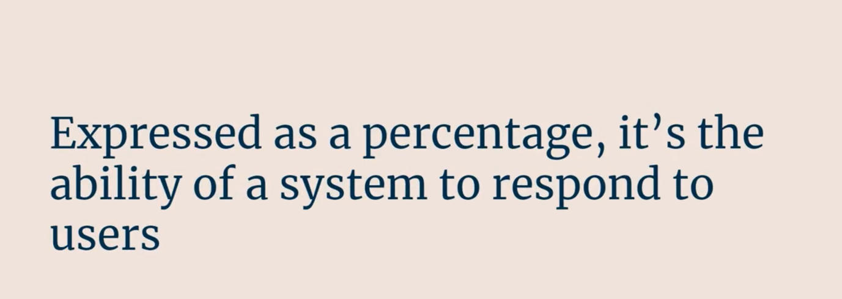

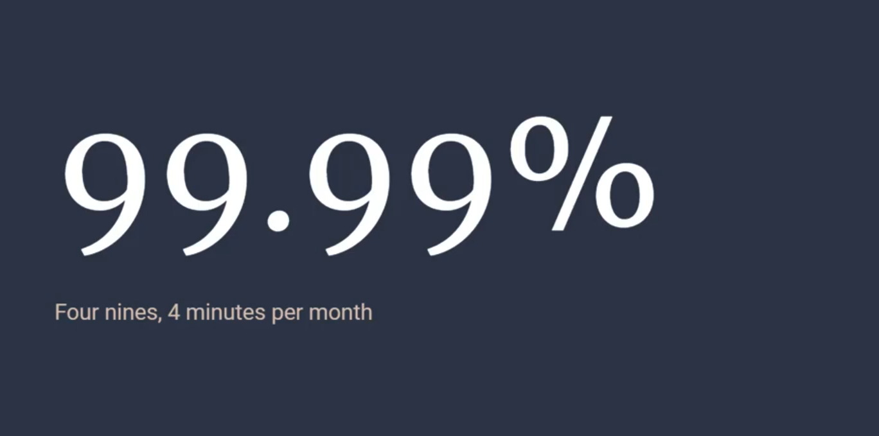

🡪 High Availability is achieved with the concept of Scalability.

1. Scalability:

🡪 Scalability is a way to add capacity to your application.



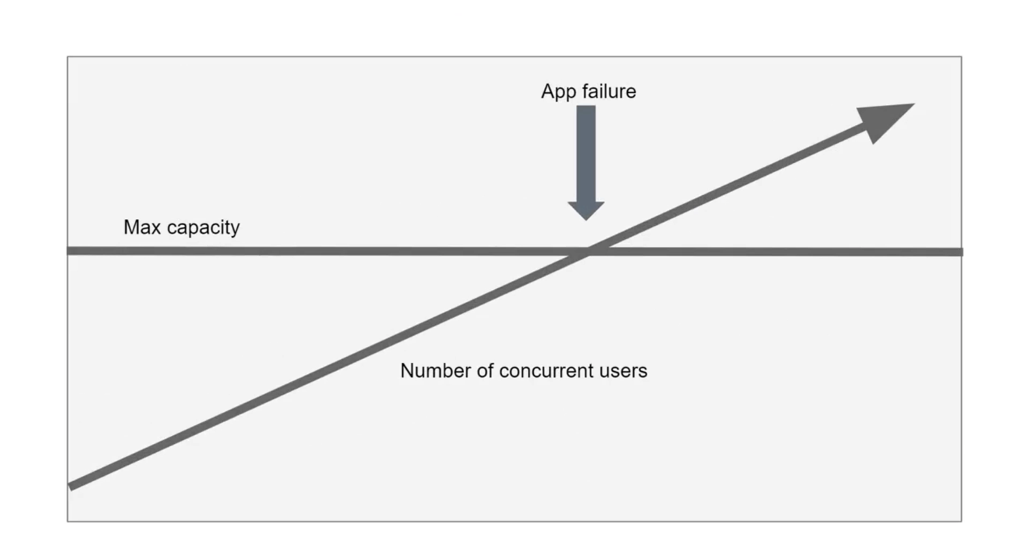

🡪 Remember these terms: Max capacity, App failure, no. of concurrent users.

🡪 When number of users increases the maximum capacity – app failure starts to happen

Mostly we see in Company portal when traffic is very high, or tatkal ticket booking

🡪 So scalability is achieved with the help of elasticity.

1. Elasticity:

🡪 The ability of a system to automatically grow and shrink based on app demand is elasticity.

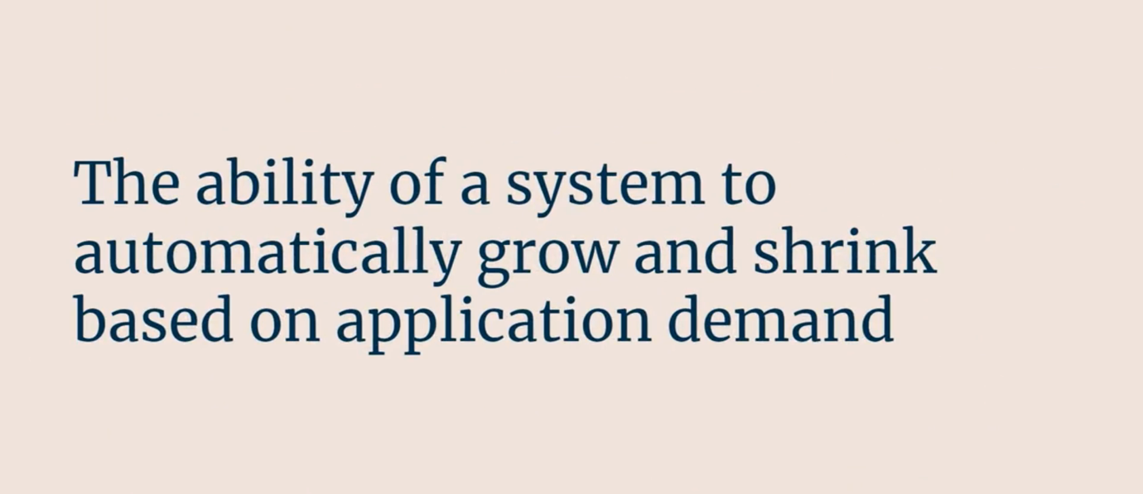

🡪 Hence we add additional servers automatically, hence called elasticity.

🡪 We can use this as an advantage, even if we require less CPU

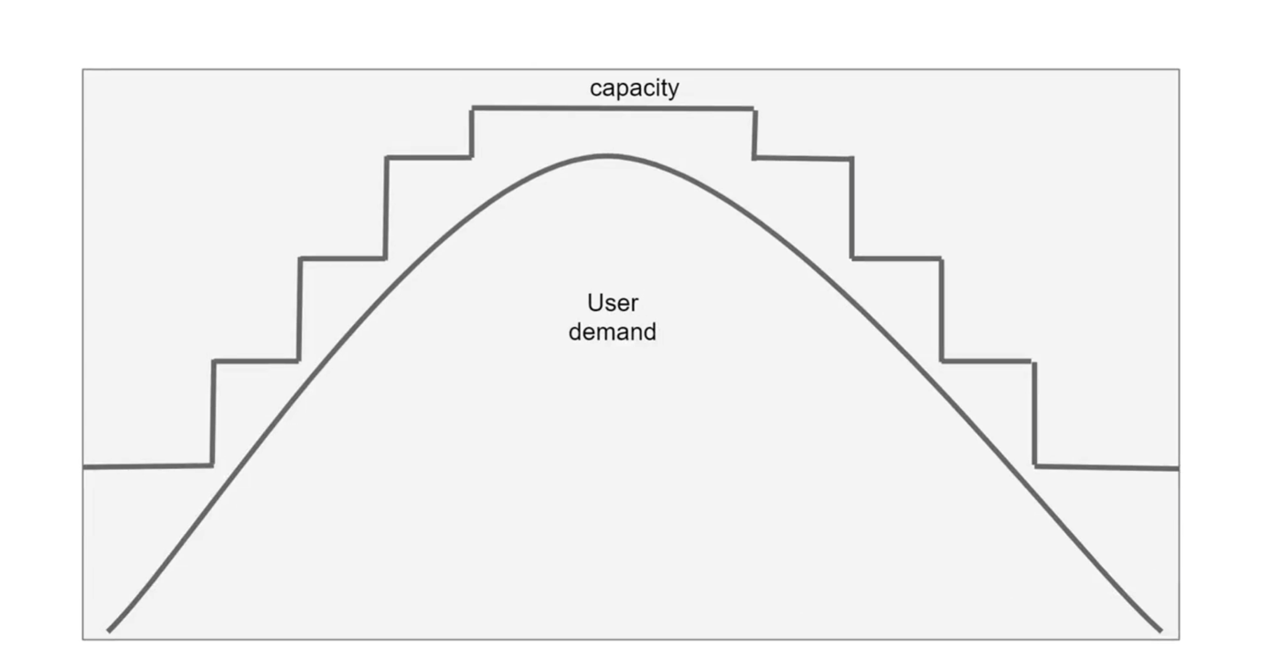

🡪 Think

High capacity = more money

Based on user demand we scale up and down.

Reliability and Predictability:

Reliability:



🡪 For every Microsoft Azure service we use, there is SLA (Service Level Agreement) signed

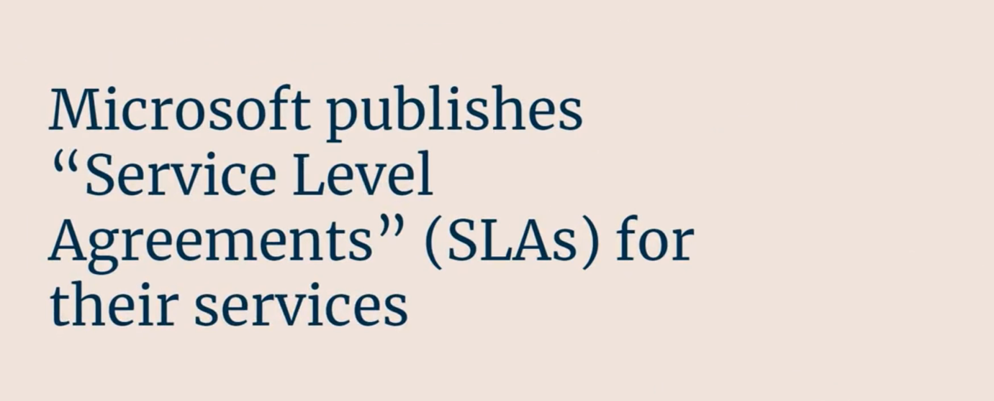

Reliability: Sometimes if Azure’s services are down and does not meet SLA, Microsoft will refund us back the money.



🡪 Azure even has established procedures for rollouts and regional recovery.

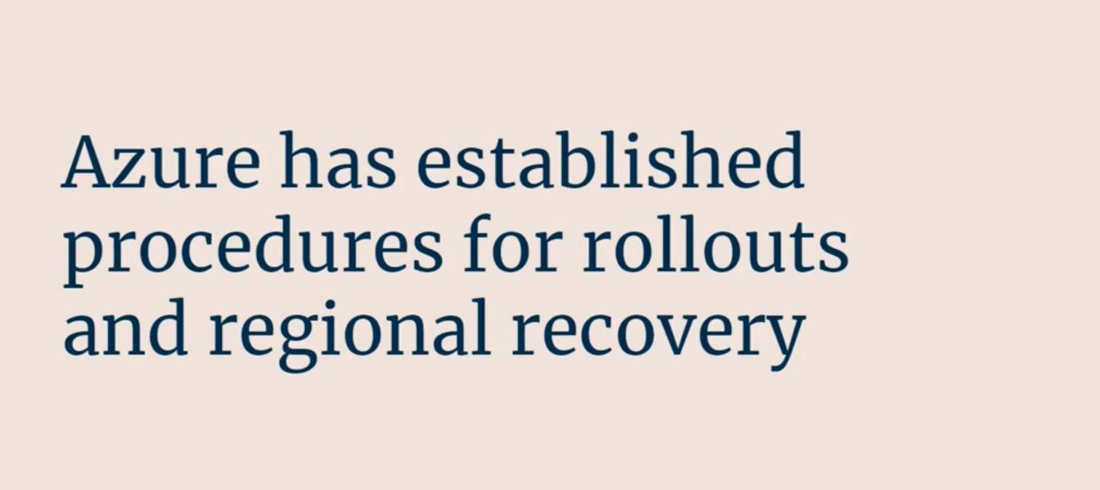

🡪 So the idea is to know that even when the services are down, Microsoft has their way to recover full data.

🡪 So there is a concept of Availability Region and Availability Zones

🡪 So we can create multiple copies of server in different zones. So even if lost in one zone, we can recover from other zone.

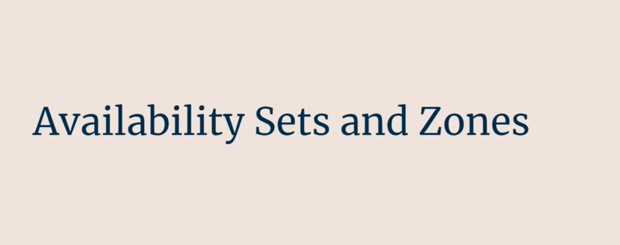

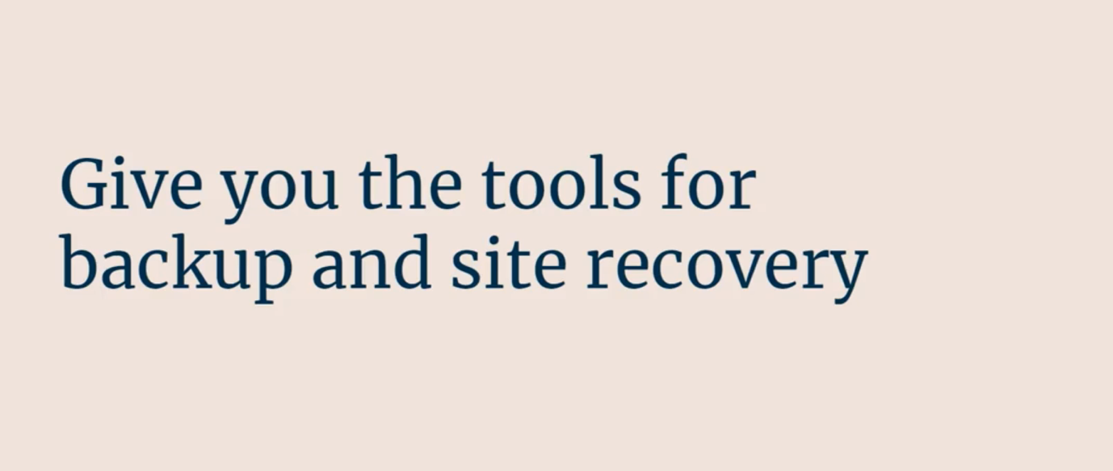

Chaos Studio:

🡪 Microsoft has the chaos studio, based on which we can check the network failures, and other failure to test the services.

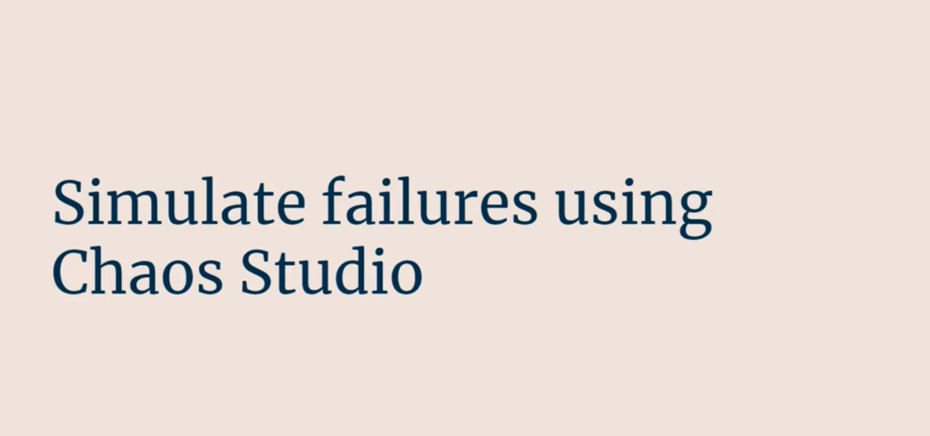

Global Reach:

🡪 This simply means having copies of codes or data across multiple regions.

🡪 Even if one server goes down the other server has data in it.

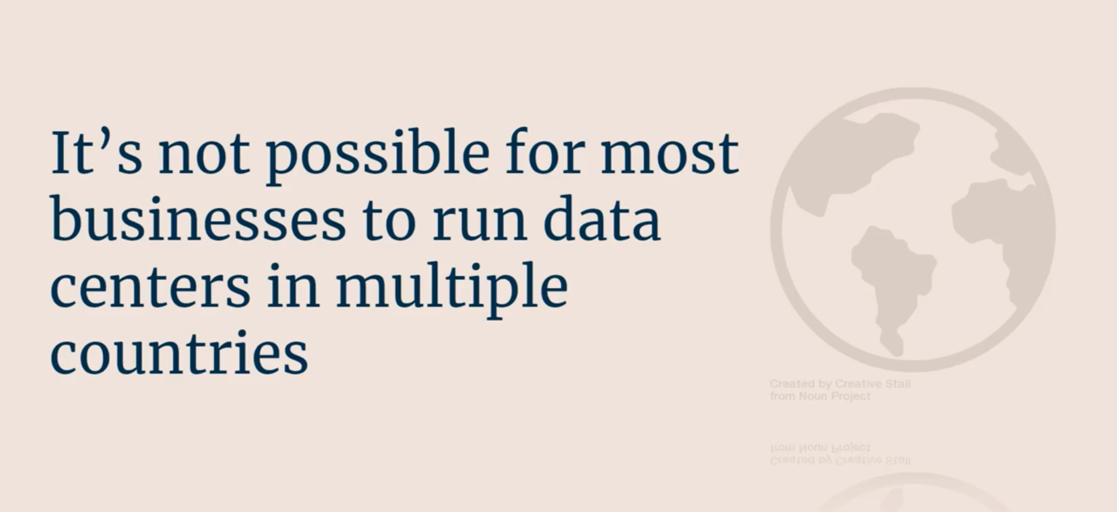

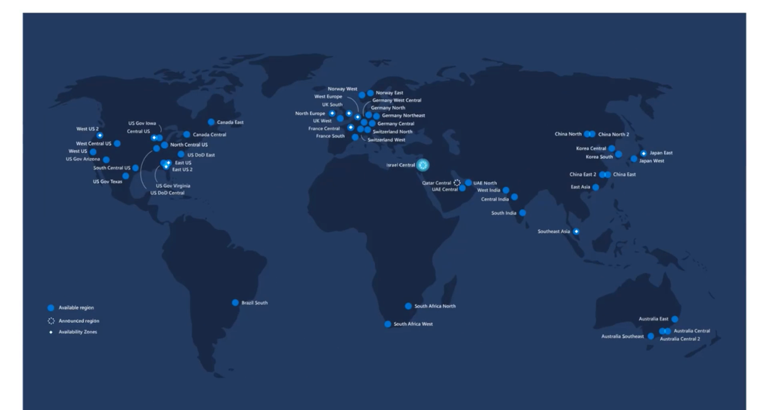

Security and Governance:

🡪 Azure has the ML/AI pattern that can recognize pattern if someone tries to hack into app

Eg. Azure Firewall will recognize some pattern and inform owner and takes some automated steps.

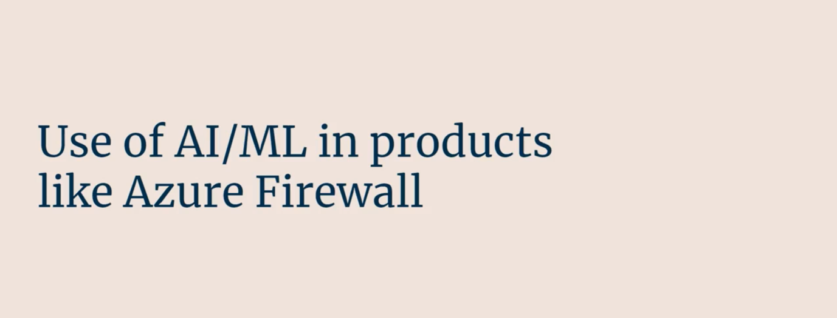

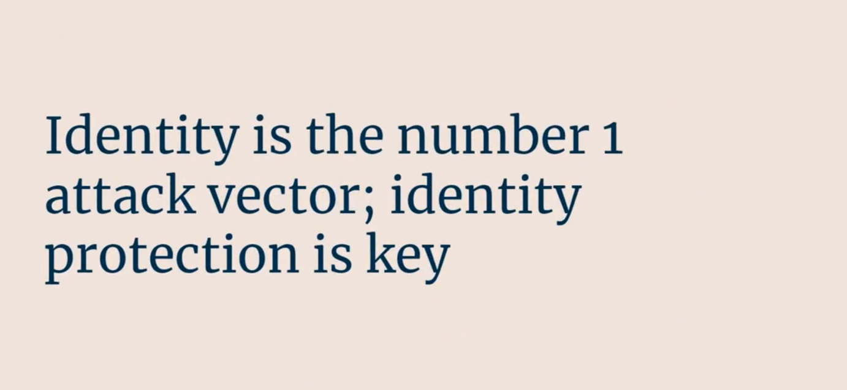

2. DDOS – Denial of Service Attack

🡪 This type of attack is hackers are tying to send some much traffic to a server by hack methods, that server is down.

🡪 They might charge ransom for fixing.

🡪 Microsoft pays for a basic free DDOS protection attack. For more sophistic DDOS protection attack Microsoft charges money for that.

Data Governance:

🡪 By governance we mean data needs to be saved as per government of your country

Eg. In Europe, Europe Union has GDPR (General Data Protection Regulation)

That restricts handling of data in companies and how data is to be stored.

Azure Tools:

1. Azure Policy
2. Blueprints

So basically some policy for group of departments or specific departments.

Monitoring:

🡪 It is important to have monitoring policy.

🡪 It is important to monitor and raise alerts when something needs to be acted upon

Azure Service:

Azure Monitor

🡪 Basically reporting, logging, get the data out of the services (similar to AWS Cloudwatch)

Cloud Service Types:

🡪 One type of cloud service is based on which Azure charges are – computing, storage, database, networking etc.

🡪 The other type of services are:

1. IaaS: Infrastructure as a Service
2. PaaS: Platform as a Service
3. SaaS: Software as a Service
4. Serverless

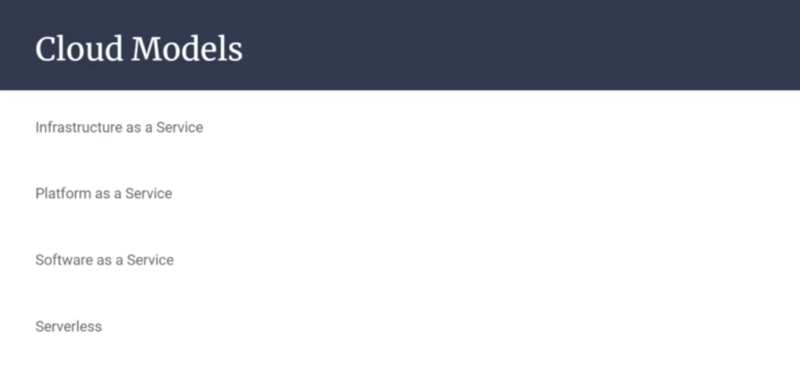

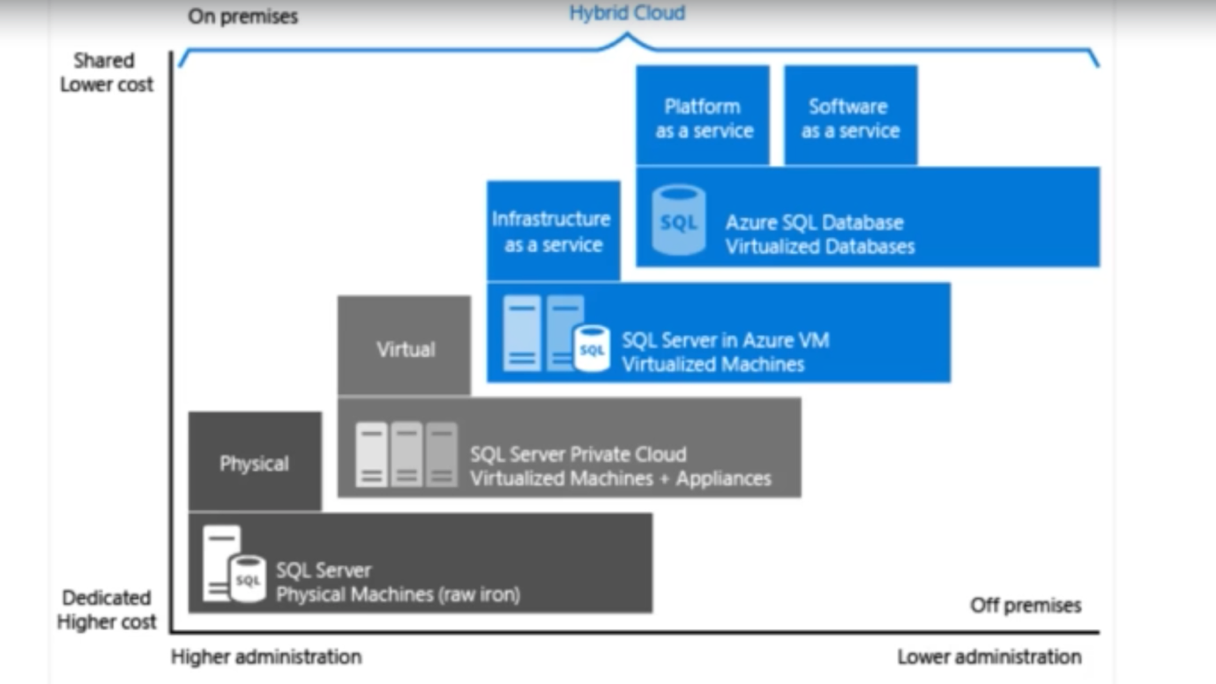

🡪 In the above diagram, it shows only databases SQL. In real time this applies to all the Azure service available in Azure Market.

Infrastructure as a Service (IaaS):

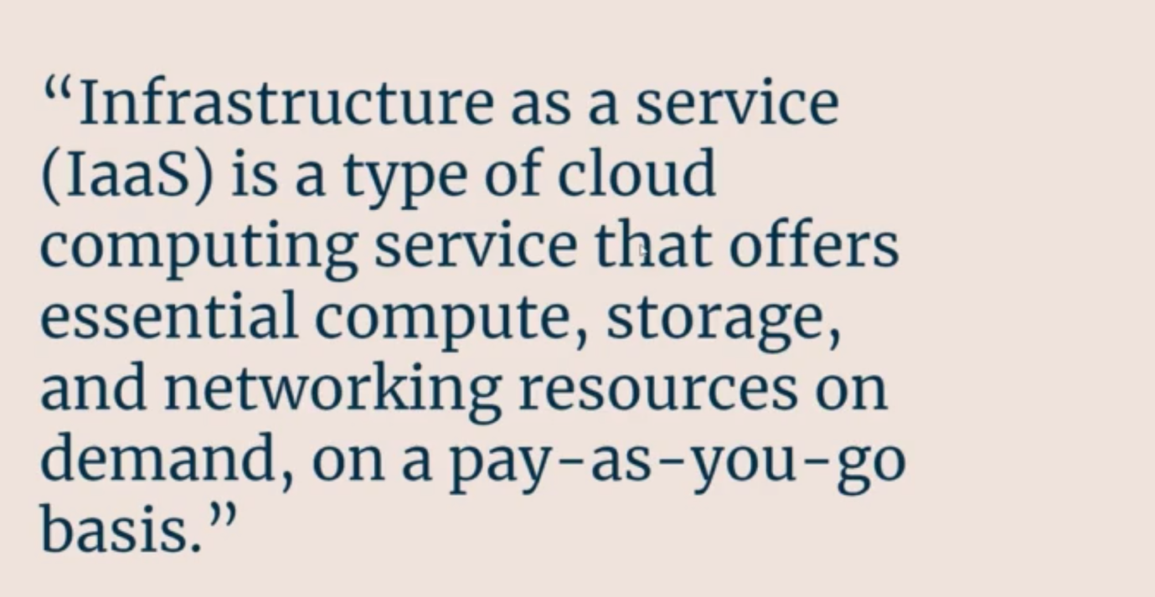

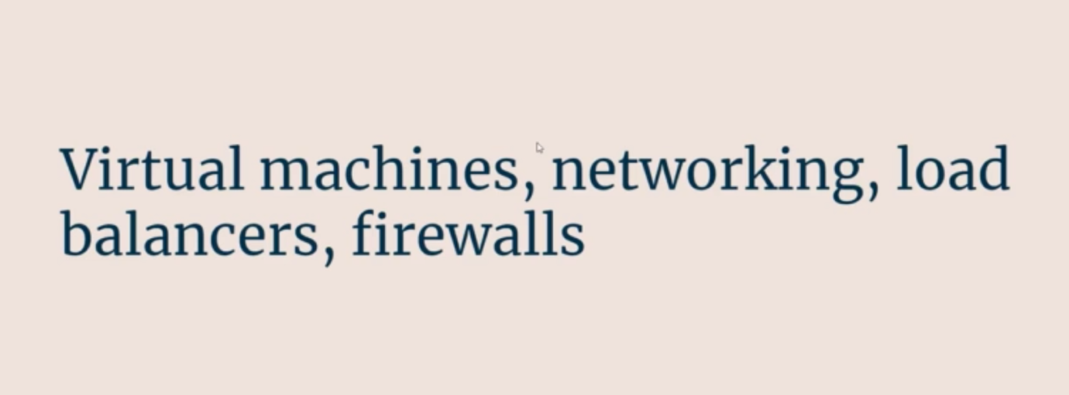

🡪 This becomes useful when we migrate from On-premises to IaaS

Platform as a Service (PaaS) / Cloud Native:

🡪 Here we have to give development and deployment facility.

🡪 Developer need to modify the app little bit to run as the PaaS model.

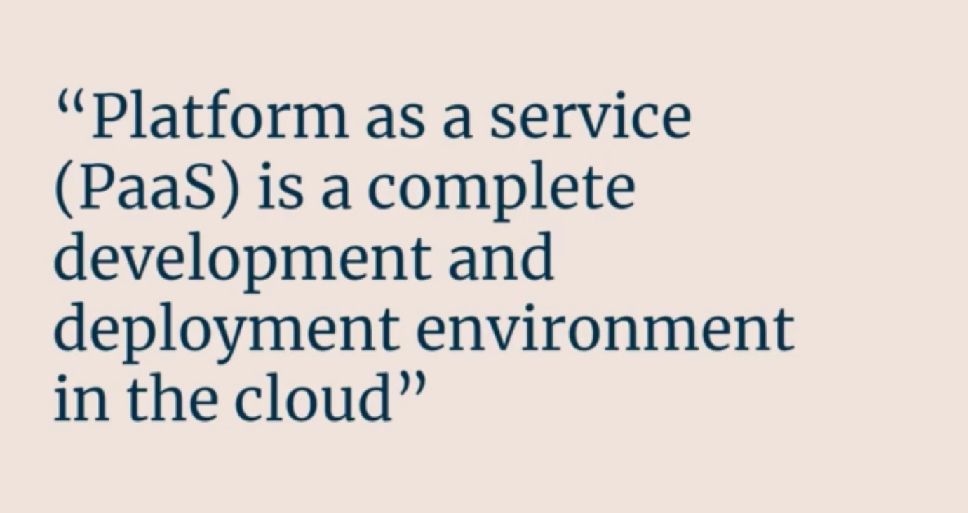

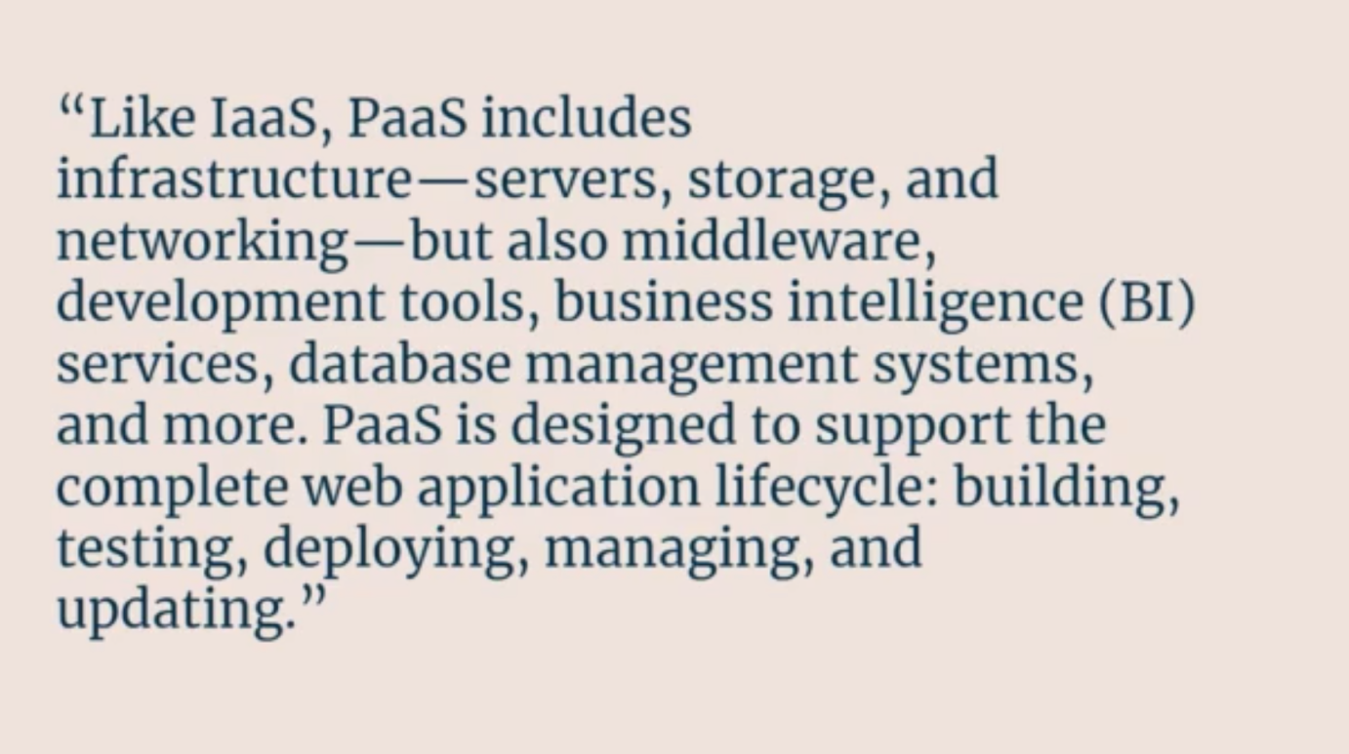



Software as a Service (SaaS)

🡪 Normally when we join the company, we get email outlook access, Microsoft Office 365 access, calendar access, Teams access

i.e. on demand software access

🡪 This is basically SaaS i.e. ready applications along with service

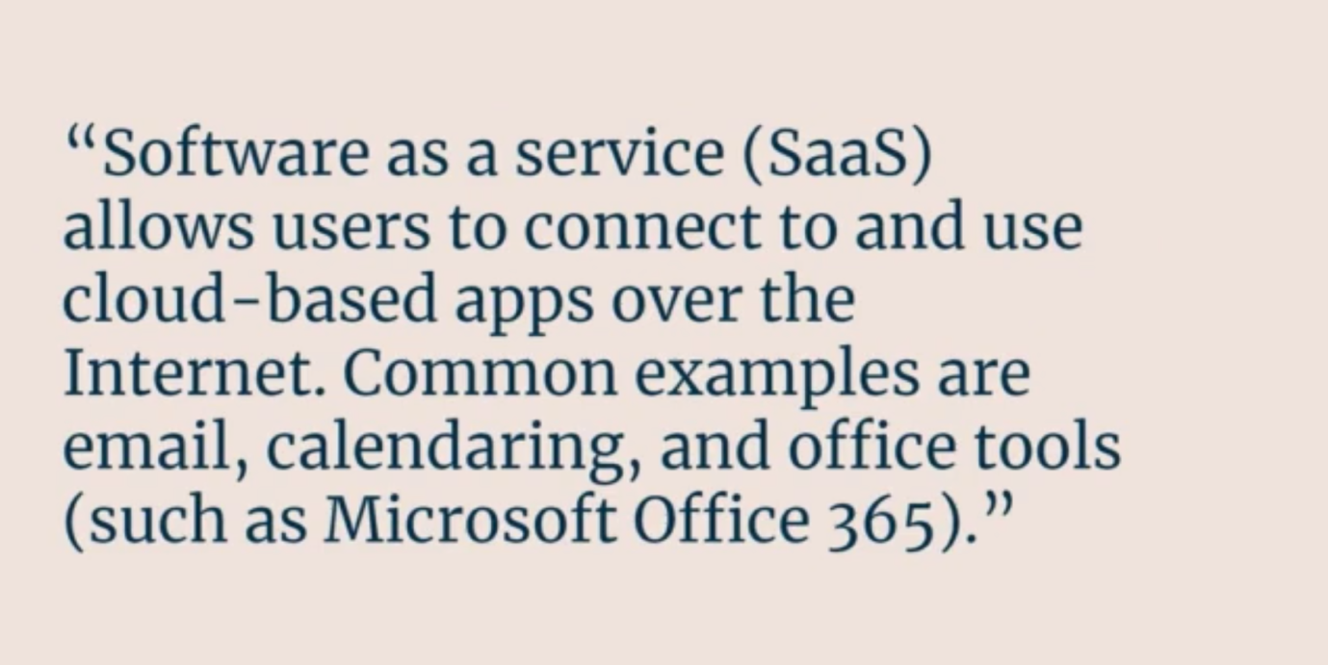

Serverless:

🡪 There are servers but we do not have to handle it.

🡪 Here we less access to the servers than PaaS.



🡪 With PaaS, scaling is our responsibility

🡪 With Serverless and IaaS, scaling is not our responsibility.



🡪 Some other serverless offering form Azure:

1. Azure Functions,
2. Serverless Kubernetes
3. Database – Azure Functions
4. Database – Cosmos DB Serverless

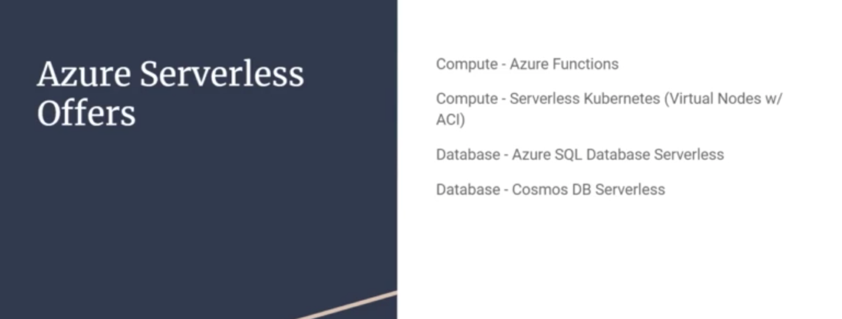

SECTION 5: Core Azure Architectural Components:

1. Regions:

🡪 There are more than 60 Azure regions in this world.

🡪 These are the geographical areas where Microsoft

🡪 We will not be able to access all the 60 regions, some of them will be available for backup, some government services

There will be a lot from chose from:

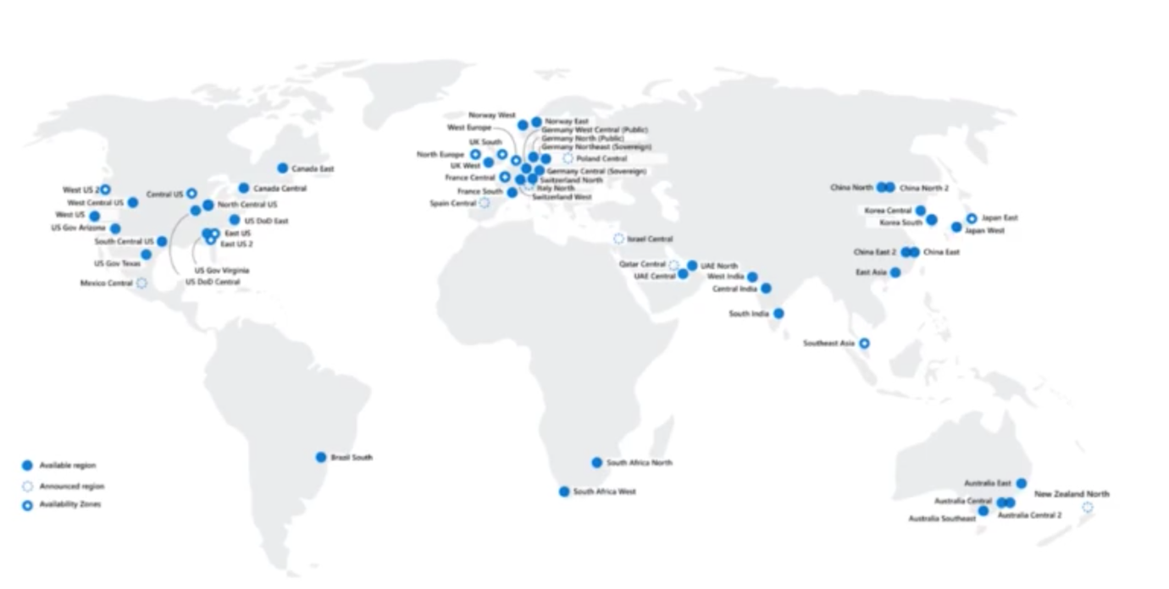

1. Region Pairs:

🡪 Not very region has equally fast to other regions.

🡪 Region Pair is designed to get the fastest connection between them.

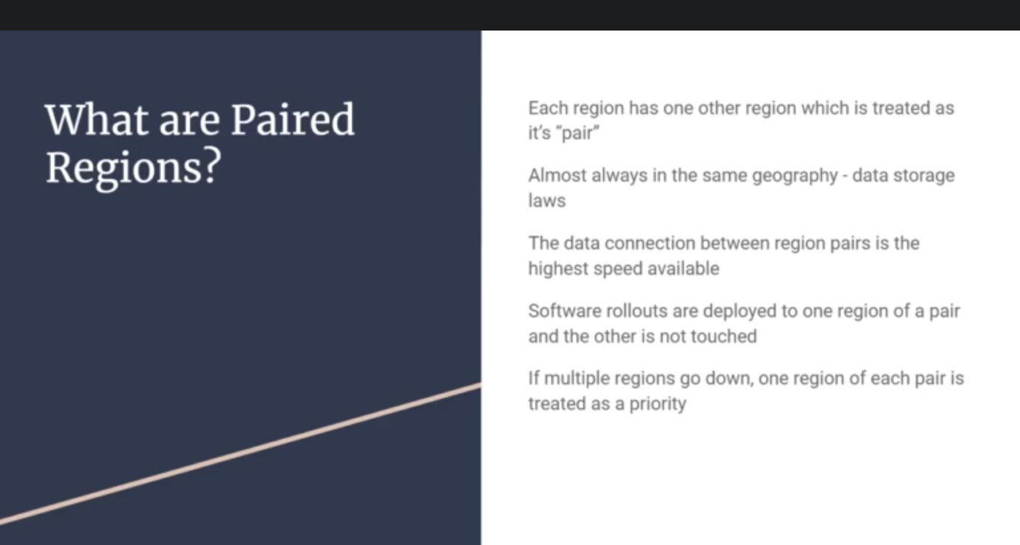

🡪 Data security is much up to date as it could be.

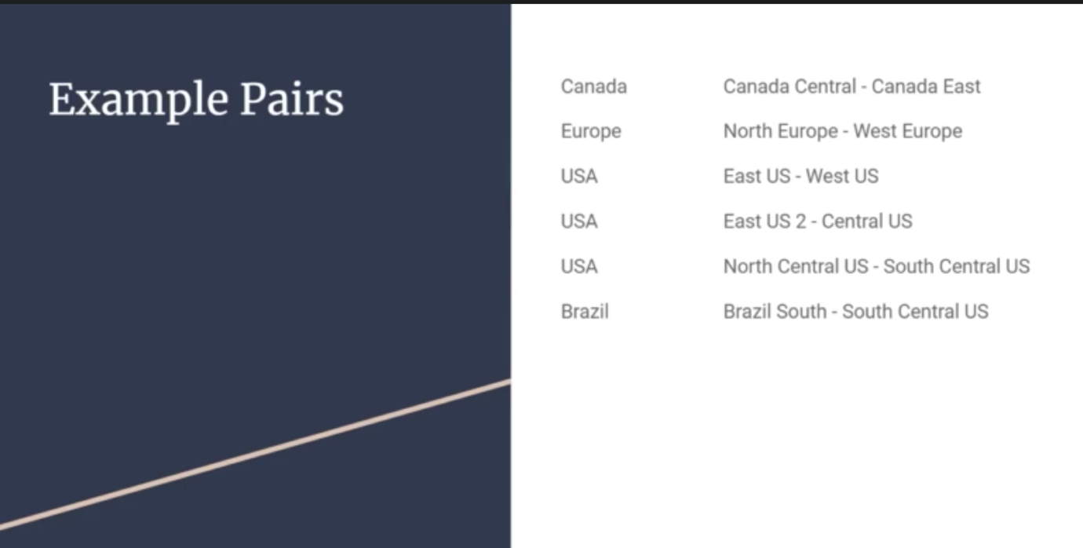

1. Sovereign Region:

🡪 Most of the region in Microsoft is public.

🡪 However there are some **region that cannot be access by everyone**. These are called Sovereign region



Availability Zones (AZ):

🡪 Inside Azure regions are Availability Zones.

🡪 Availability Zones are physical separate buildings that has own power, internet and cooling.

🡪 Basically Availability Zones are what separates data centres from one server to another server.

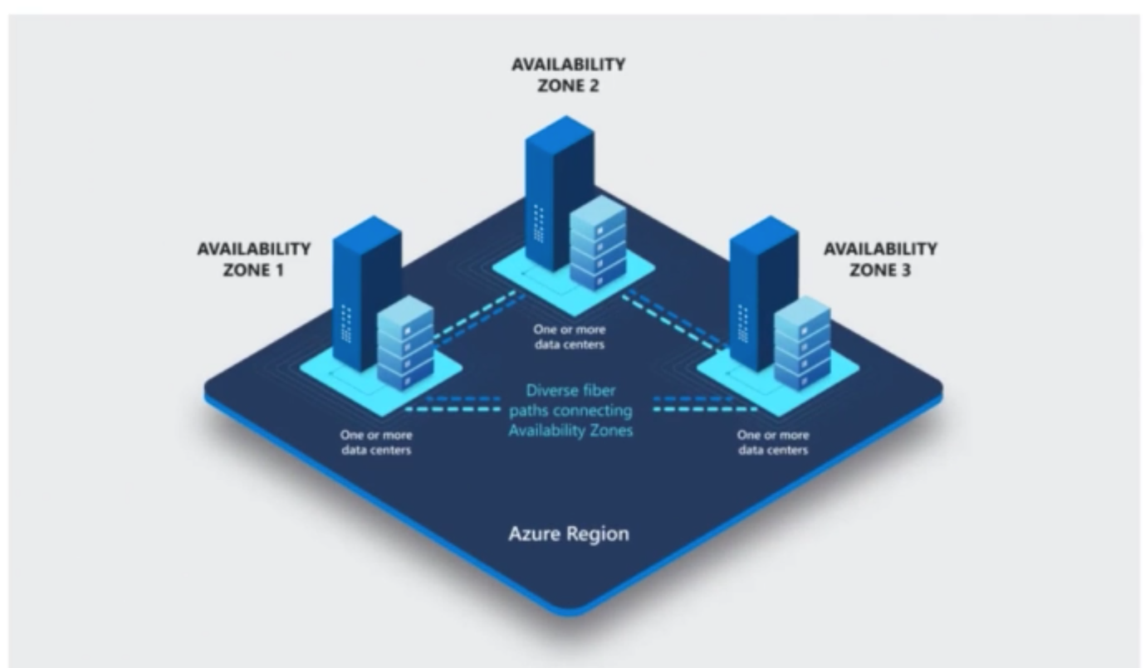

🡪 Suppose there are three servers (i.e. 3 Virtual Machine or 3 buildings)

🡪 Whenever we open the application, one of the server is connected

🡪 If something is supposed to happen eg. power cut or some other reasons server inactive

Then server is down and application is down.

🡪 So Availability zone will help here it will automatically route to another AZ

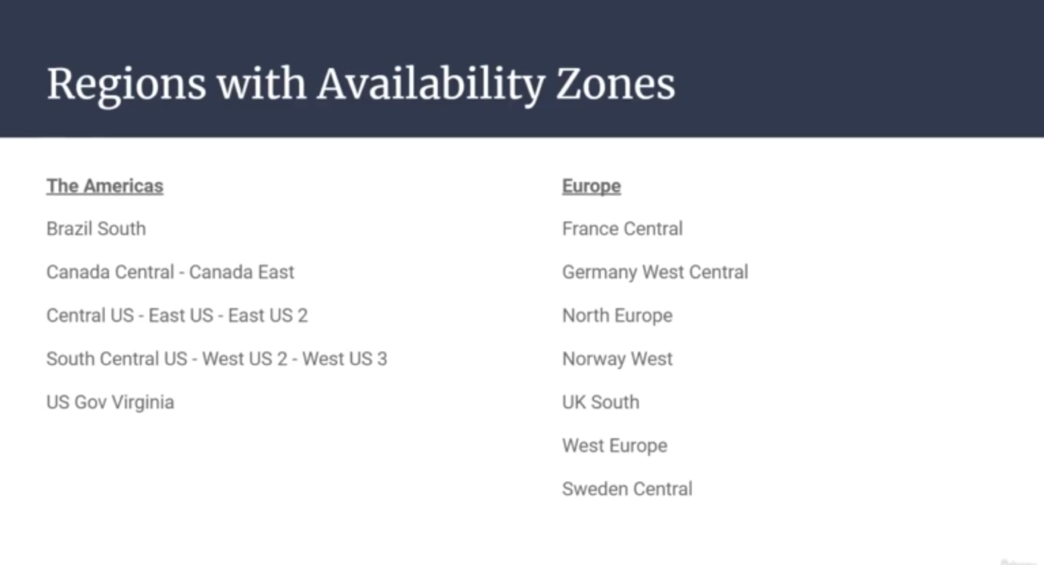

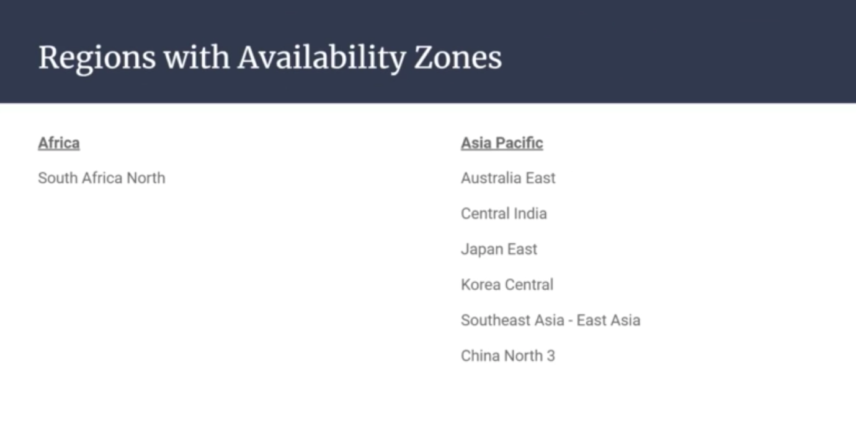

Data Centres:

Microsoft may build nearby multiple data centres with min distance 50 KMs

E.g. of one data centres:

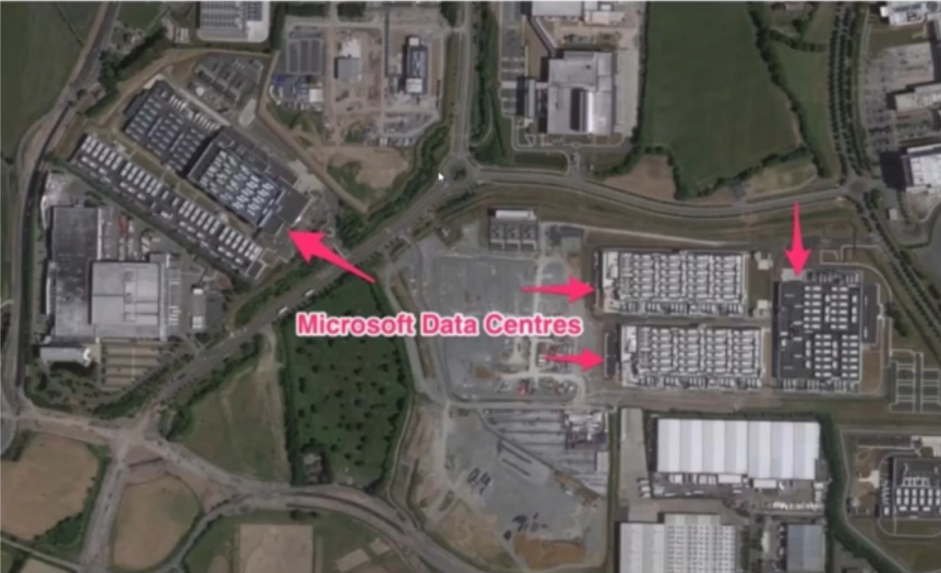

Resource Groups:

🡪 The logical grouping of resources is called resource group

🡪 We can have storage account, Virtual machine, database and a load balancer and a network all in the same Resource group.

🡪 This allows to act on them as one unit.

🡪 We can set security, lock resources or set a policy

🡪 The resource group does not have to be in the same virtual location

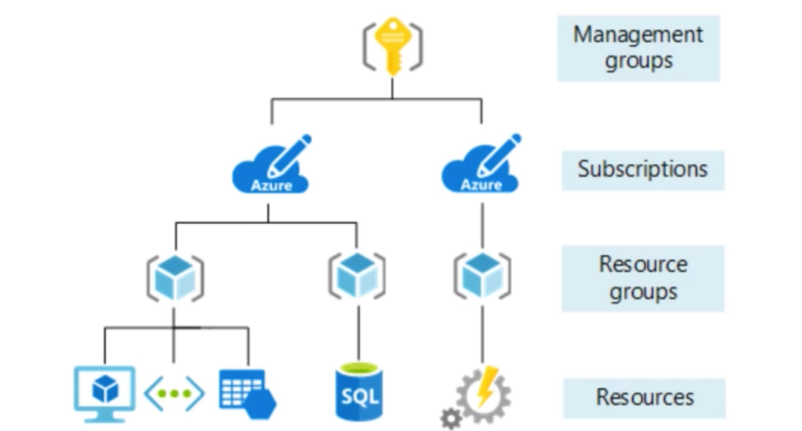

Resources:

Any of the servers or services that we create within Azure for our own use is called Resources.

Eg. VM, network, database, a function, Logic App, Queue

Resource Group:

🡪 Logically grouping the resources (i.e. not based on physical distance)

🡪 We cannot make resource part of multiple groups

🡪 All resources must belong to one group.

Subscription:

🡪 Whoever is going to pay the bill or credit card bill i.e. subscription.

🡪 We can have more than one subscription.

🡪 Suppose a company have more one subscription for multiple projects.

Mainly for clarity for billings

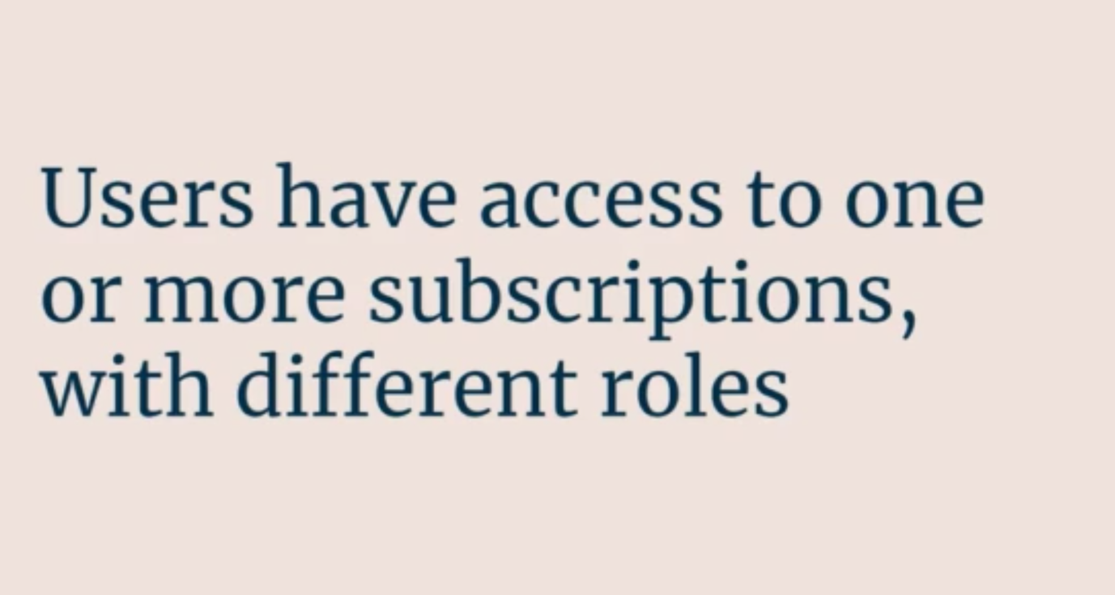

🡪 So one user may have multiple subscriptions and role wise – for one user may be admin and for another may be read-only.

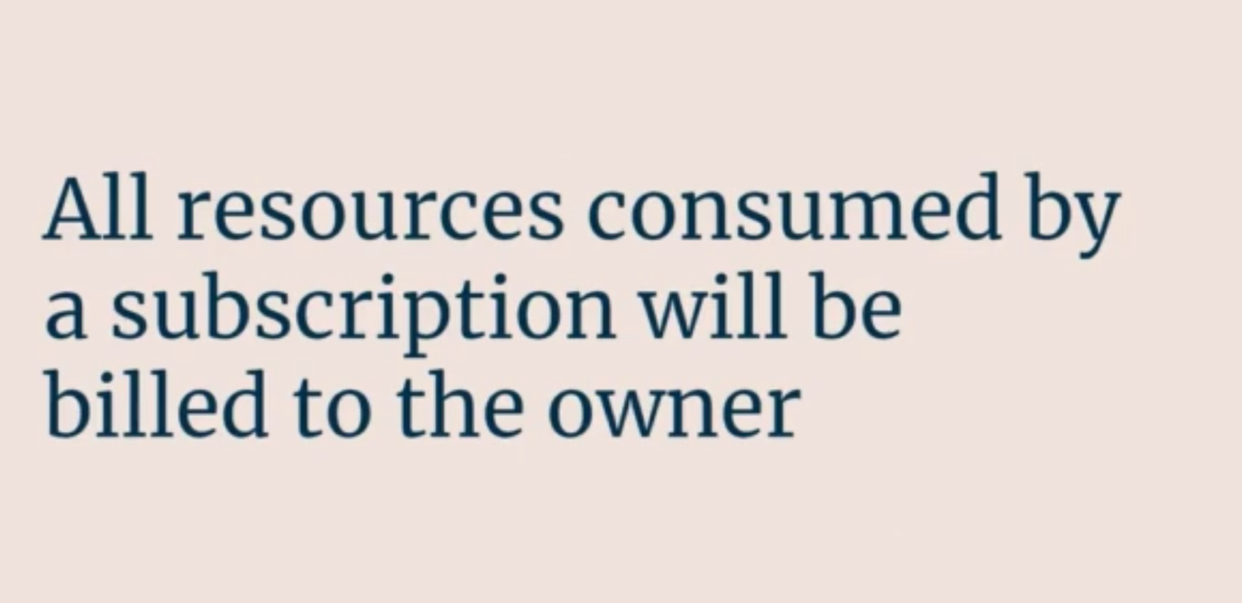

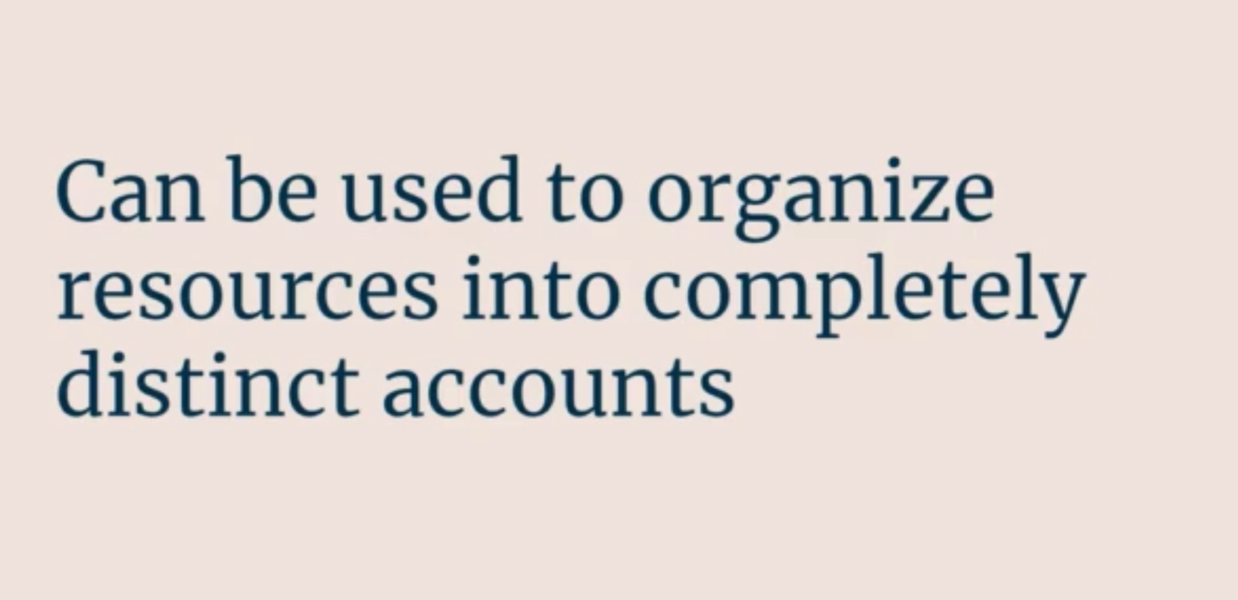

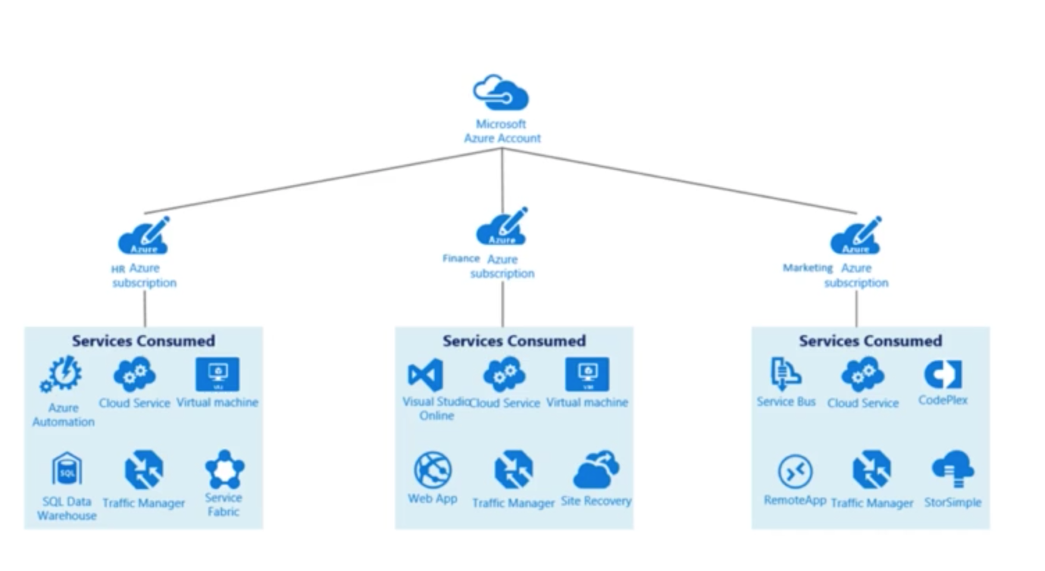

🡪 So here we have single Azure user have access to 3 subscriptions:

1. HR subscription
2. Finance subscription
3. Azure subscription

🡪 Here we have different combination of services running in accountse

Management Groups:

🡪 The top of the organization structure is the concept of Management Groups

🡪 We can put subscription into management group

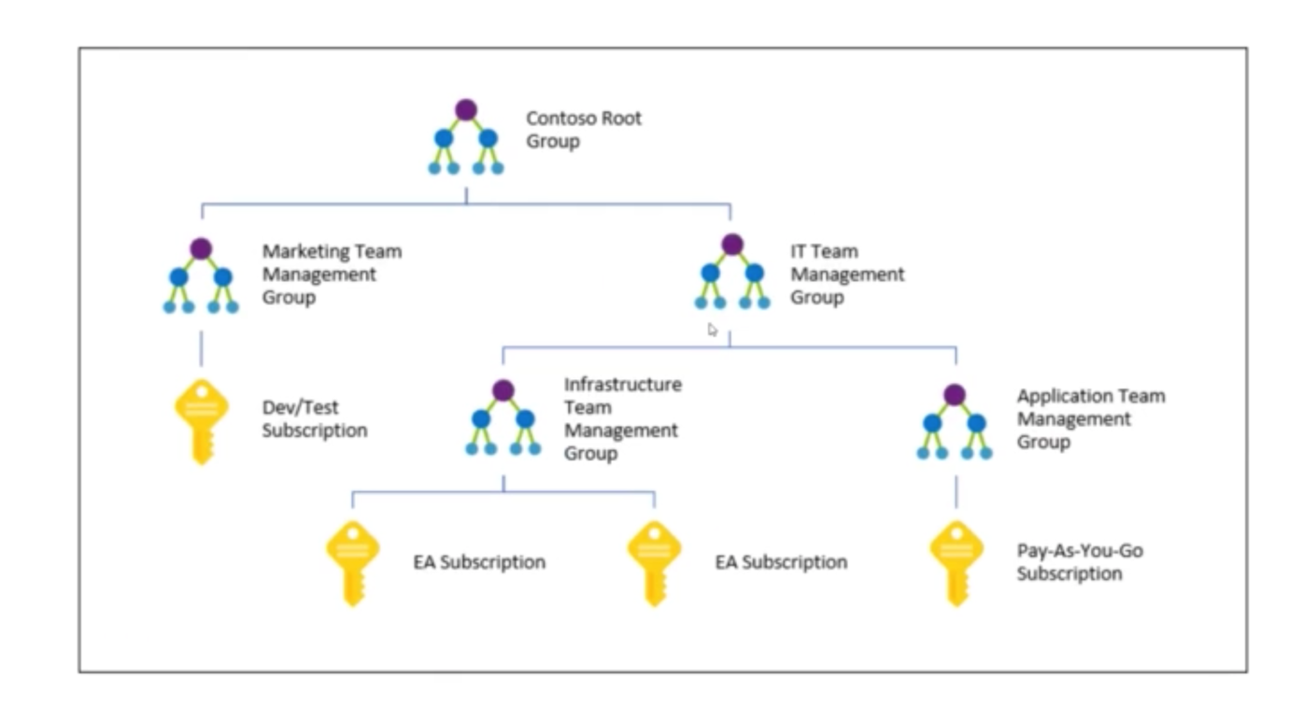

🡪 We can organize subscription into nesting if we have dozens of subscriptions.

🡪 We basically do this when we have common policies, common rules and restrictions across the subscriptions

🡪 Someone with administrator access can apply a rule or policy that can force into the children groups.

🡪 So this is more purely for control.

Azure Compute and Networking:

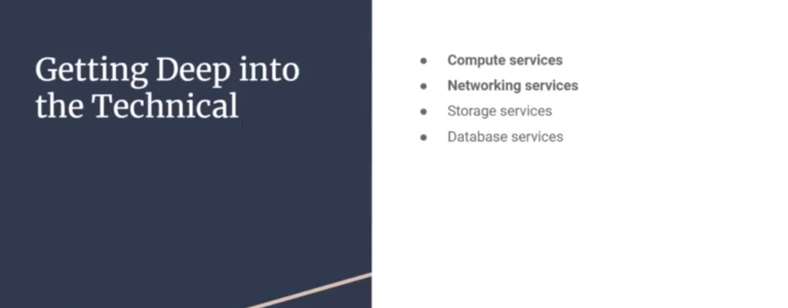

🡪 Microsoft Azure has lots of options when it comes to compute:

Compute: The ability to execute code in the cloud

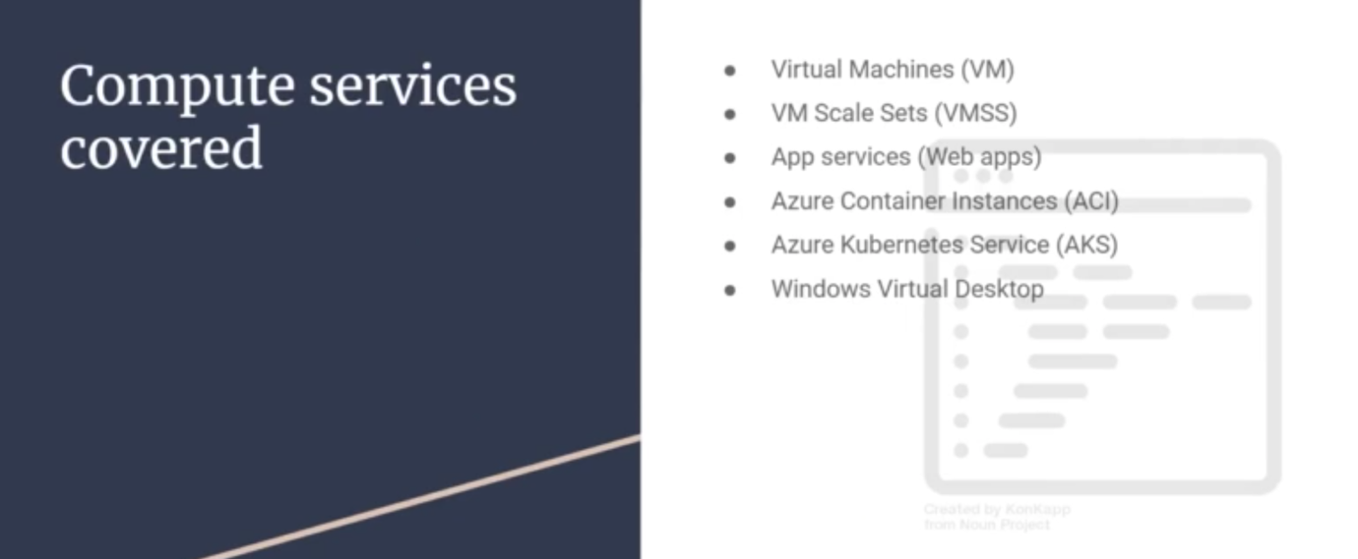

1. Virtual Machine:

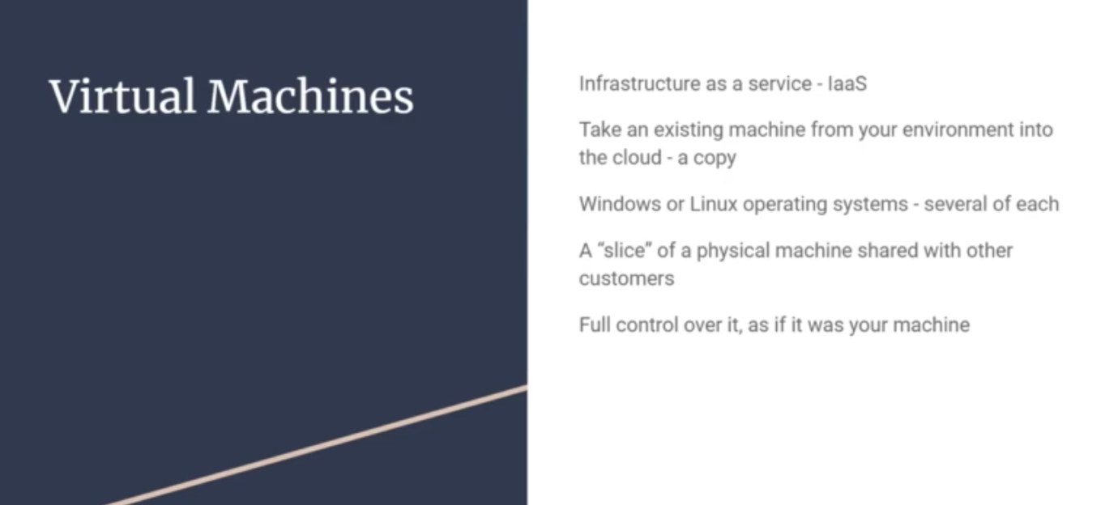

🡪 This is IaaS

🡪 We get OS like it is my computer OS – Windows, Linux, etc

🡪 AWS calls it EC2 (Elastic Could Compute)

🡪 Azure calls it Virtual Machines

🡪 There are literally 200 unique configurations to choose from

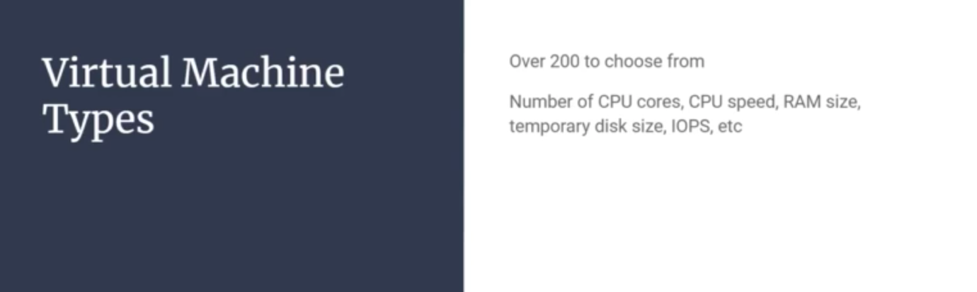

1. VM Scale Sets (VMSS):

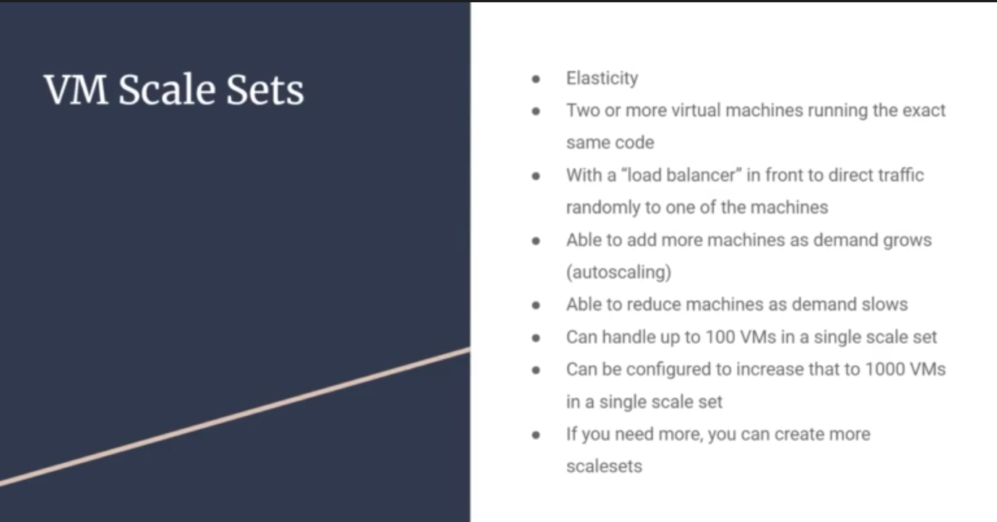

🡪 This uses concept of Elasticity.

Elasticity: The ability of a system to automatically grow and shrink based on app demand is elasticity.

🡪 There are two or more identical VM running.

🡪 Load balancer will direct traffic to one of these VM

🡪 As demand grows, VMSS can add more machines and demand reduces, VMSS removes machines.

🡪 By default we have 1000 VMs in a single scale set.

Azure makes VMSS – free

🡪 We pay for the Virtual Machines that are running but not for VMSS, autoscaling, load balancing.

1. App Service:

🡪 It uses Platform as a Service (PaaS). Sometimes called Web Apps

🡪 So here we can zip up the code and the configuration and publish into Azure

Integration into studio in Github

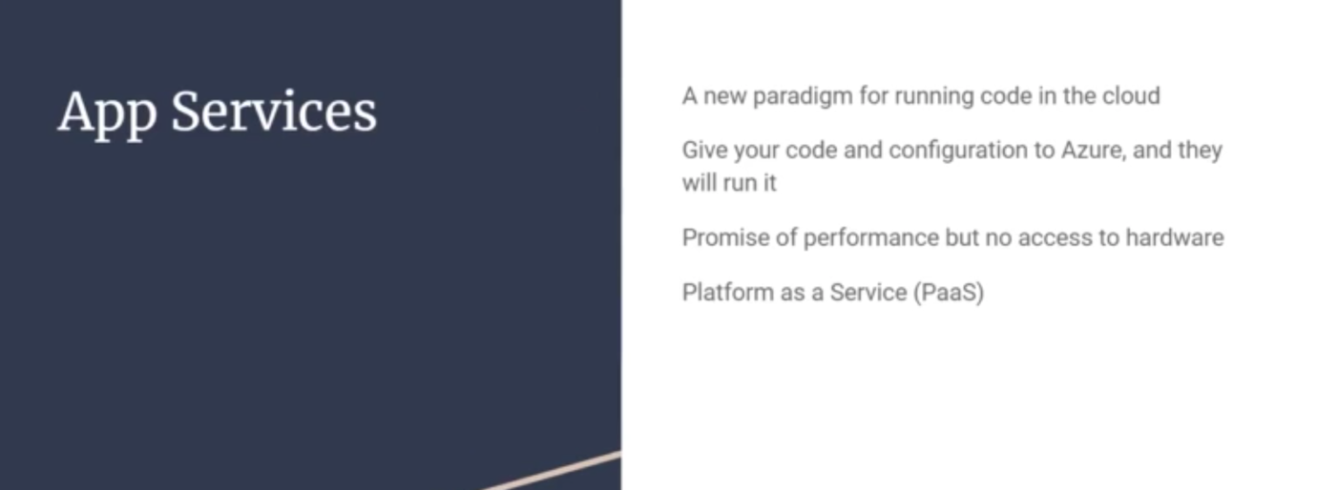

1. Containers:

🡪 It makes deployment a lot easier.

🡪 Here we convert our code to image.

🡪 That image can be copied into development environment, staging environment, production environment, etc.

🡪 So instantly code is deployed. There is no deployment complexity.

Two most famous containers are:

1. Azure Container Services (ACI) – single instance
2. Azure Kubernetes Services (AKS) – runs clusters of servers, enterprise-grade

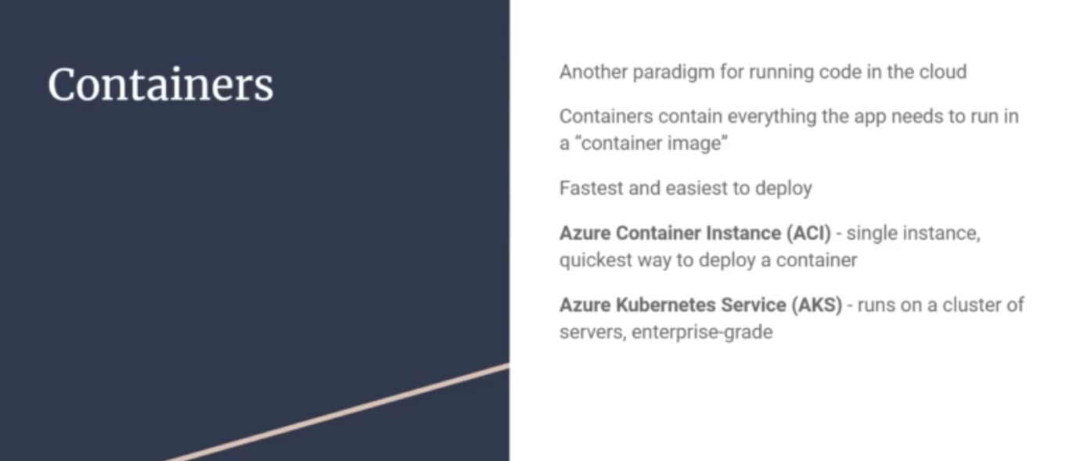

1. Azure Virtual Desktop:

🡪 This is basically Azure can run OS from cloud say Windows, Linux or Mac that looks alike local OS.

🡪 So we can login from any laptop or office computer and the Cloud OS follows us.

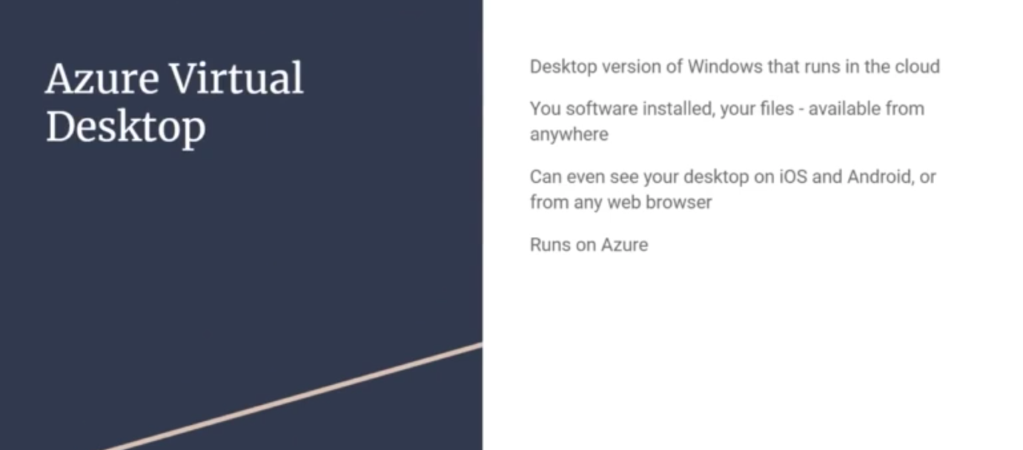

Networking Services Covers:

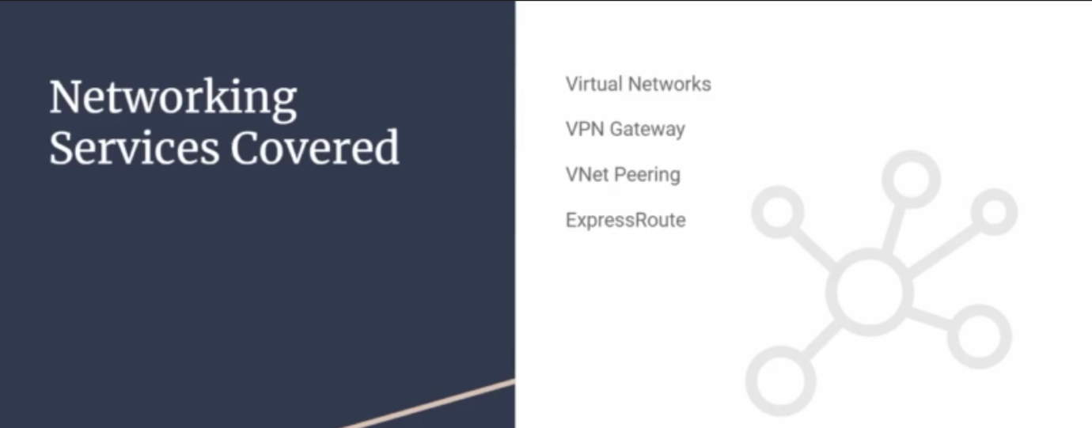

1. Virtual Networks:

🡪 In AWS Virtual Networks is called **Virtual Private Cloud (VPC)**

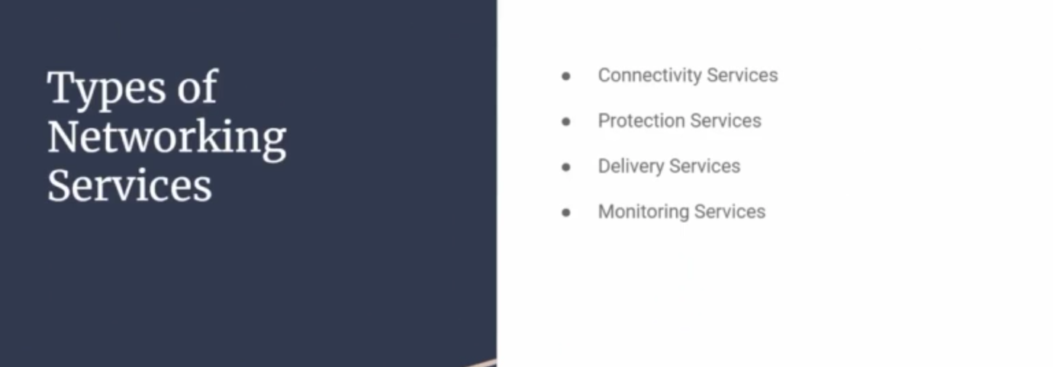

🡪 There are different types of Networking covered:

1. Connectivity Services:

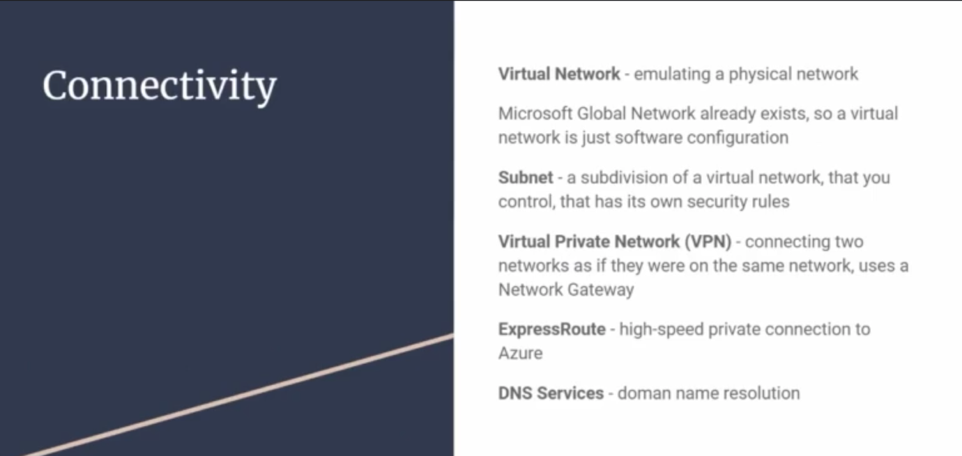

When we have office laptop, we connect with VPN to get office websites access.

Azure Protection Services:

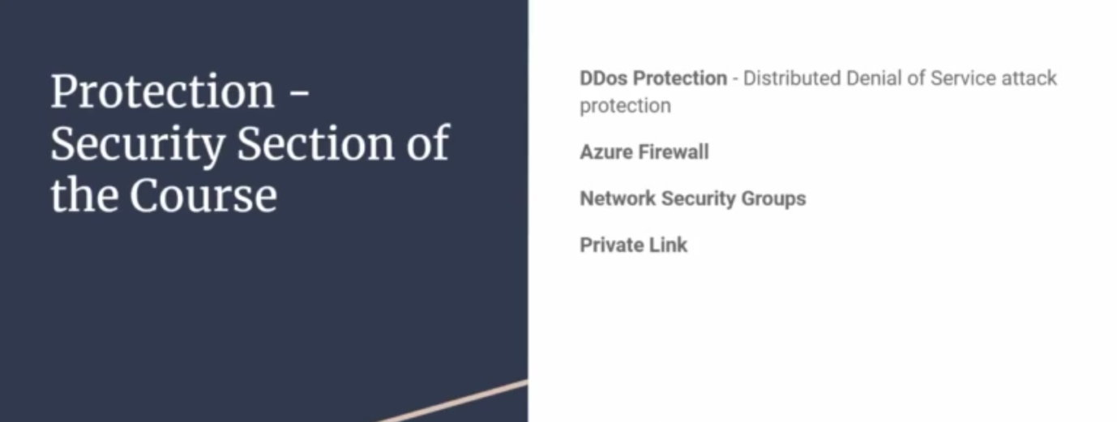

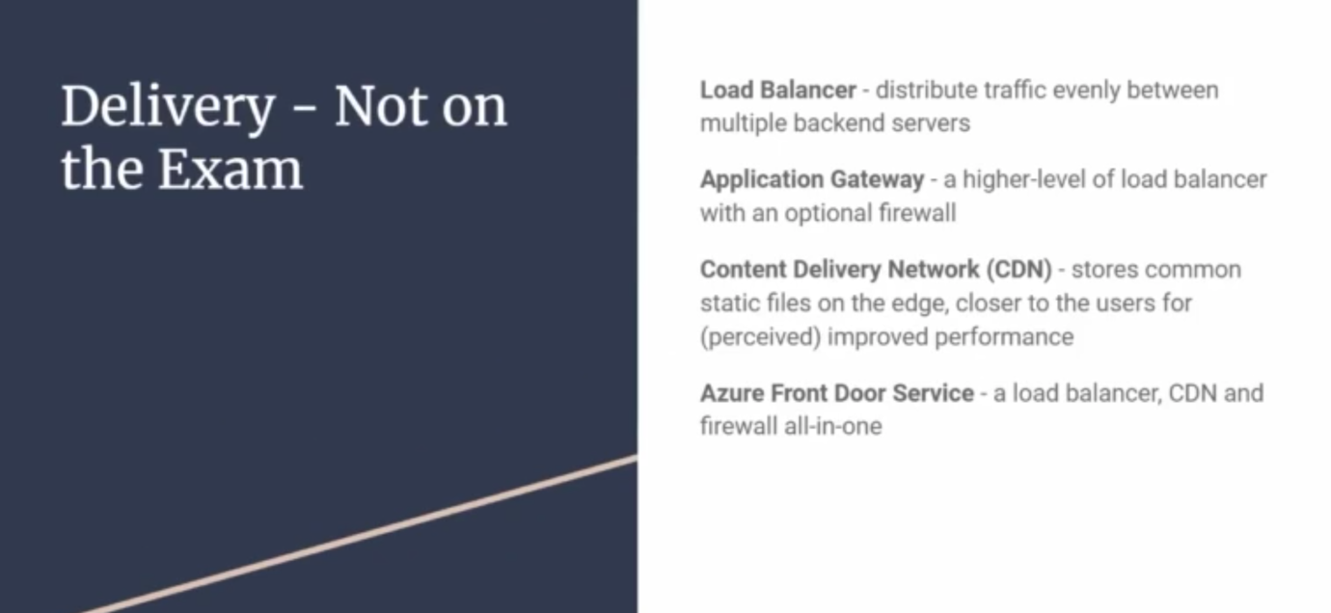

Azure Monitoring Services:

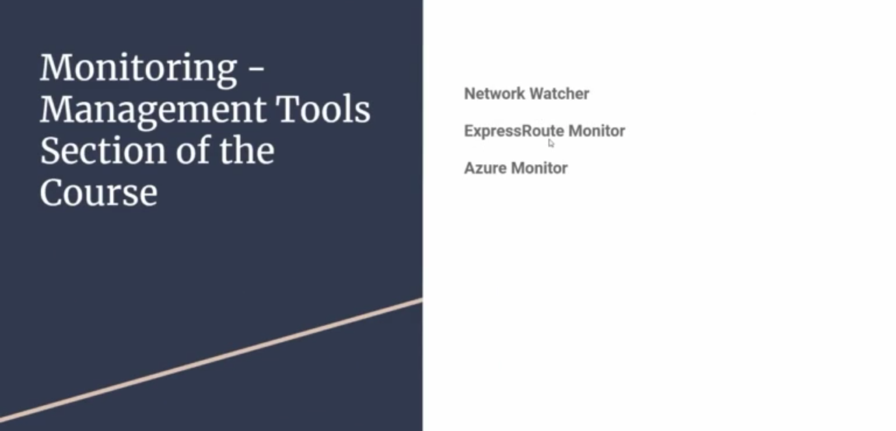

Network Watcher – Not on Exam

Express Route Monitor – Not on Exam

Azure Monitor – In Exam

Creating Azure Free Account:

🡪 Login with Outlook, Gmail or some email account

<https://account.microsoft.com/account/Account>

Resource: <https://www.youtube.com/watch?v=sPY6S_QWQ1I>

🡪 Go to Microsoft Free Account

🡪 Then enter you Debit or Credit card details

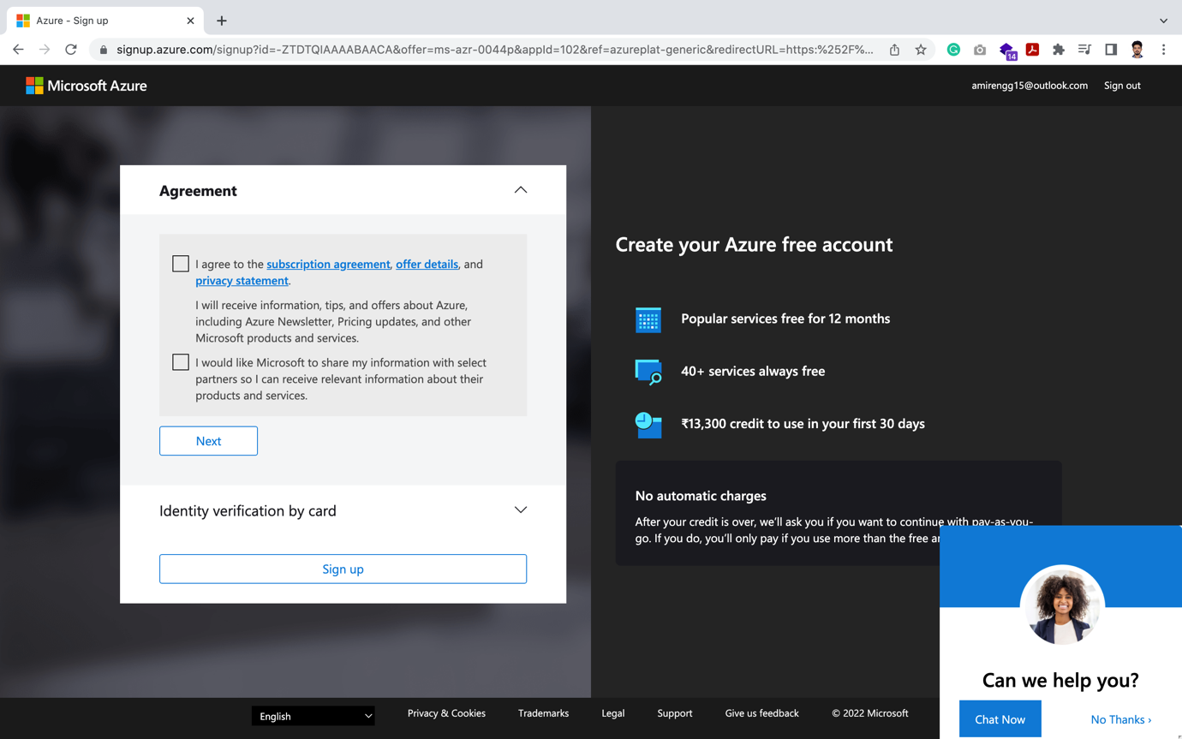

🡪 Once payment is complete, chose free subscription. Will not use Debit/Credit card until change subscription to Pay on use plan

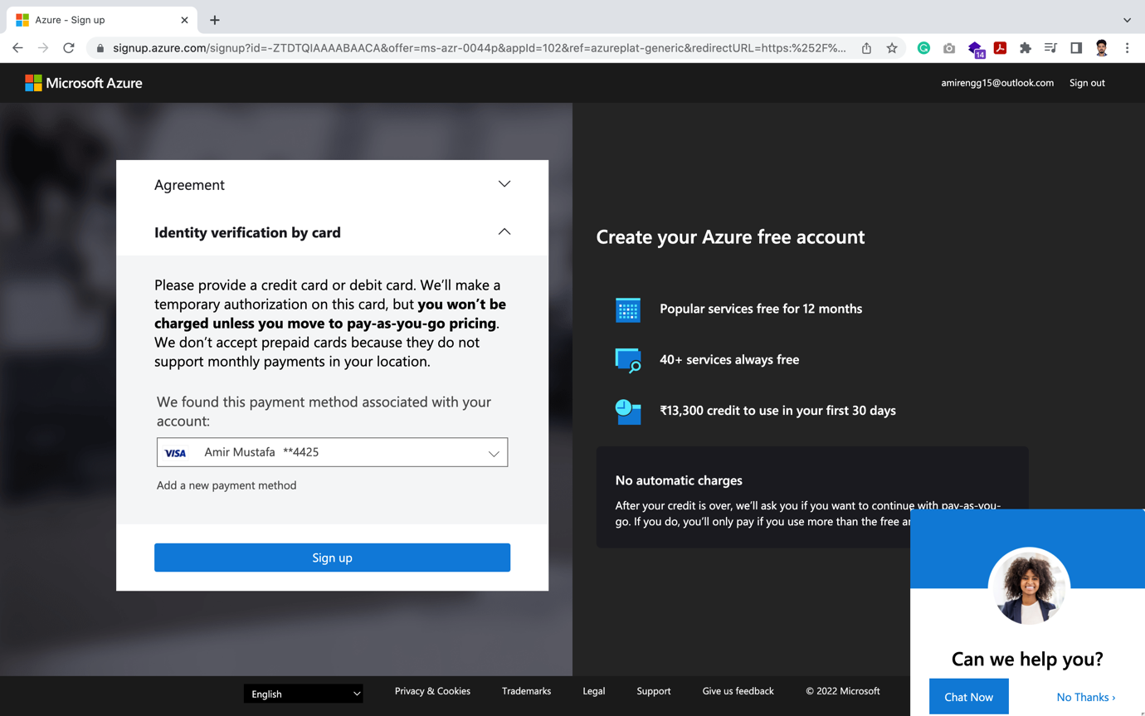

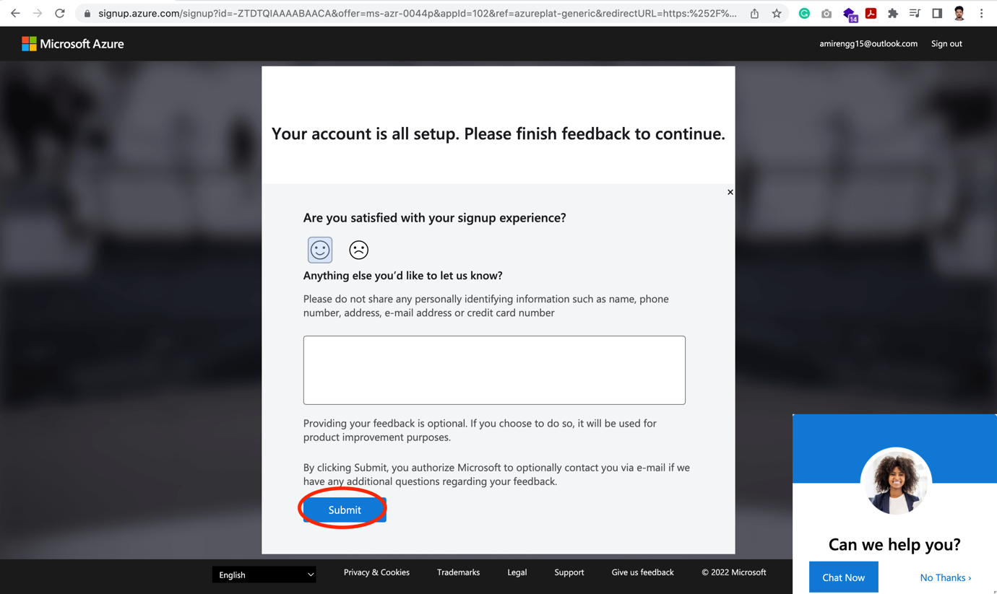

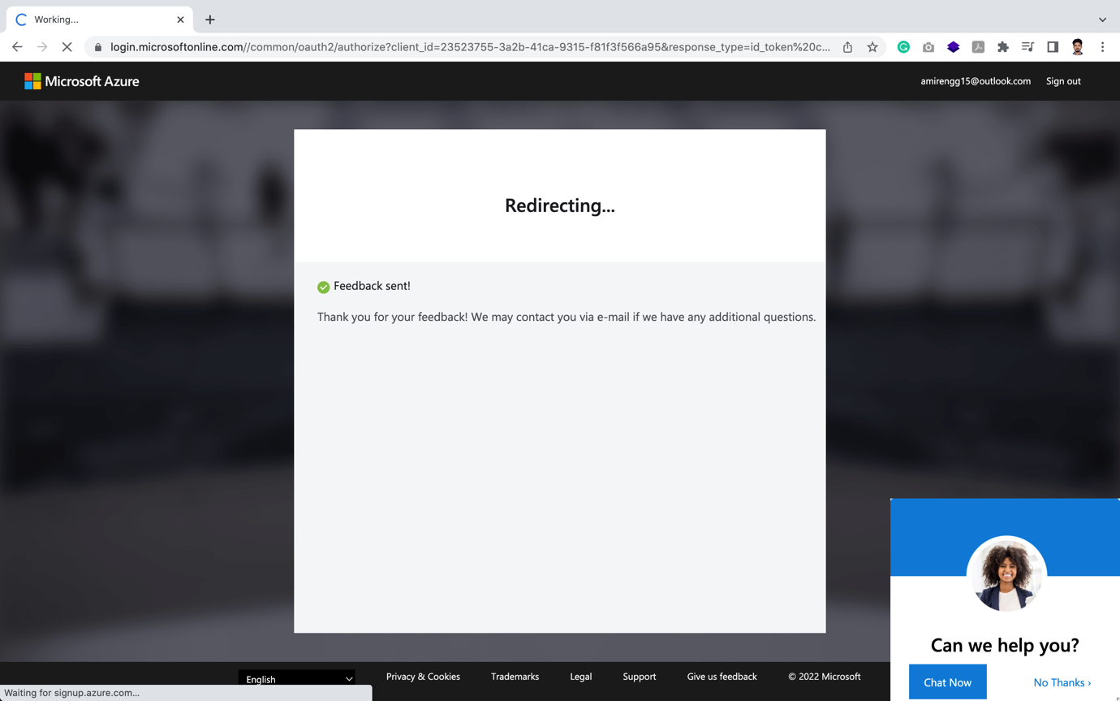

🡪 It will then be redirected to sign in page. Click Signin or Go to Azure portal

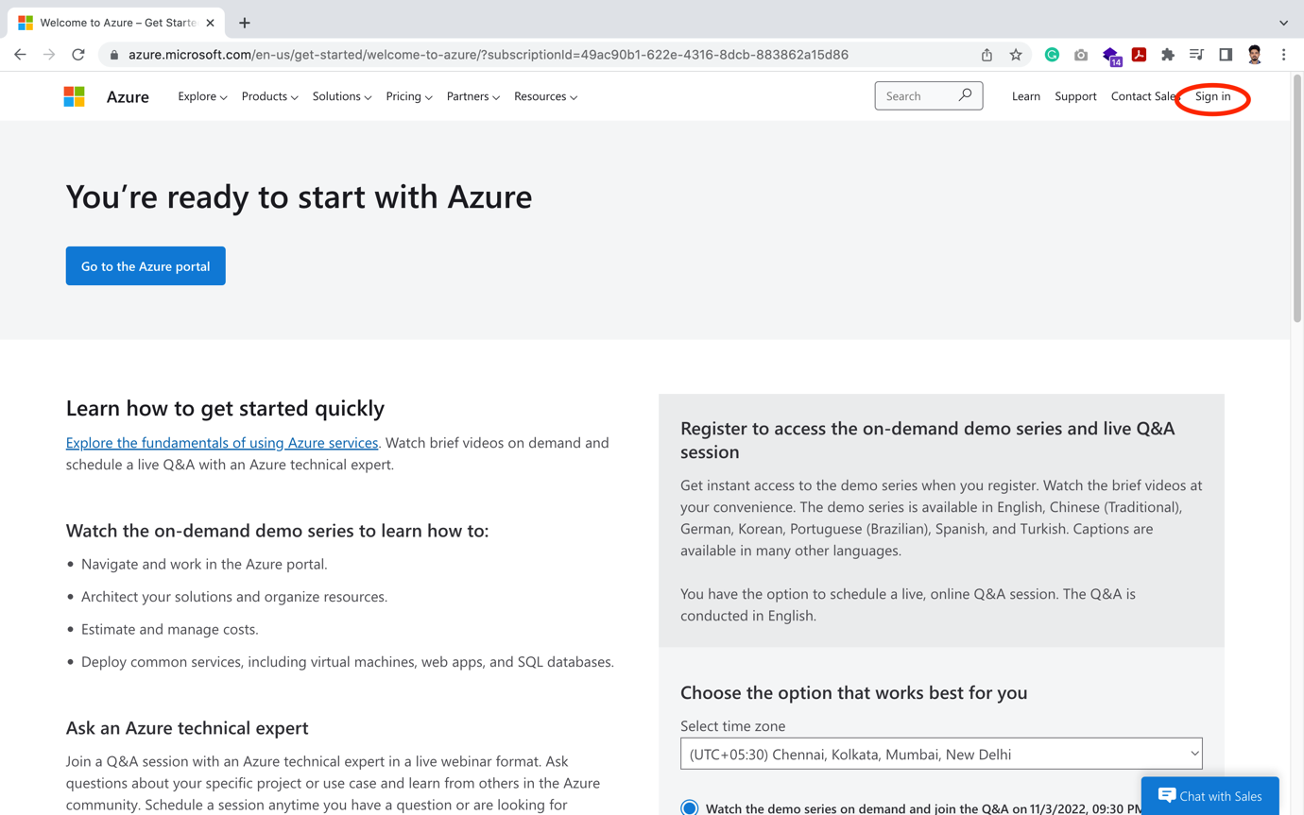

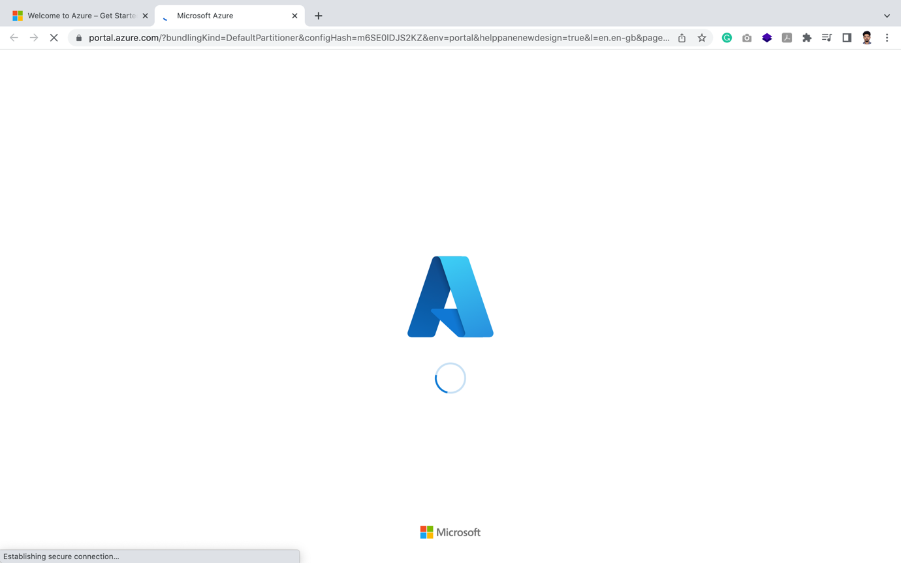

🡪 Finally entering Azure Cloud

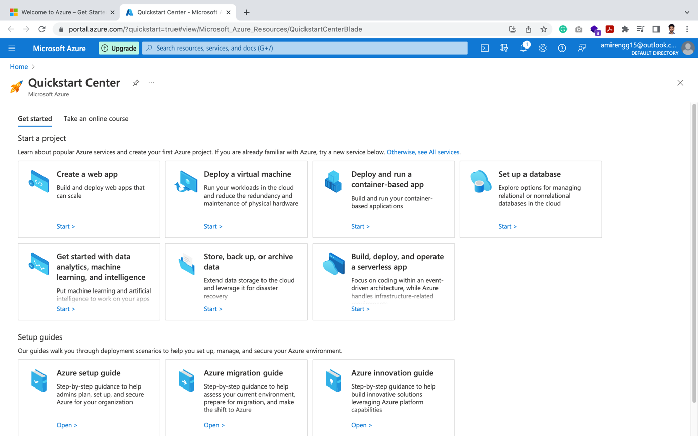

🡪 We get $200 USD (14,500 INR) free credits.

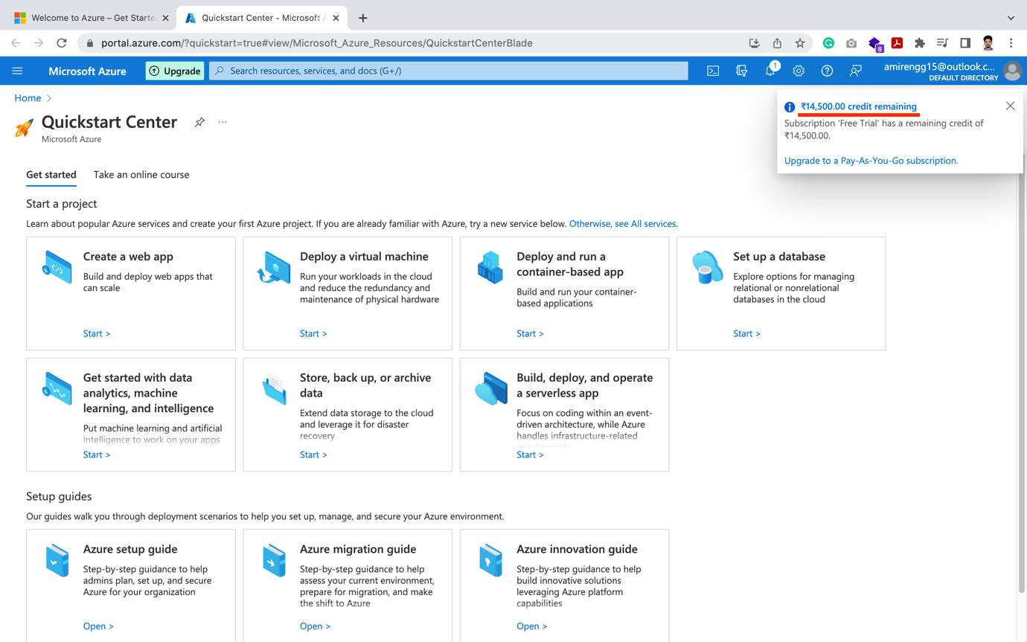

Creating Azure Virtual Machines:

STEP 1: Click on Add Resource – either from right or left menu bar after expanding

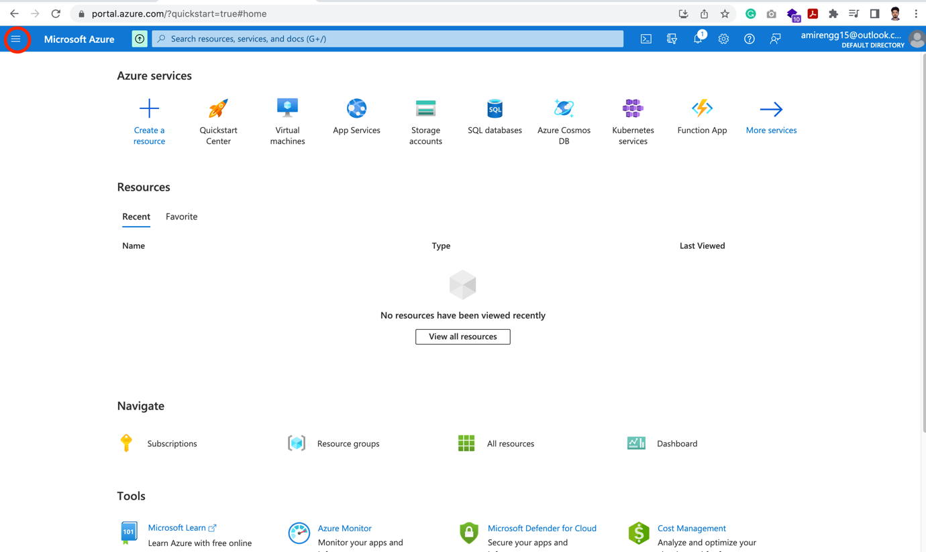

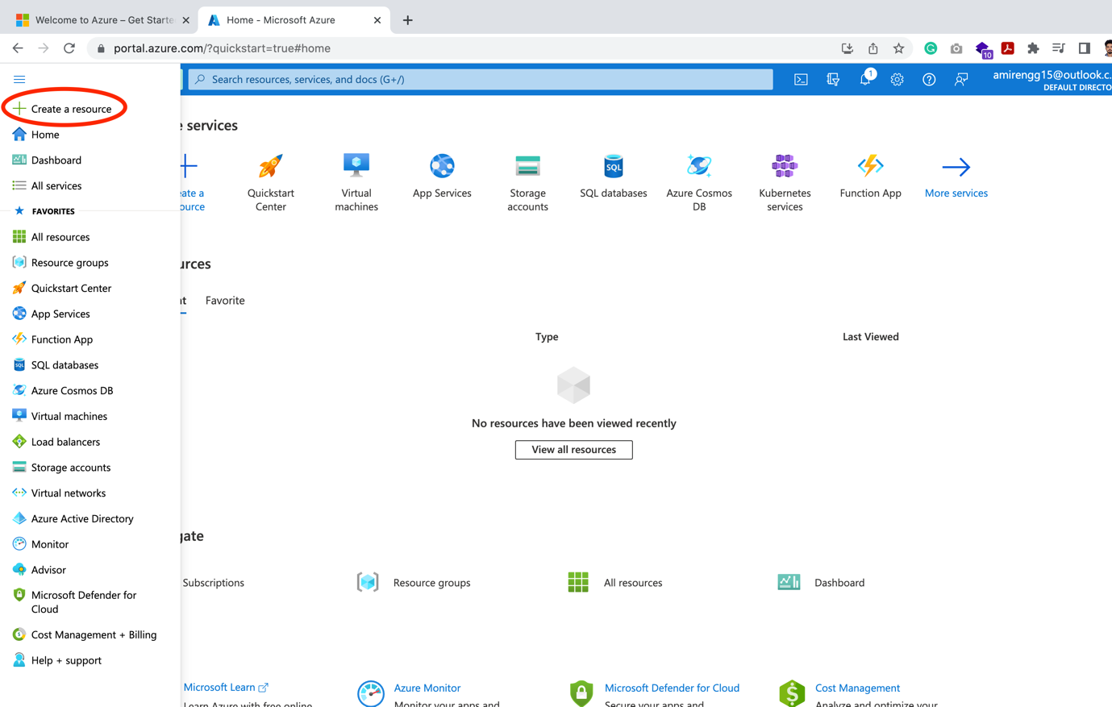

🡪 In the next step we get to chose the OS. We can chose from variety options. Let us see some of them below:

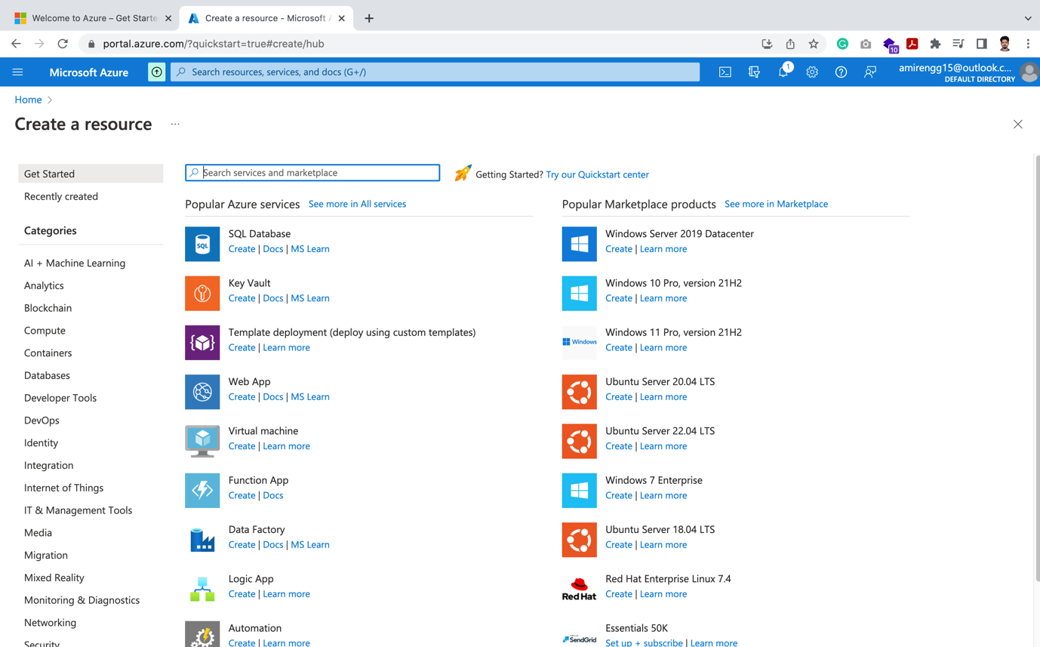

Say: Windows 11

Click Create link on Windows 11 me



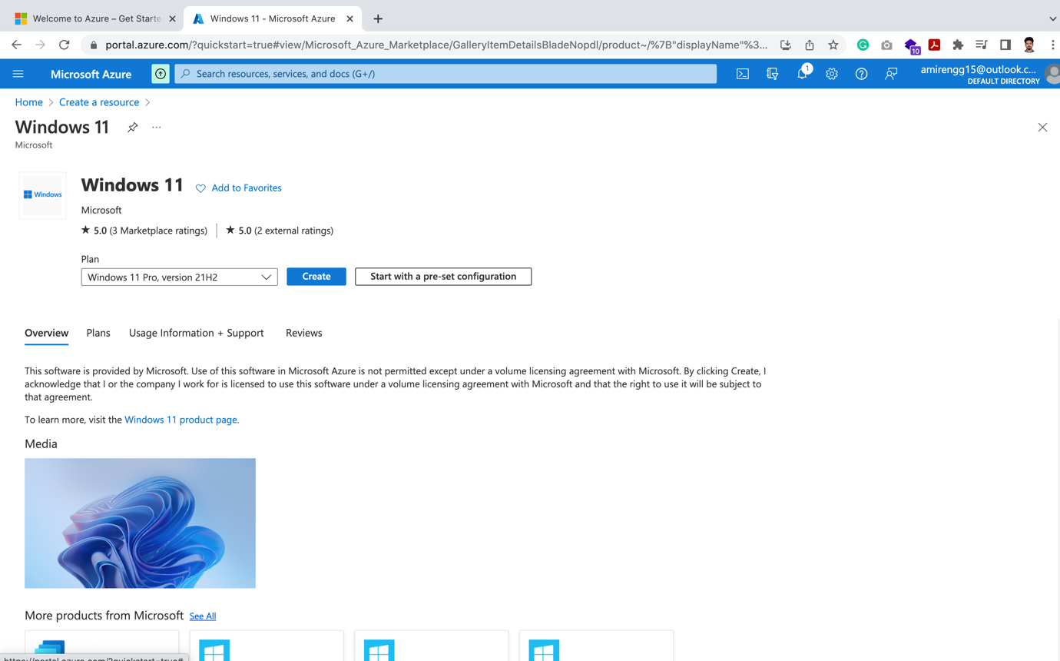

Eg2: Say SQL Server

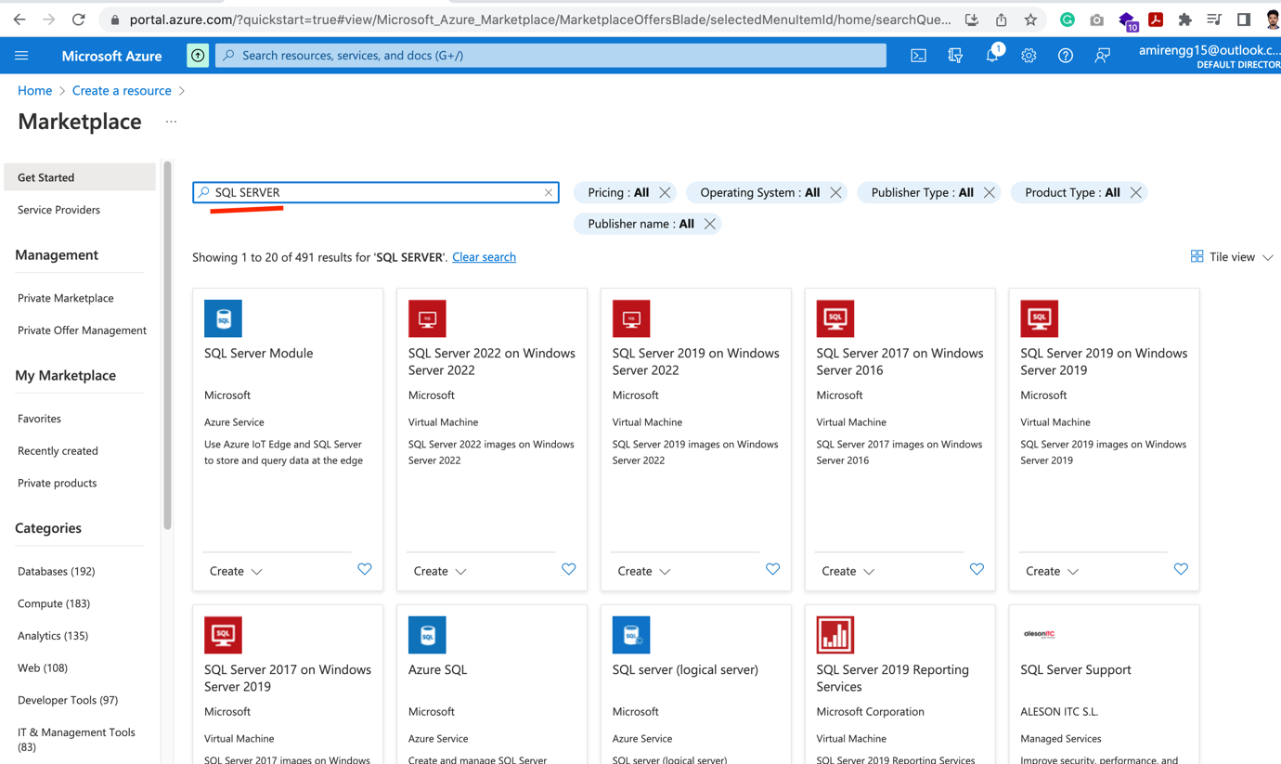

Eg3: Say Ubuntu

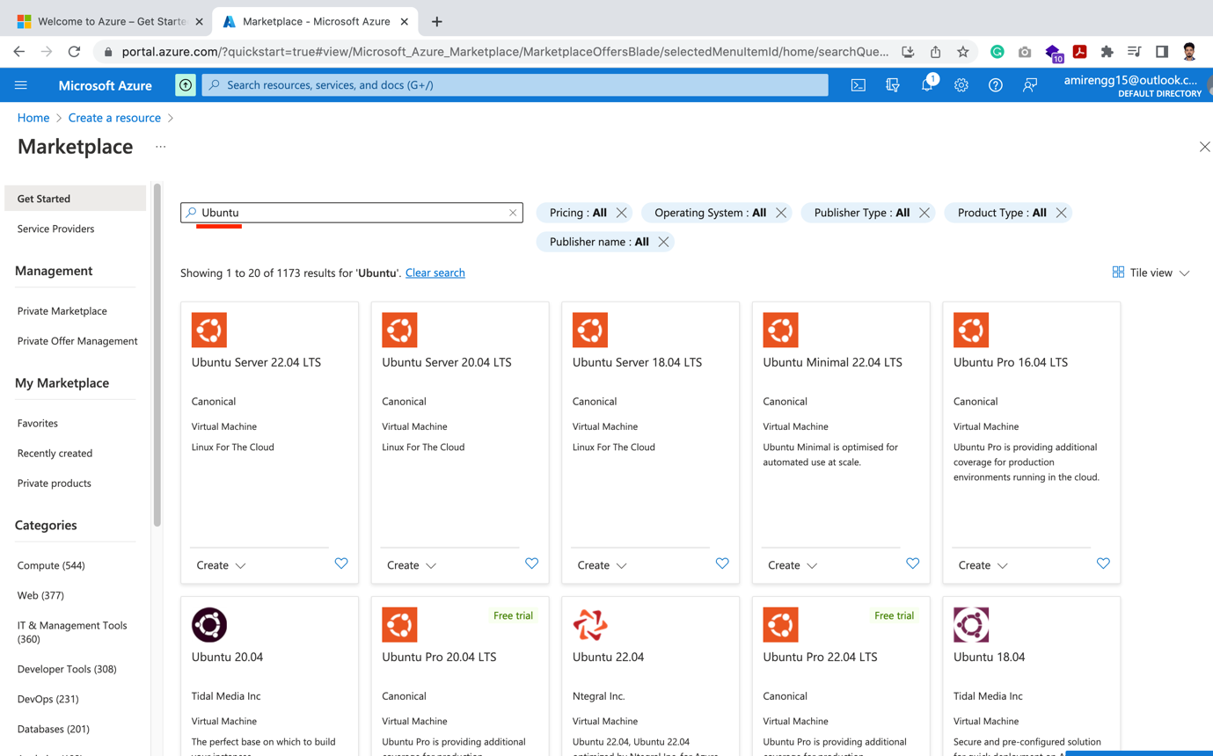

🡪 Let us install latest Ubuntu OS: i.e. Ubuntu Server 22.04 LTS. Click Create

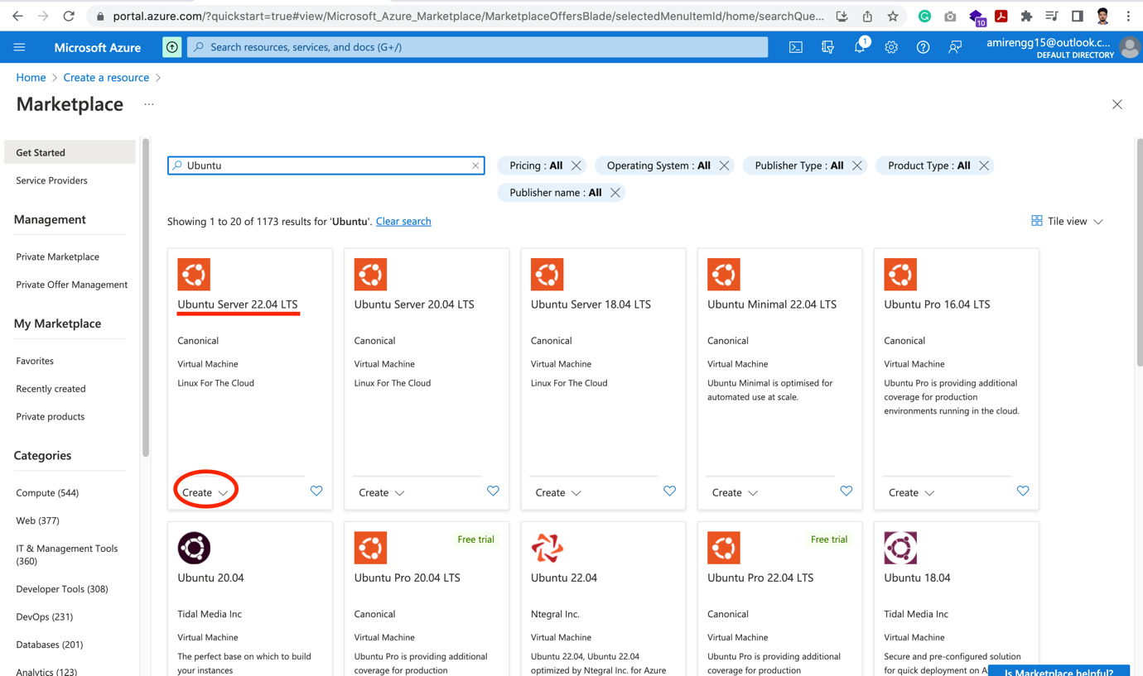

🡪 Select from dropdown. Mostly when lots of version updates will be there. It will display here.

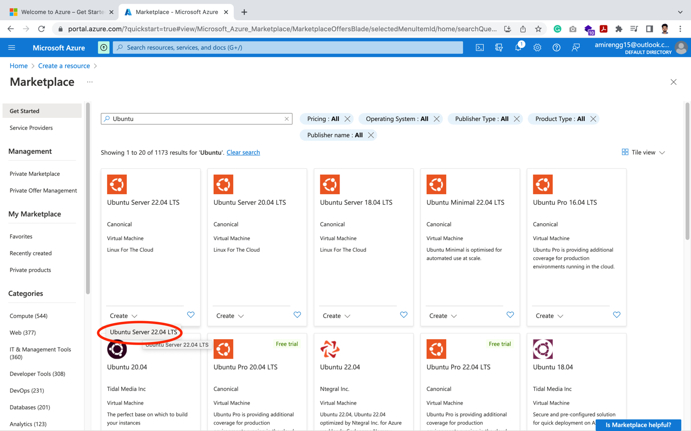

🡪 We will be directed to below page:

STEP 2: Here we enter Basic details of the servers

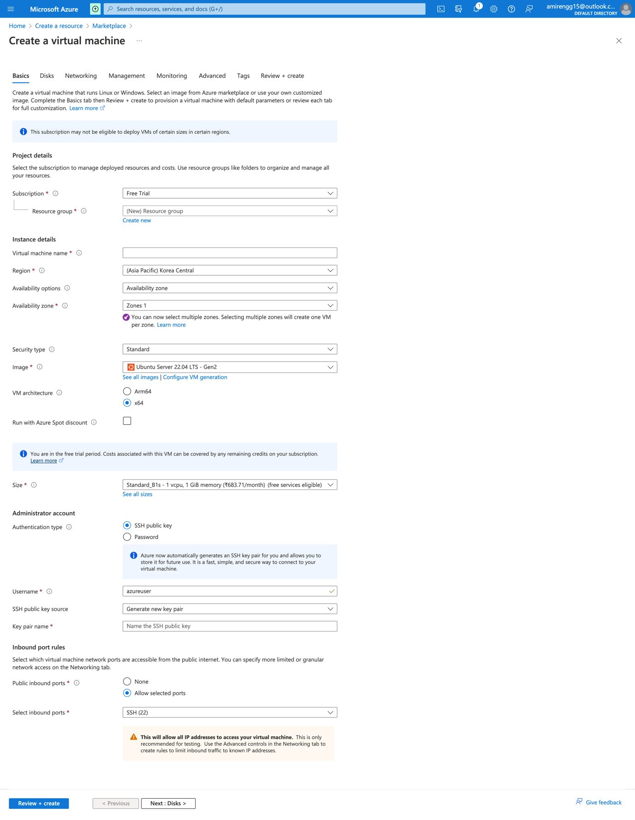

🡪 Click on Create Resource Group, basically OS containers will lie in this region

🡪 Give it a name

Eg. demo-reource-group

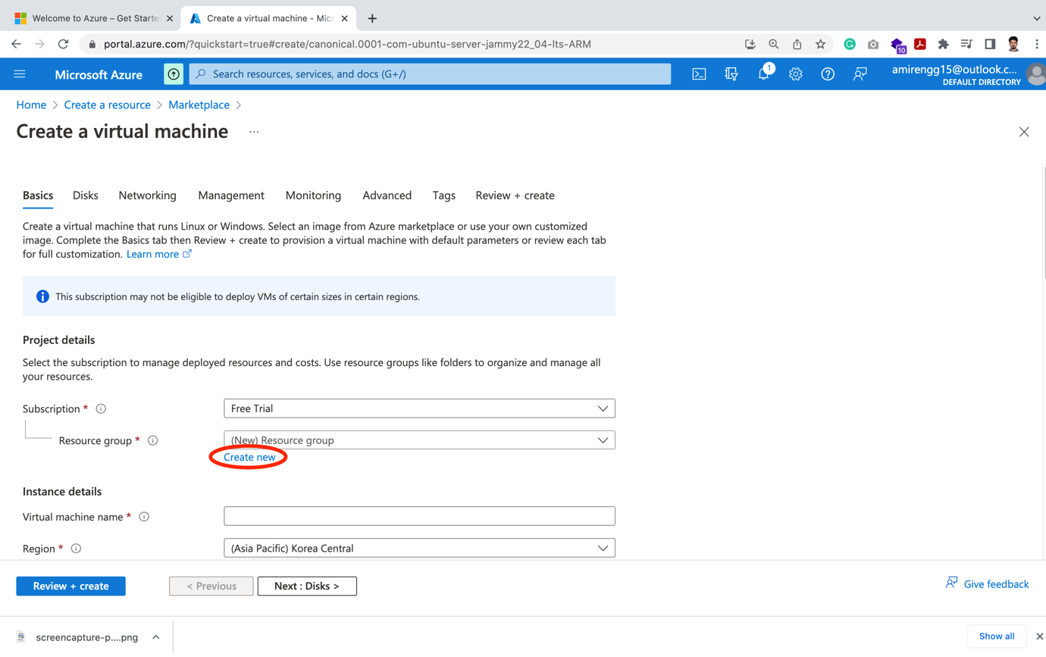

Click Ok button

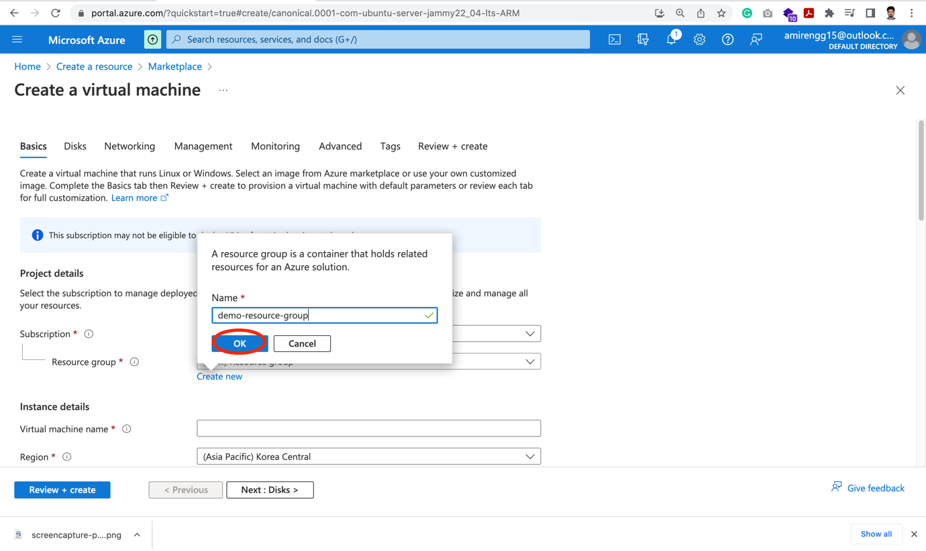

🡪 Now here we have availability zone options. Suppose we have high traffic server we can create servers in multiple zones in single Availability zone

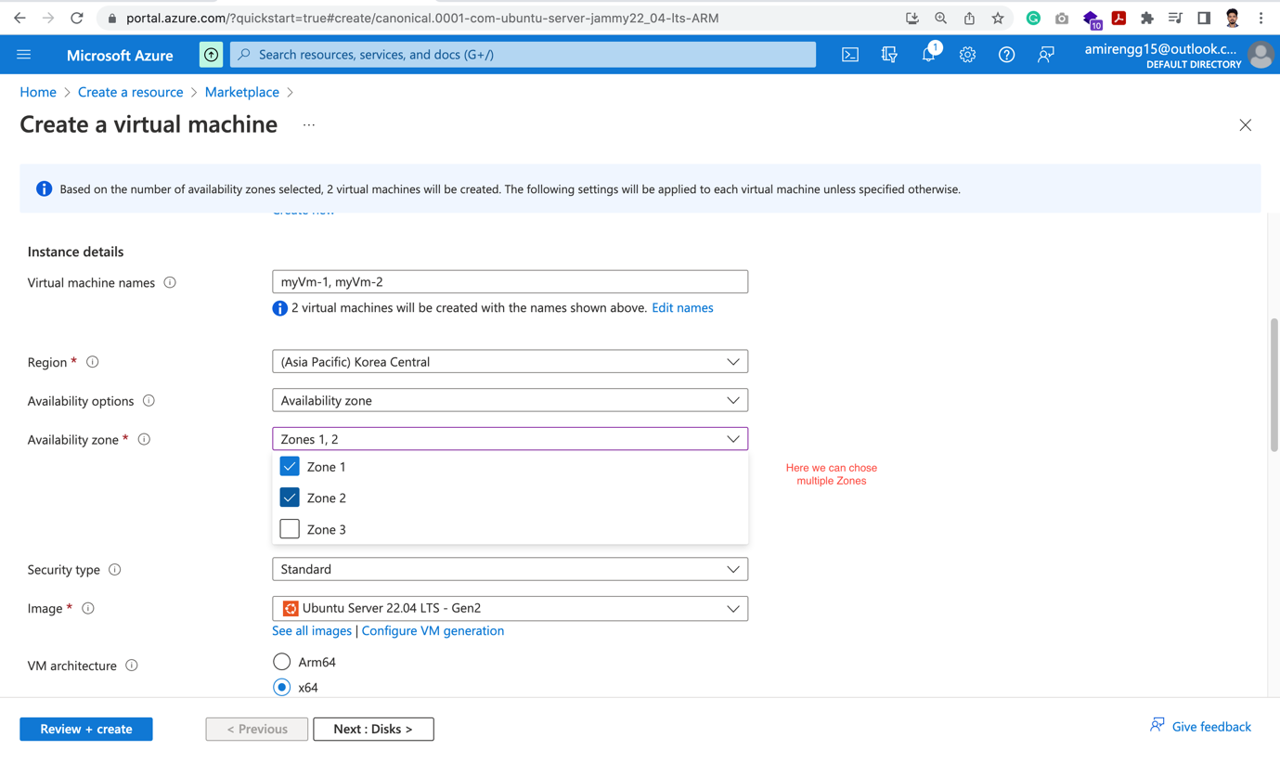

🡪 For now let us choose – No Infrastructure Redundancy required

🡪 Here Azure will keep randomly in some of their server.

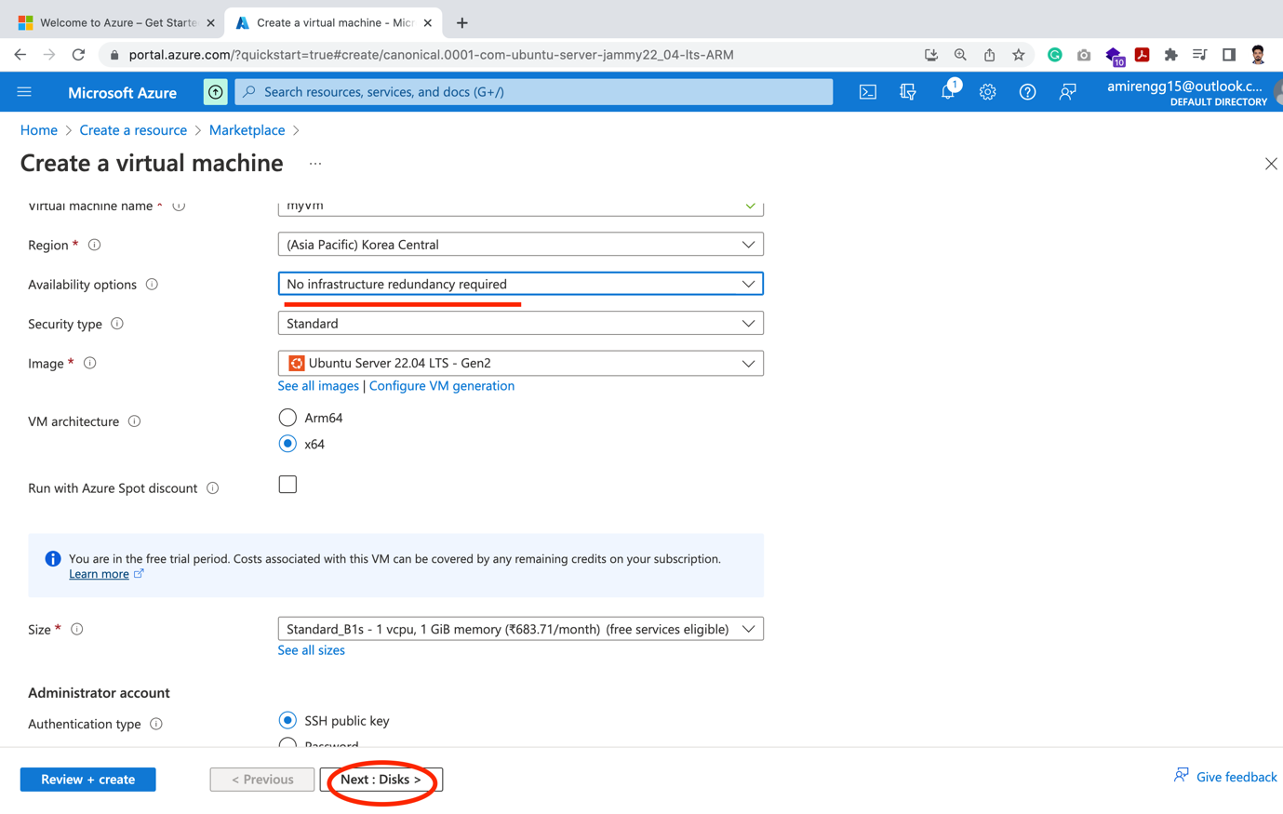

STEP 3: Disks – Here we enter storage details and storage plans

🡪 In the Disk page we chose size SSD/HDD configurations

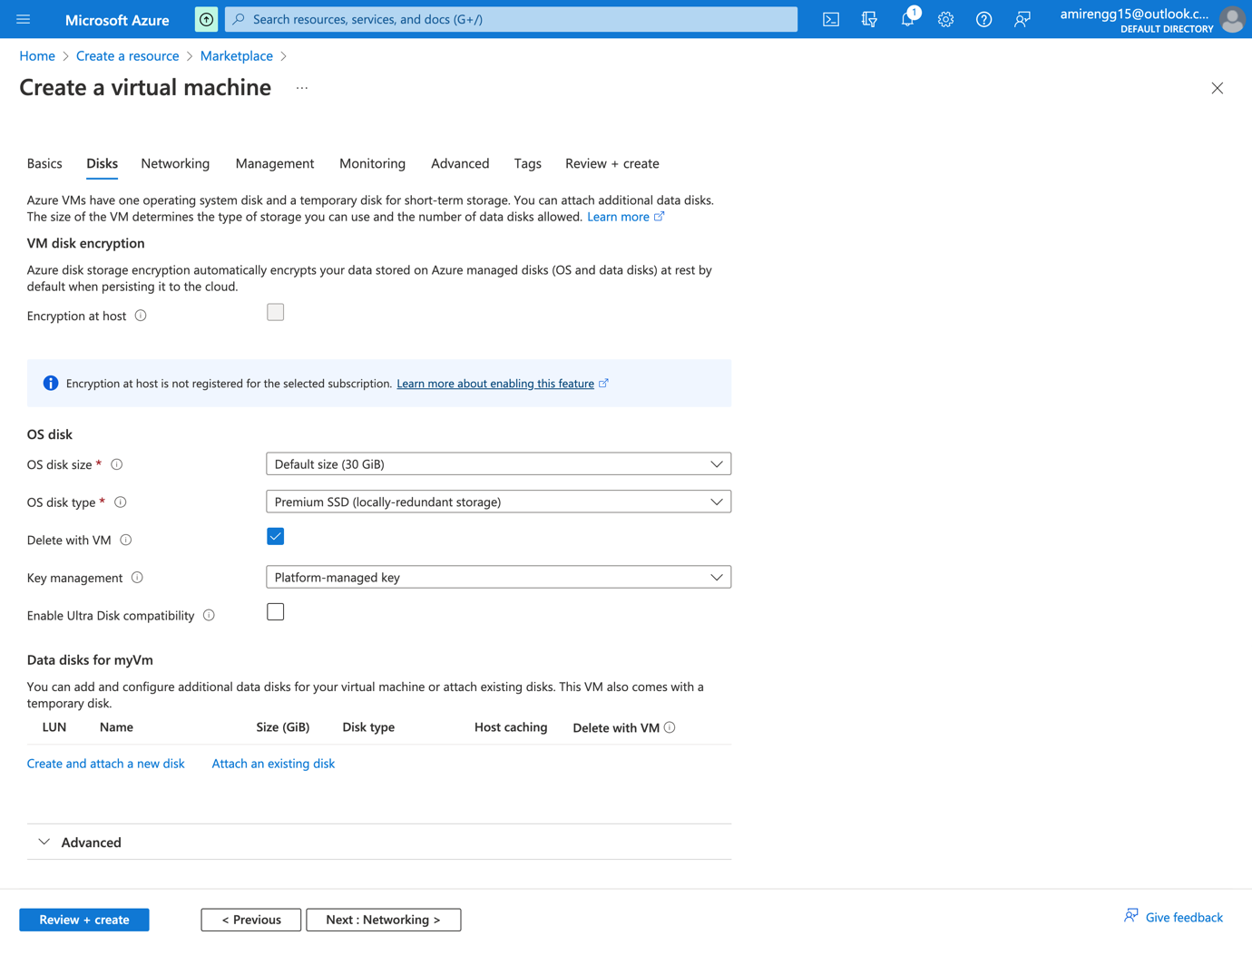

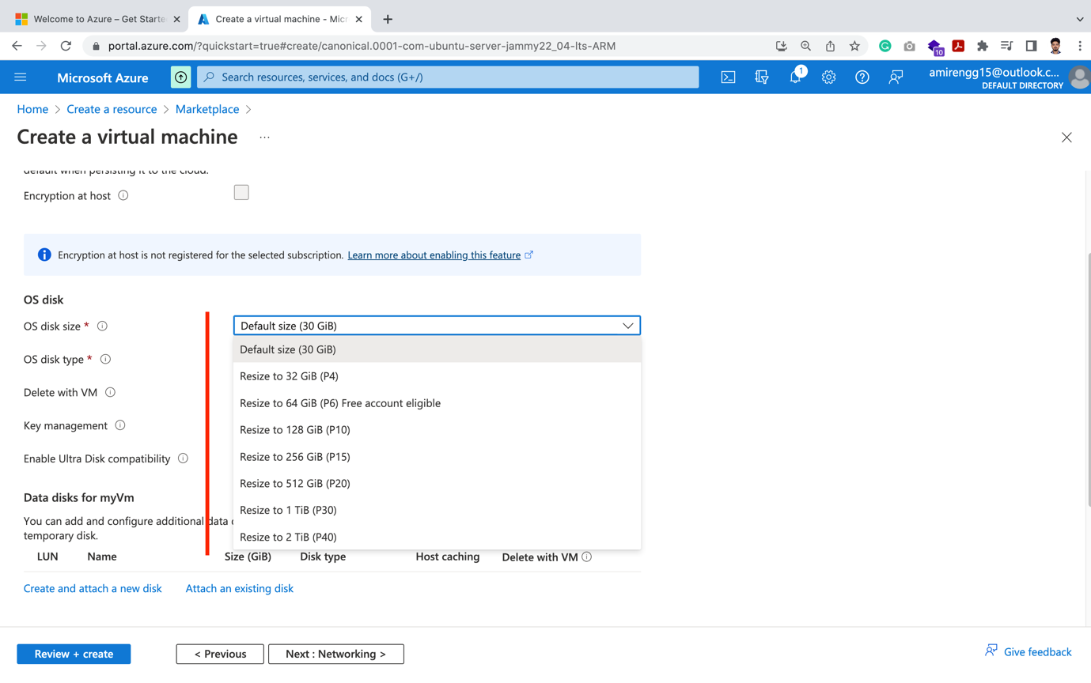

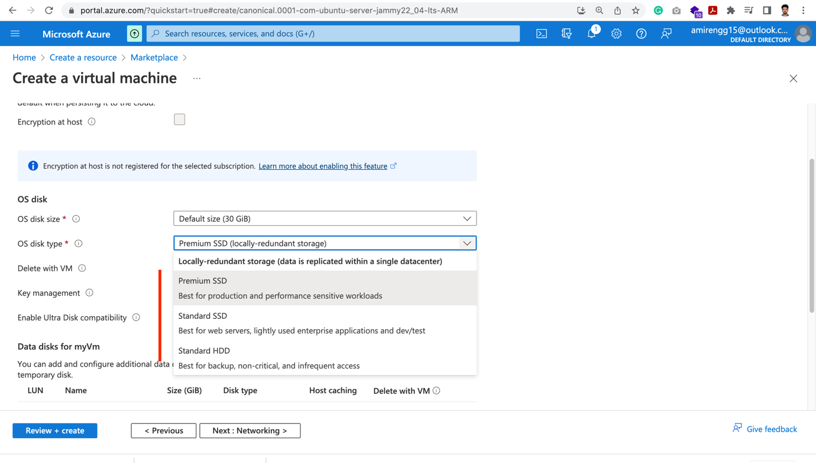

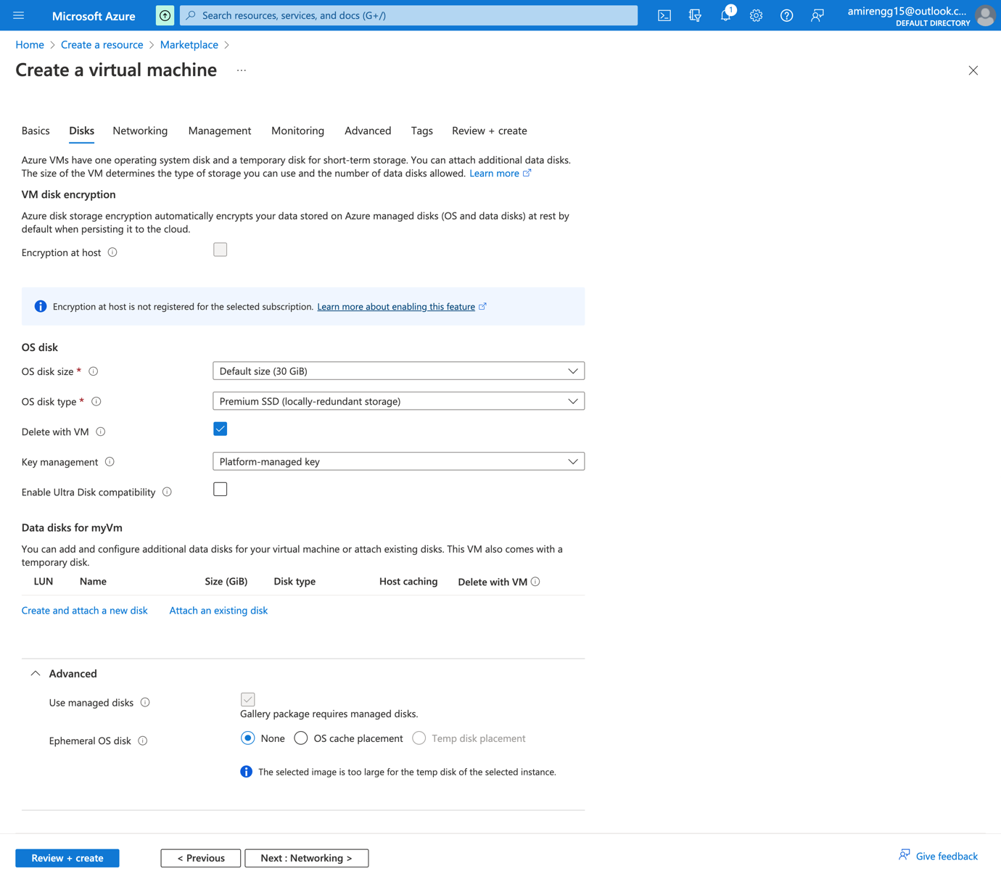

STEP 4: Networking: Here we basically add server details – subnet, public IP, etc.

🡪 Next step is Networking. Let us keep default option and Next button.

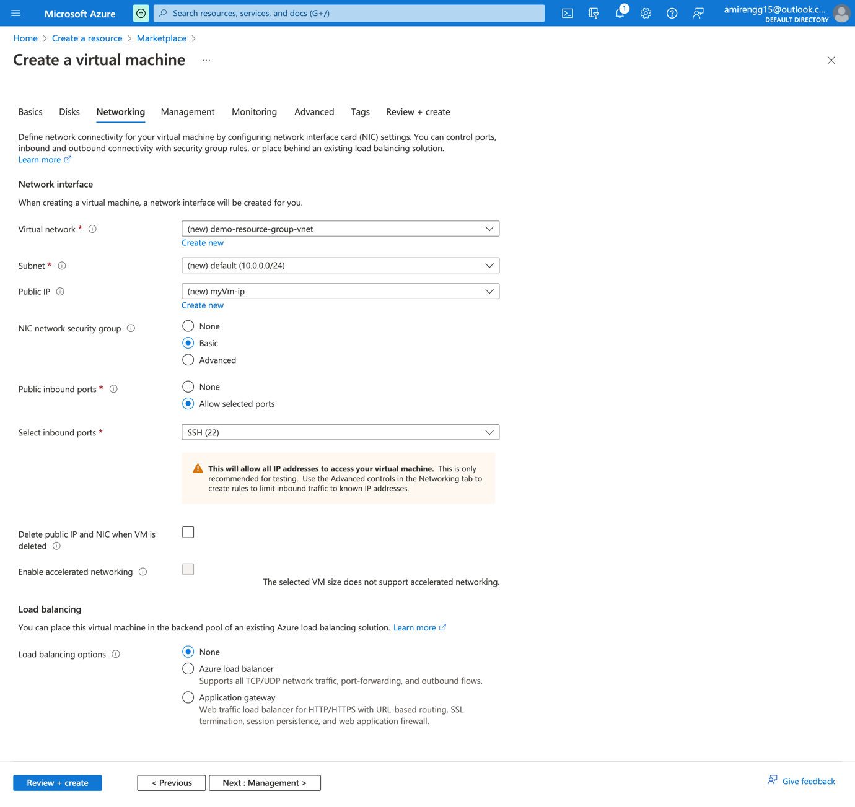

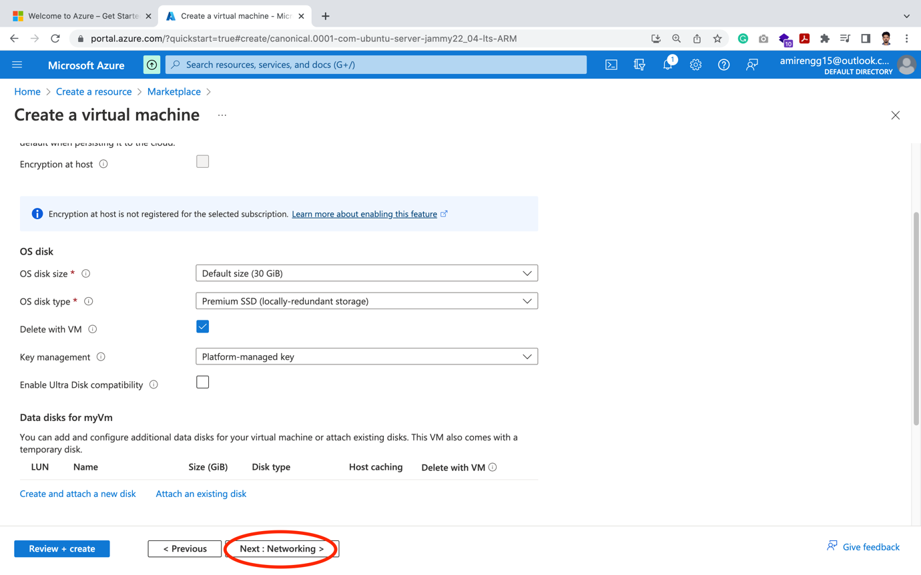

STEP 5: Networking: Here we basically add server details – subnet, public IP, etc.

Let us keep it by default

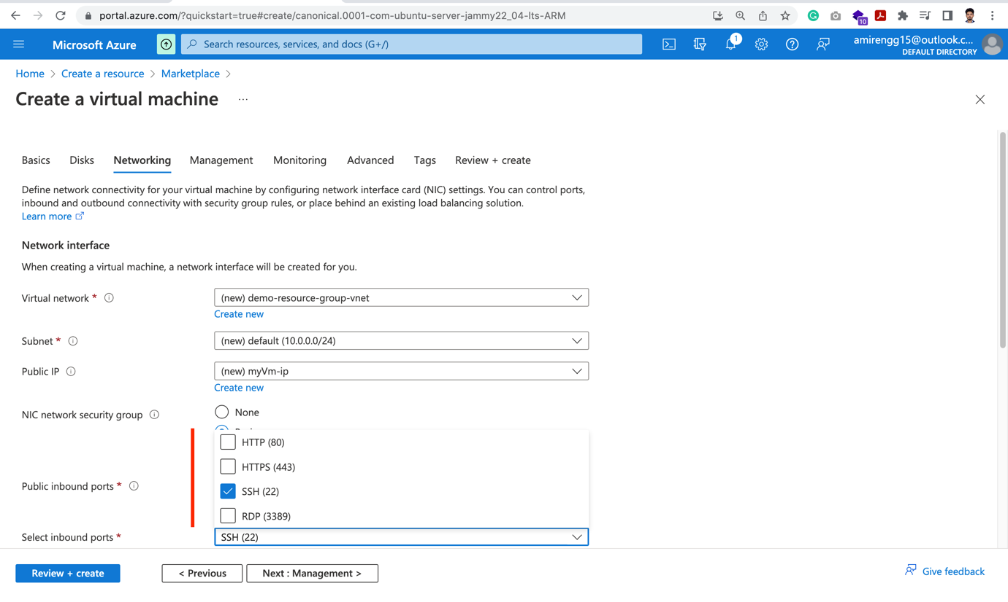

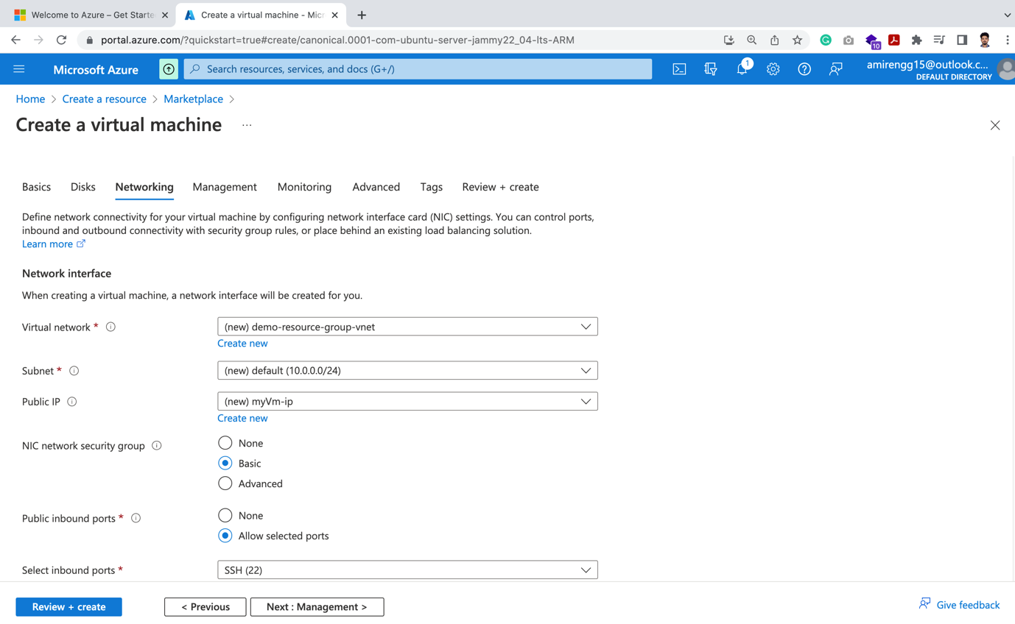

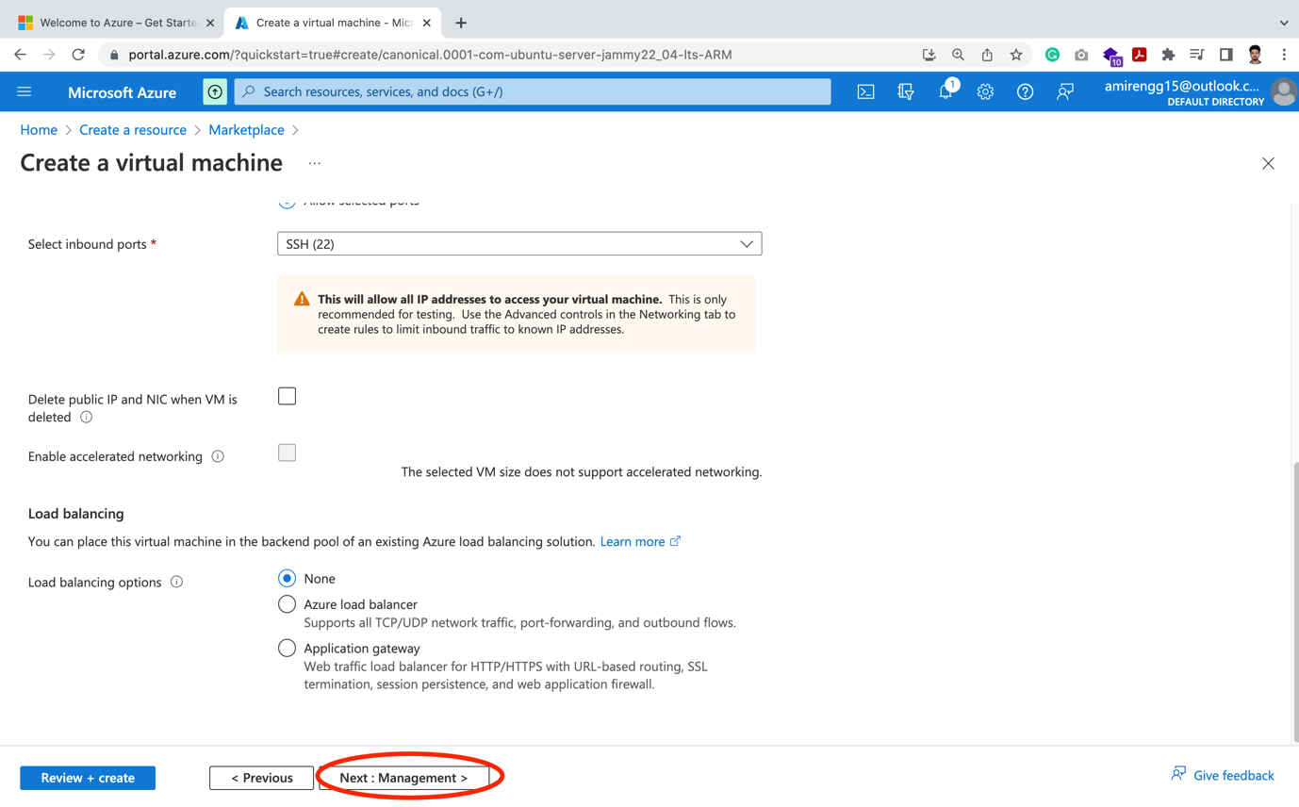

STEP 6: Management:

🡪 At present, no need for boot diagnostic – Like Microsoft Defender, etc.

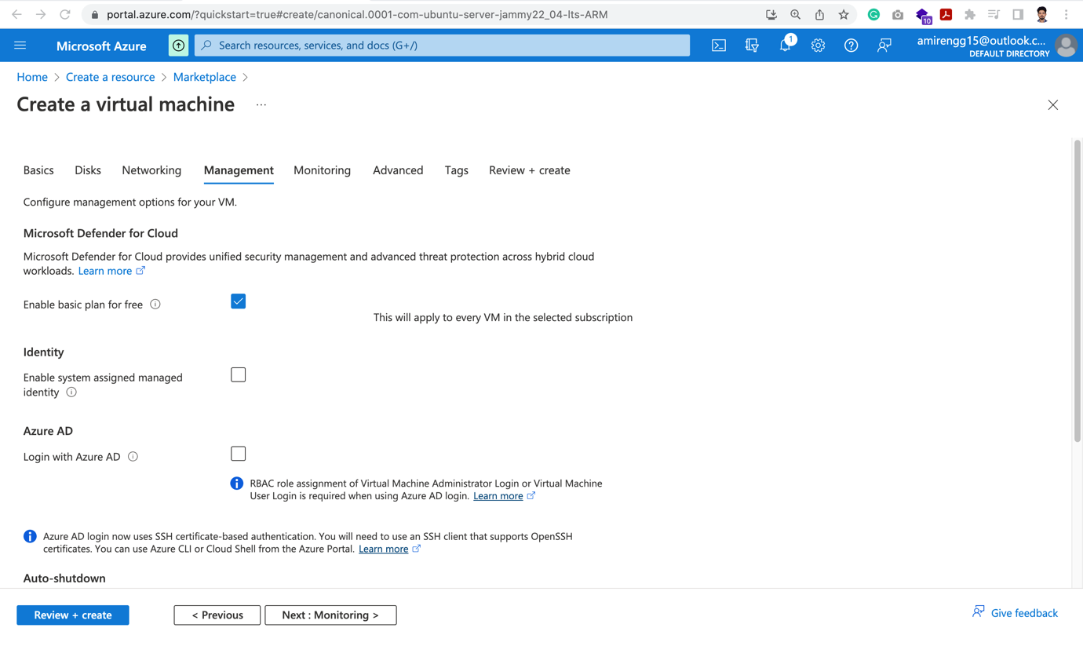

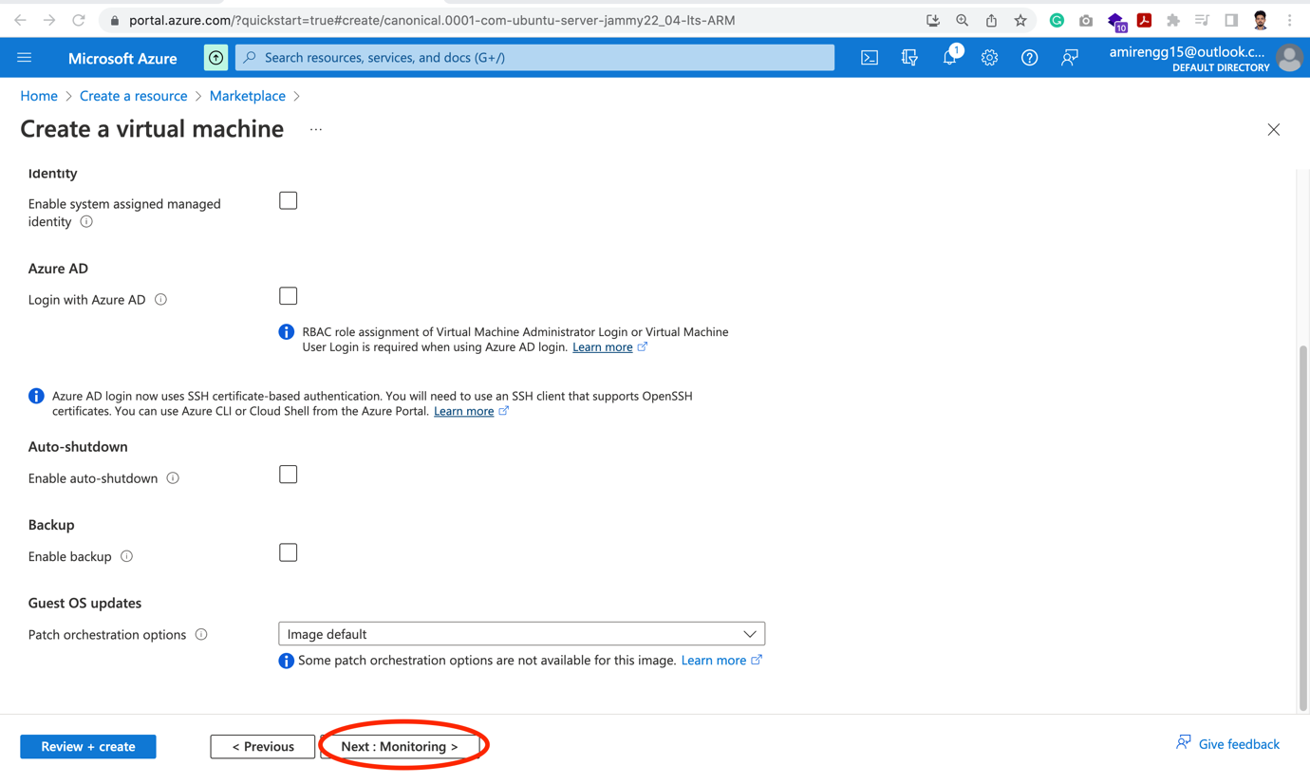

STEP 6: Monitoring:

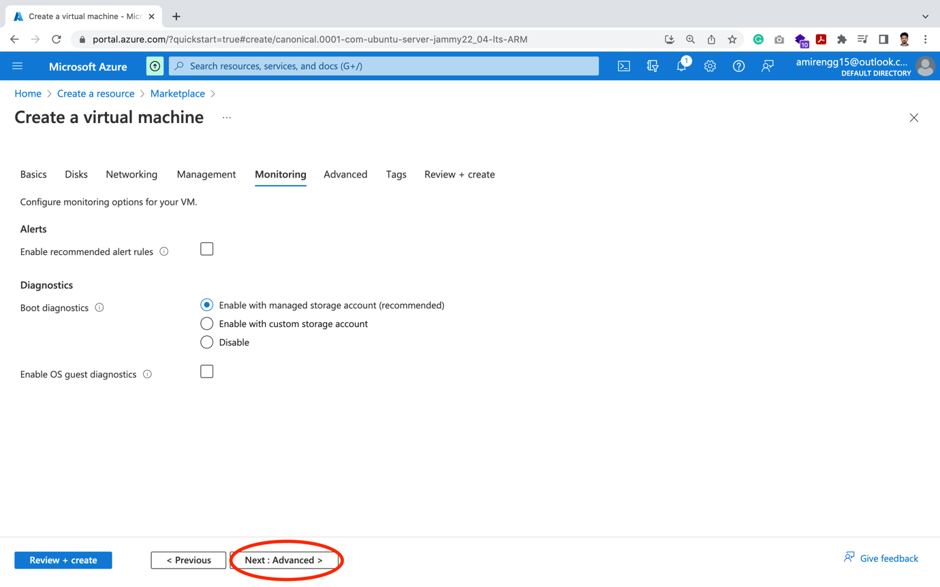

STEP 7: Monitoring:

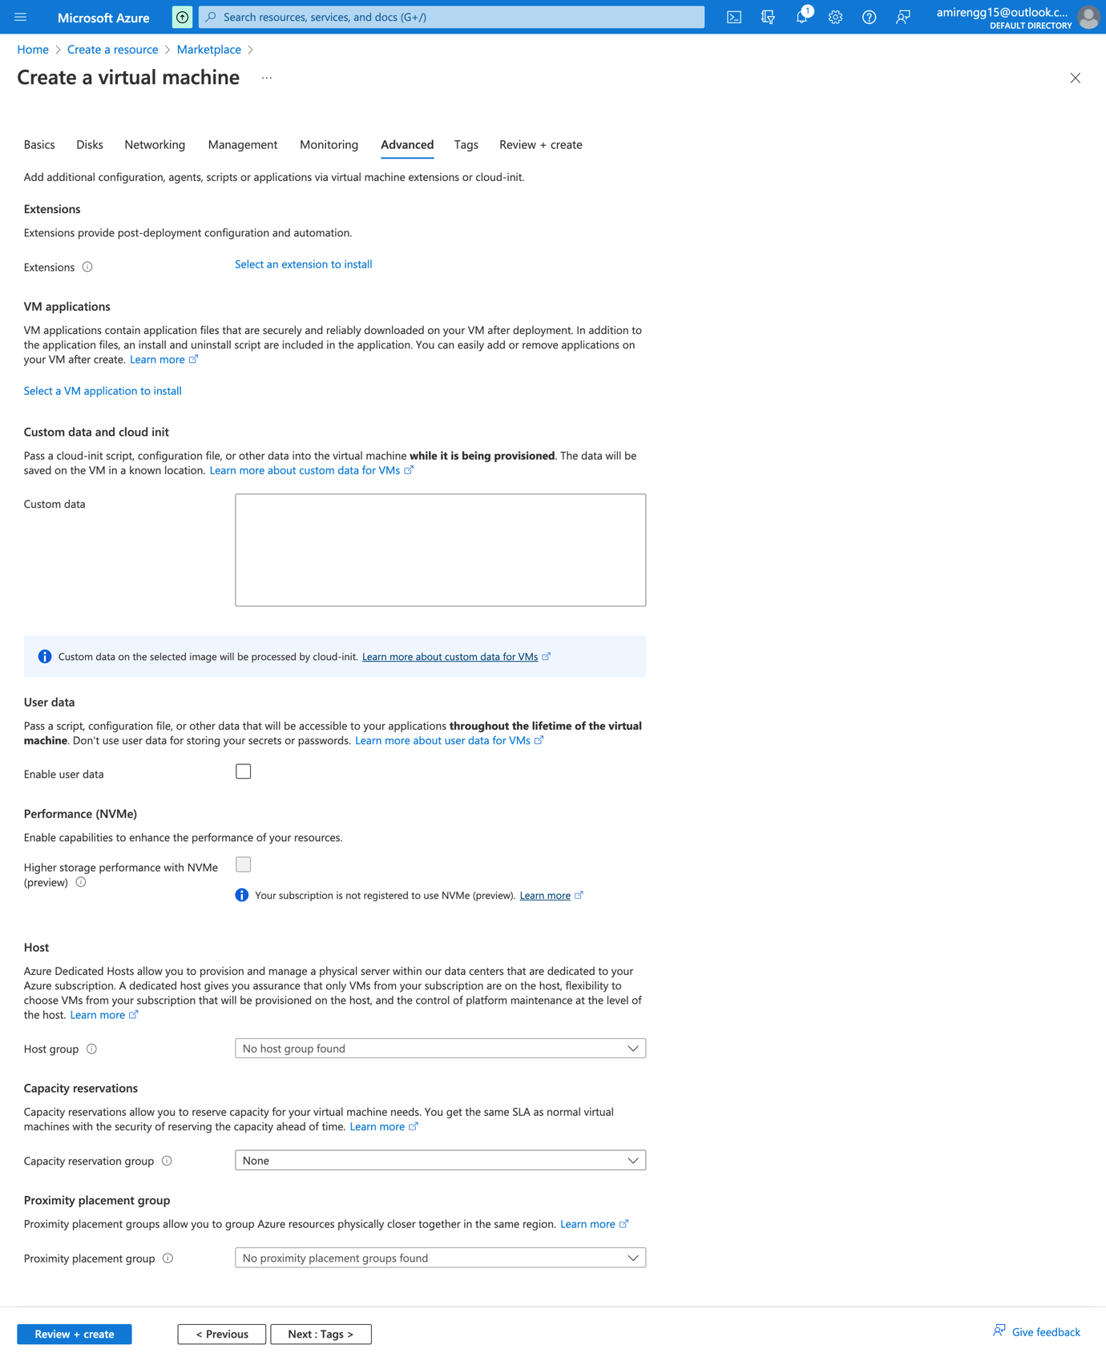

🡪 Click Next button for Tags option

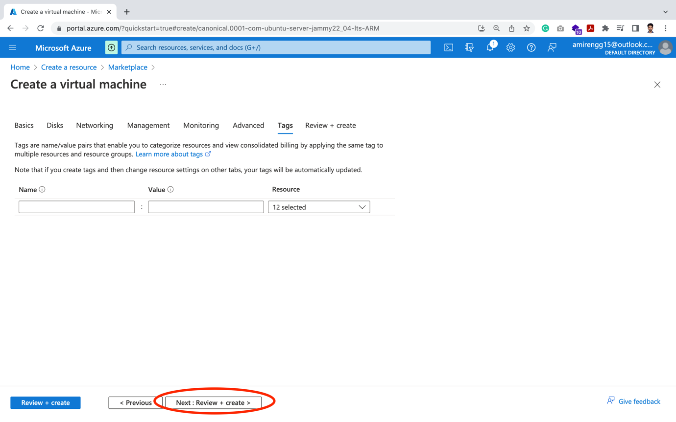

🡪 Finally we review our selection

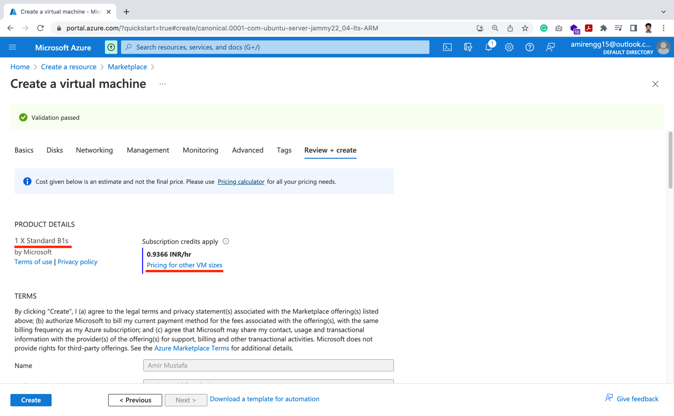

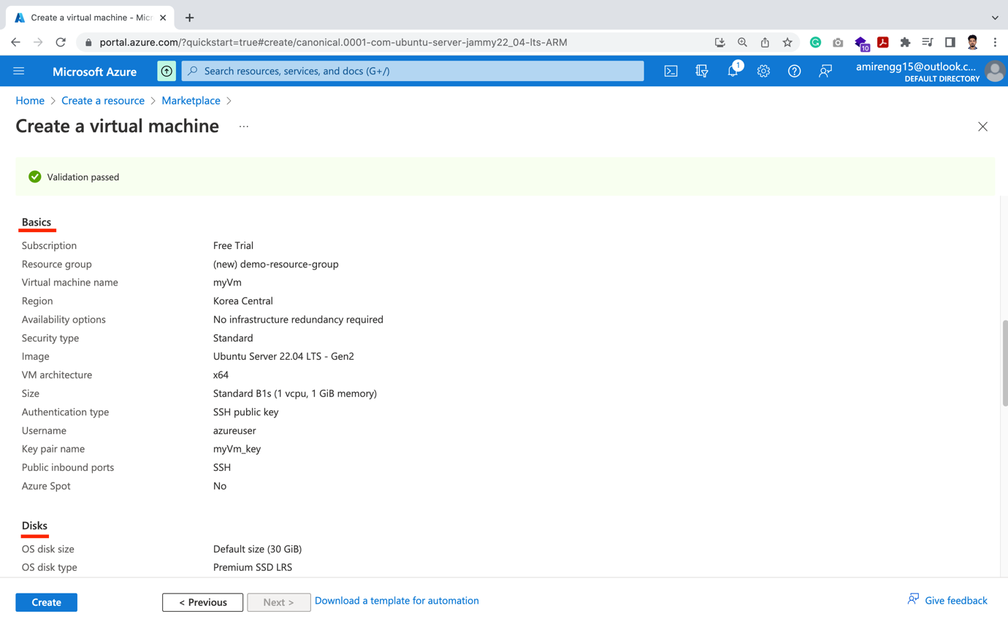

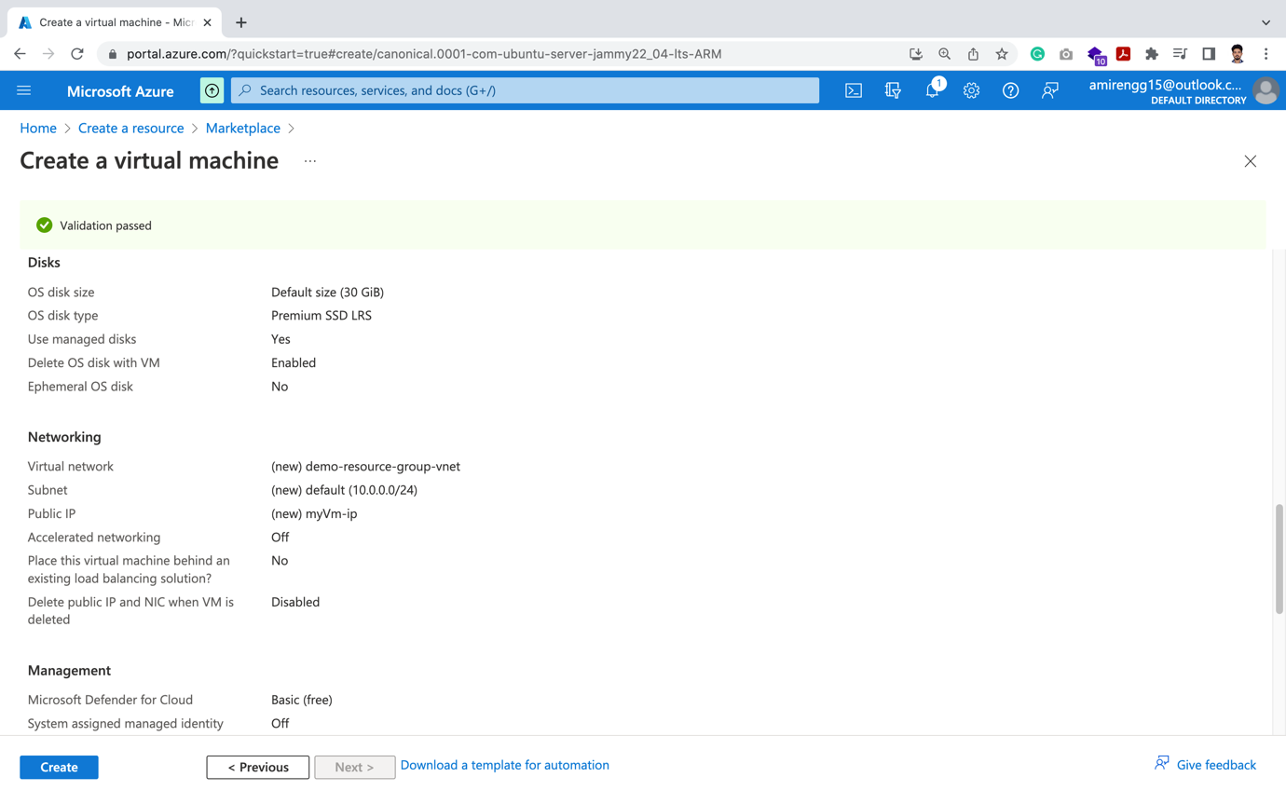

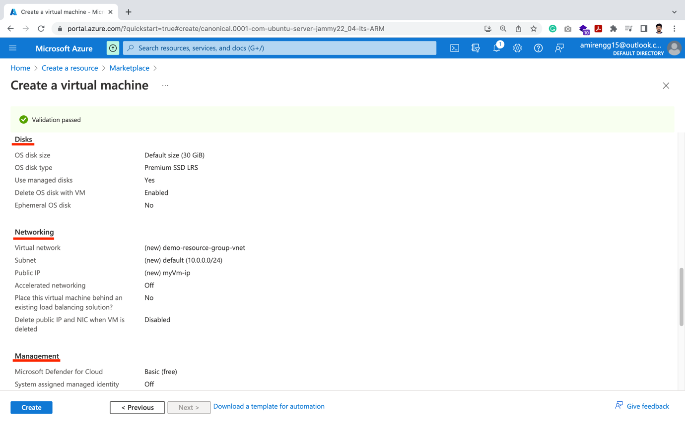

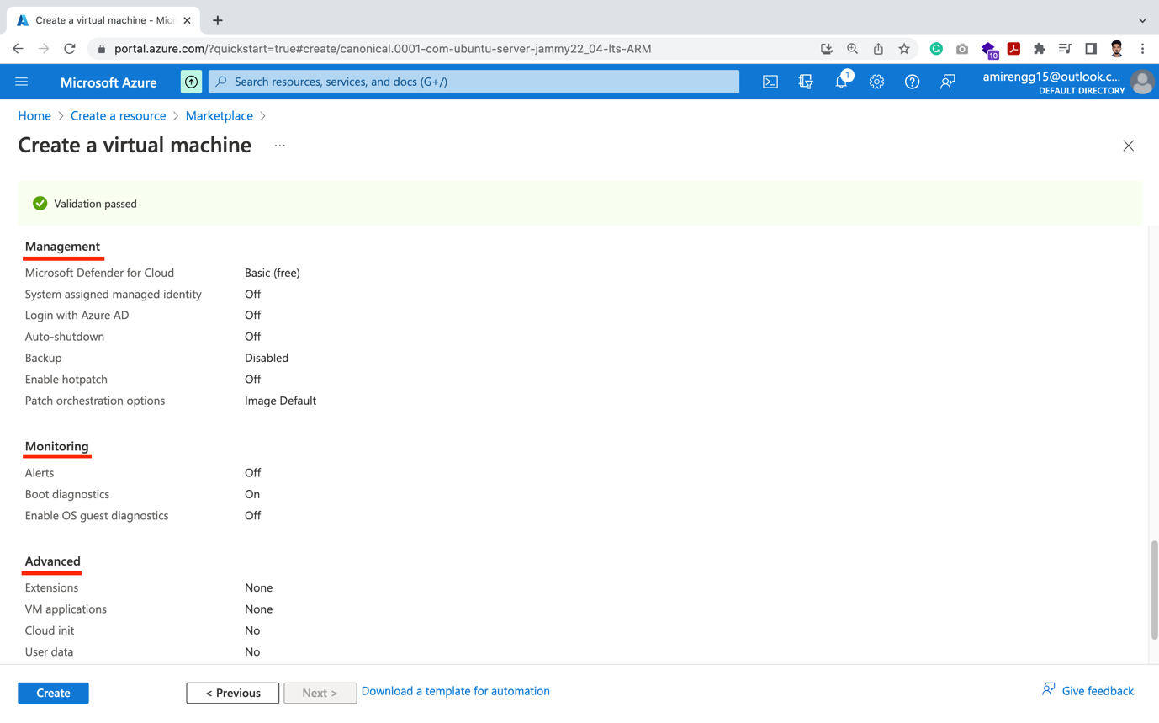

🡪 Click on Create button: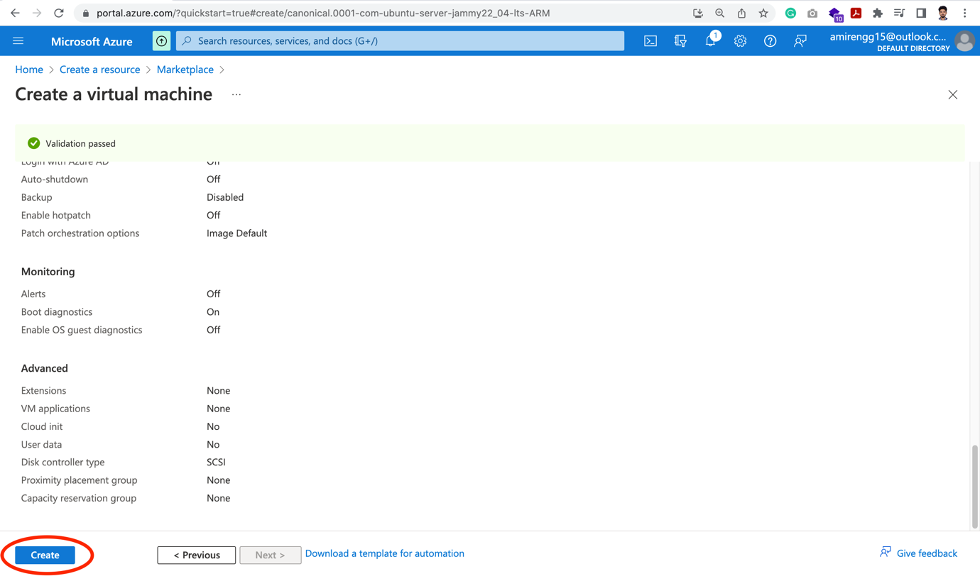

🡪 A pop-up comes when we create the server first time for generating key-val pair.

🡪 Click Download private key and create resource.

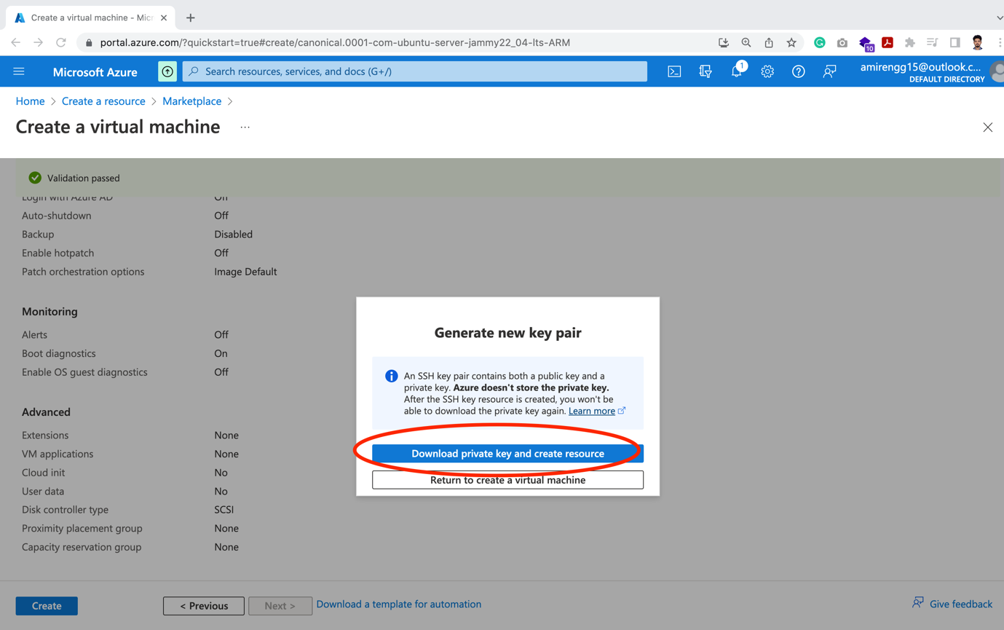

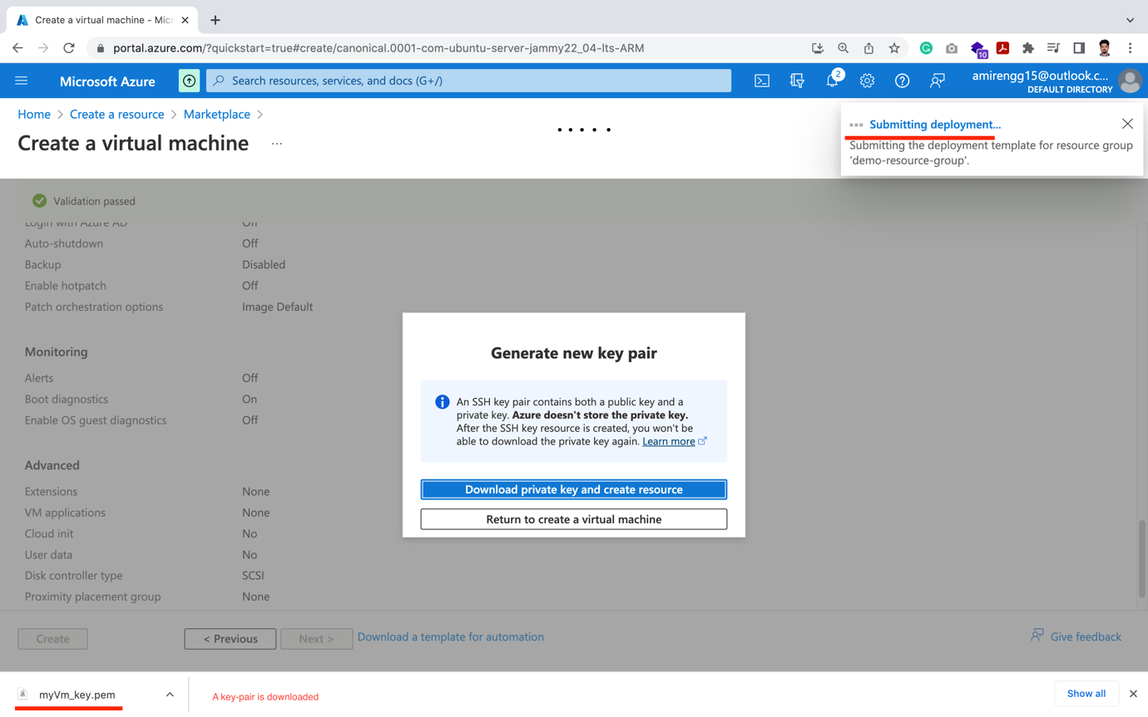

🡪 A .pem file is downloaded and will be redirected to Virtual Machine (VM) landing page.

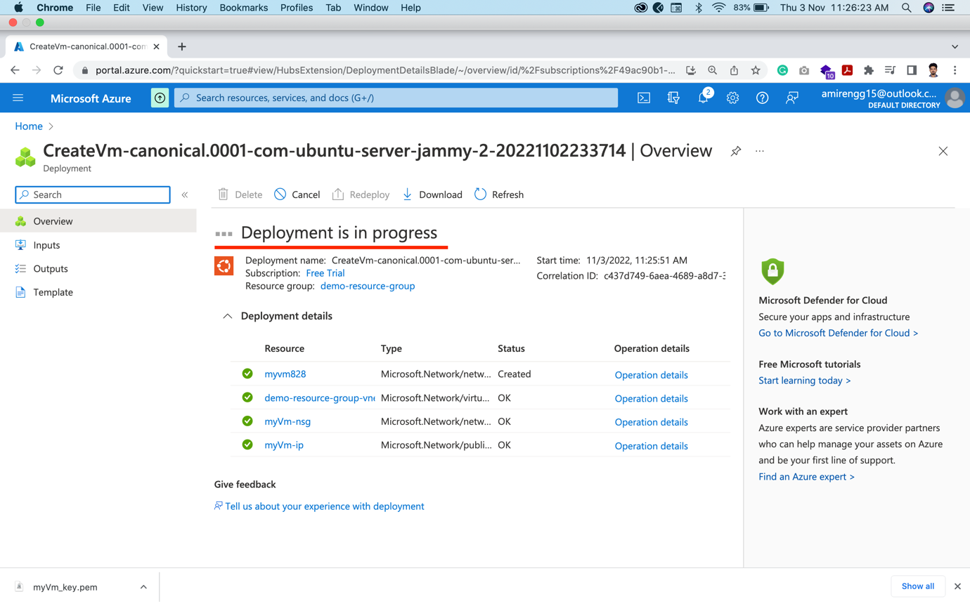

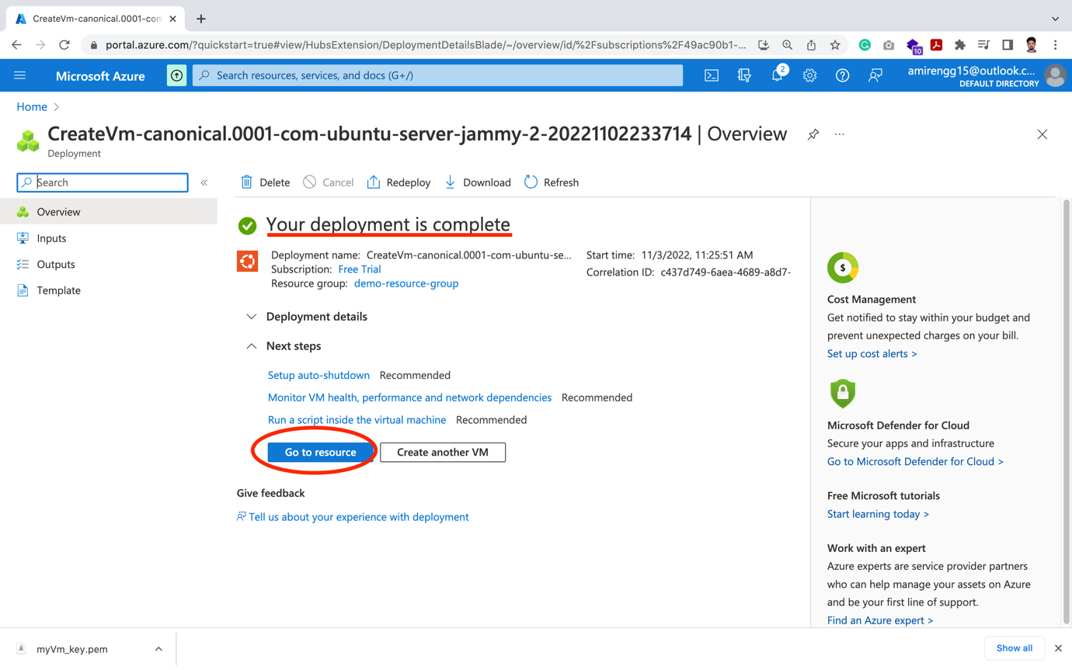

Landing page of VM:

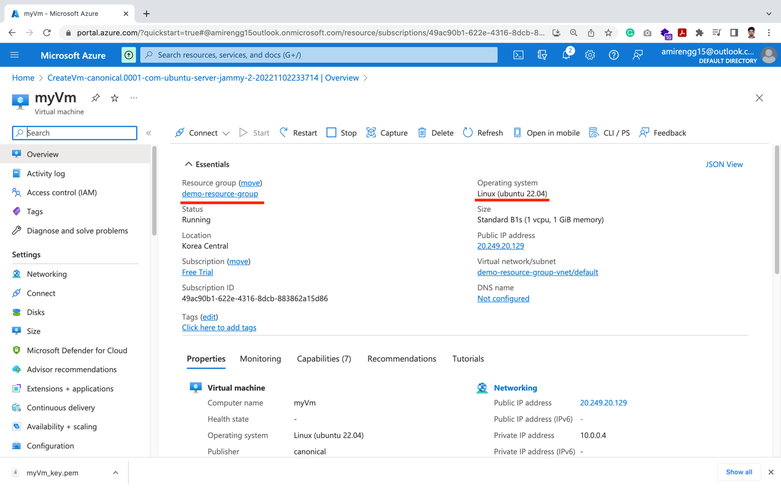

Connecting to VM:

🡪 When we are inside VM, we see details about server running:

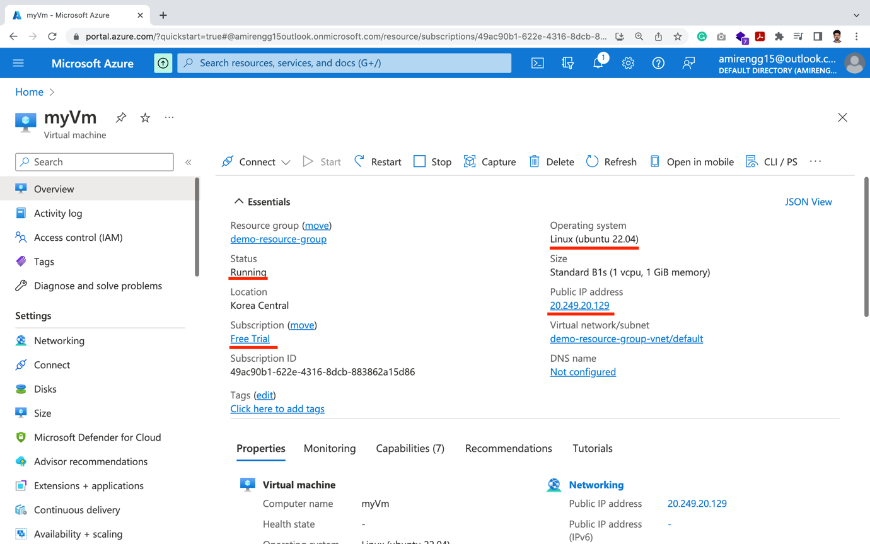

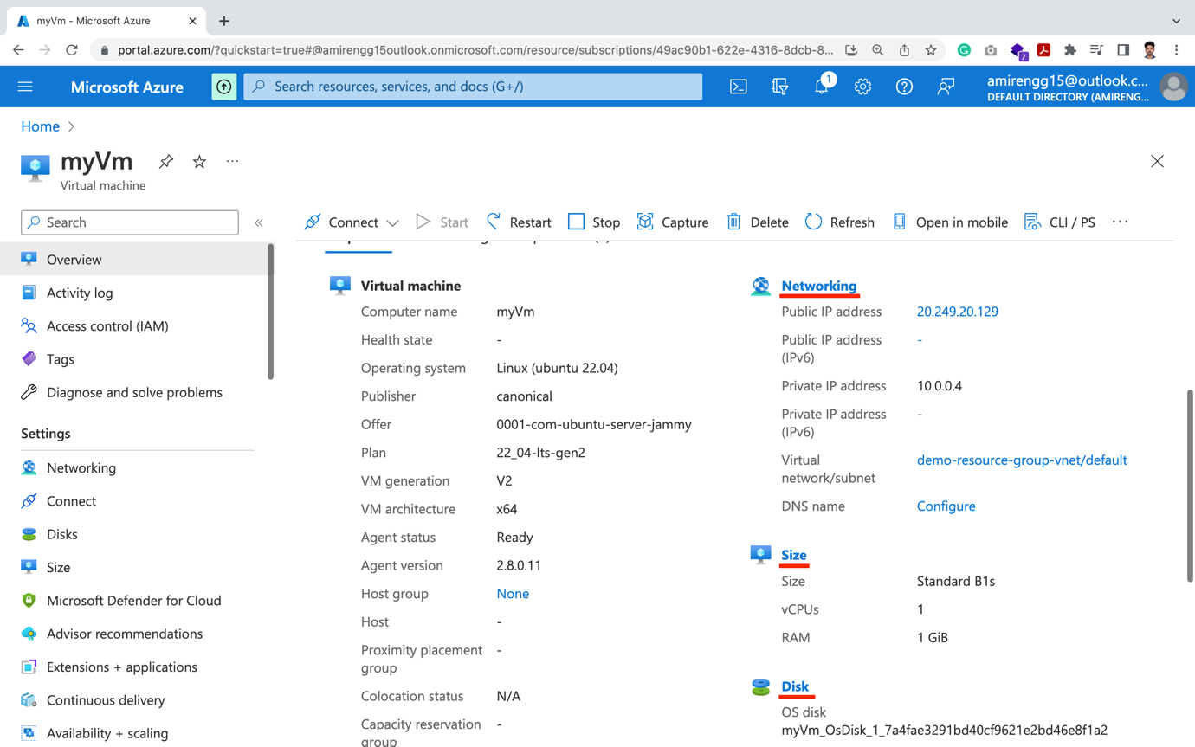

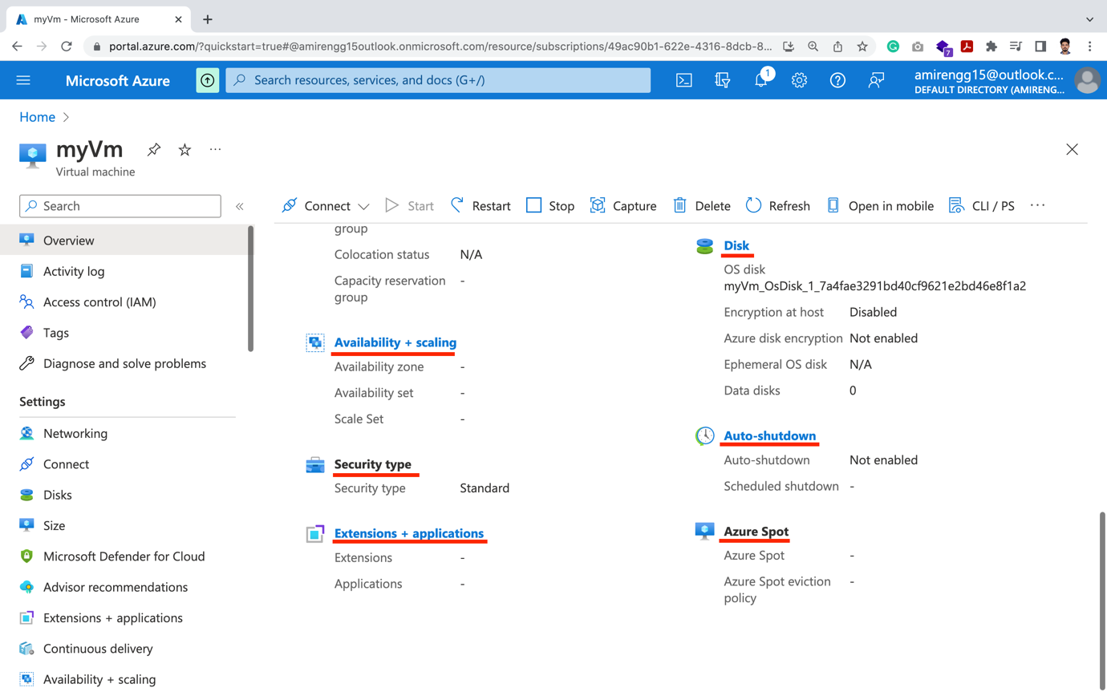

🡪 Based on OS type we can connect to server’s terminal/command prompt

🡪

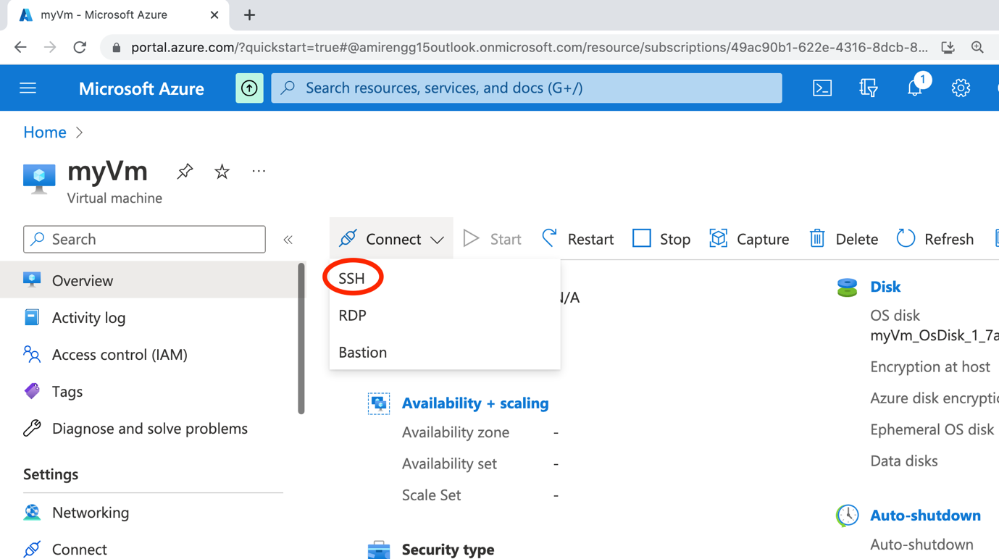

Linux: SSH:

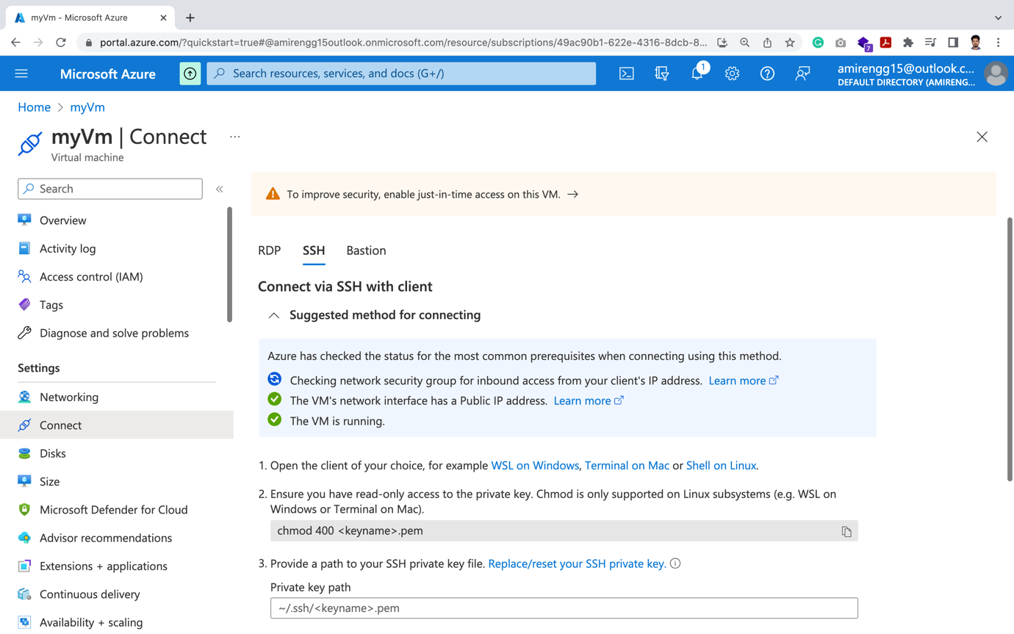

Windows: RDP:

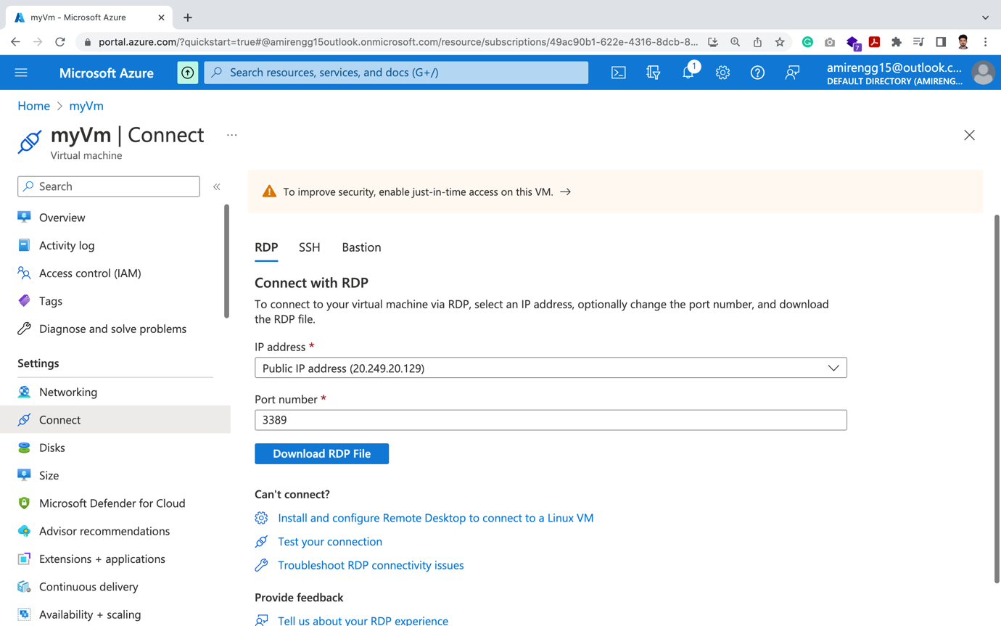

Bastion:

🡪 This is the Azure service for fast connect

Connecting to SSH

STEP 1: Go to below Azure link and copy-paste SSH command in terminal / Powershell

<https://portal.azure.com/?quickstart=true#@amirengg15outlook.onmicrosoft.com/resource/subscriptions/49ac90b1-622e-4316-8dcb-883862a15d86/resourceGroups/demo-resource-group/providers/Microsoft.Compute/virtualMachines/myVm/connect>

ssh -i <private key path> [azureuser@20.249.20.129](mailto:azureuser@20.249.20.129)

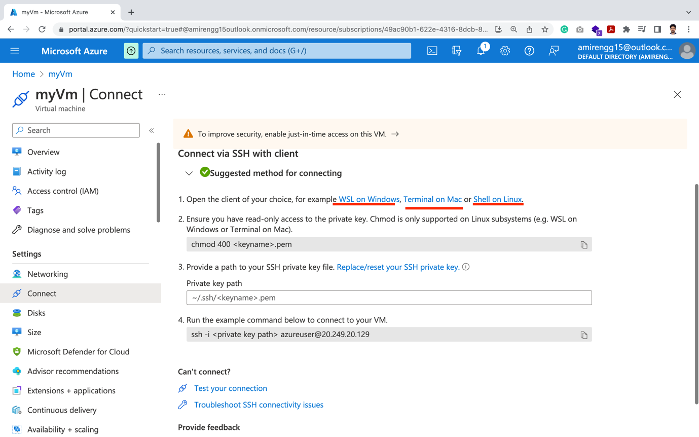

STEP 2: At the time of creation of VM, a .pem key should be downloaded (also called SSH keys)

Public key kept in Azure VM Resource

Private key: .pem key downloaded in local

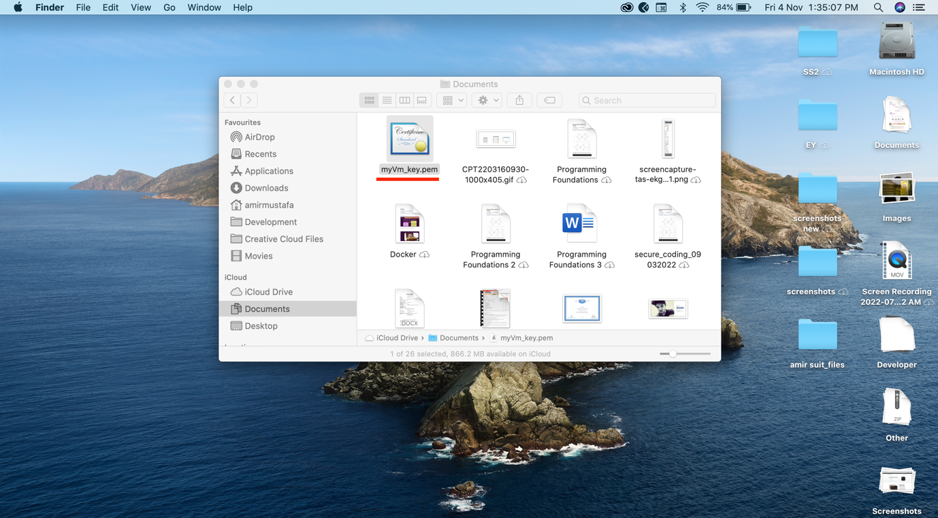

🡪 Let is get the .pem file path

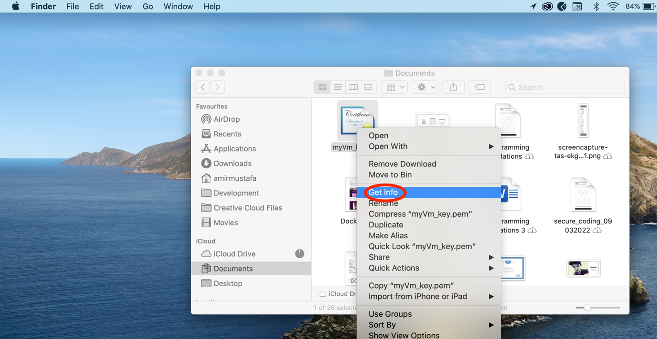

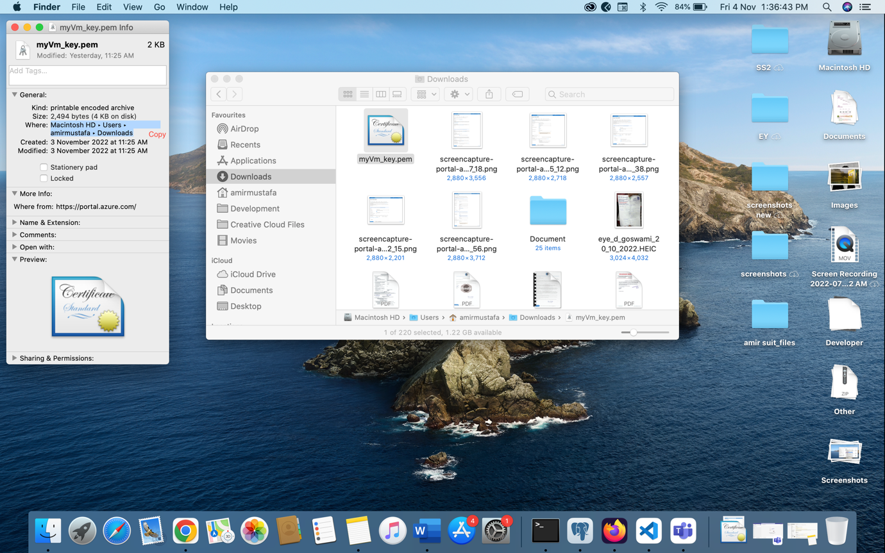

🡪 Let us now Open Terminal / Powershell paste SSH command

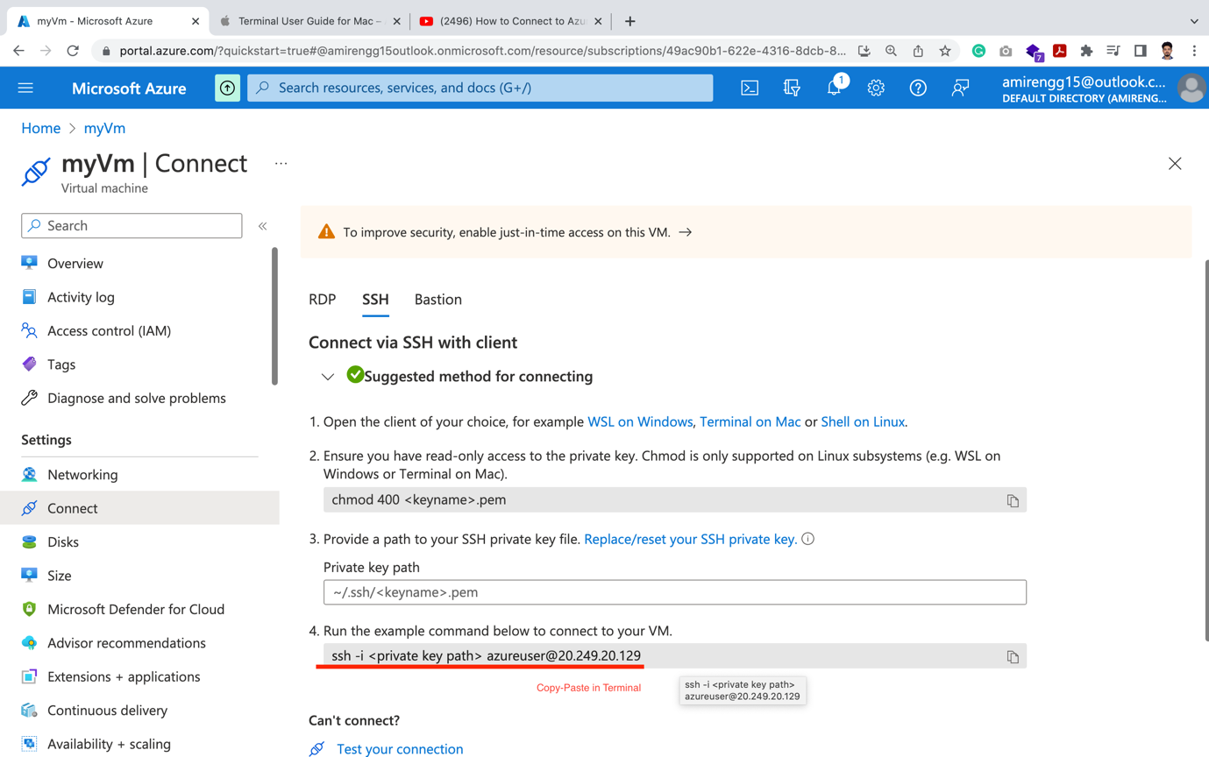

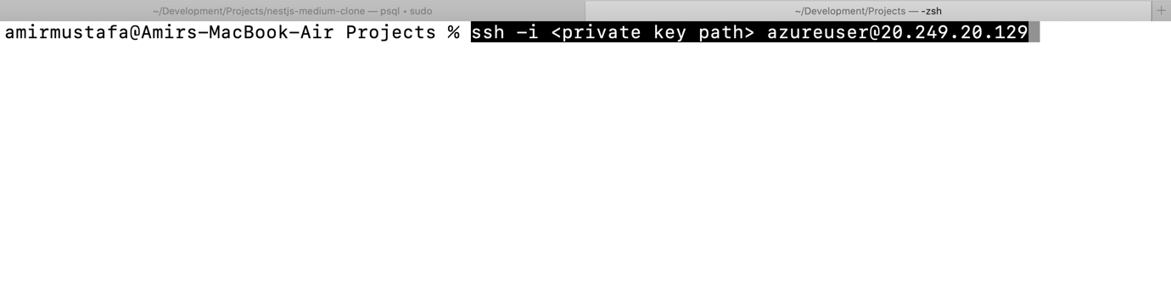

🡪 Giving permissions to .pem file

Sudo chmod 400 <keyname>.pem

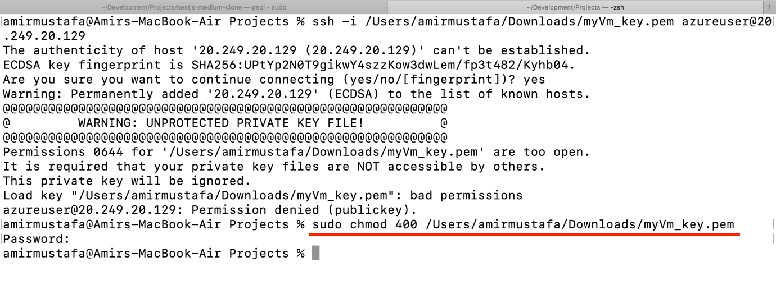

🡪 SSH command Replace by .pem file path

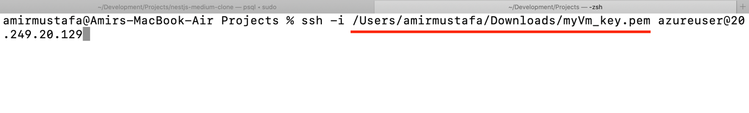

🡪 Type yes 🡪 Enter

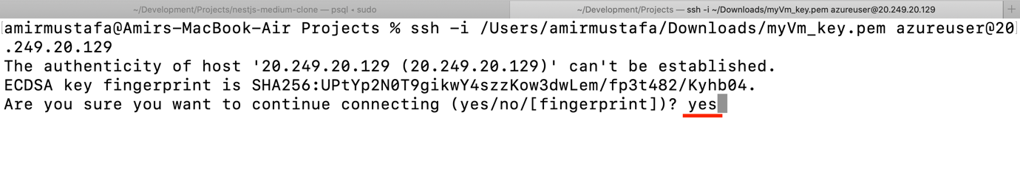

🡪 We are finally inside Azure SSH:

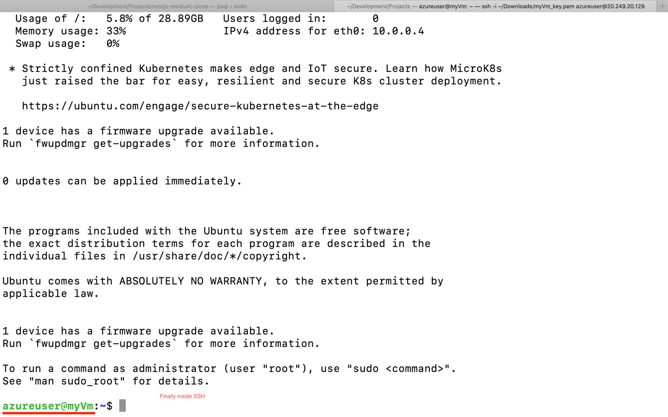

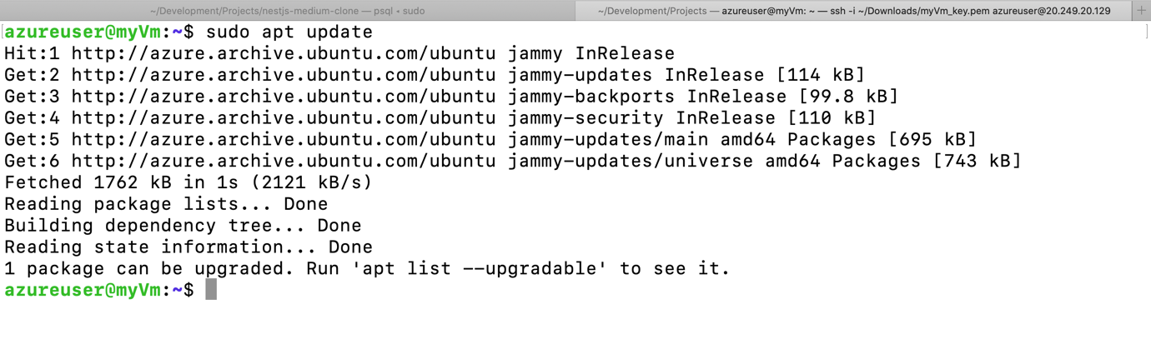

Stopping after Use:

🡪 There is a stop Tab button. Clicking it will stop the server

🡪 As Cloud will charge per hour basis, when not using we can stop it.

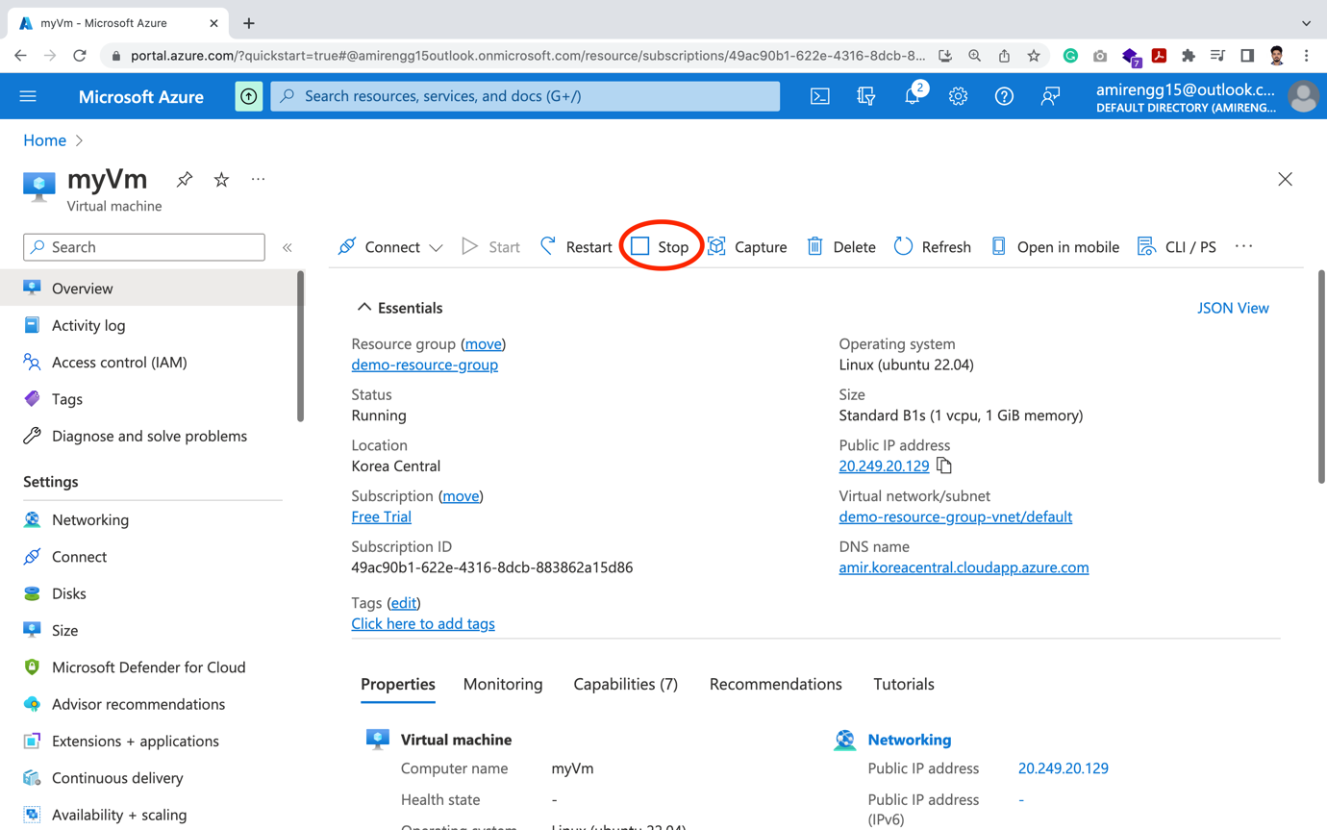

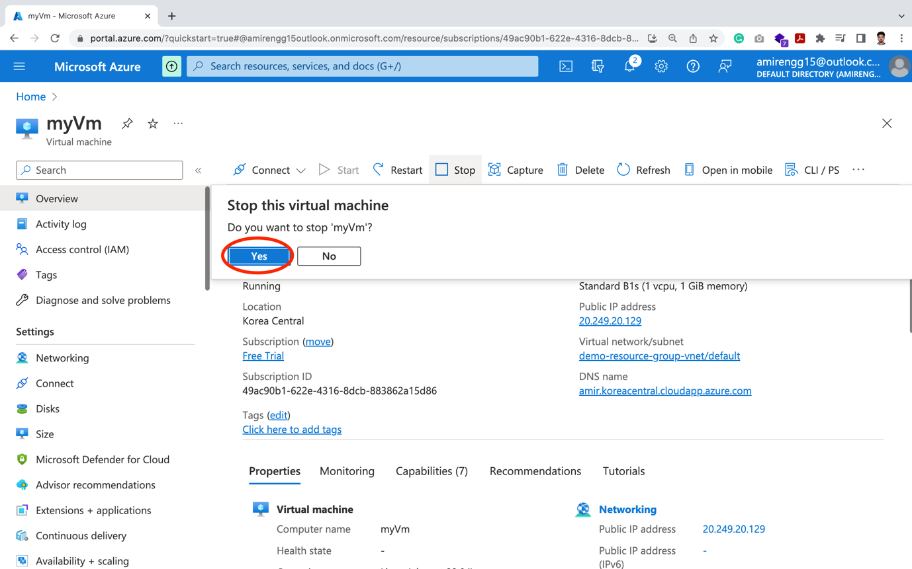

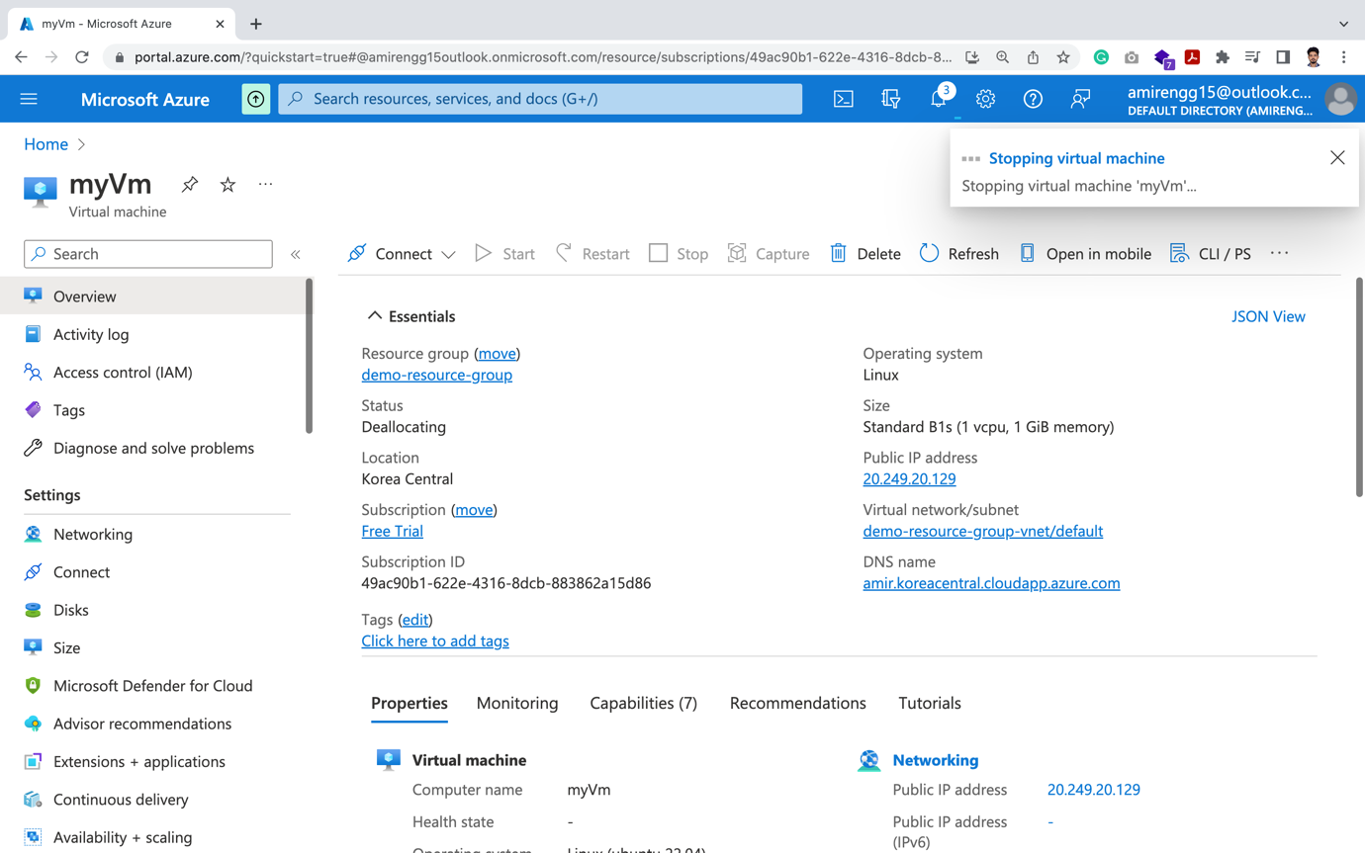

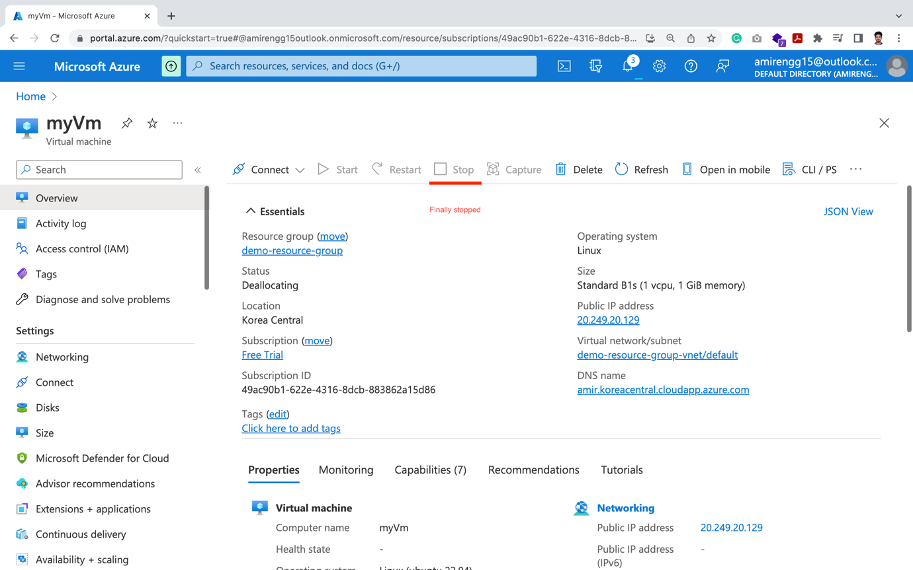

Resizing CPU/RAM:

🡪 If we have created VM. Now if our app requires more powerful computer

🡪 We can easily go to size and upgrade

Current Size: B1s: Standard B1s (1 vcpu, 1 GiB memory)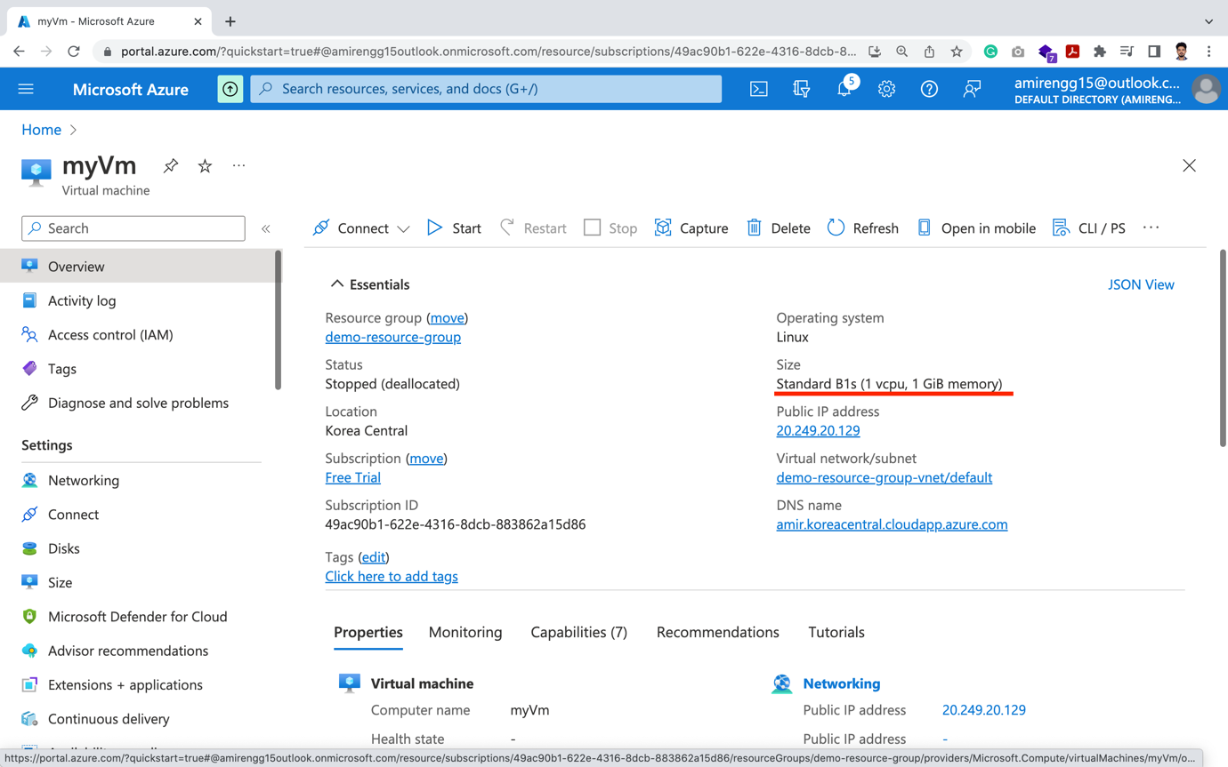

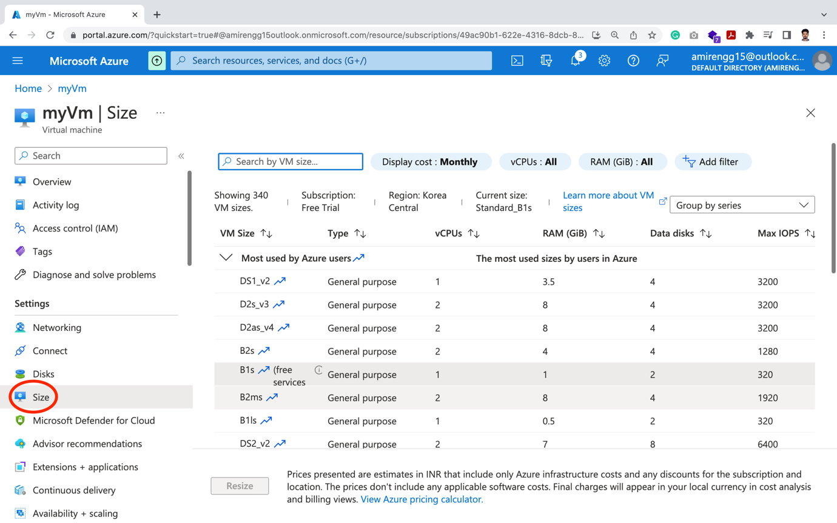

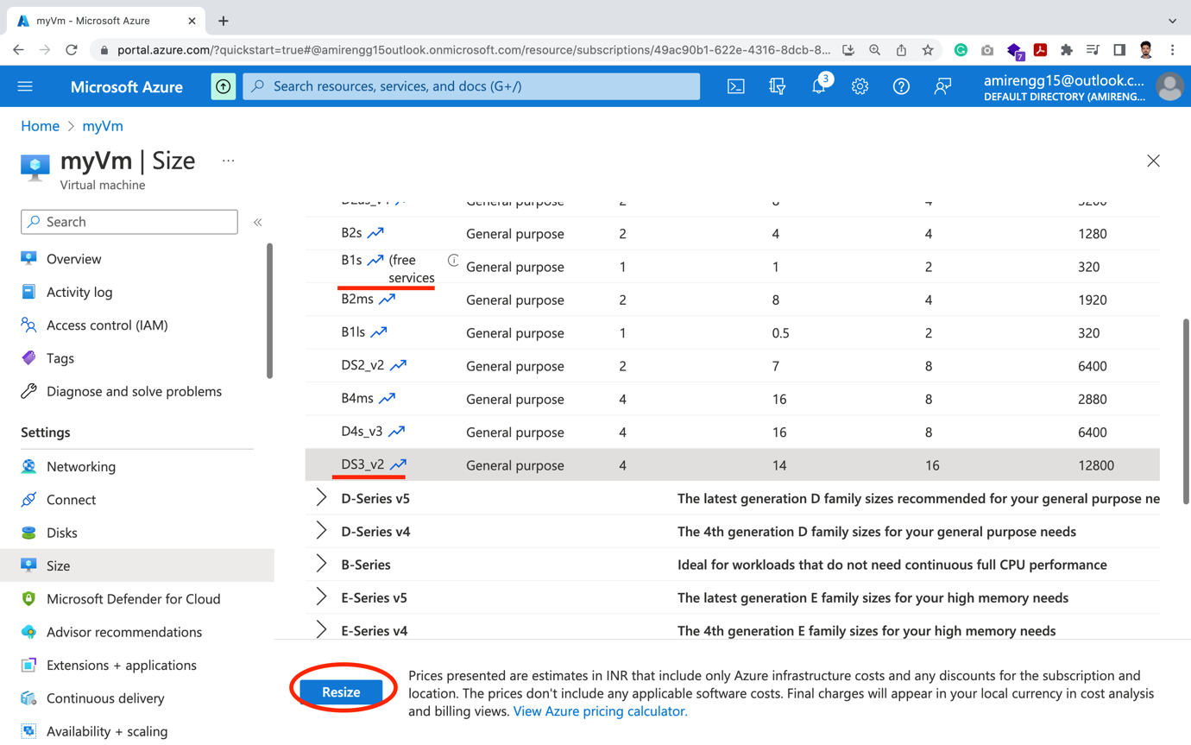

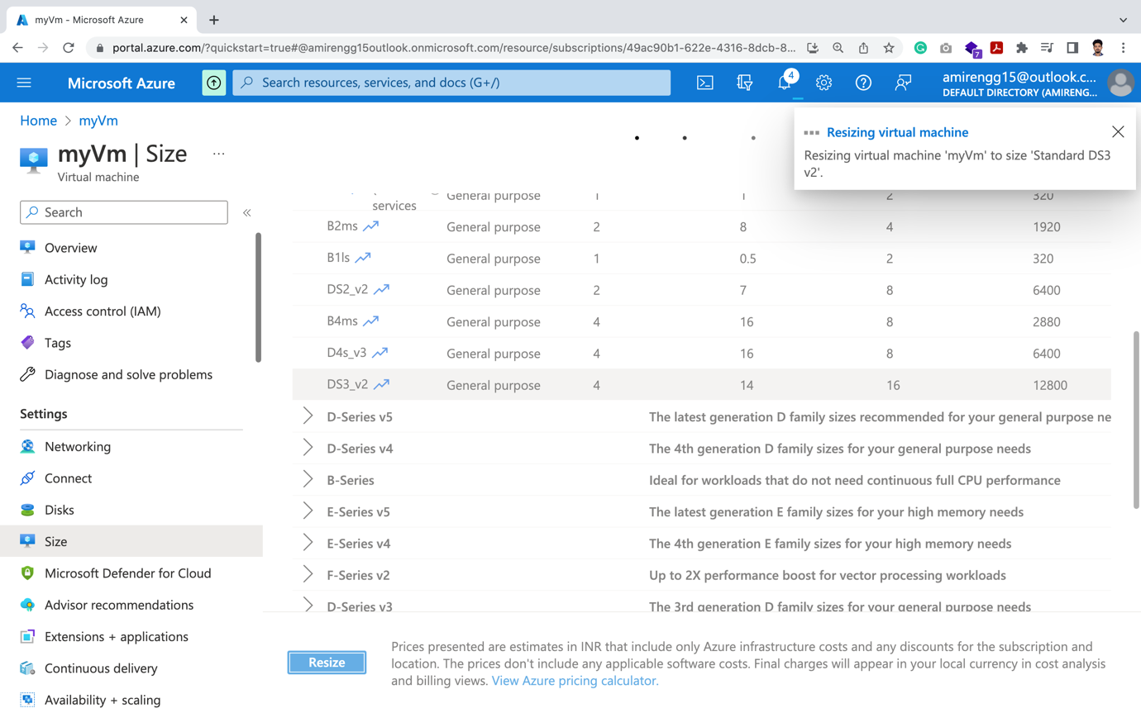

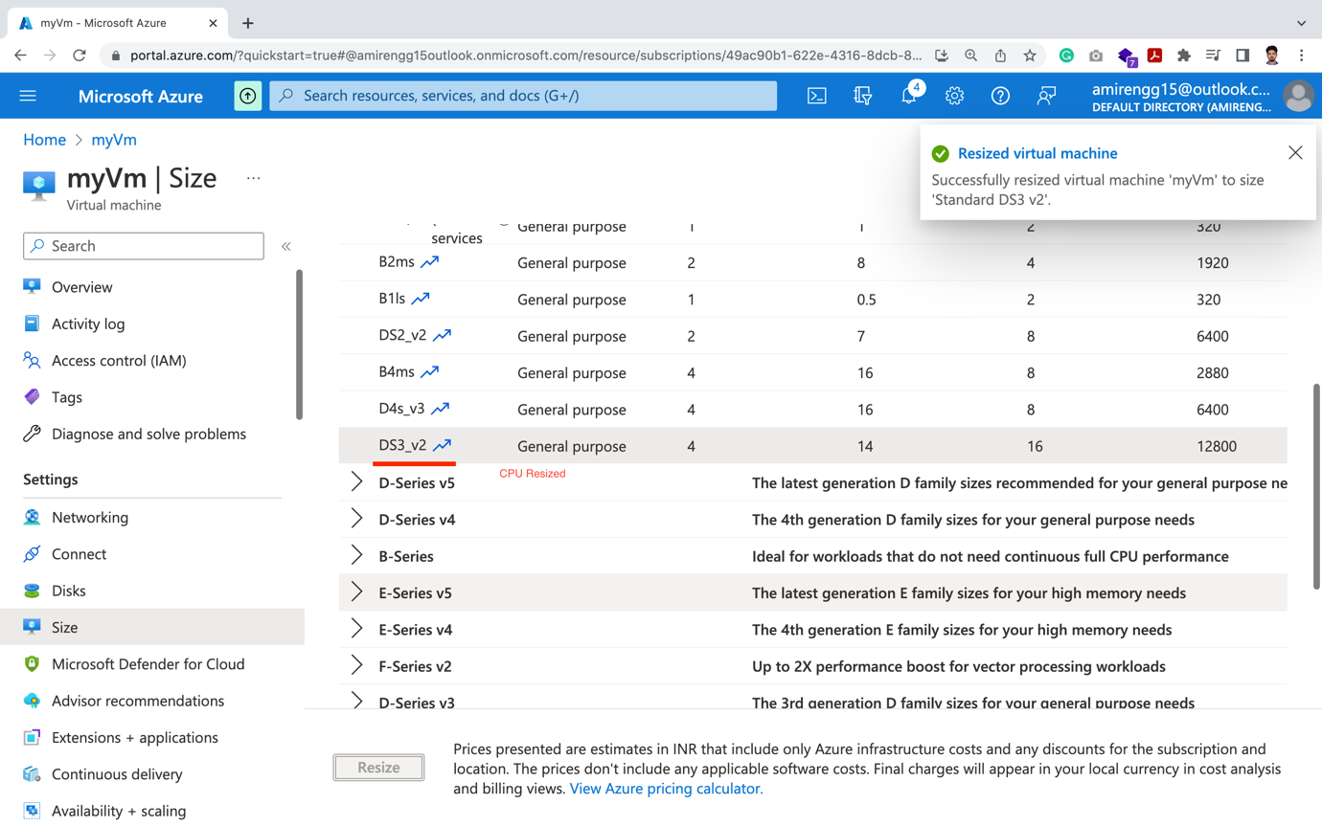

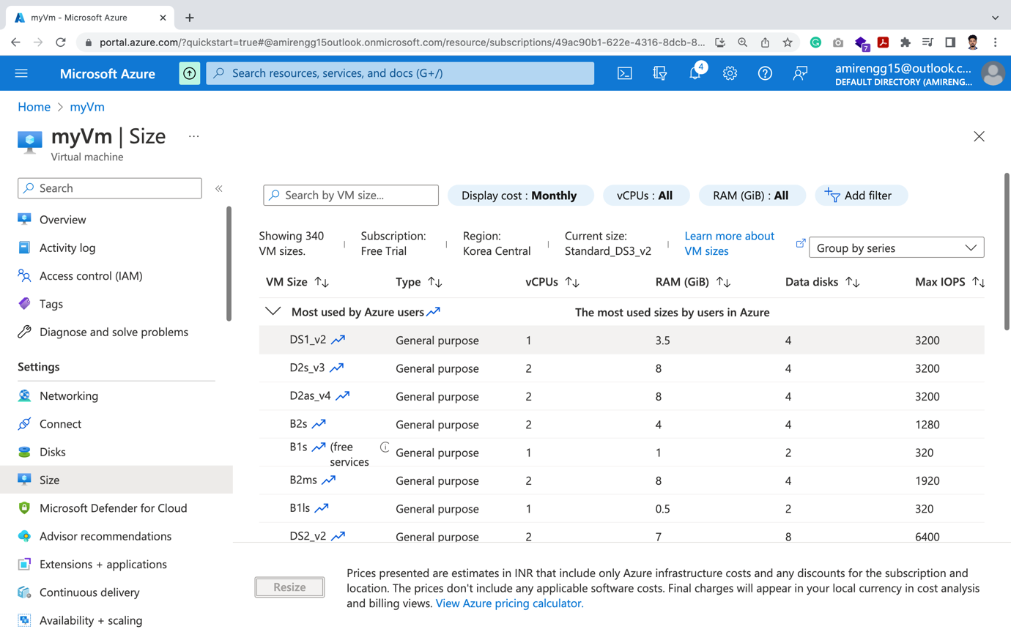

Upgraded To: Standard DS3 v2 (4 vCpus, 14 GiB)

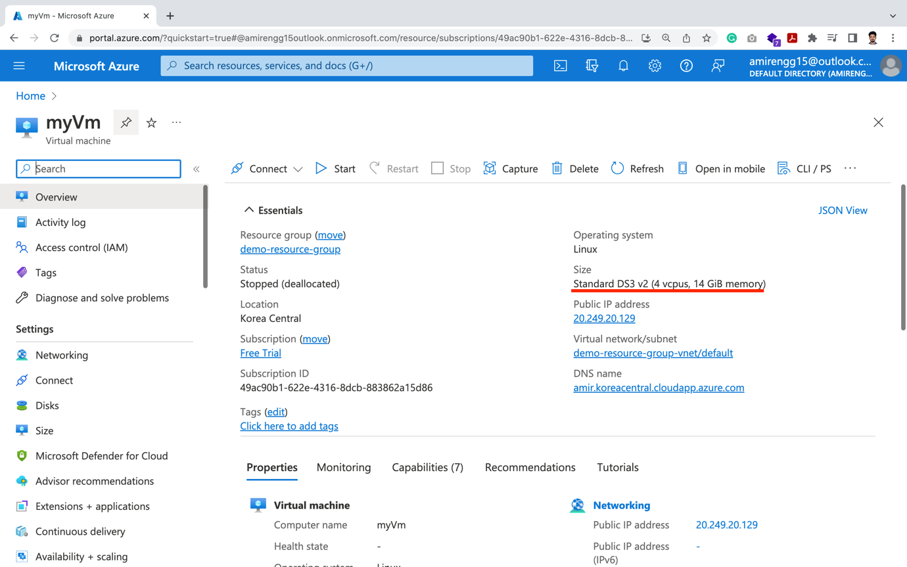

Creating Azure App Web Service:

🡪 Previously we created Ubuntu server. Today we will be creating Web App service.

🡪 Click on Create a Resource

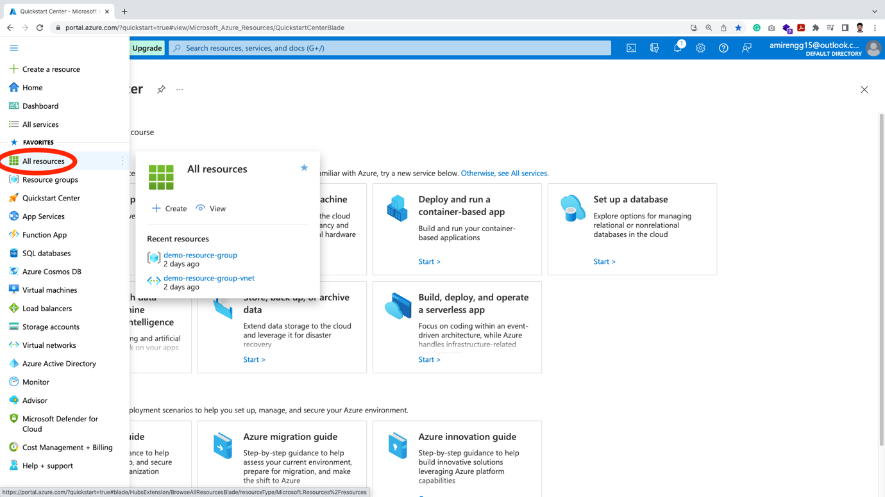

🡪 Click on Compute

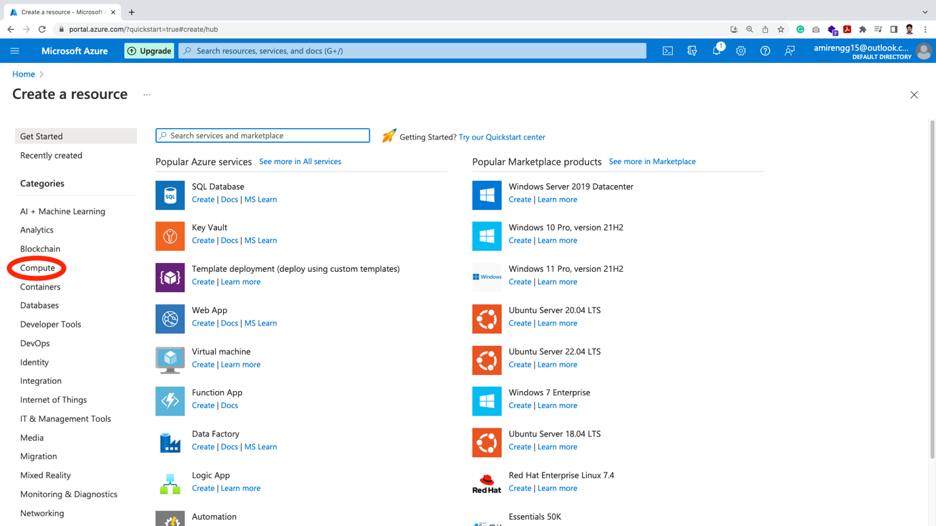

🡪 Search for Web App. Click Create.

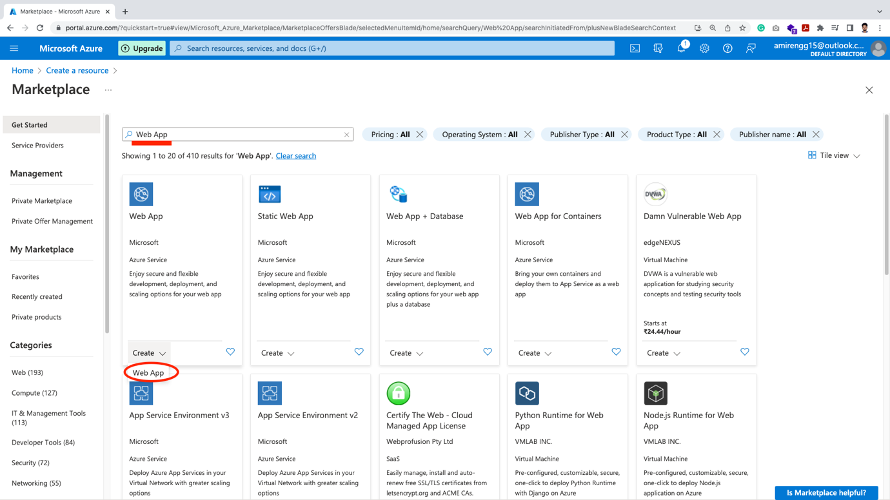

🡪 A similar type of page will open.

🡪 Microsoft does great job looking same look and feel throughout cloud. We subscription plan and creating resource

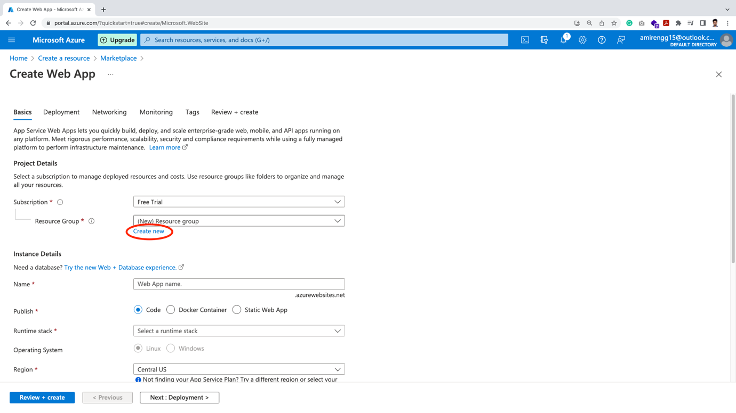

🡪 Click on Create resource. Enter Application name 🡪 Click Ok button.

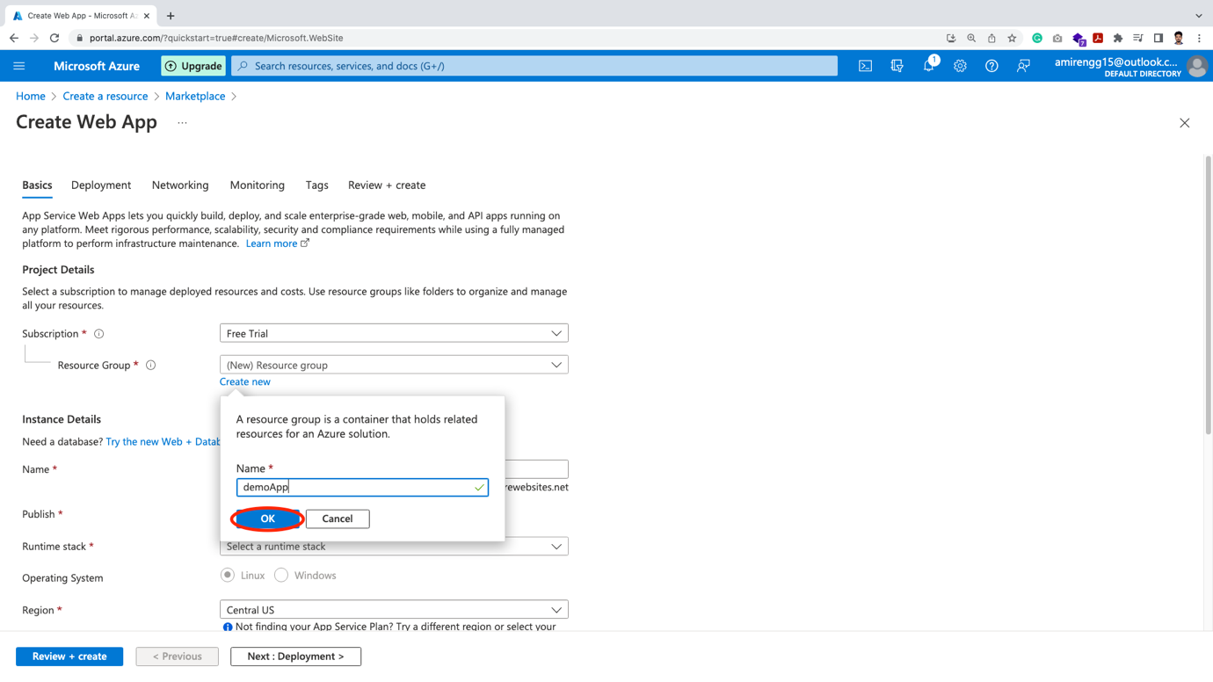

🡪 Here we have to give name, that will reflect on the web app url

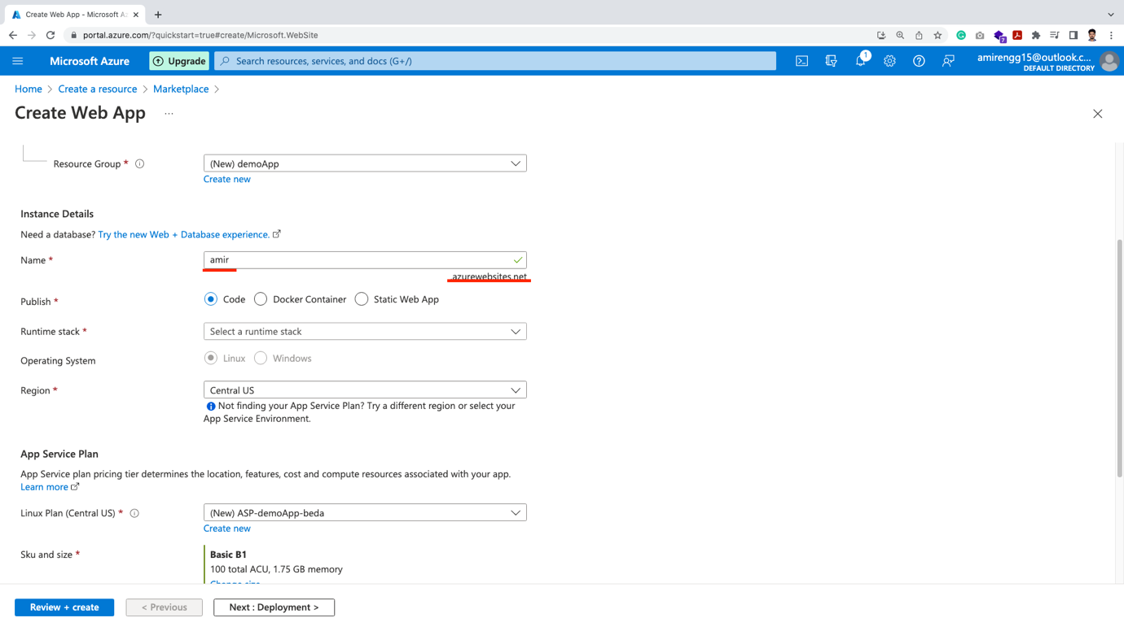

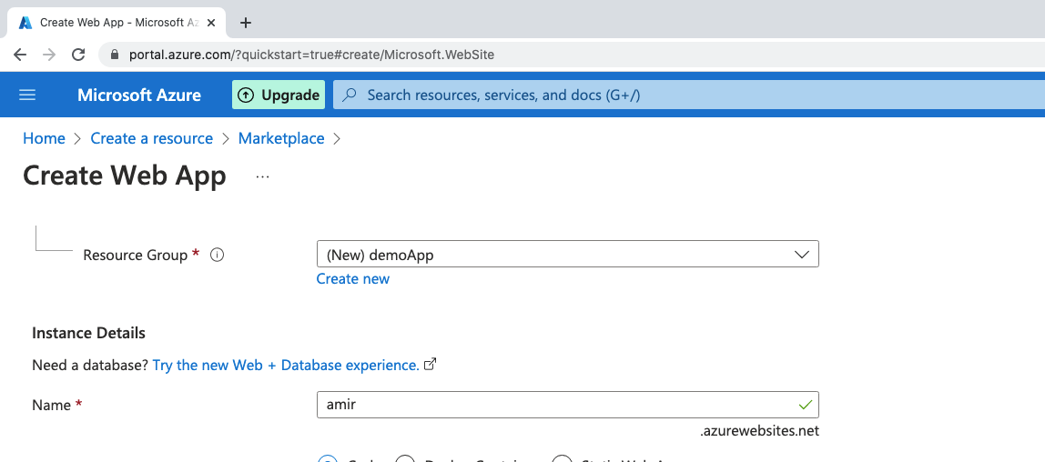

🡪 The difference between previous one was we have to purchase a domain and sync with it

🡪 Here we directly get the web URL.

🡪 Azure has multiple ways in which code can be deployed – Code, Docker container or one for static App. This same feature AWS also has.

Let us see these options one by one:

1. Code:

Here multiple technology programming language are there eg. PHP, Node, JAVA, Python, etc

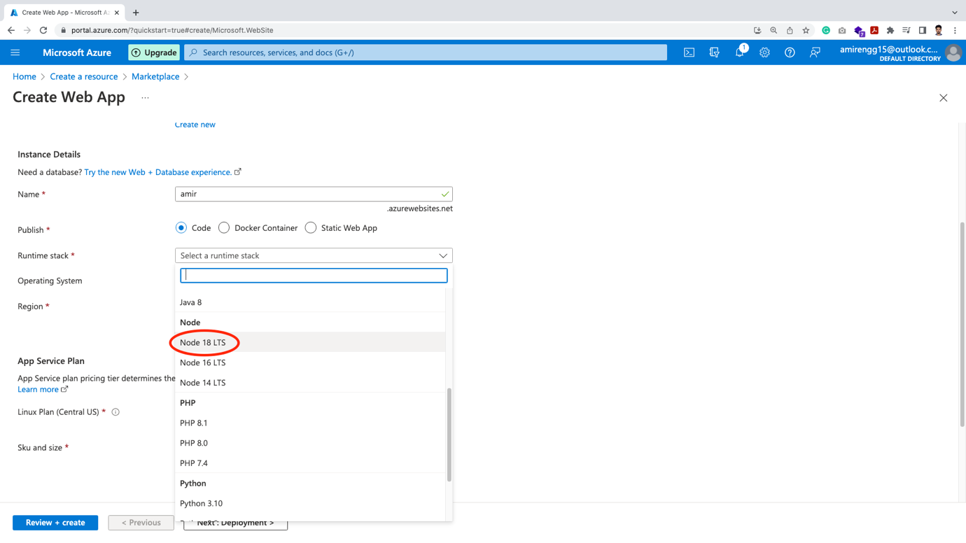

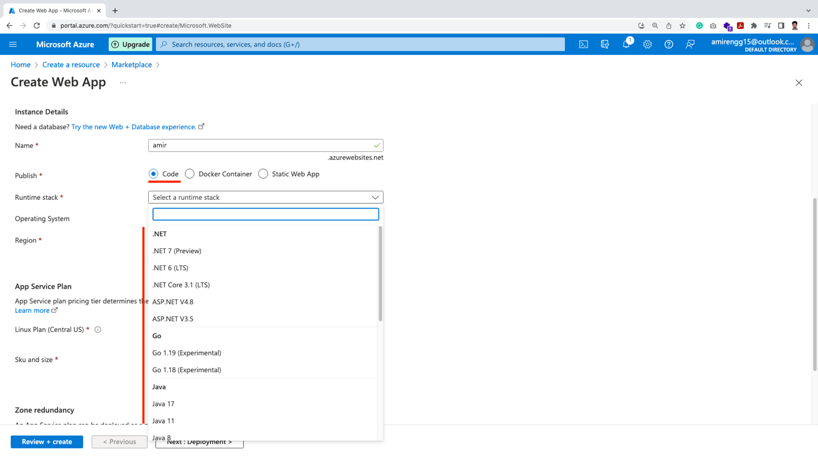

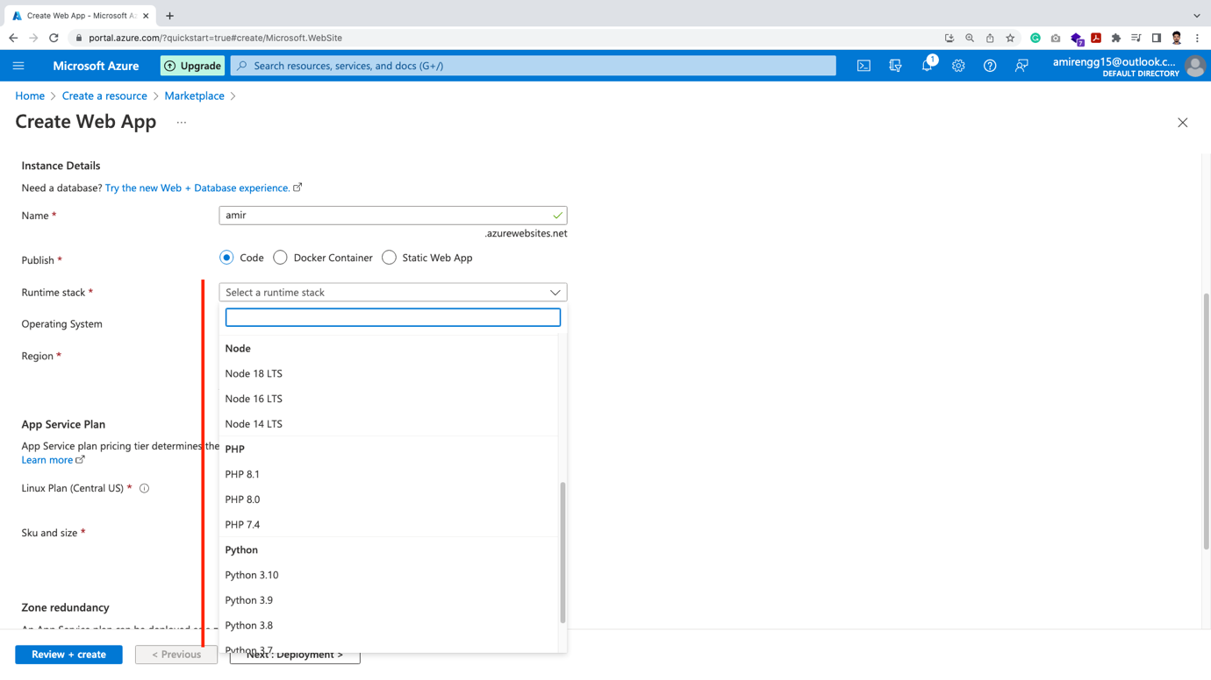

🡪 We can chose our favourite programming language to create Web App.

1. Docker Container: Microsoft provides us with the facility to use containers over both Windows and Linux platforms

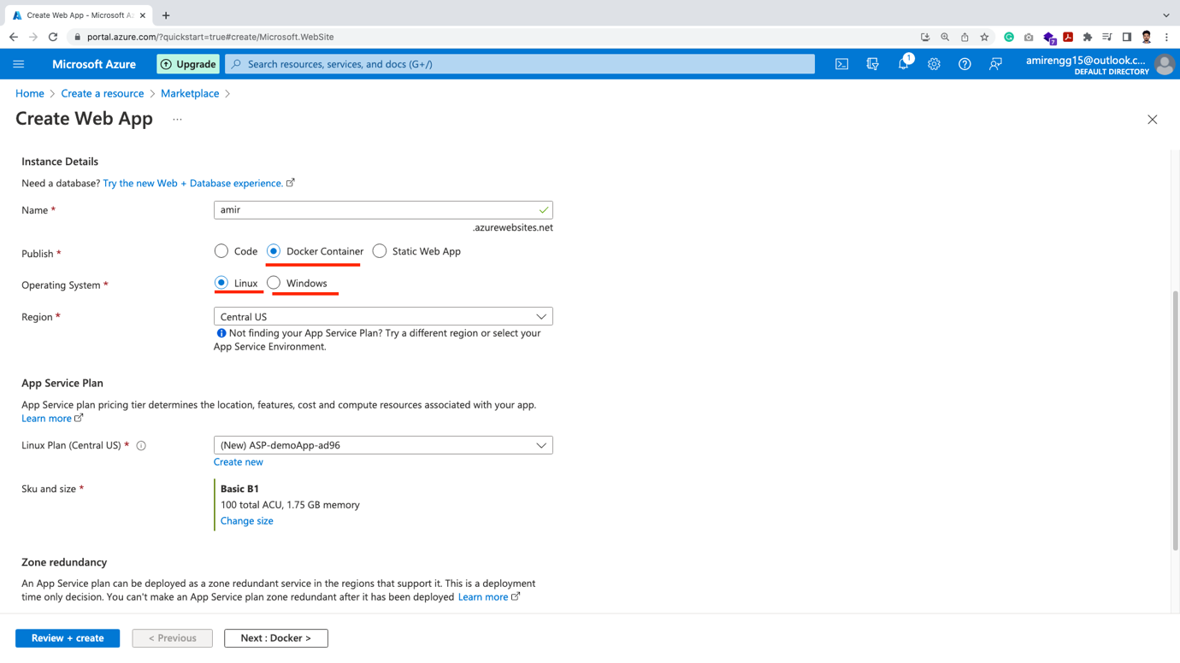

1. Static Website:

🡪 Suppose if we have a static application eg. Portfolio, we can use this option

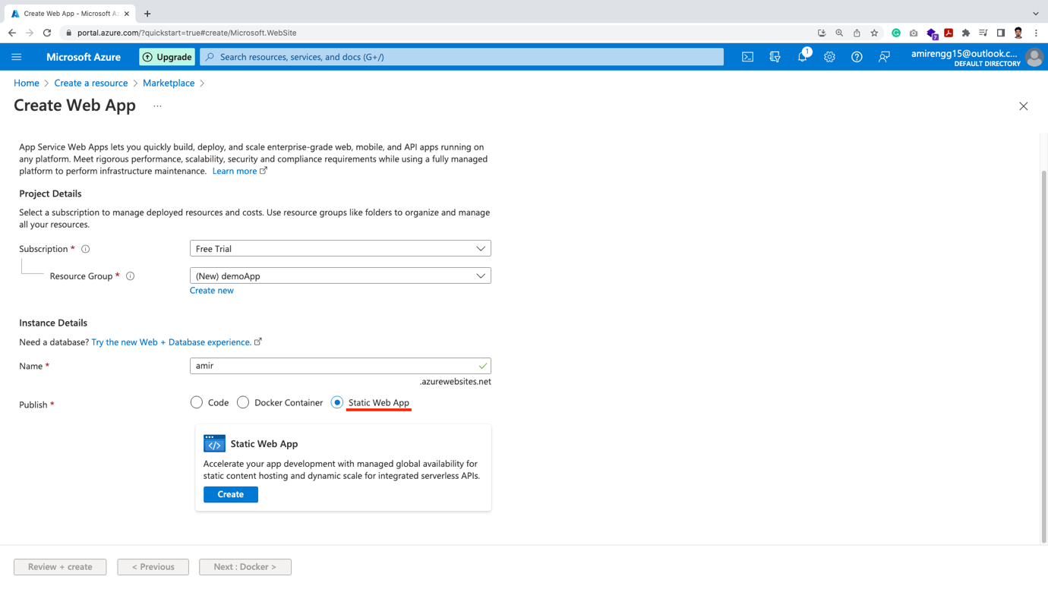

🡪 Let us chose Code, Node 18 (first option and proceed)

🡪 Next couple of options are there like Deployment (for CI/CD), networking, tags, that can be configured or proceed with default settings.

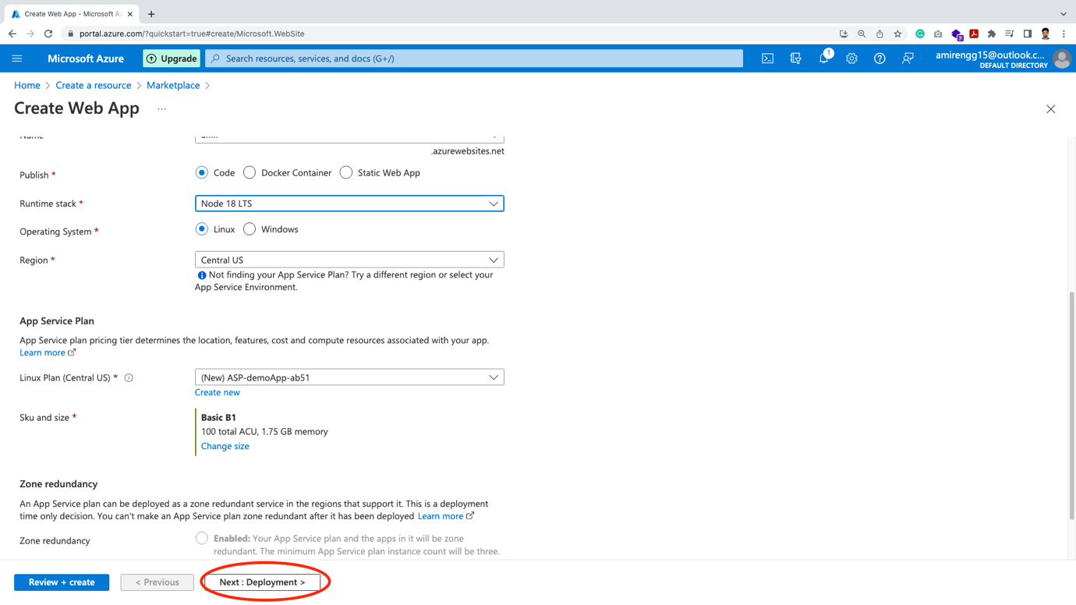

🡪 In deployment, we basically asks for Github linking, can be conjured later.

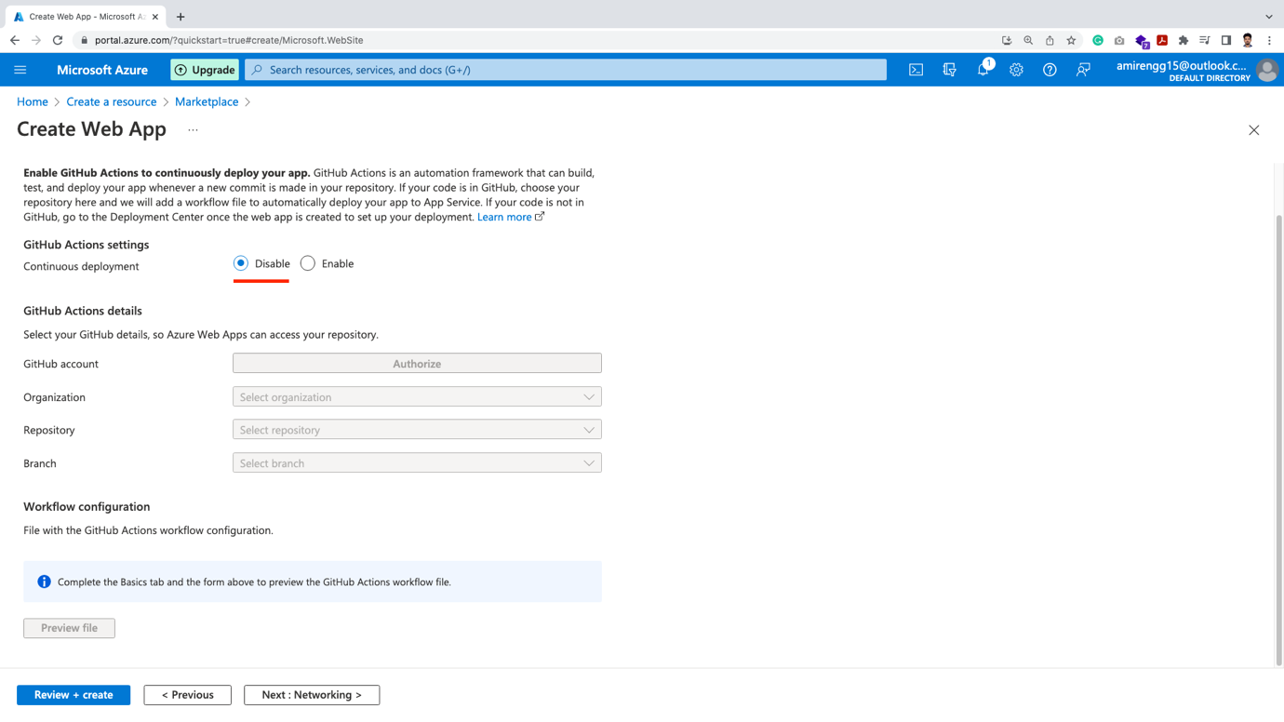

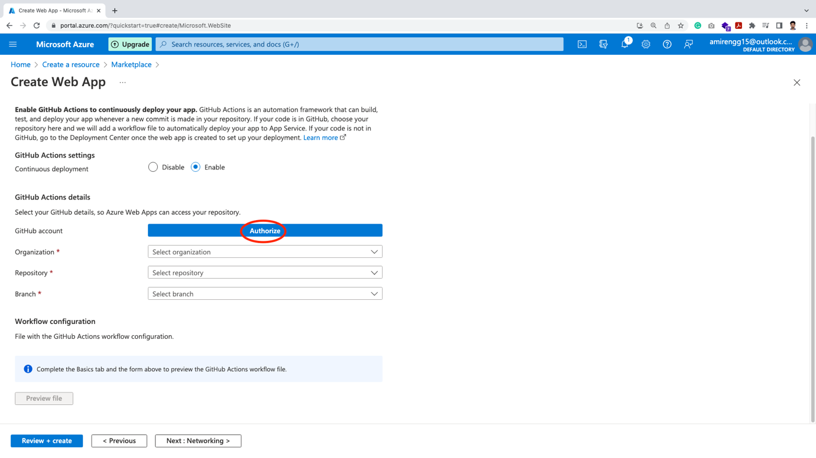

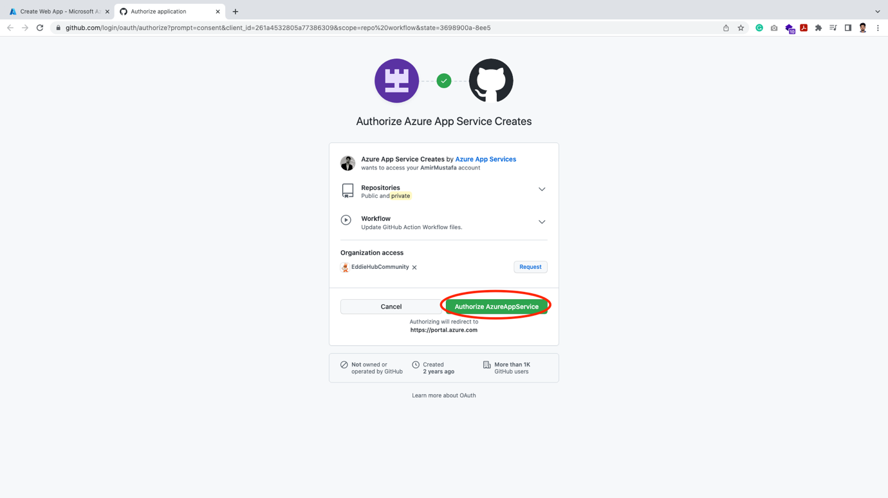

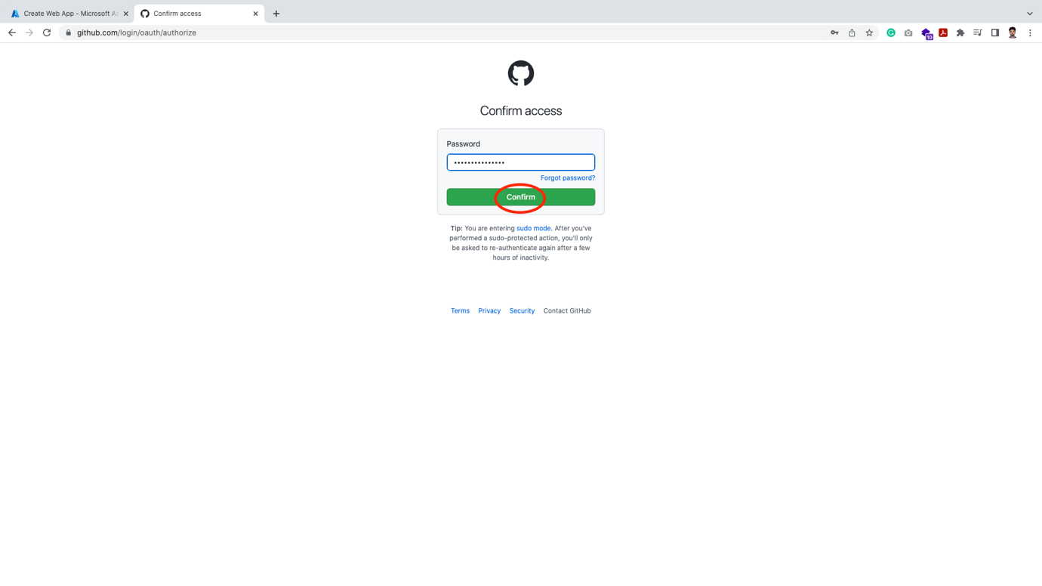

🡪 At present, we do not require this option and can continue with disabled options

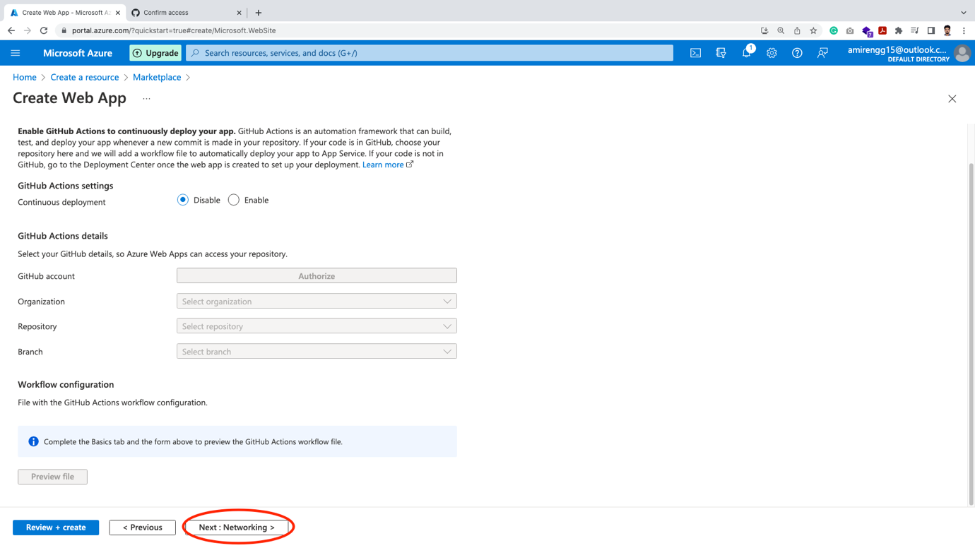

🡪 Click Next in Networking

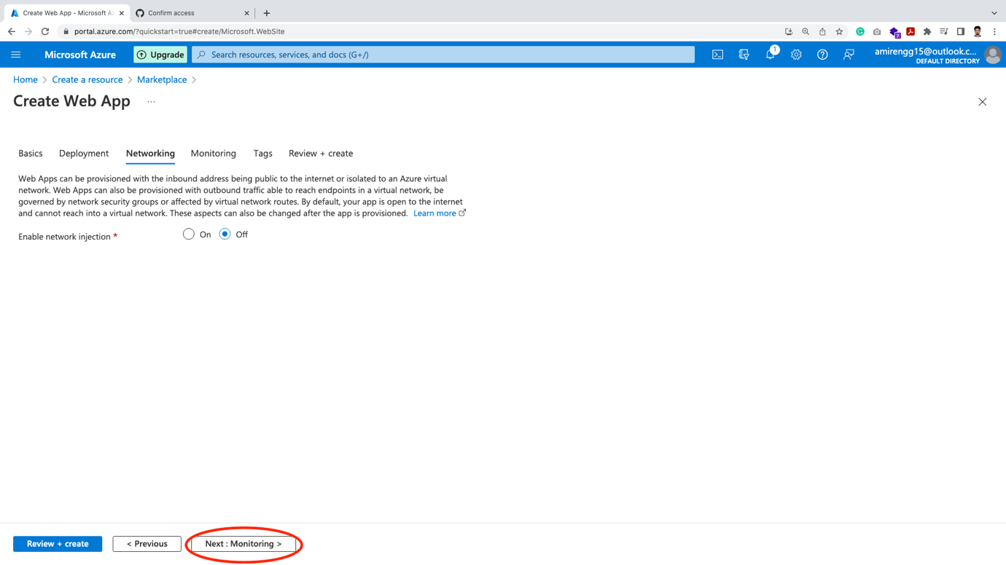

🡪 Monitoring options:

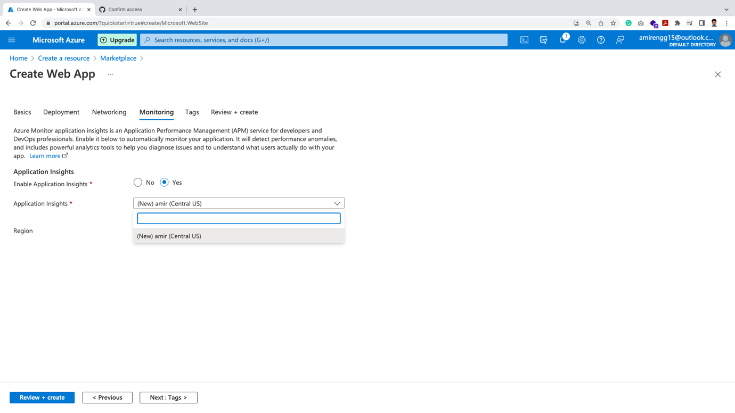

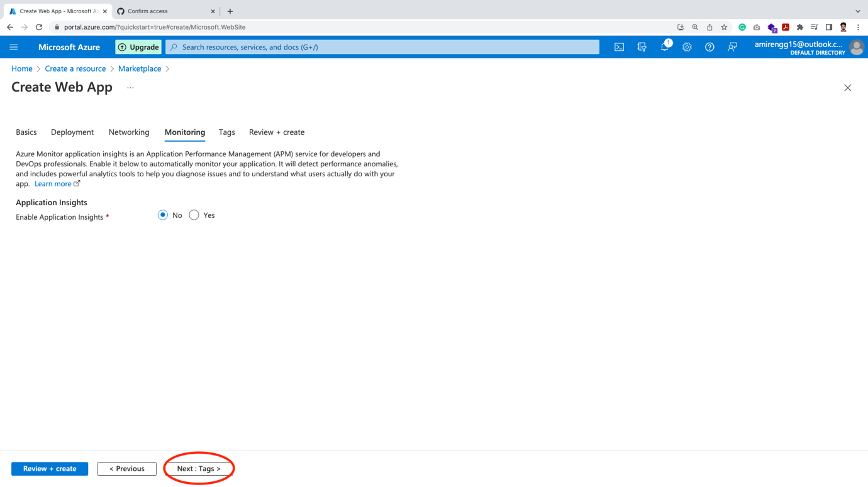

🡪 Click Next for Tags:

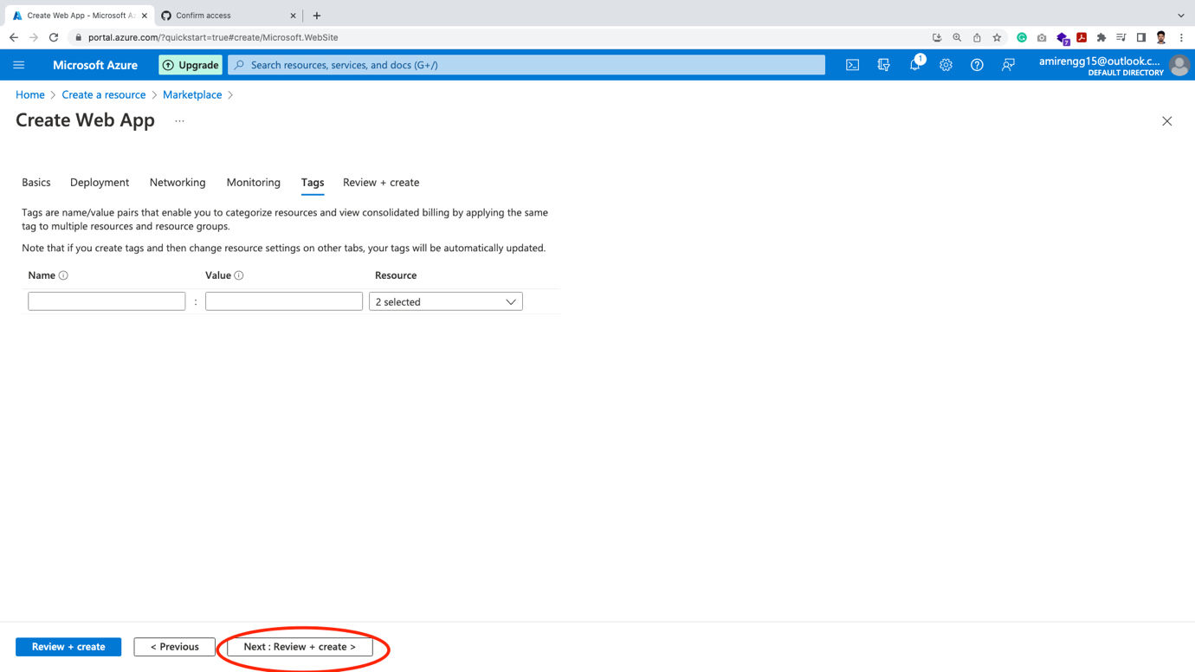

🡪 Finally in review page, we should review all selected configurations 🡪 Create

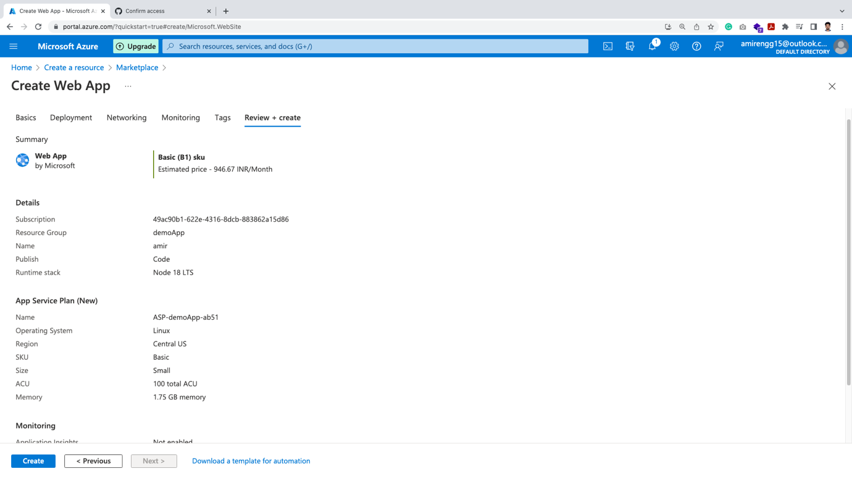

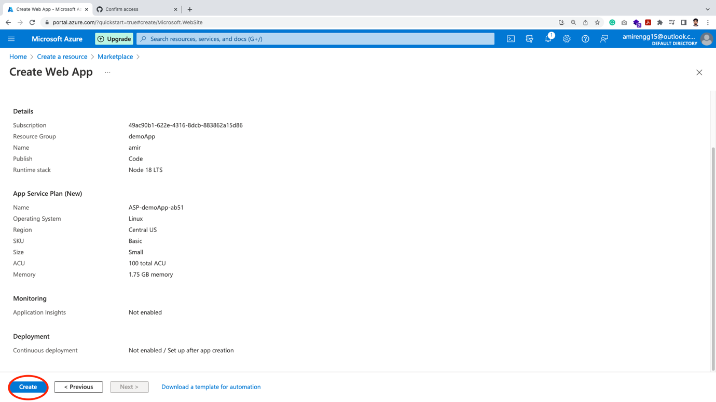

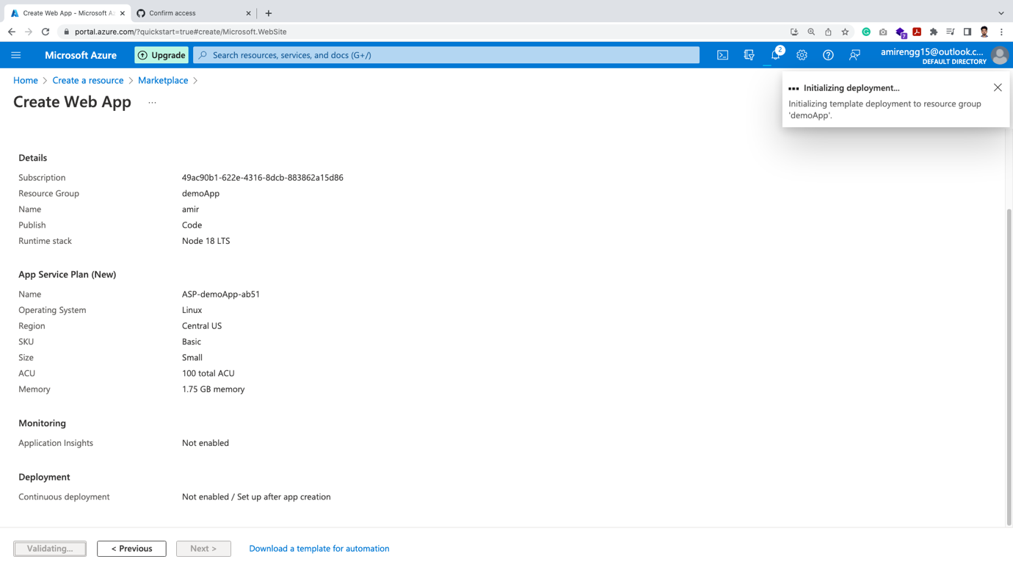

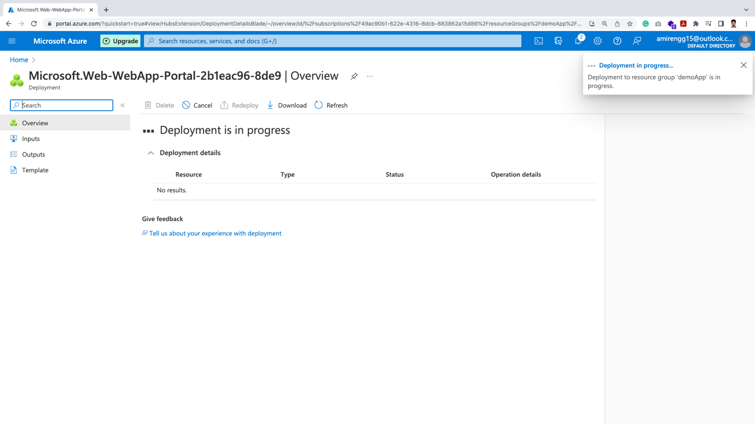

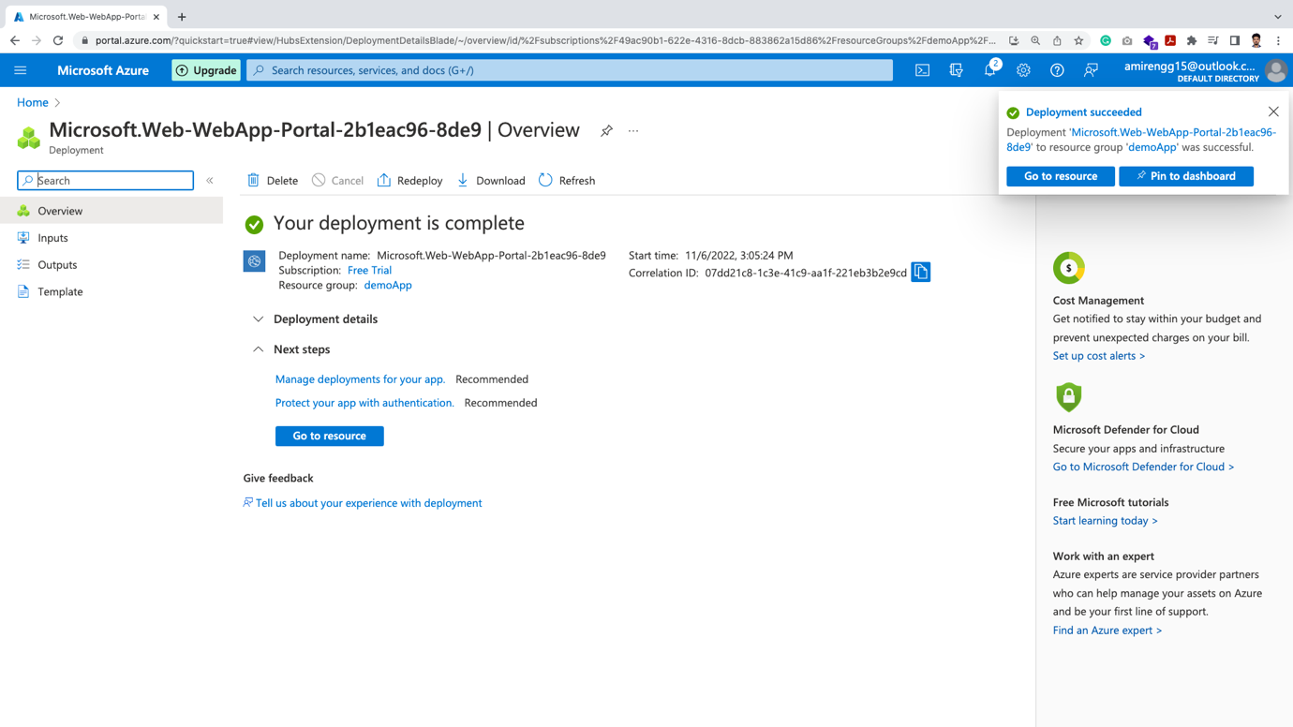

🡪 Finally our Web App deployment is complete. Click Go to resource

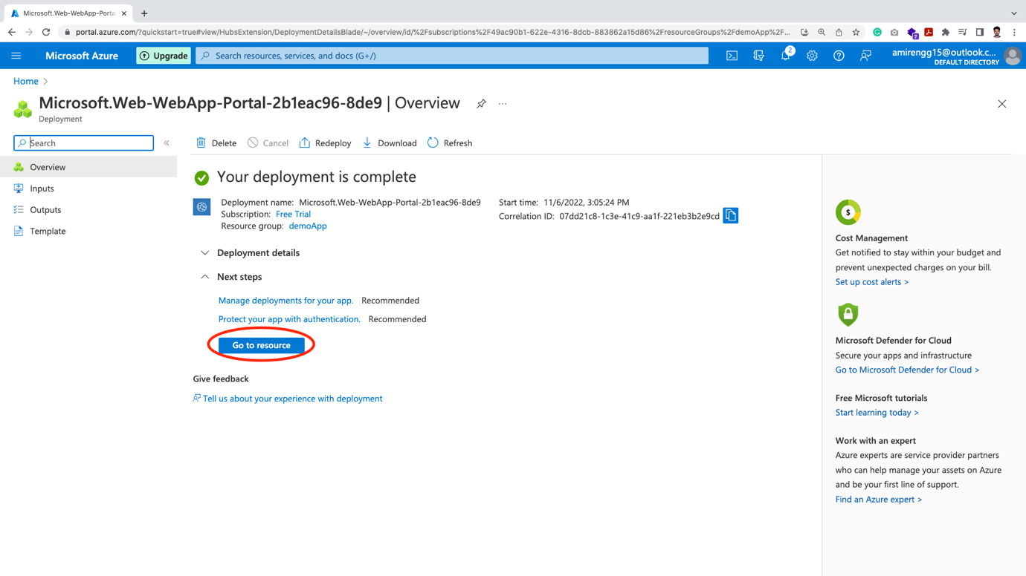

🡪 We get our URL

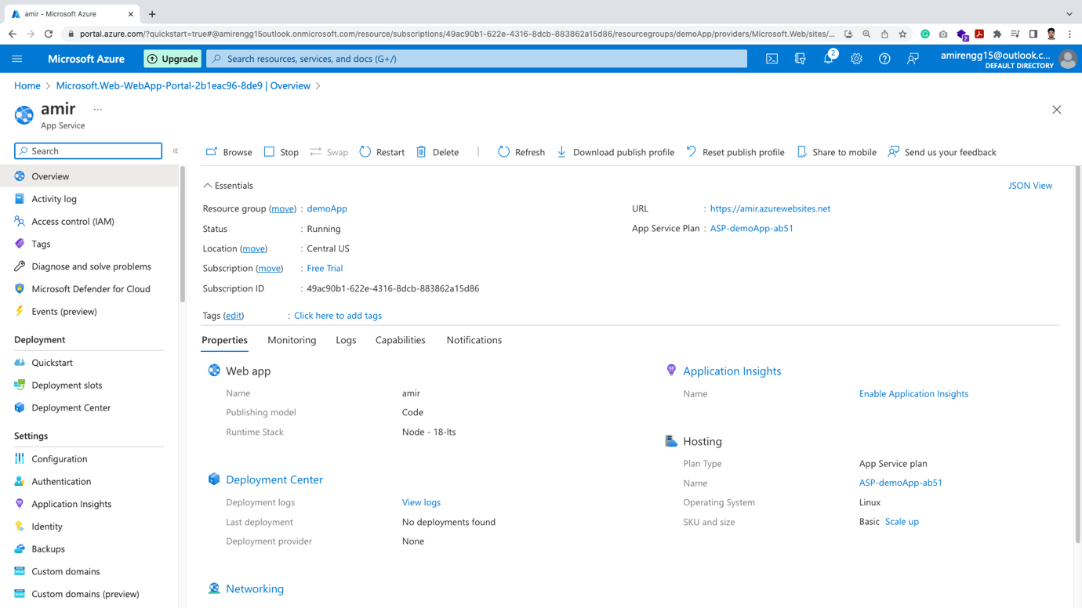

🡪 Name of the app displays, plus lots of monitoring or configuring tool

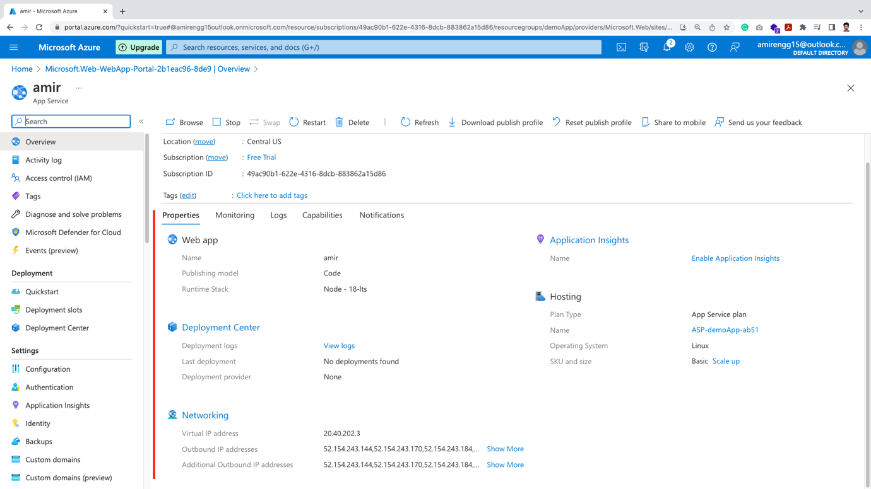

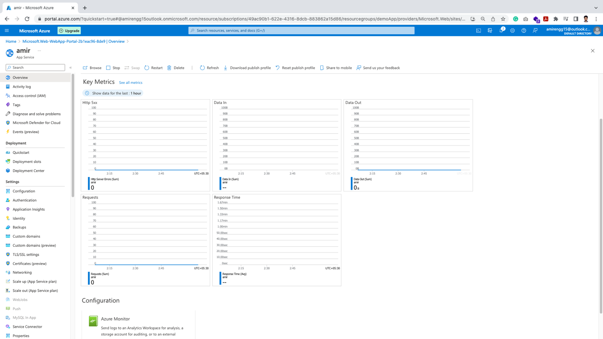

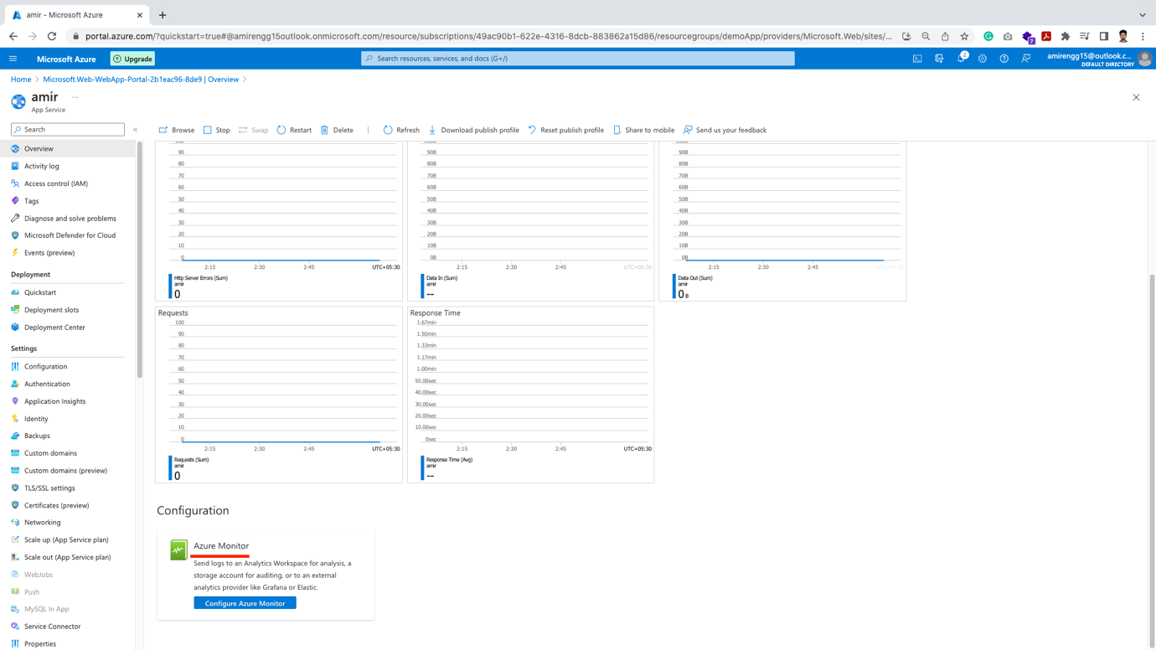

Logs Tab:

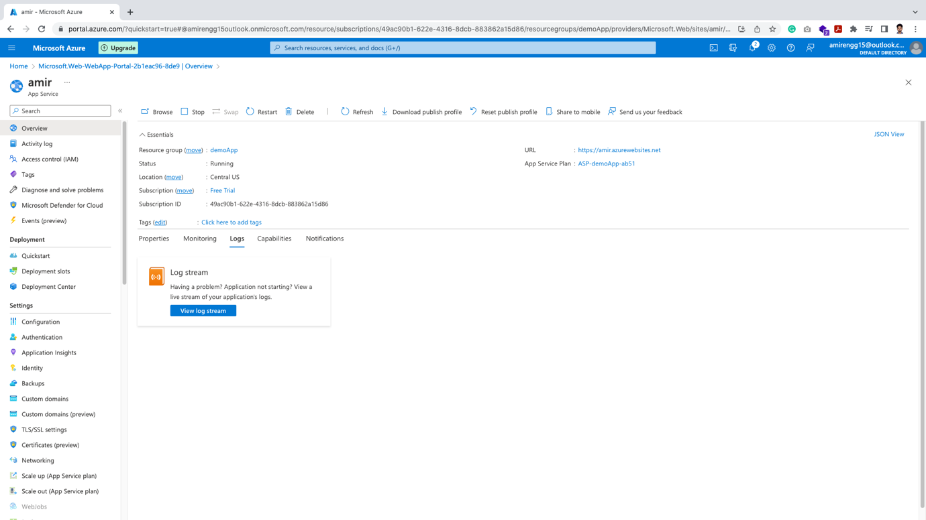

🡪Deployments tab:

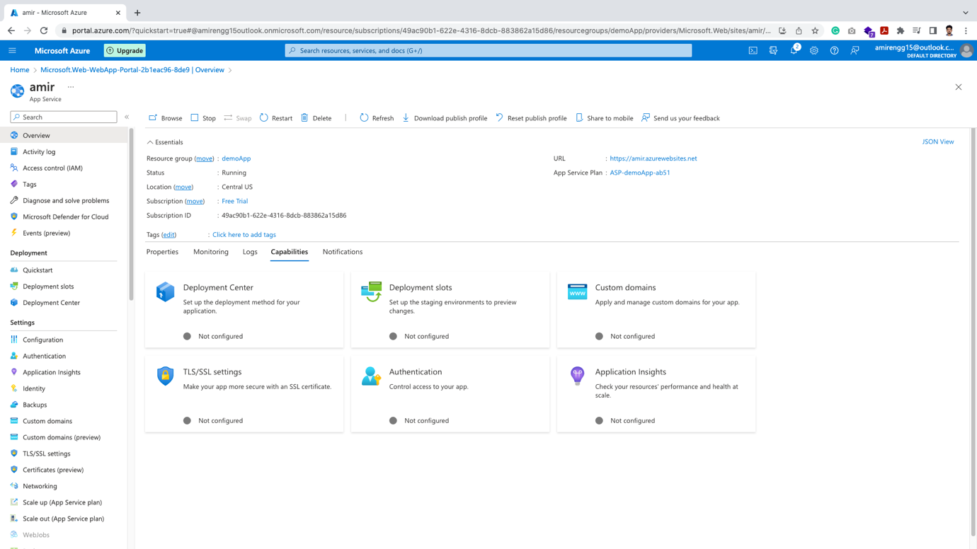

🡪 Notification Tabs (for notifications if any):

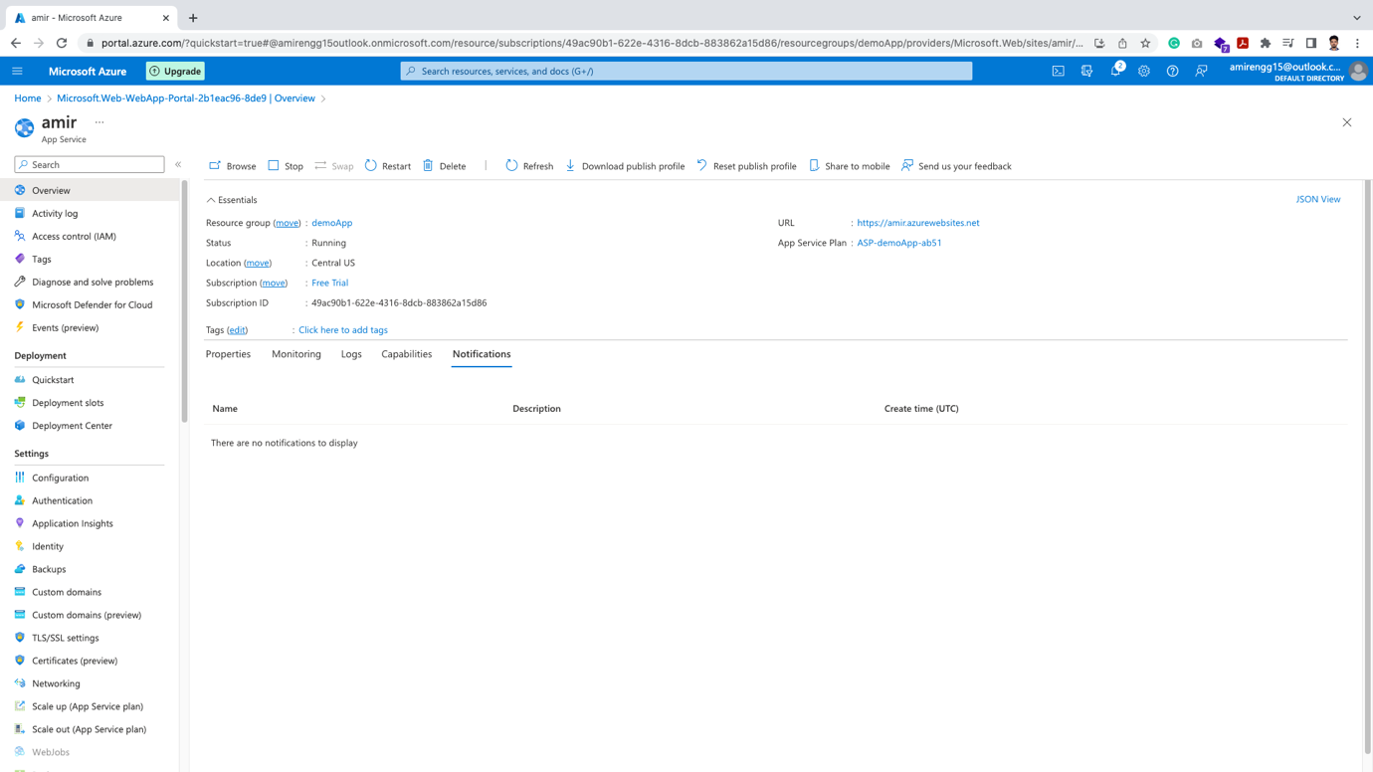

🡪 Let us click the URL to open default homepage of app:

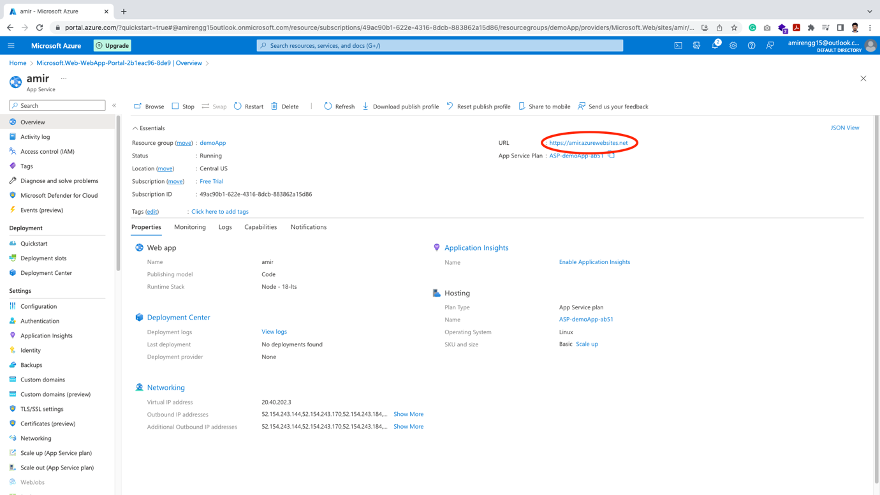

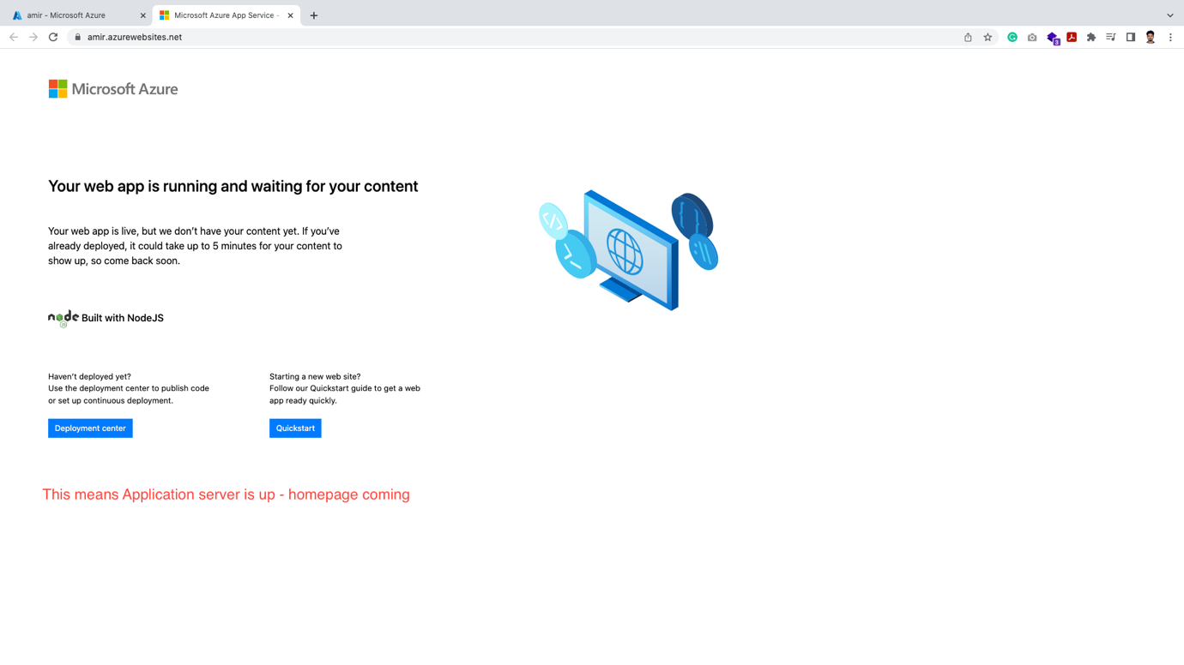

Scale Up:

🡪 Once our application is up and suppose traffic in app increases.

🡪 We can scale up the computer easily from App itself

🡪 Click on Scale Up from left hand side:

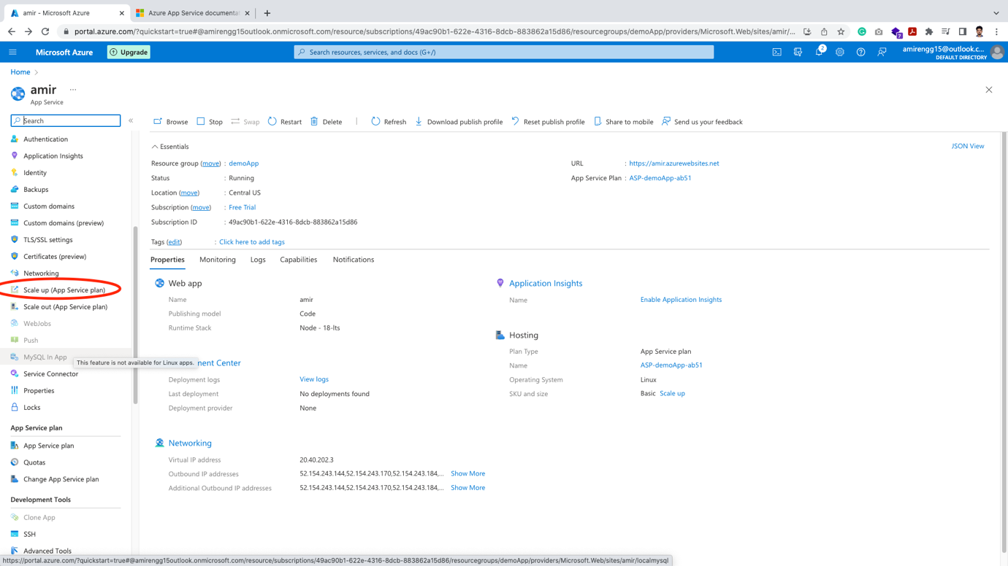

🡪 Normally it has three modes: Dev, Production and Isolate mode.

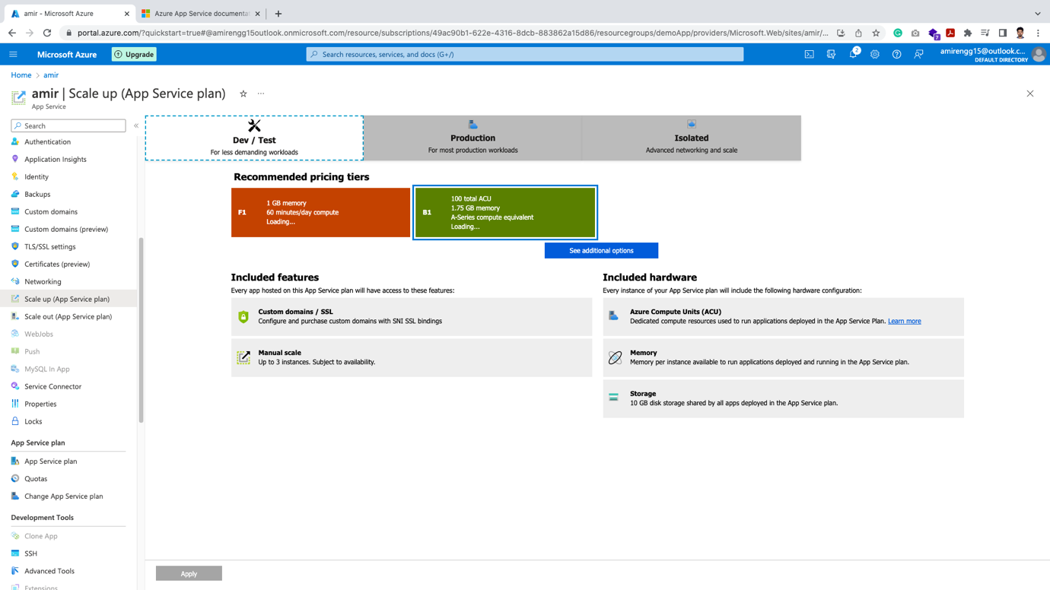

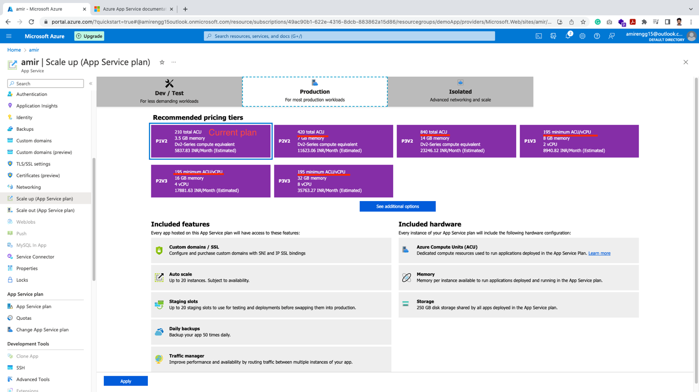

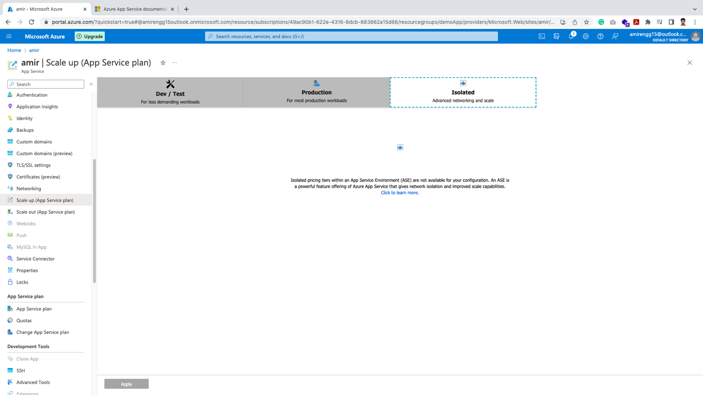

Scale Out:

This means we start the second or third or forth application.

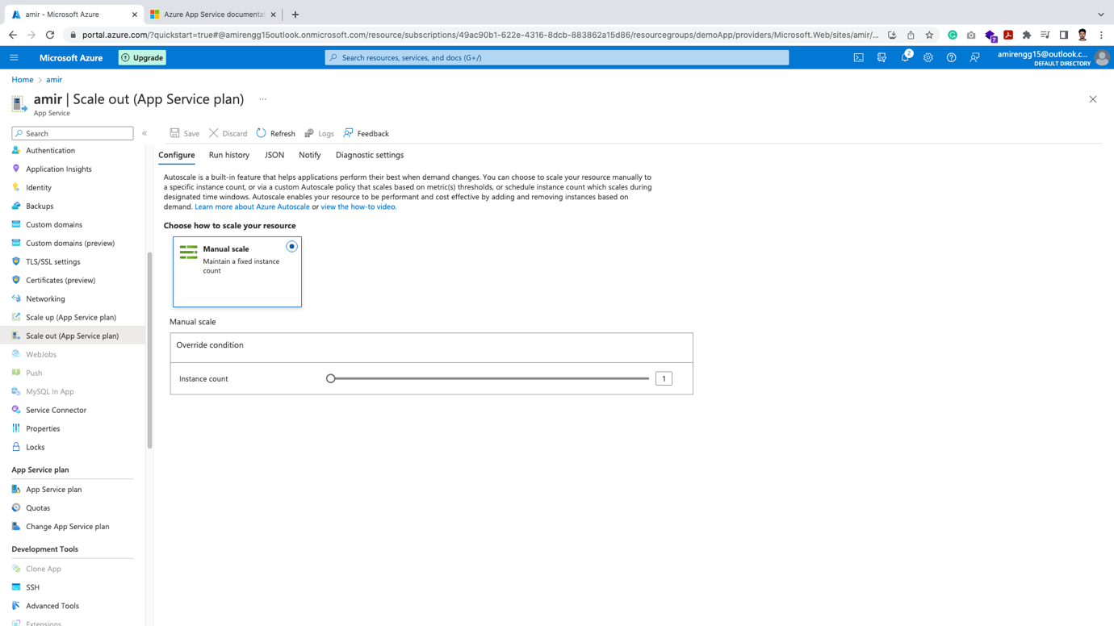

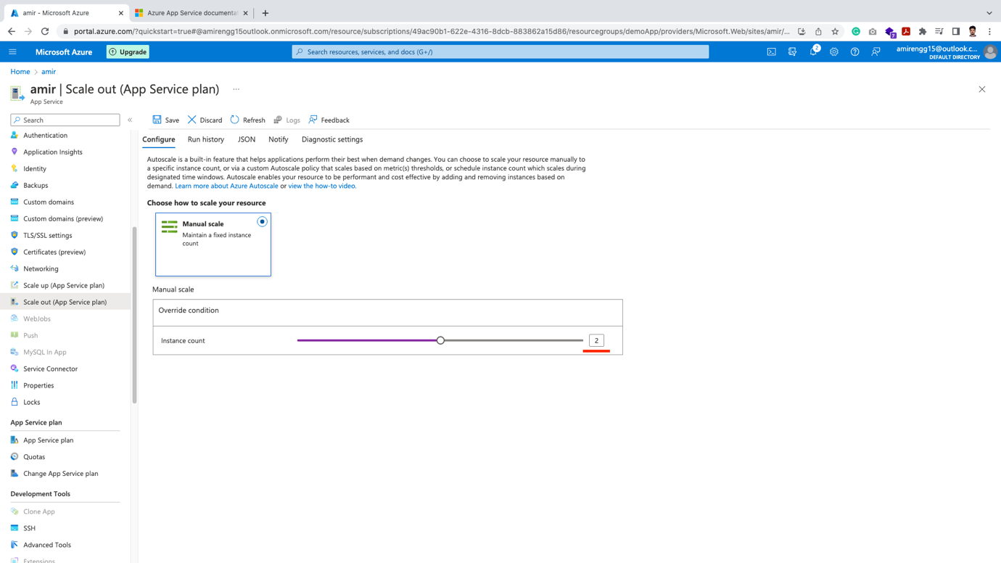

Deployment:

🡪 We have skipped deployment option at the time of App service creation, we can easily add them from left menu.

🡪 Click Quick start in Deployment section

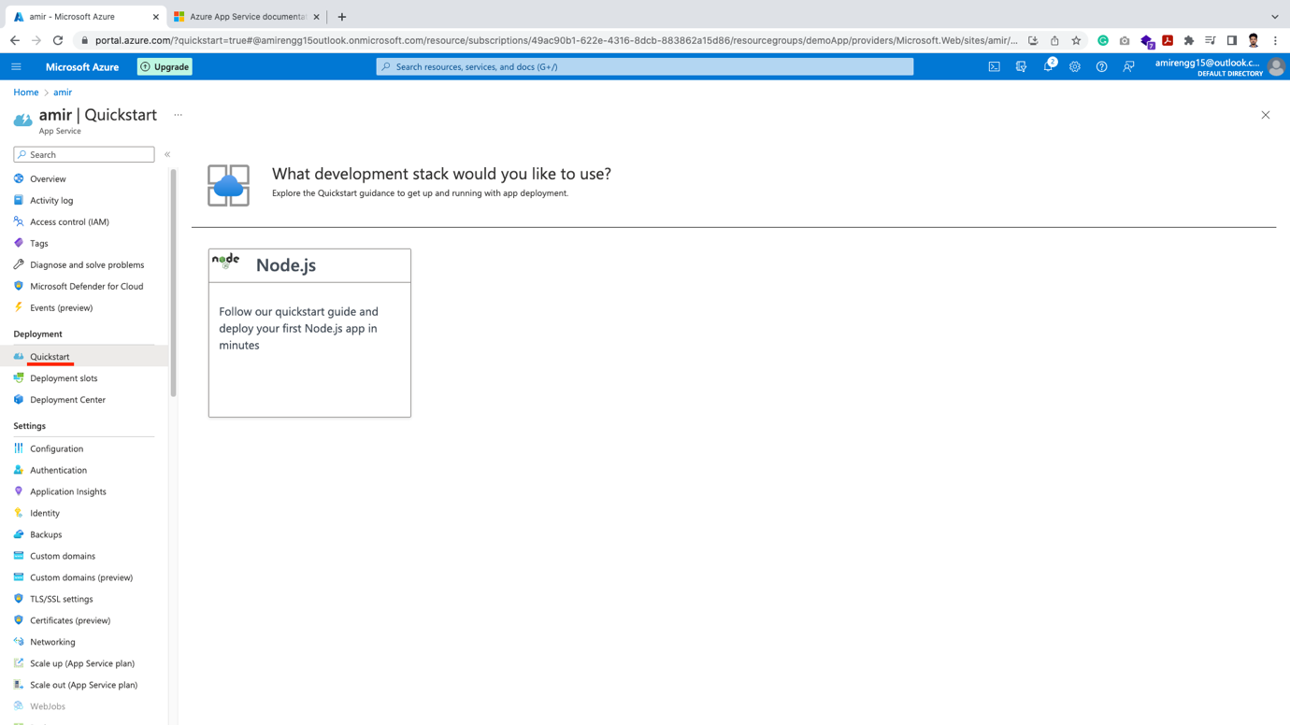

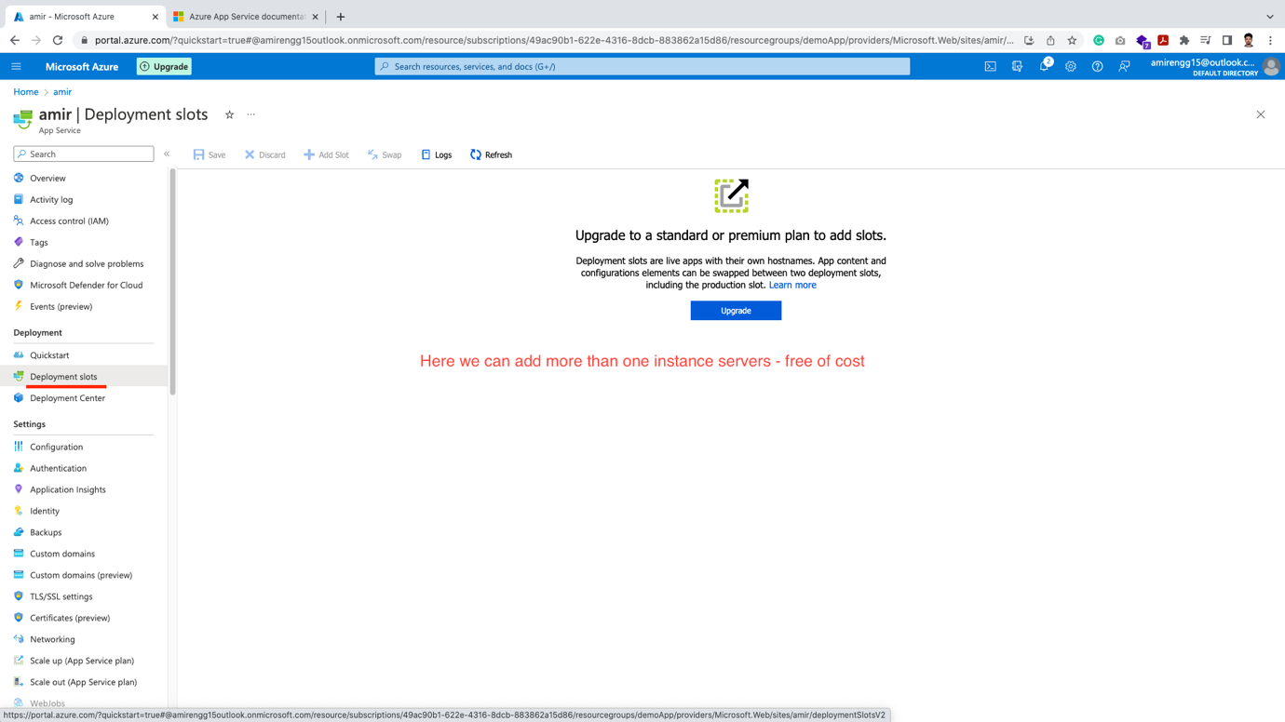

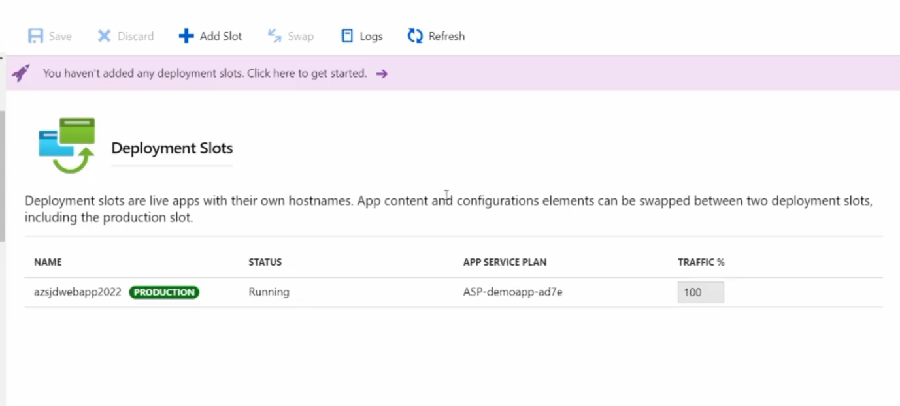

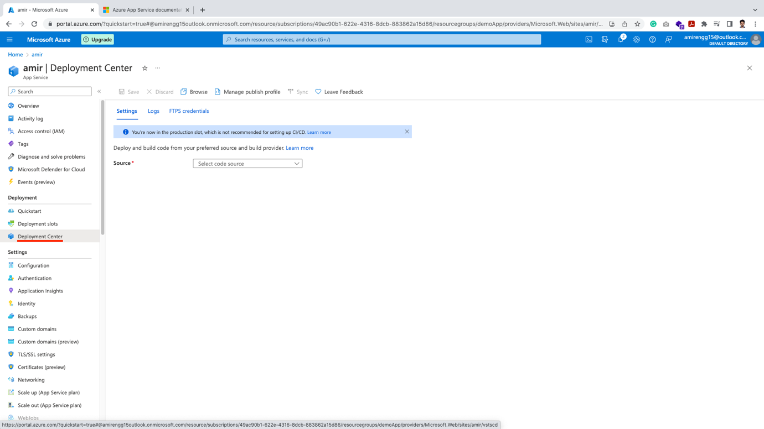

🡪 From Deployment center, we can easily add CI/CD – multiple Git repositories like GitHub

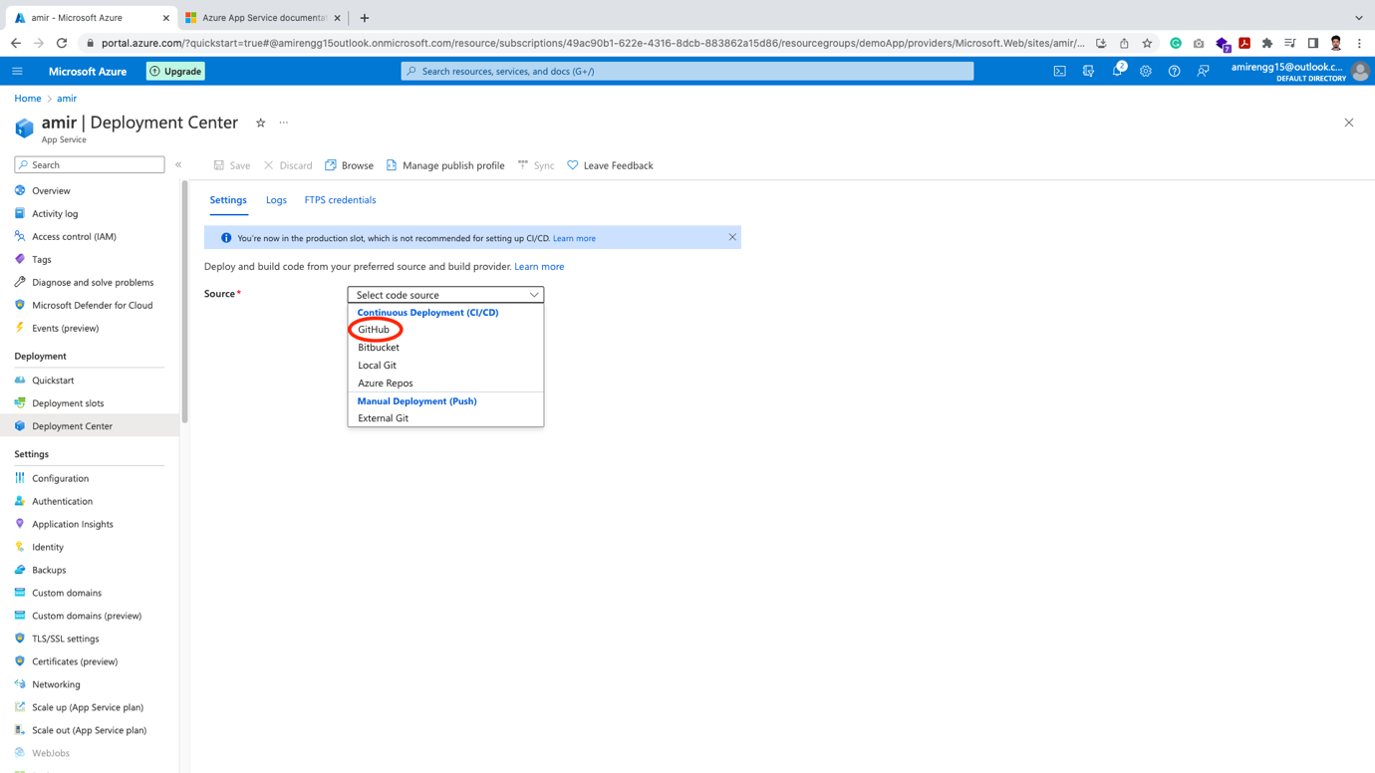

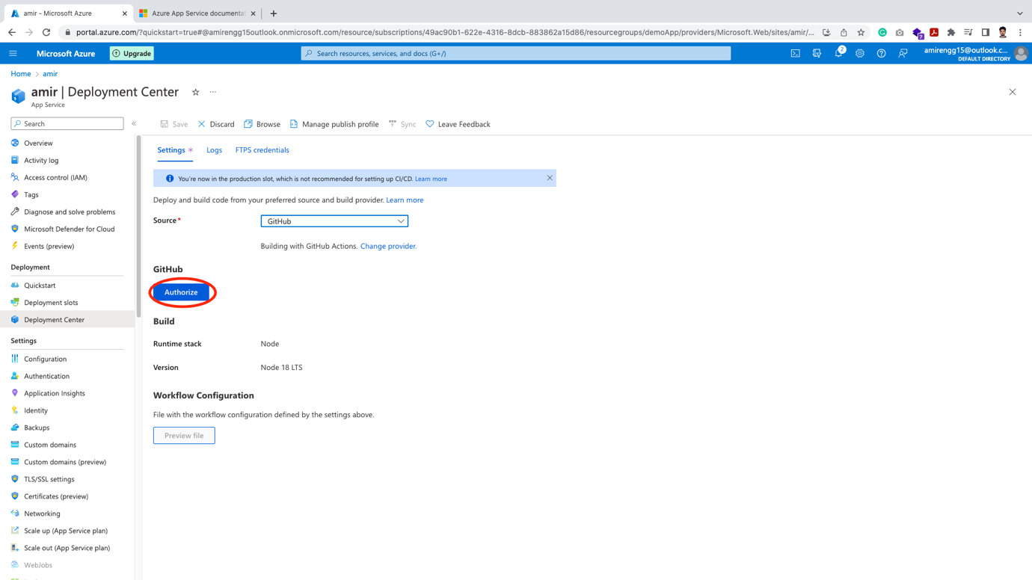

🡪 The step appears that appeared at the time of Web App creation for deployment configurations.

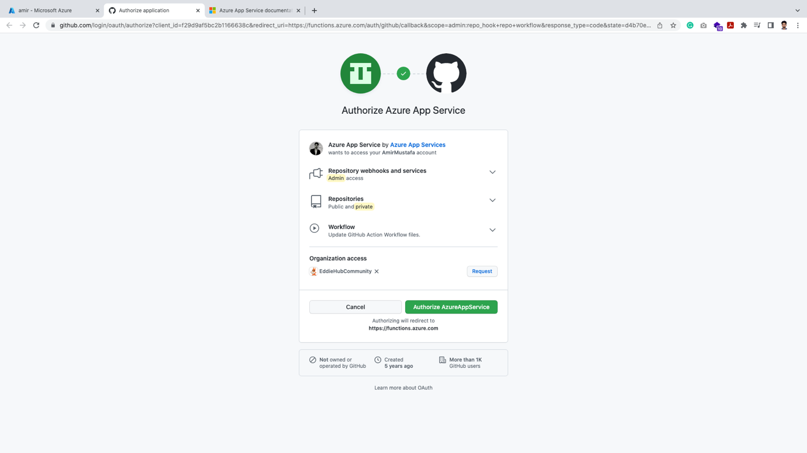

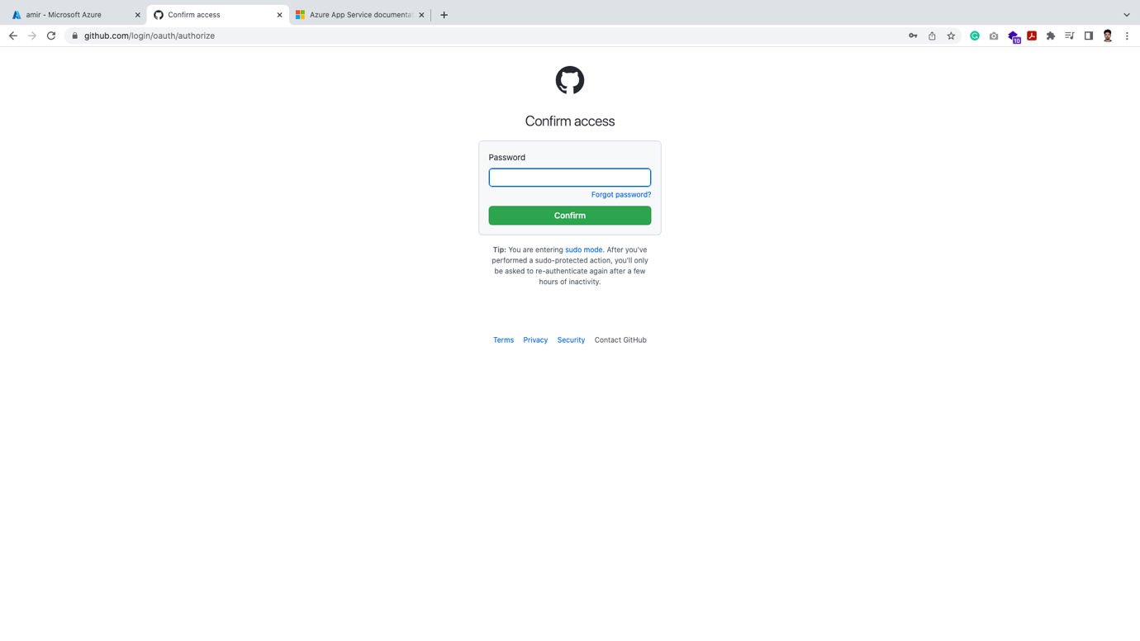

🡪 Other than that there are lots of configuration options like – backups, SSL, MySQLApp etc.

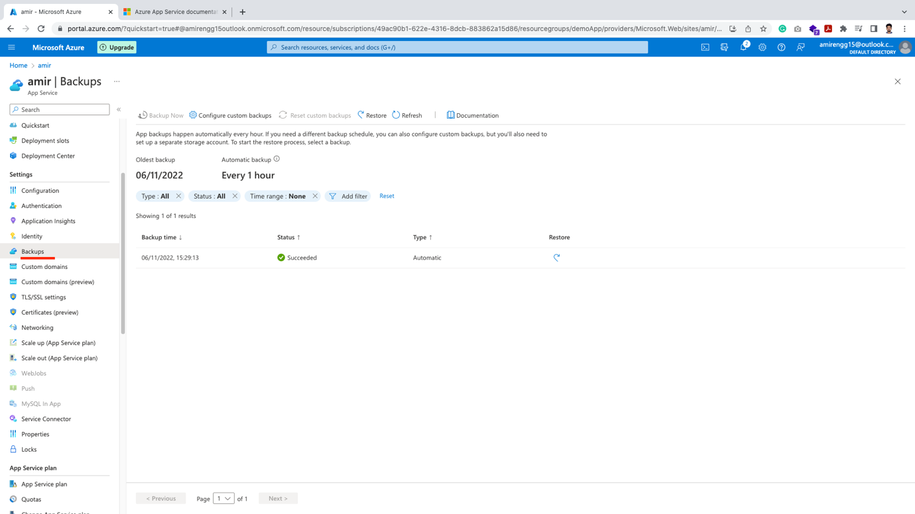

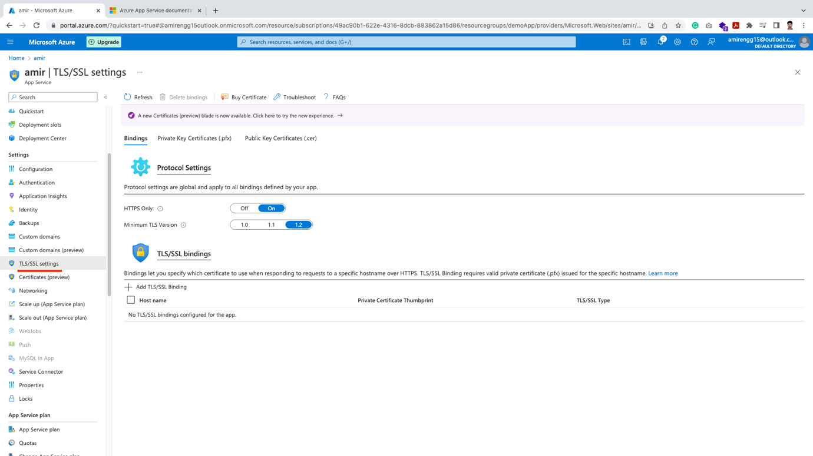

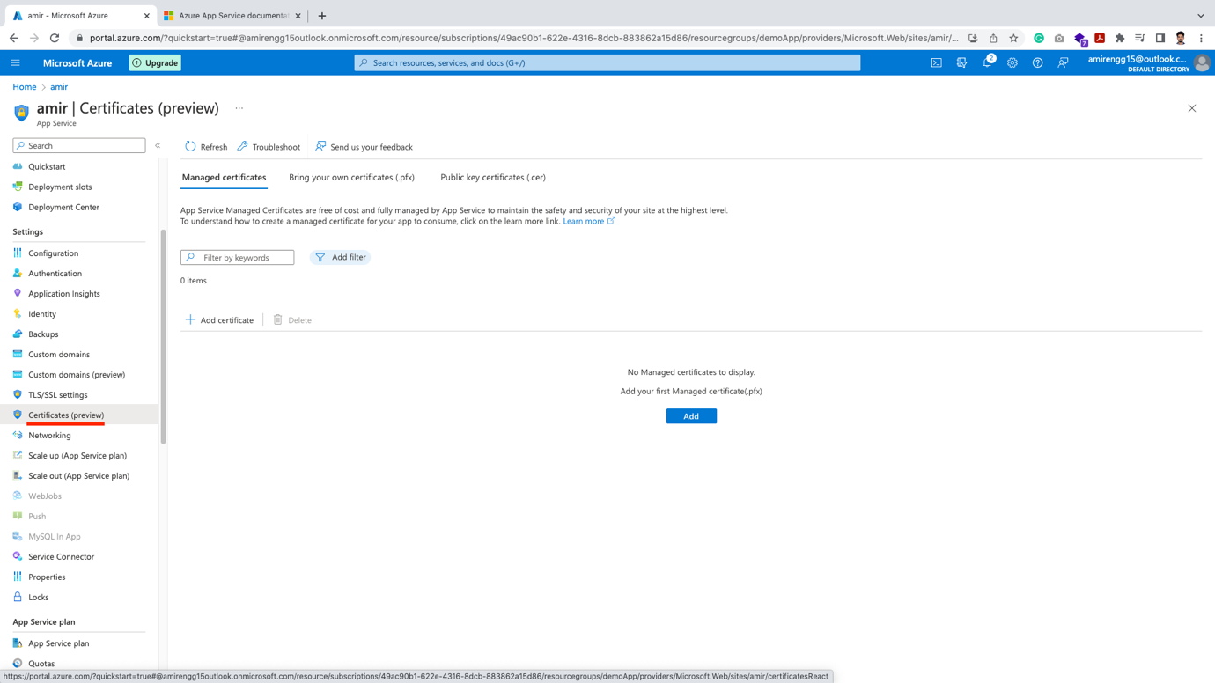

🡪 We can also current Plan subscription for the App:

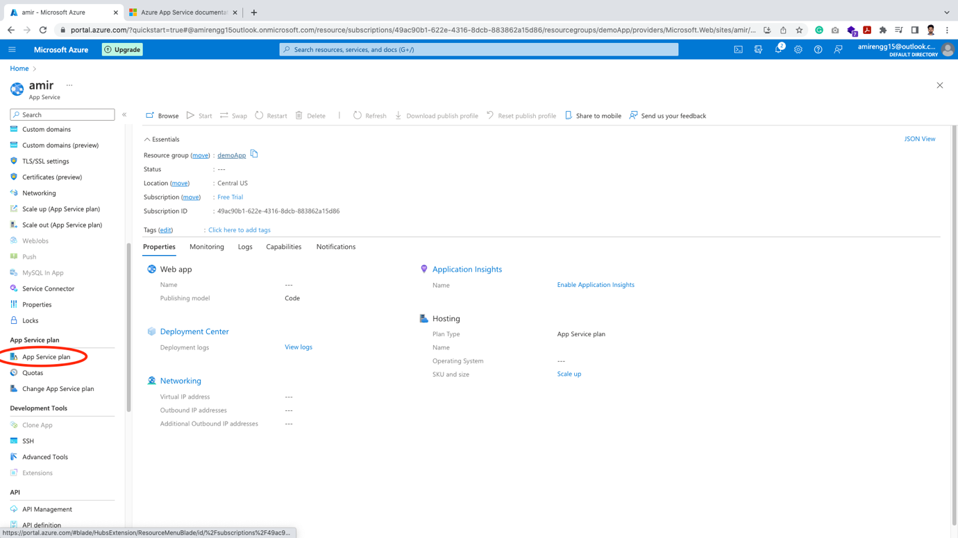

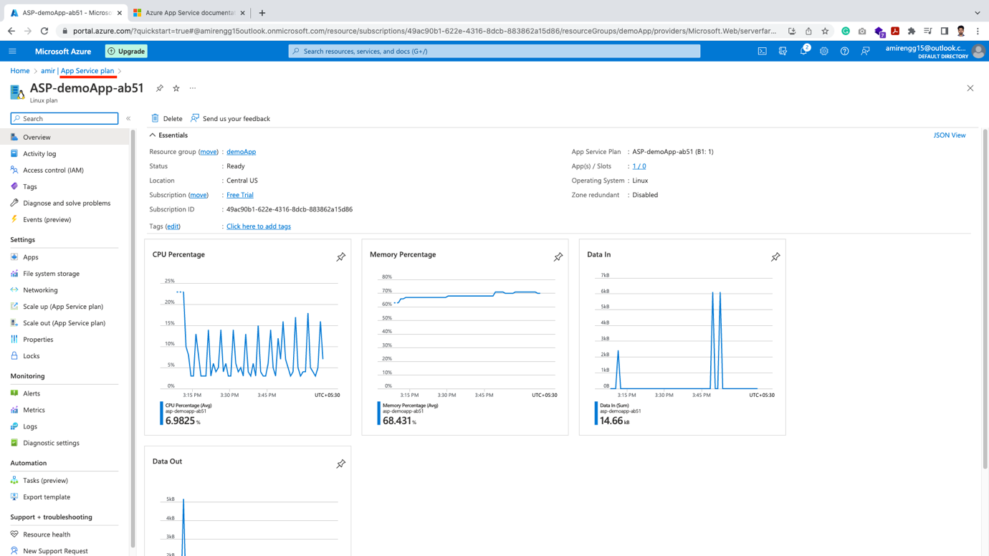

🡪 We can also configure Networking – Inbound, Outbound traffic

From this option we can configure limited options to the server or specific whitelist Microsoft Azure apps can access it.

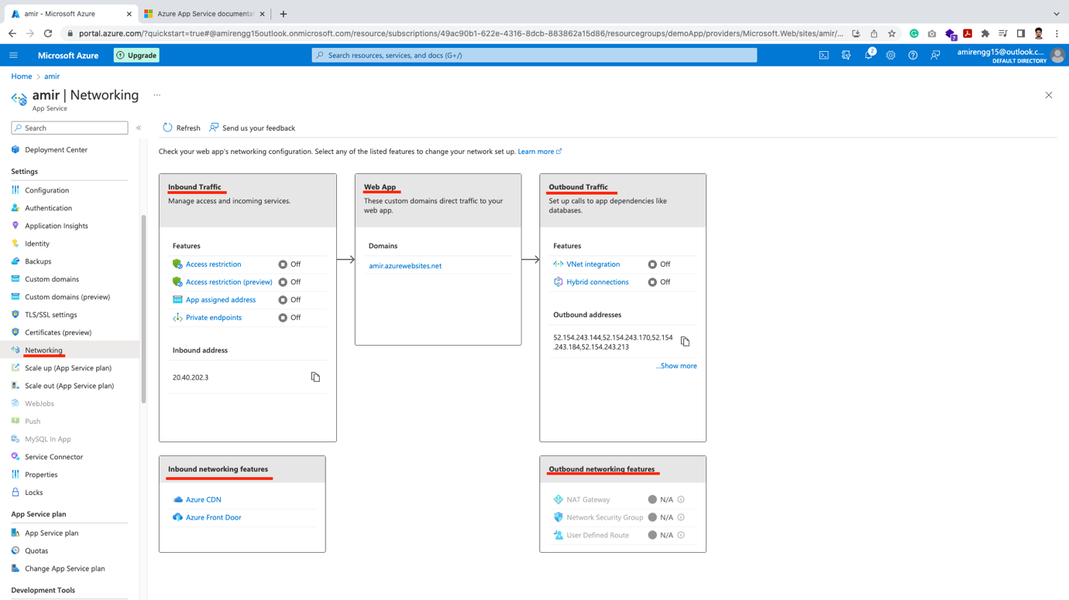

Development Options:

🡪 We can connect with SSH. Click Go.

🡪 A new tab opens and we can access terminal securely

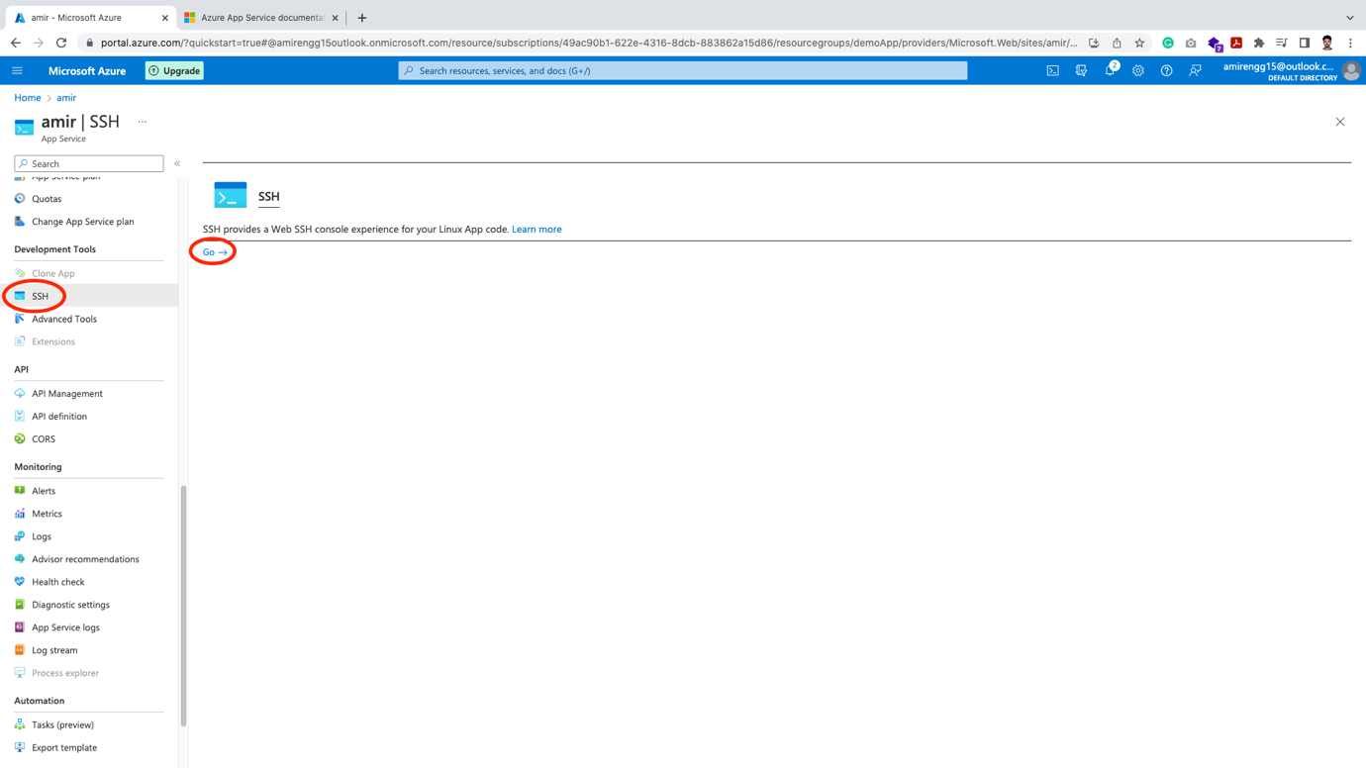

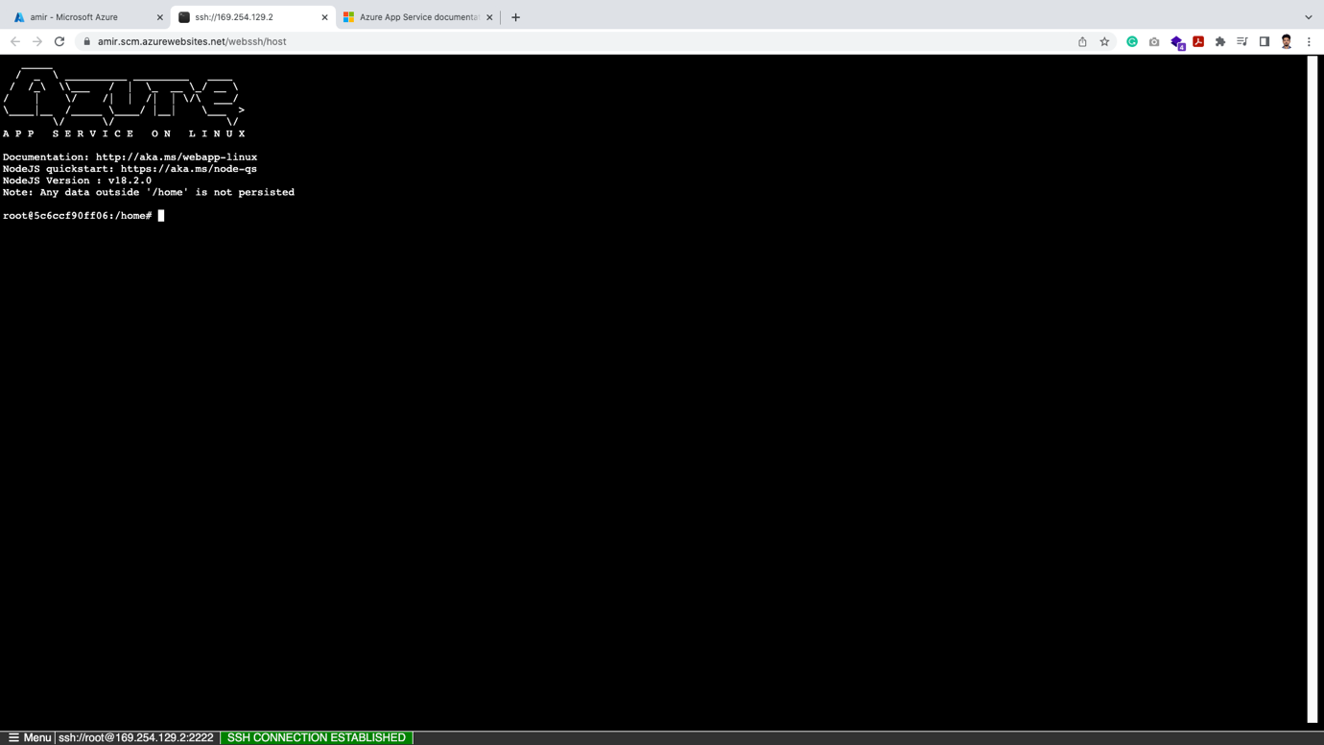

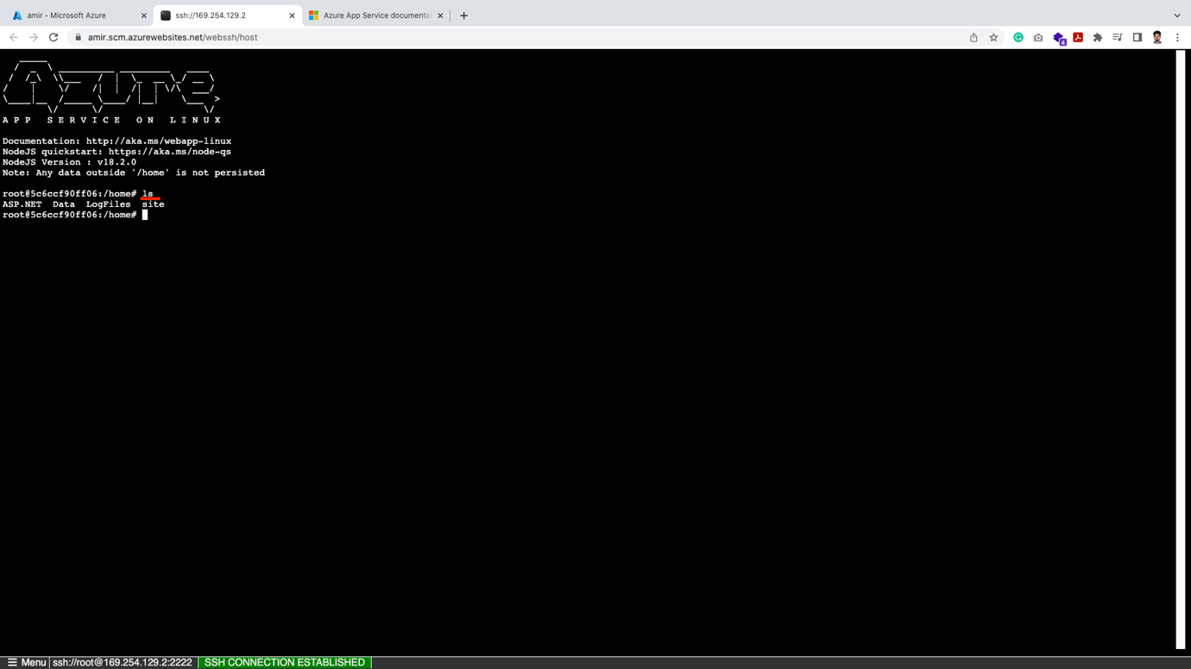

🡪 We also have other development option:

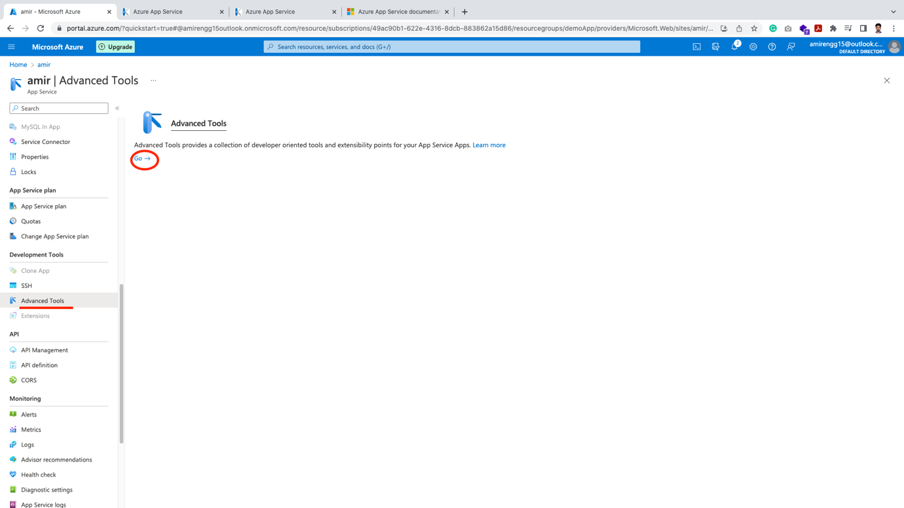

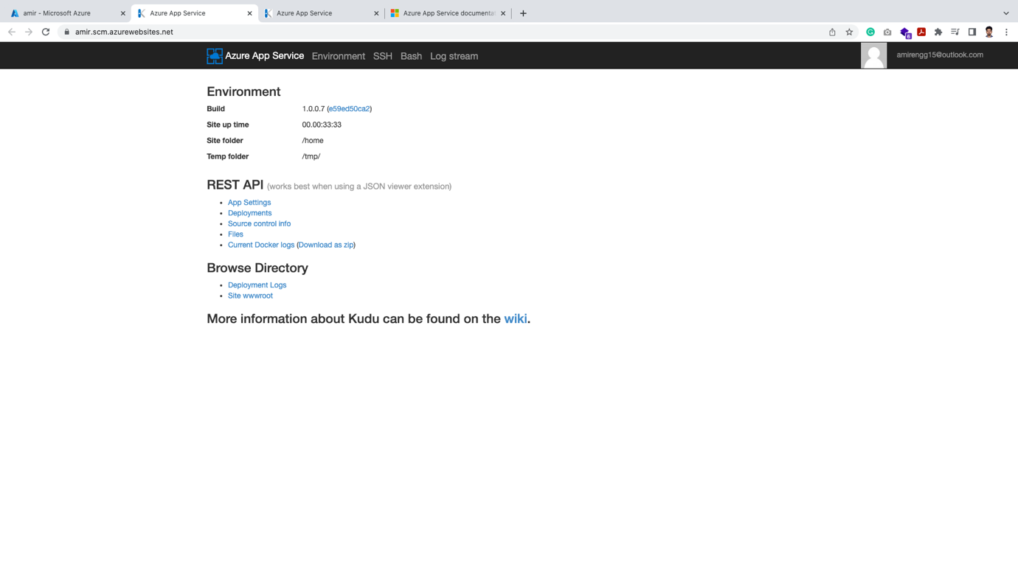

🡪 So here it is giving by default lots of service. Configuration is less controlled.

🡪 In Virtual Machine more controls were there but we have to set it up.

🡪 This is PaaS (Platform as a Service)

Deleting App Service:

🡪 Click on Delete option inside App service

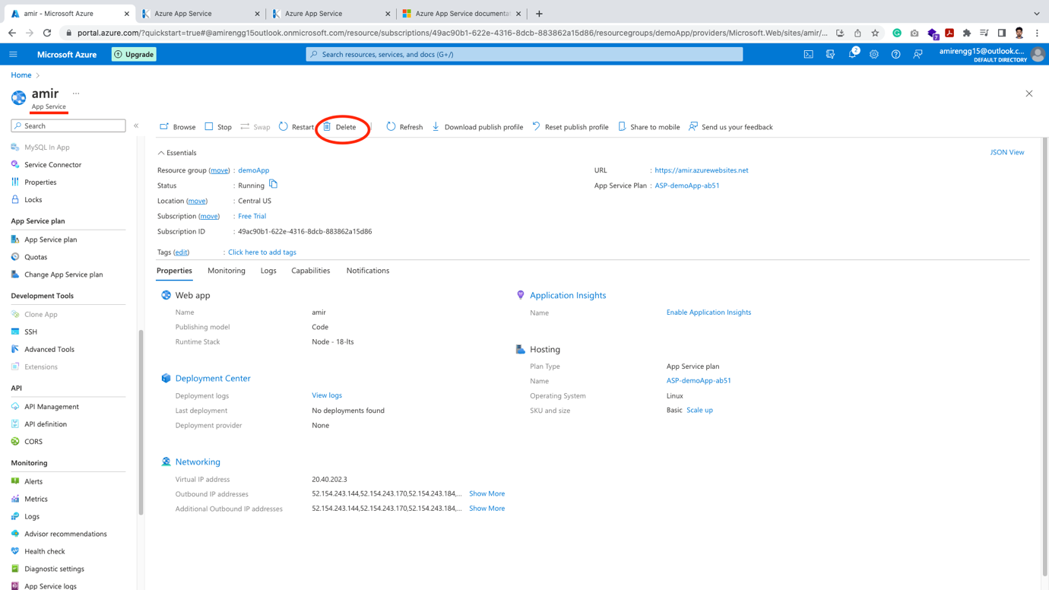

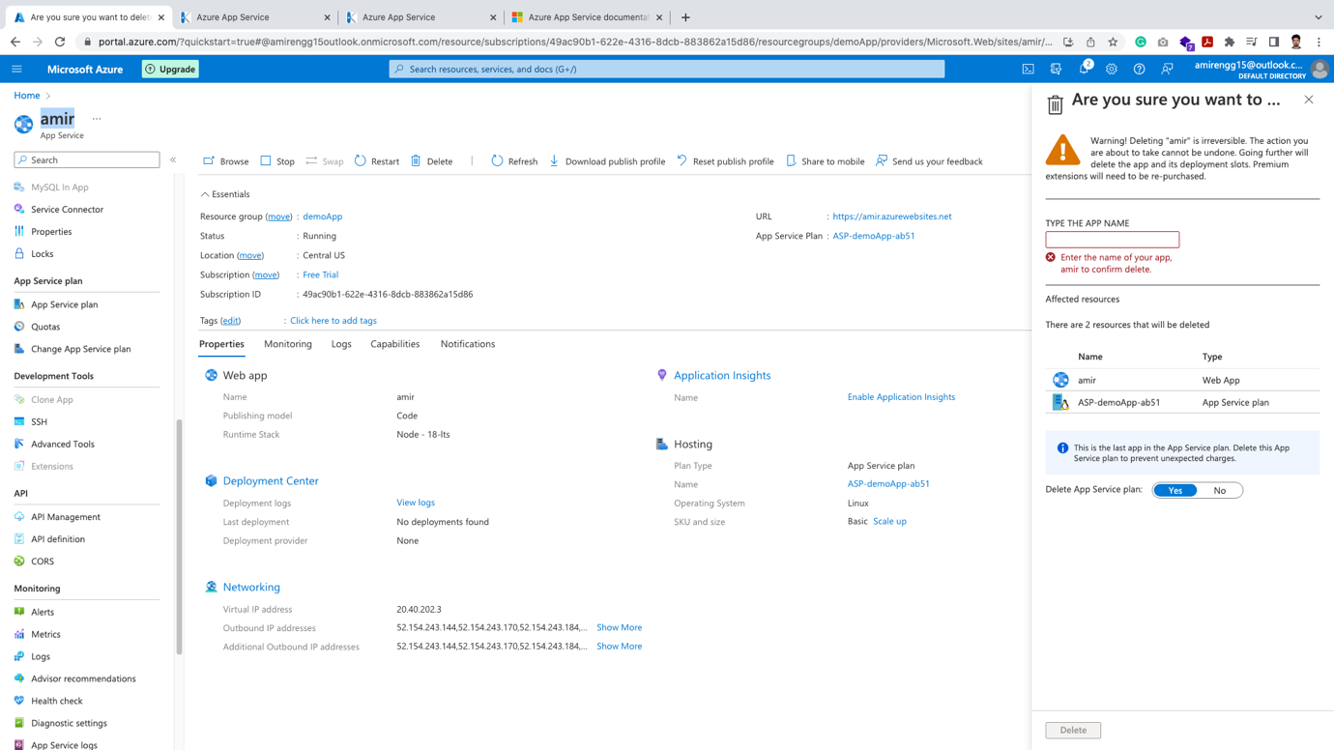

Type name of App service inside text

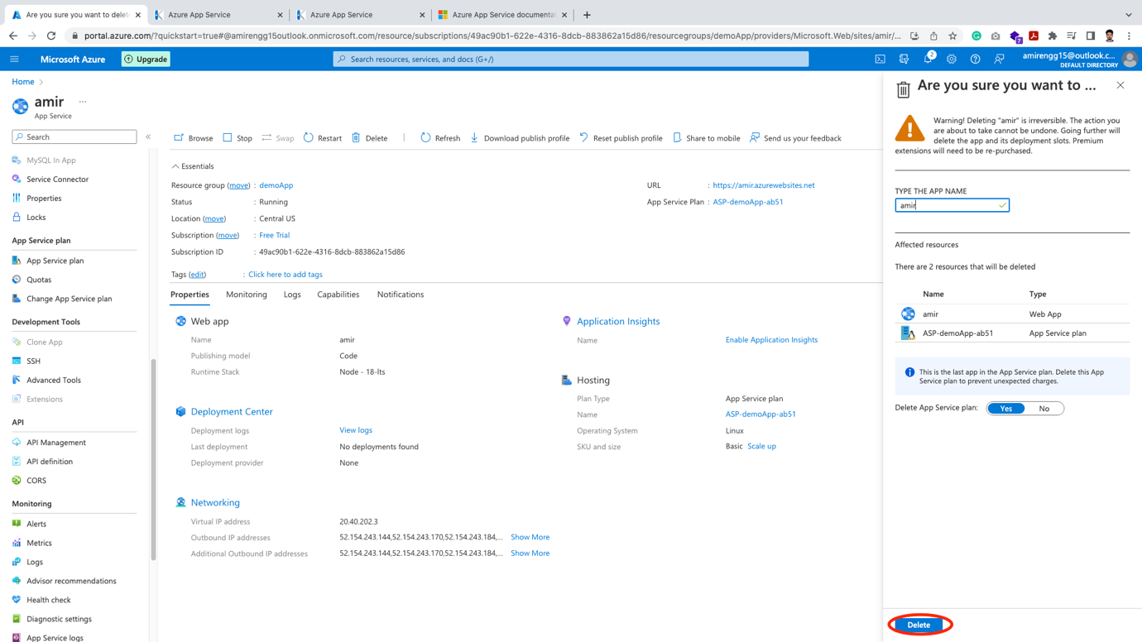

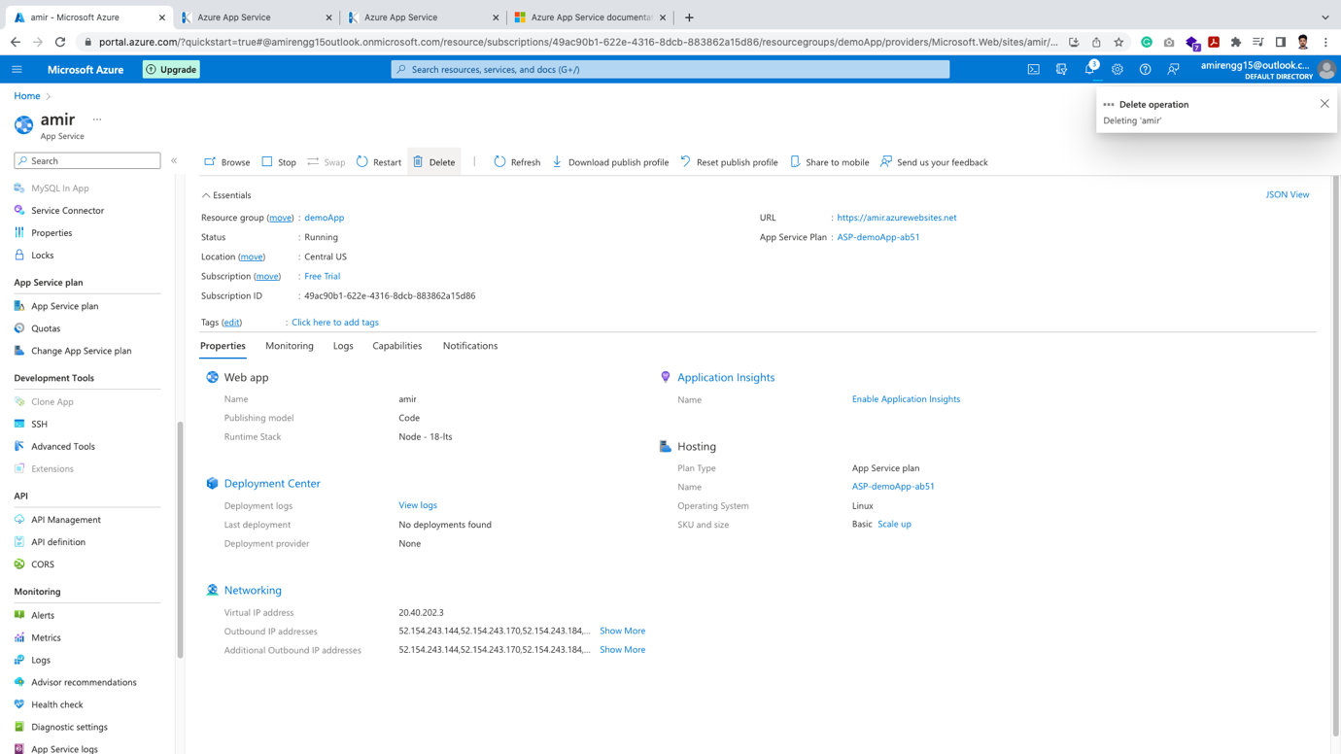

🡪 Go to All resources 🡪 Delete all unwanted resources:

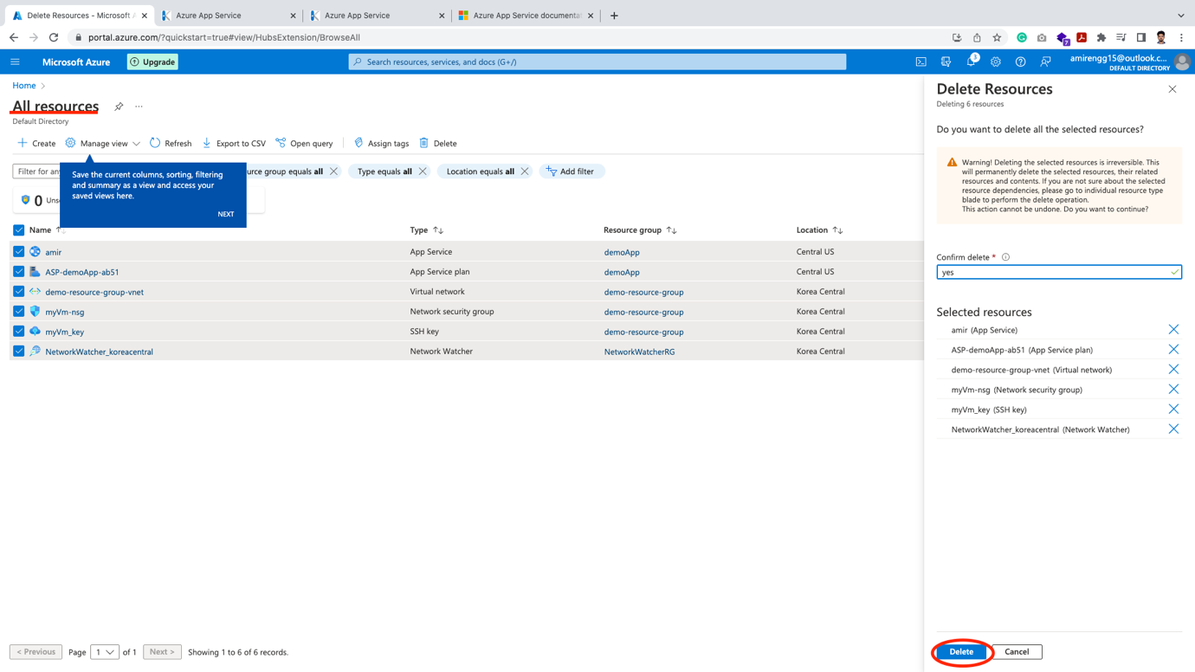

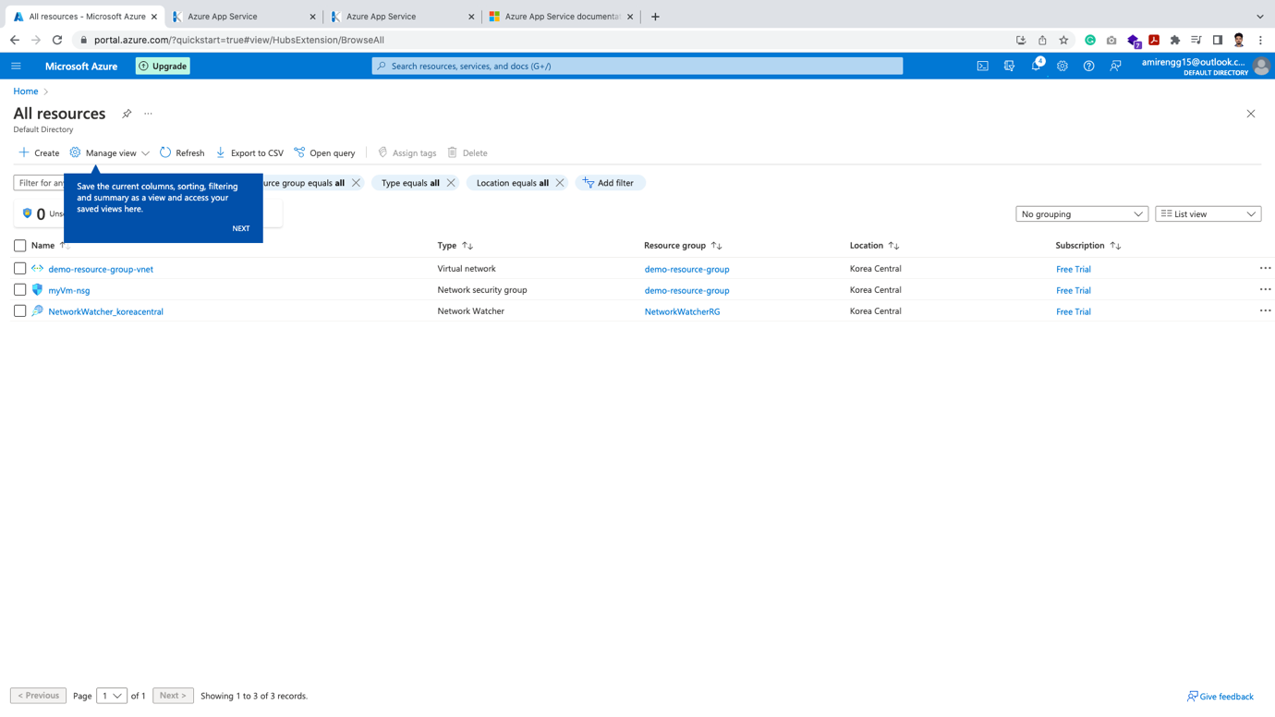

Azure Functions:

Azure Functions is a serverless solution that allows you to write less code, maintain less infrastructure, and save on costs. Instead of worrying about deploying and maintaining servers, the cloud infrastructure provides all the up-to-date resources needed to keep your applications running.

Medium:

<https://amirmustafaofficial.medium.com/azure-functions-creating-azure-functions-using-node-js-e3cddb5ec7c7?fbclid=IwAR1iEd2aR7plh4fRYTqqCefmLDCBwvDarqyIifImQlbpEGvg29titFWhhFw>

Kubernetes and Azure Container App:

🡪 Here we will review Azure Containers. We have many options from Azure, but the most used are – Containers and Kubernetes

🡪 Click on Create a Resource

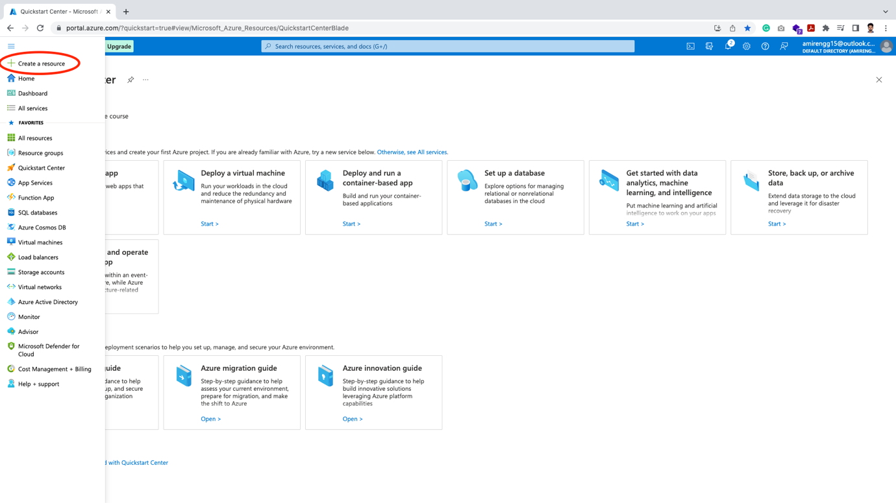

🡪 Click Containers

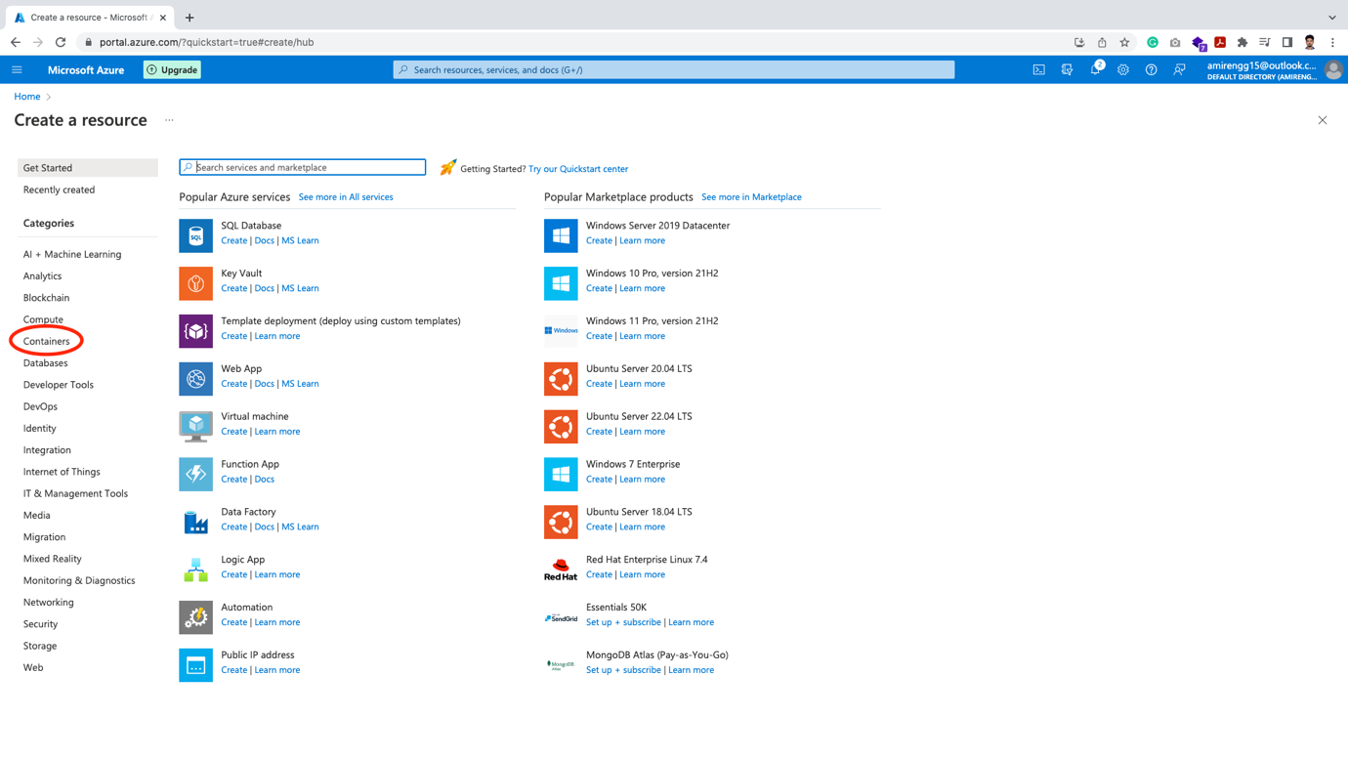

🡪 There are couple of options. Mostly used are:

1. Azure Containers Services (ACS) – when running single Instance
2. Azure Kubernetes Services (AKS) – when running cluster of instances

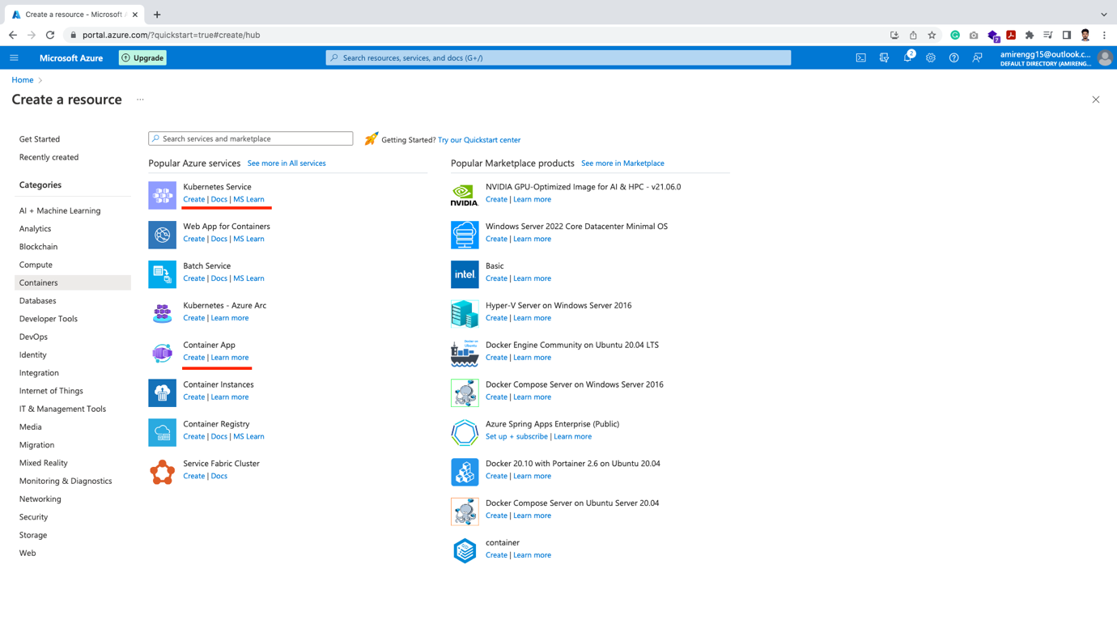

Creating Container Instance:

Go to Container App 🡪 Click on Create

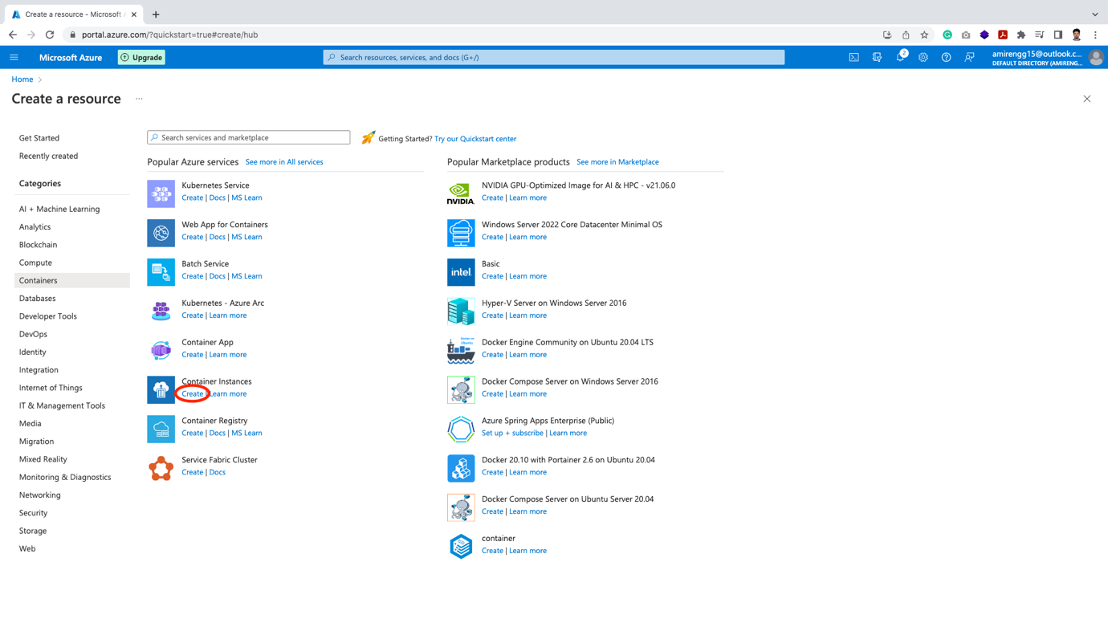

🡪 First we have to create a Resource group. Click Create new.

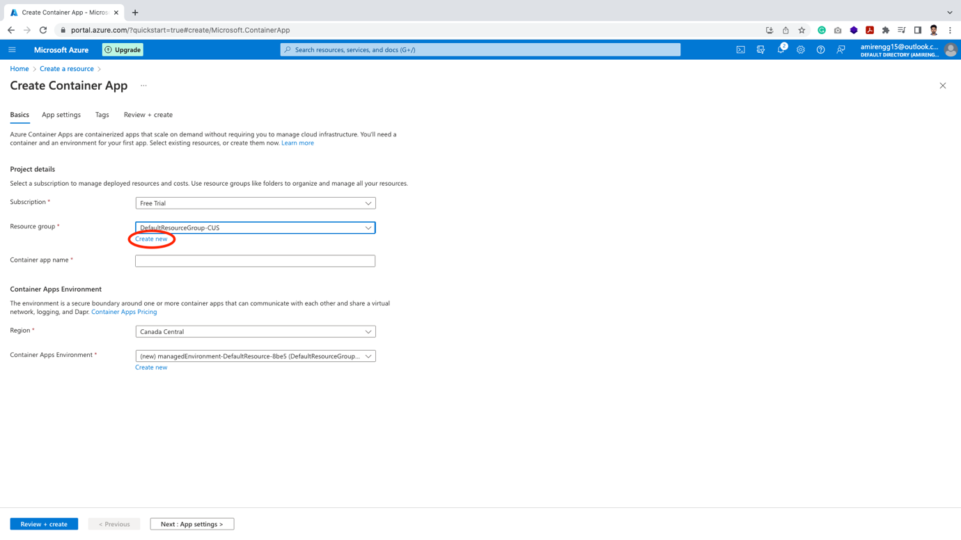

🡪 Let us give it a name eg. containers. Click Ok

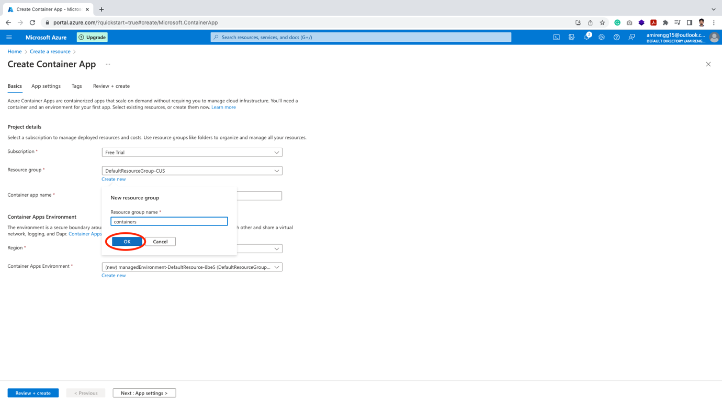

🡪 The next thing is to choose nearest Region. This is important as nearest region will bring results fast.

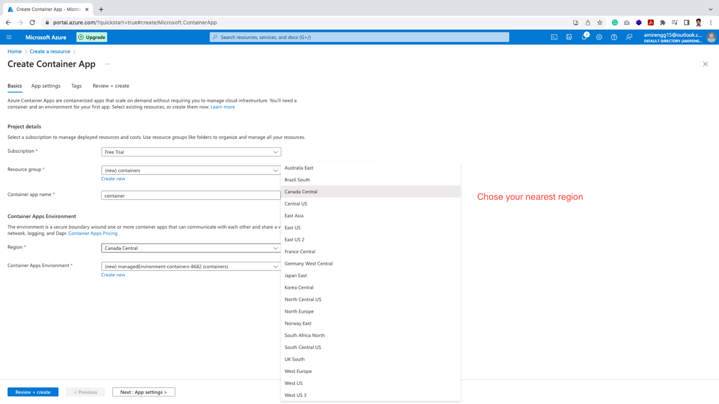

🡪 Click on Next: App setting button

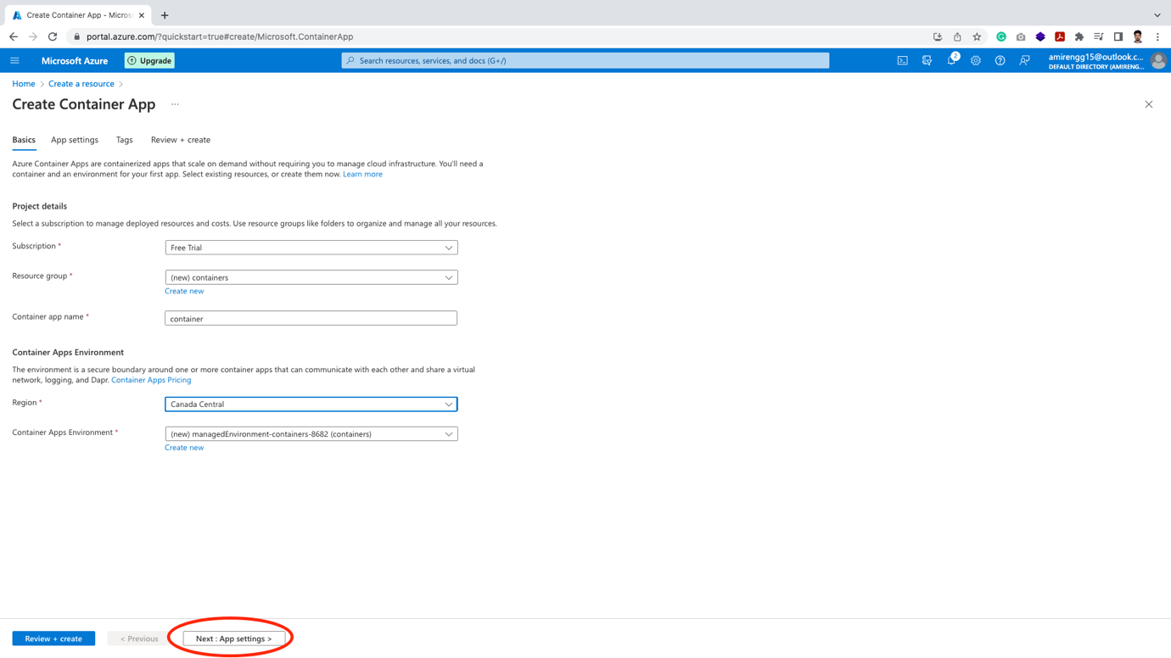

🡪 For now let keep default settings and proceed.

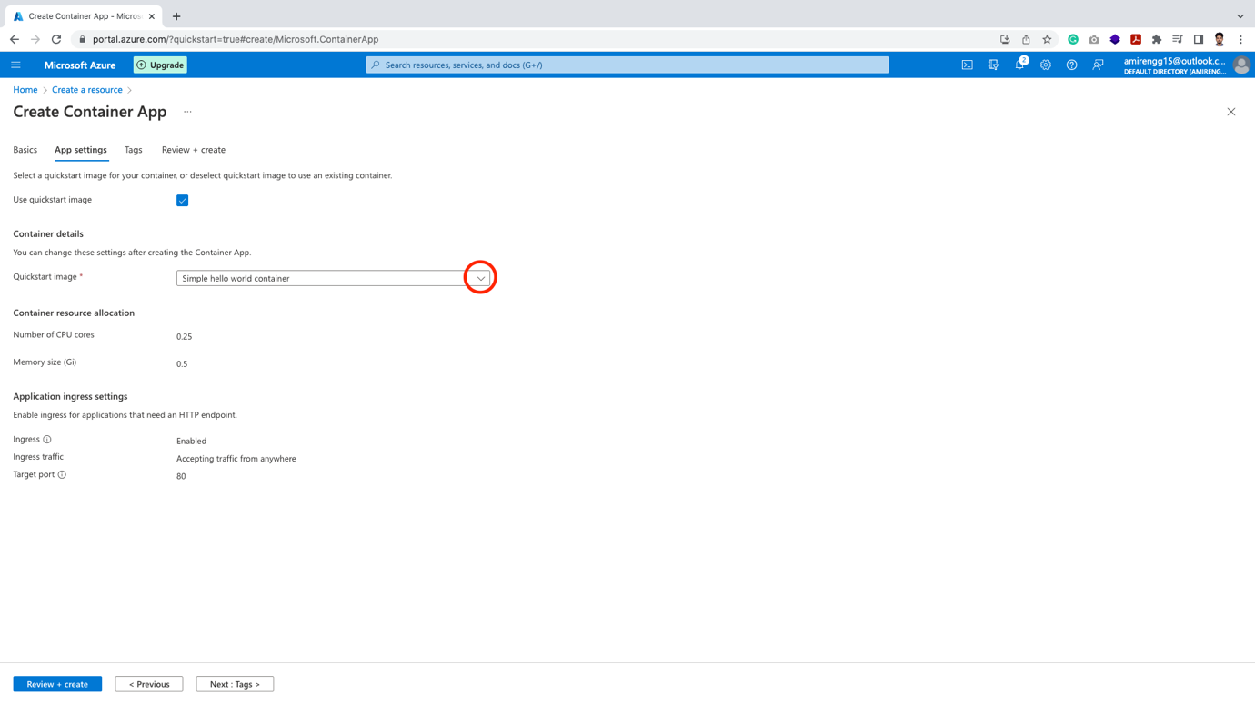

🡪 Click Tag

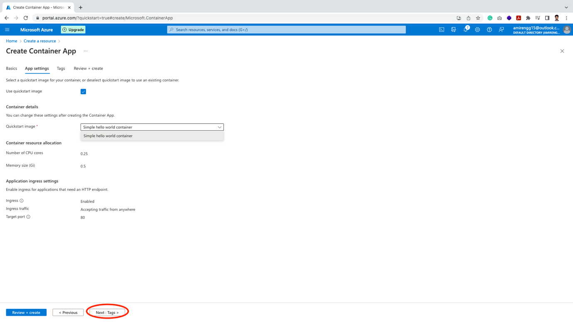

🡪 Click Next: Review and Create button. We get an image URL.

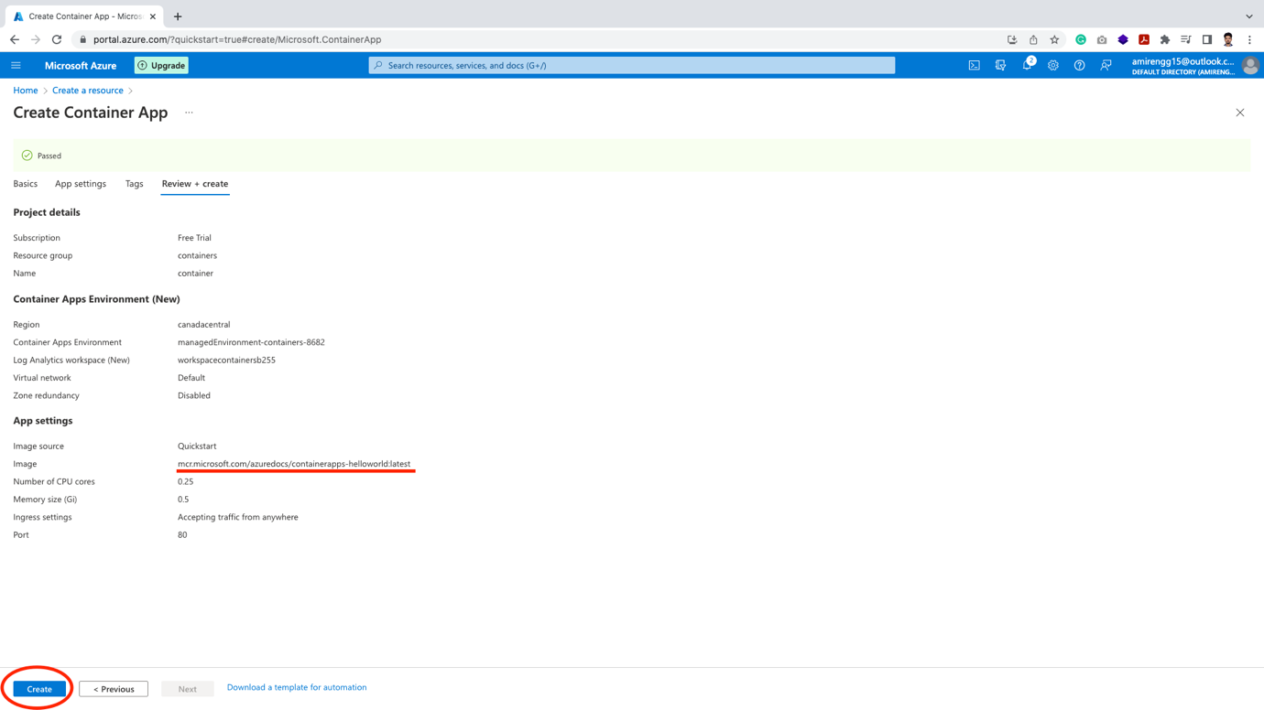

🡪 It takes a couple of minutes and finally gets deployed

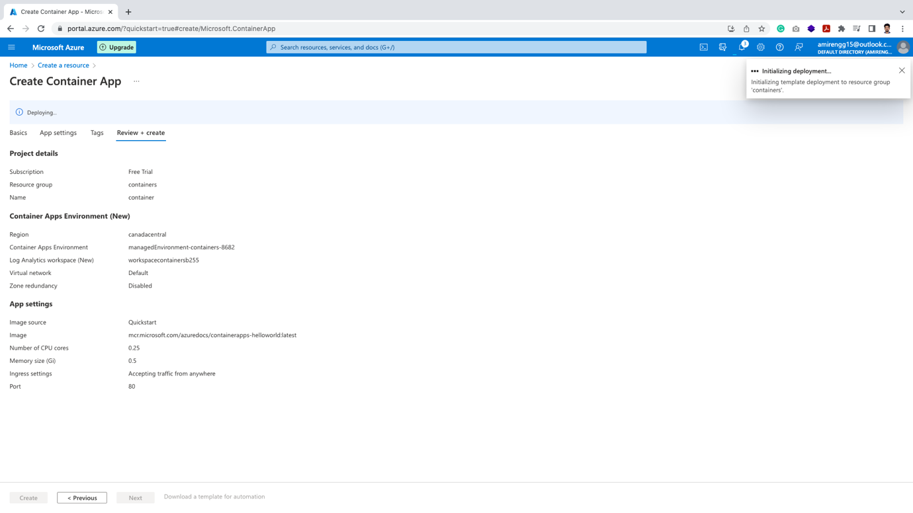

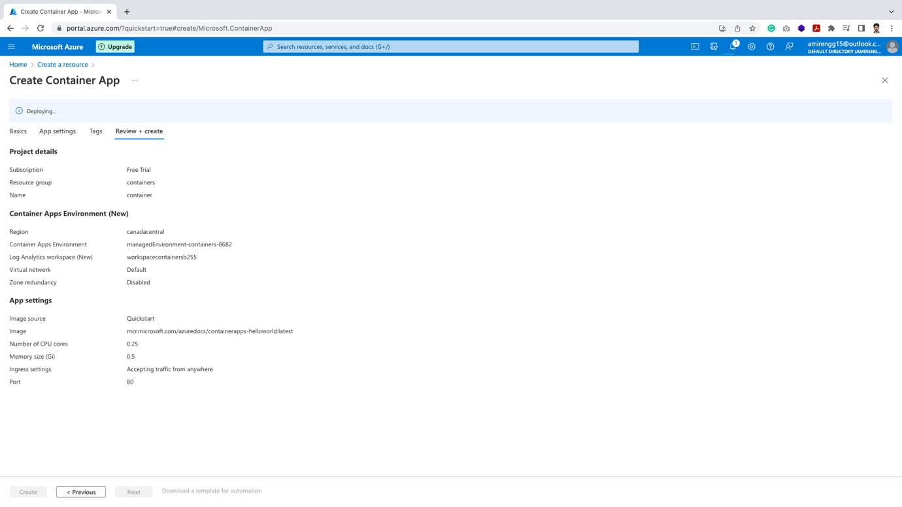

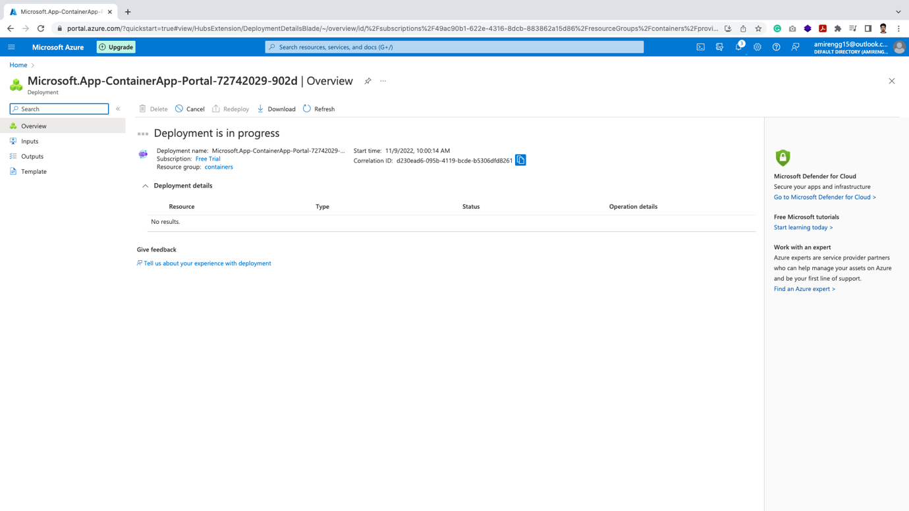

🡪 Finally, it gets deployed. Click Go to resource.

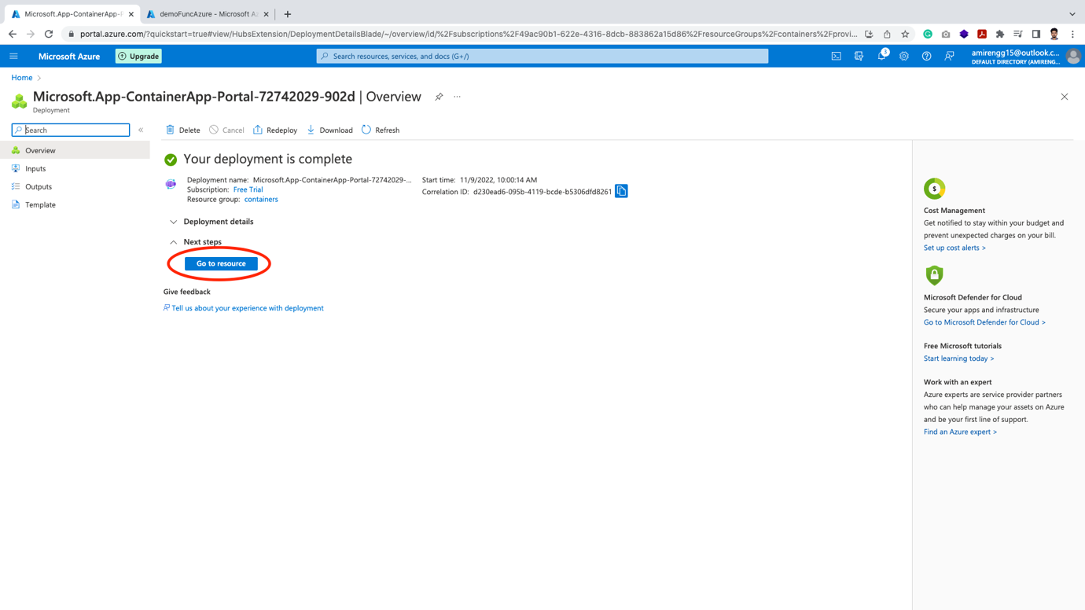

🡪 Finally our container is created

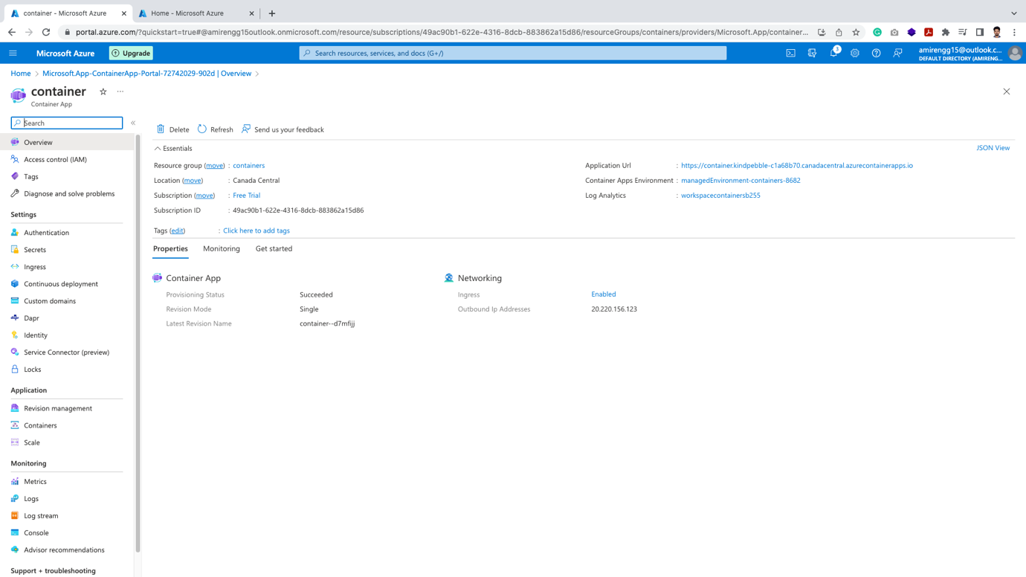

🡪 Now developers and Operations team need to do is to take program and bundle them (It is like zip file).

🡪 Everything a program need is in image. Once the program is created it can be deployed in any environment – development, staging or production

NOTE:

Normally Images are saved to Registry: Microsoft saves to MCR (i.e. Microsoft Container Registry)

One good thing about image it can be used any where – say own machine, AWS, Google Cloud, etc. (i.e. Non-Azure portals as well).

🡪 Finally our application is up. Let us click the URL:

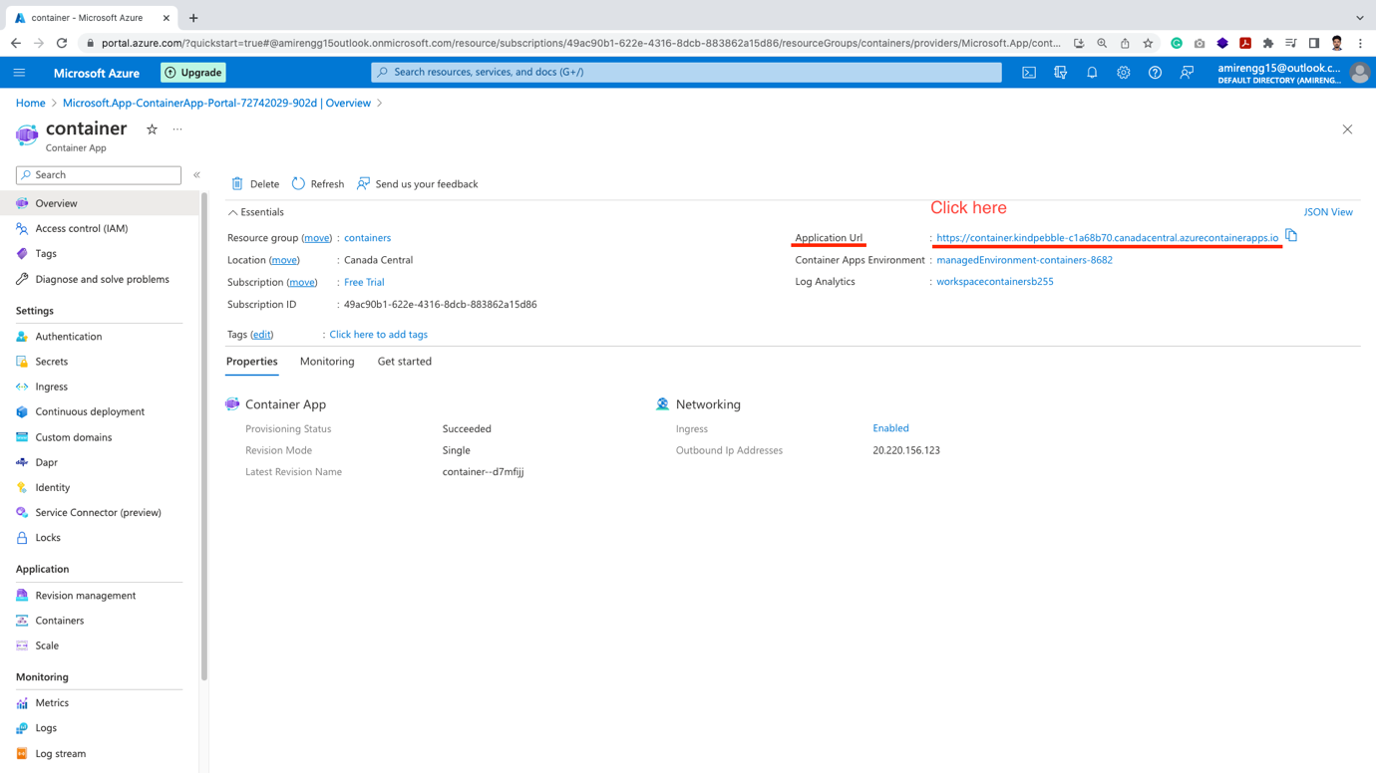

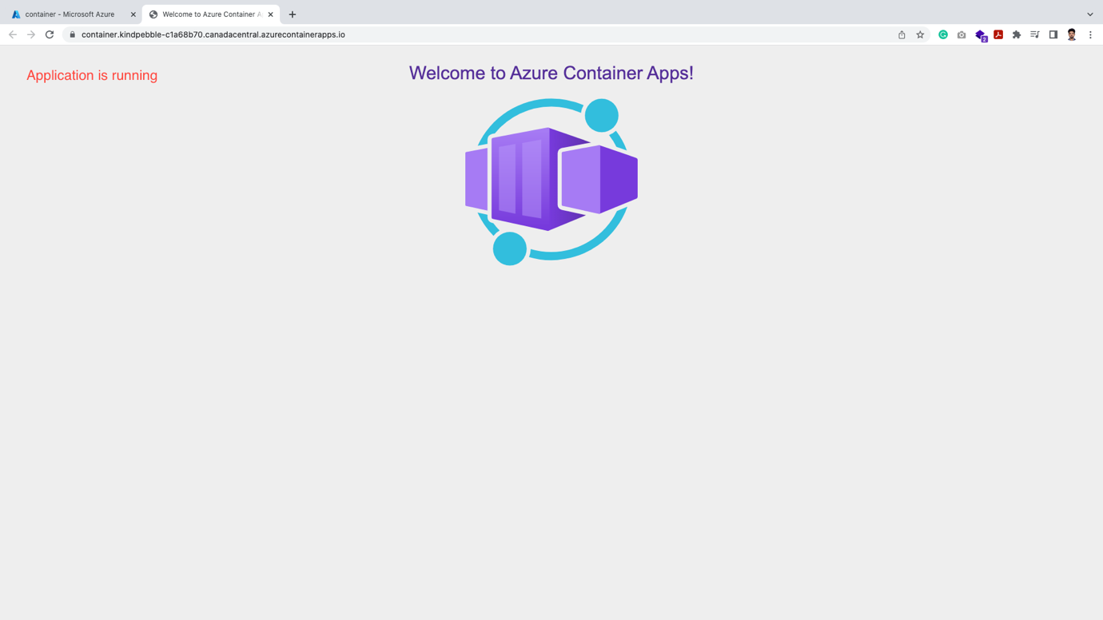

Stopping the Container:

🡪 Once our server is up and running, we can easily kill the container

🡪 Click the Resource Group name

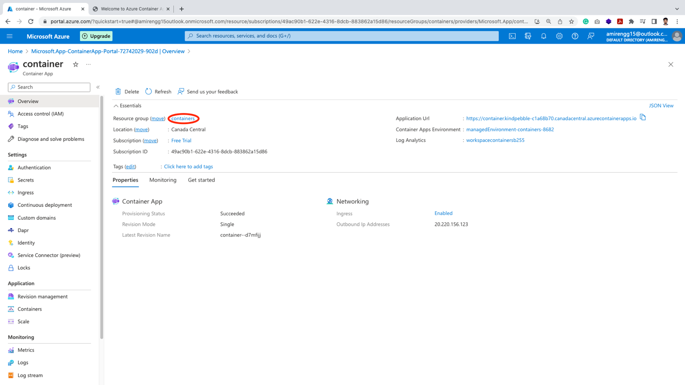

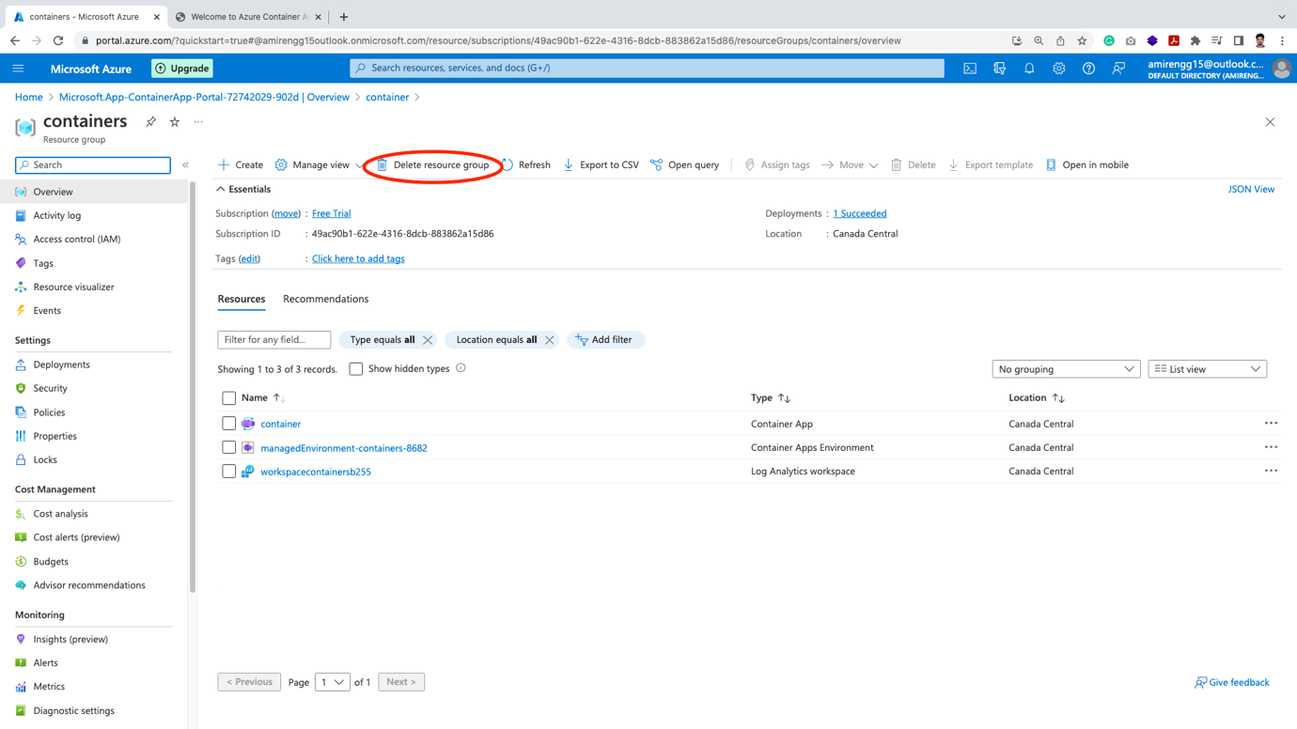

🡪 Copy-paste Resource group name in the box. Click Delete button.

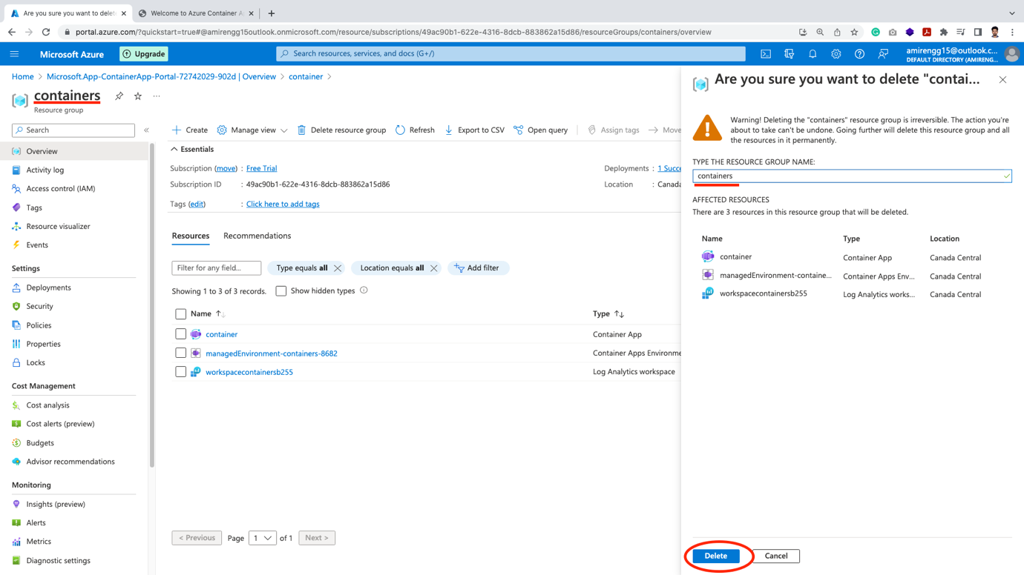

🡪 Finally containers will be deleted.

Azure Storage:

🡪 In this service we store files, media, etc.

🡪 This is like S3 service of Amazon platform.

🡪 Azure has couple of storage options:

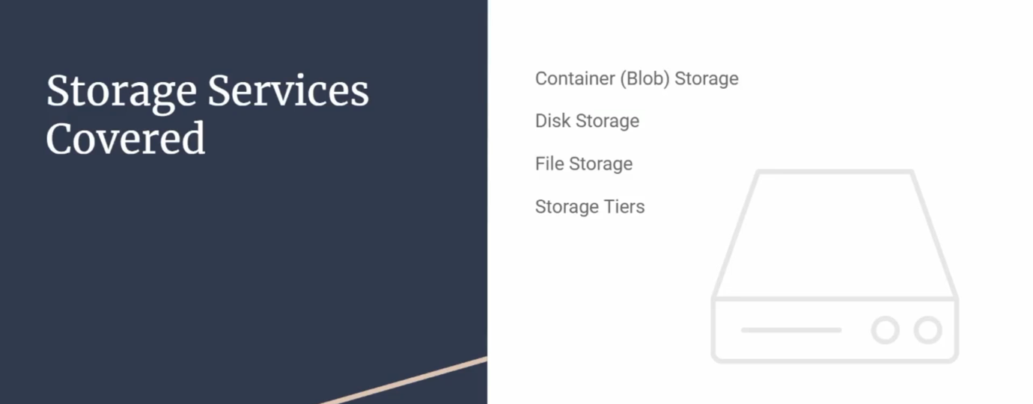

🡪 Azure storage is one of the foundational technologies for other Azure services:

Eg1: Creating Virtual Machine requires virtual hard disk that stores in storage account.

Eg2: We created Azure Functions. This also requires storage account as well to operate.

🡪 So storing is base service that requires computing as well in general.

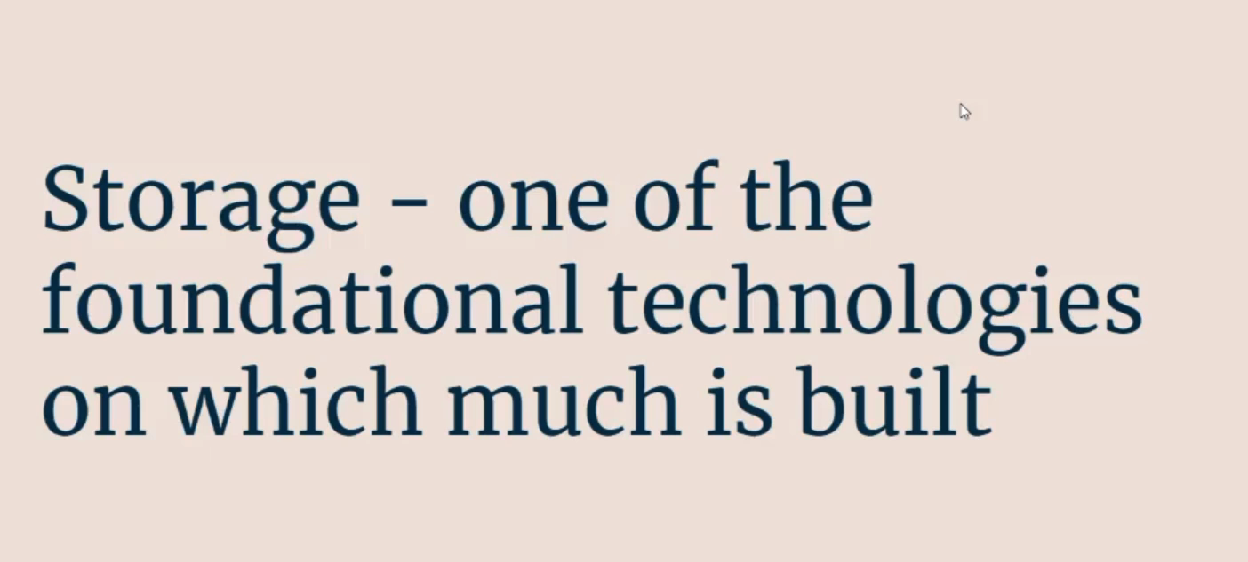

There are different types of **Azure Storage Account**:

1. Unmanaged Storage:
2. General Purpose v2 (gpv2):

🡪 This is the most common type of file storage

🡪 Here we can store multiple types of files – Blobs, Tables, Queues, Files

For Blob type of storage – we can set flag something called Data Lake

1. Data Lake:

🡪 This is helpful when we store large data Peta Bytes of Data (PB) – something called Big Data.

🡪 We have to specifically configure that in the storage account.

🡪 In general both these services are called unmanaged service.

🡪 This is also one of the most cheapest account in Azure Storage.

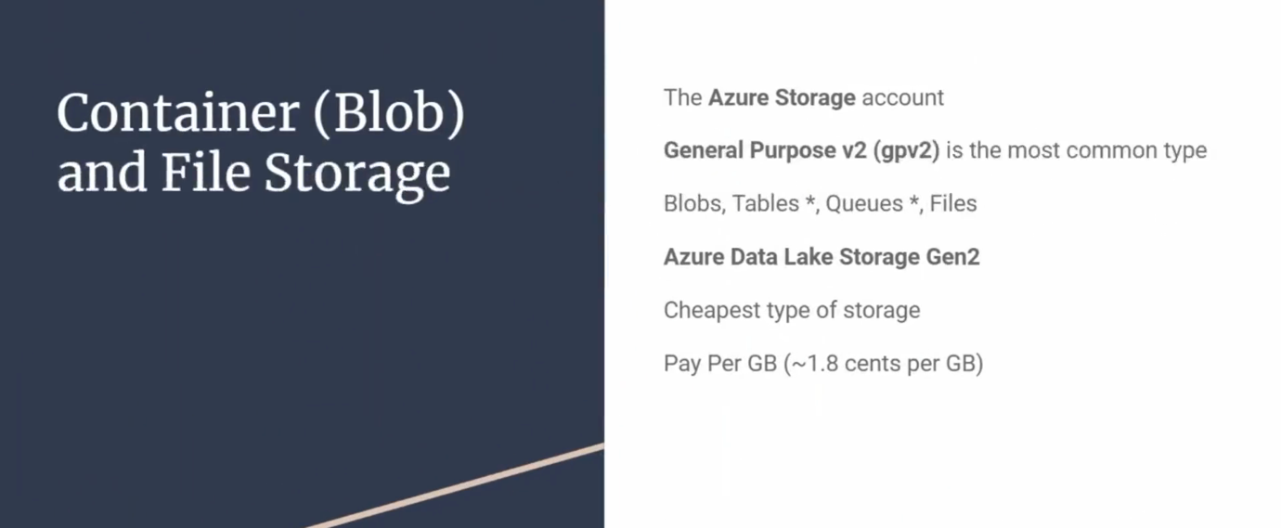

BLOB:

🡪 Full form is Binary Large Object.

🡪 BLOB is a collection of binary data. That binary data could be in the form of a file

Eg1: Files stored in storage a/c: PDF, Excel files

Eg2: Data stored in databases.

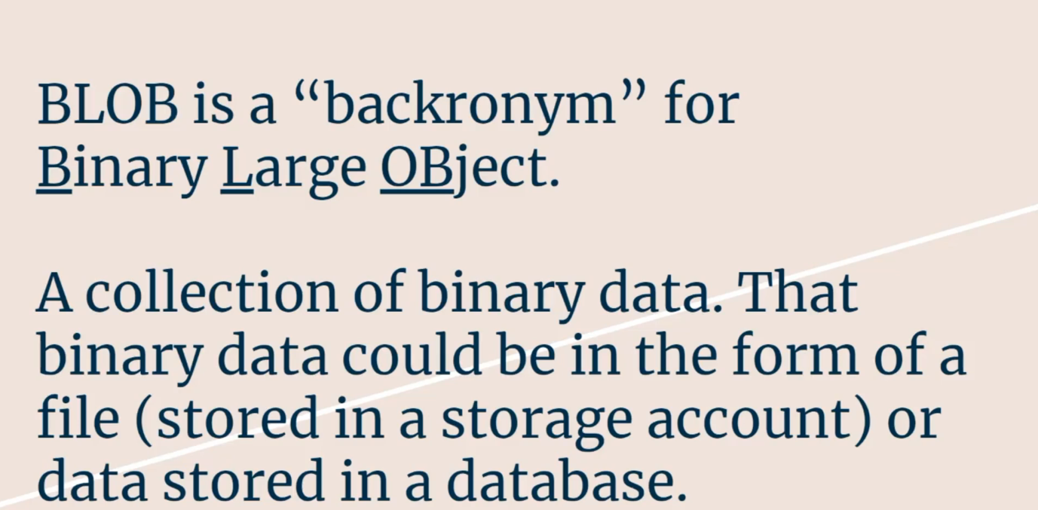

🡪 There are couple of options for storage Account:

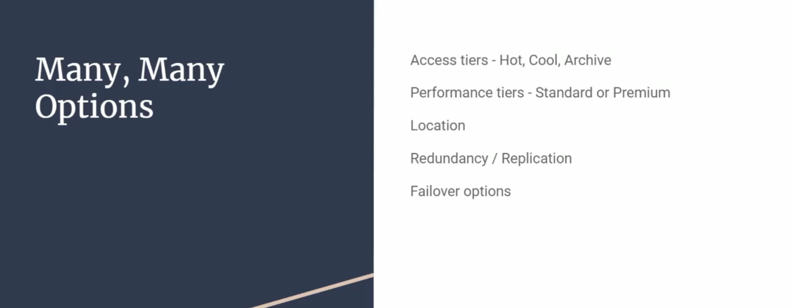

1. Access Tiers – Hot, Cool, Archive
2. Performance Tiers – Standard or Premium

This is something related to quicker performance (Premium) or Standard performance (Standard)

1. Location – Geographical region where storage account will be deployed.
2. Redundancy – If we need files in more that one geographical region then we can use this option
3. Failover Region – This feature was added in recent years by Microsoft. Here we can keep backup of the storage account and something fails we can use this as primary storage.
4. Disk Storage (or Managed Disks):

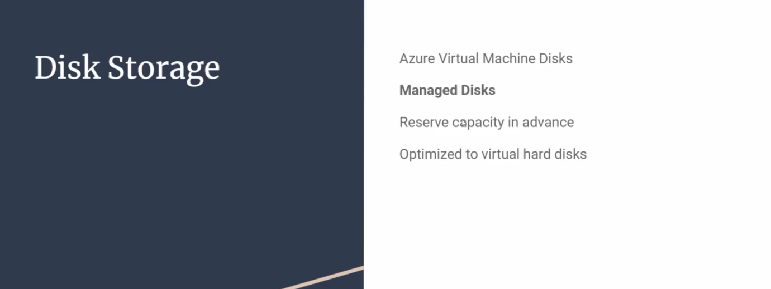

🡪 Managed hard disk is exclusive used as virtual hard drives.

🡪 So when we set up a Virtual Machine and install OS, the C drive uses hard drive is stored in Managed Disk storage.

🡪 This also has separate charge plans

Unmanaged Storage account – we pay by GB.

Managed Storage account:

Here we pay by tiers effectively in our reserving full capacity 🡪 Paying for full capacity.

Creating a Storage Account:

🡪 Click create a Resource

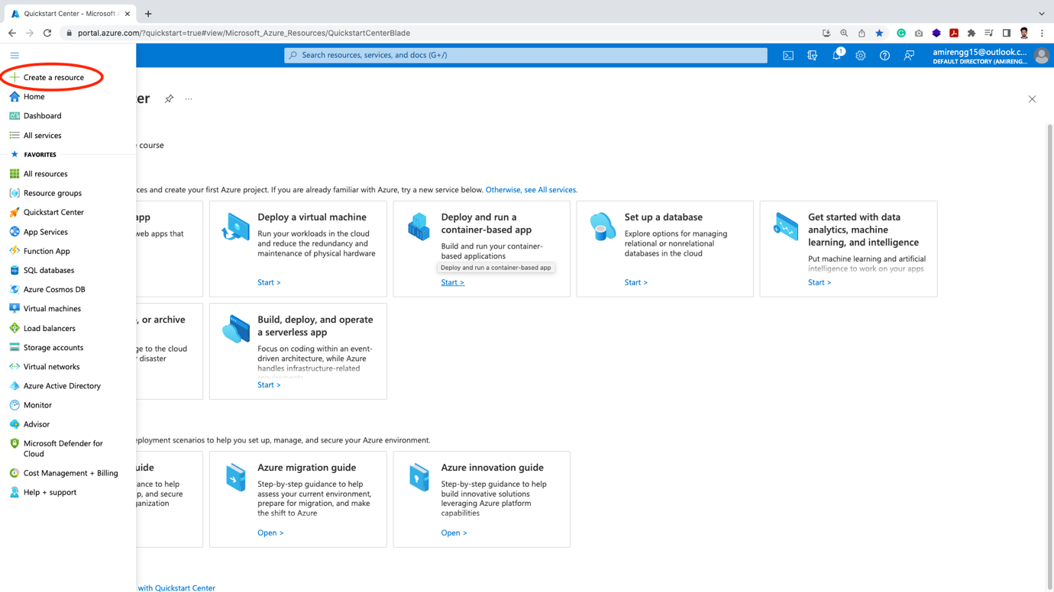

🡪 Click Storage link from left explorer.

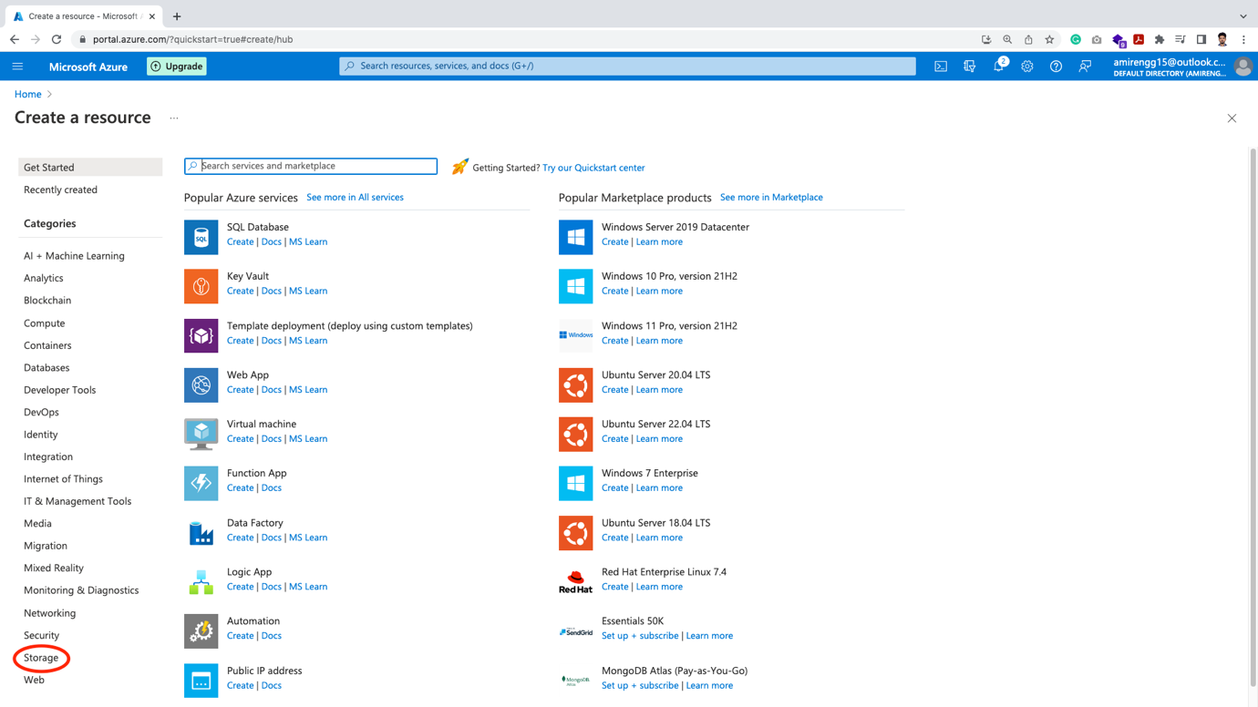

🡪 Click Create link below Storage account

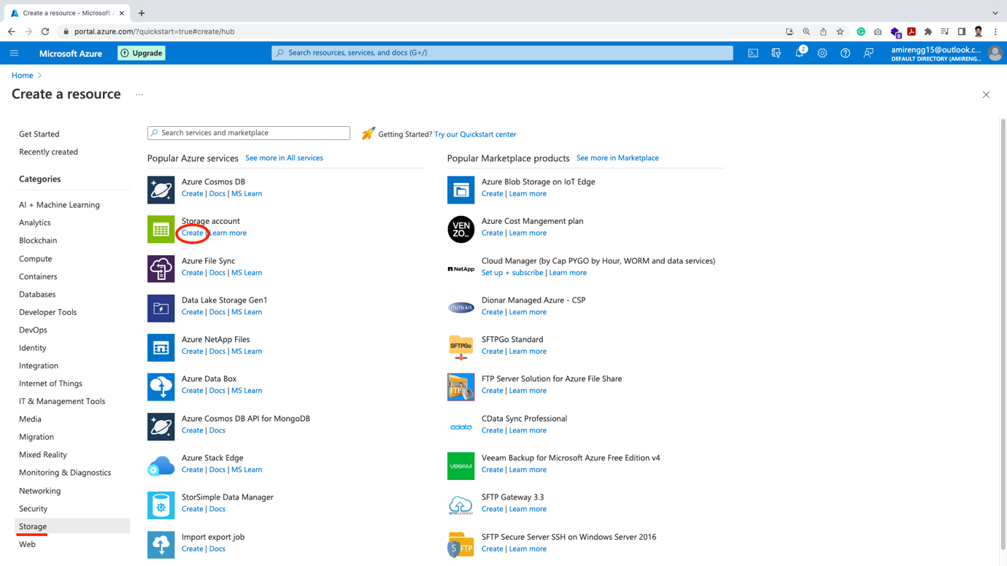

🡪 The theme of Azure Cloud is similar. Click on Create new resource.

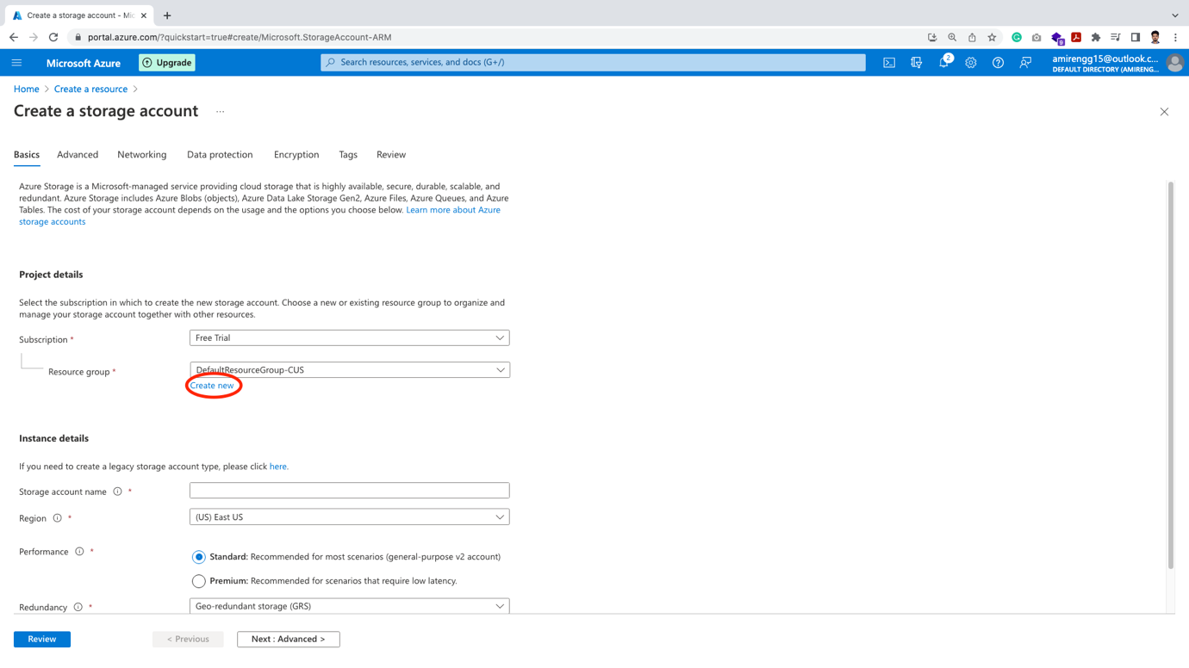

🡪Enter Storage resource group name:

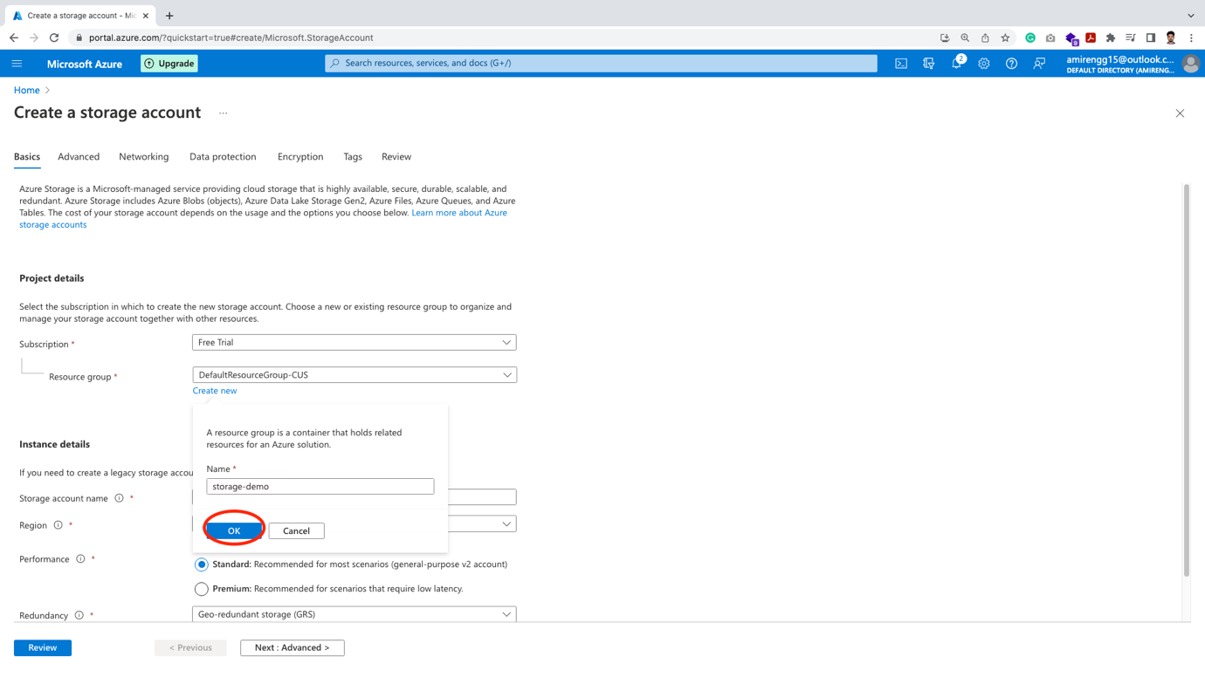

🡪 Enter storage account name (Note this name should be unique across Azure storage)

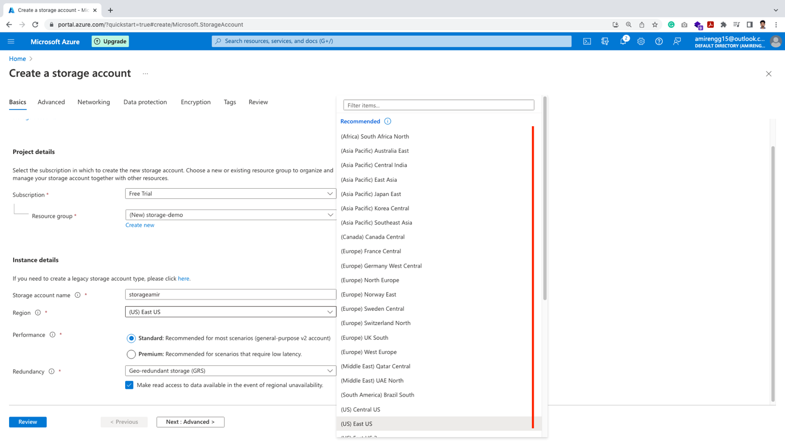

🡪 Based on the region Microsoft charges price.

Eg. Price in South America – Brazil is expensive compared to US East US region.

Mostly depends on servers available on the regions and other factors.

🡪 The next important is Performace plan – Standard and Premium

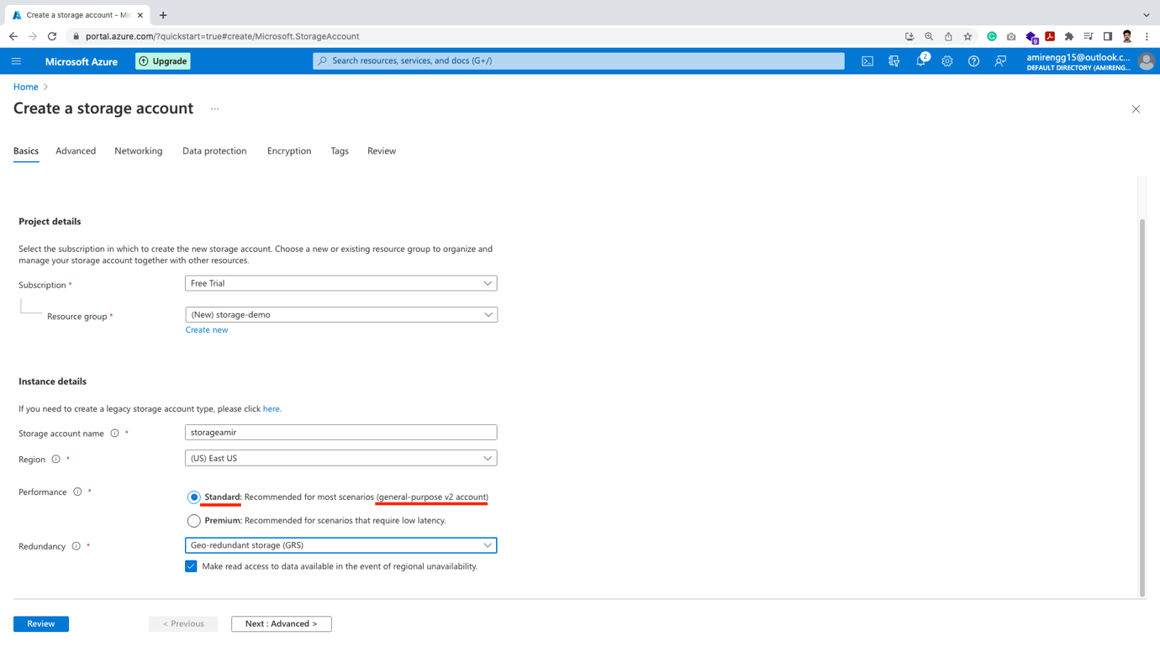

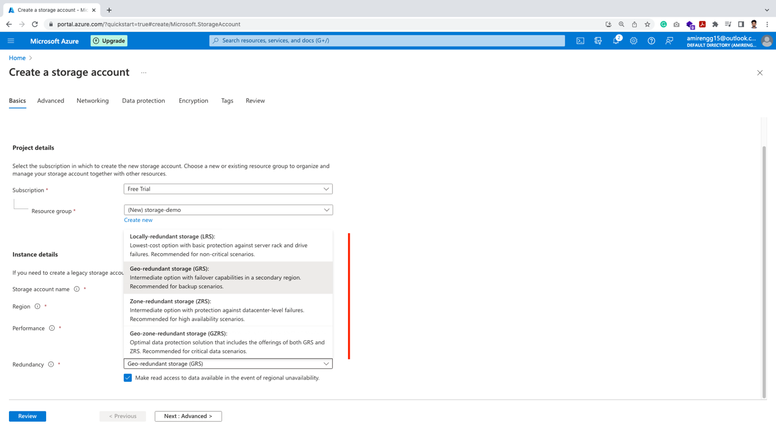

Based on the project business requirement – we can chose plan.

Standard one uses – general purpose v2 account

Premium uses – Solid State Drive (SSD)

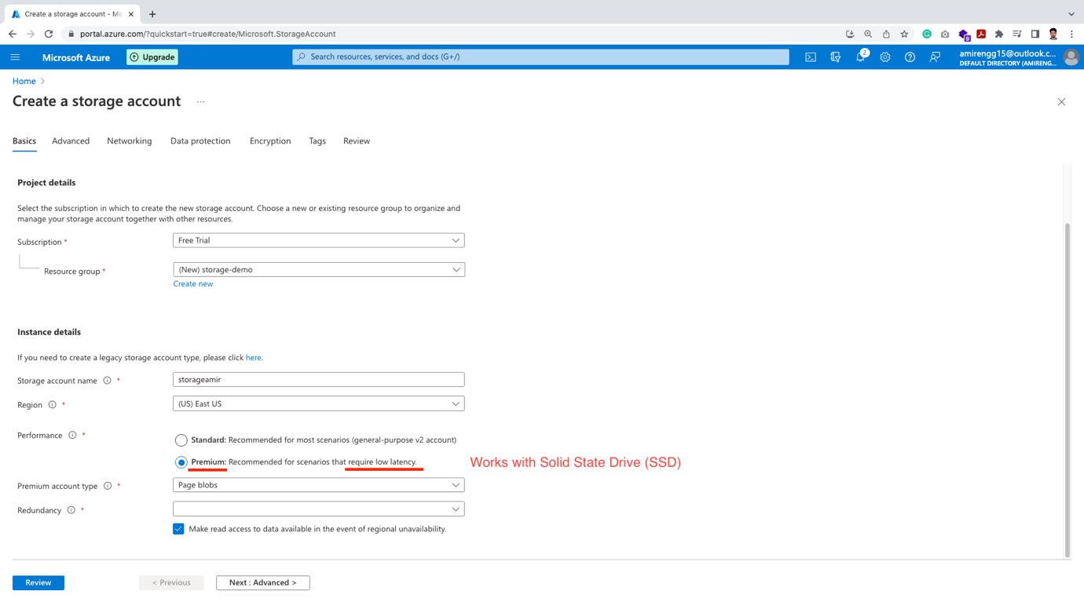

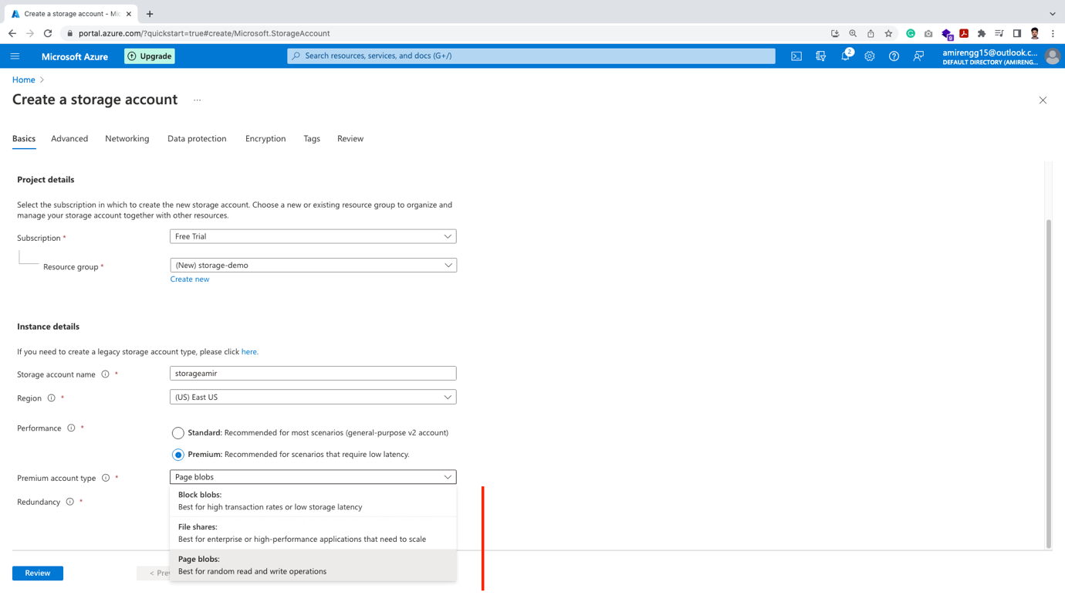

On Premium there are:

Block Blob: if there are high transaction rates (eg – reading and writing a lot i.e. 32 MB at a time) – general read and writes

Page Blog: If we are on the Virtual Machine and want to read somewhere middle of a file this is helpful (not from beginning) – i.e. random read and writes.

Redundancy:

This means keeping multiple copies in certain regions

Azure provides –zone copy and local copy

Note: Global copy facility is not there at present

1. Zone Redundant Storage (ZRS) – Copies in all zones
2. Local Redundant Storage (LRS) – Copies locally in same data center

Standard:

In Standard performance plan, there are more options:

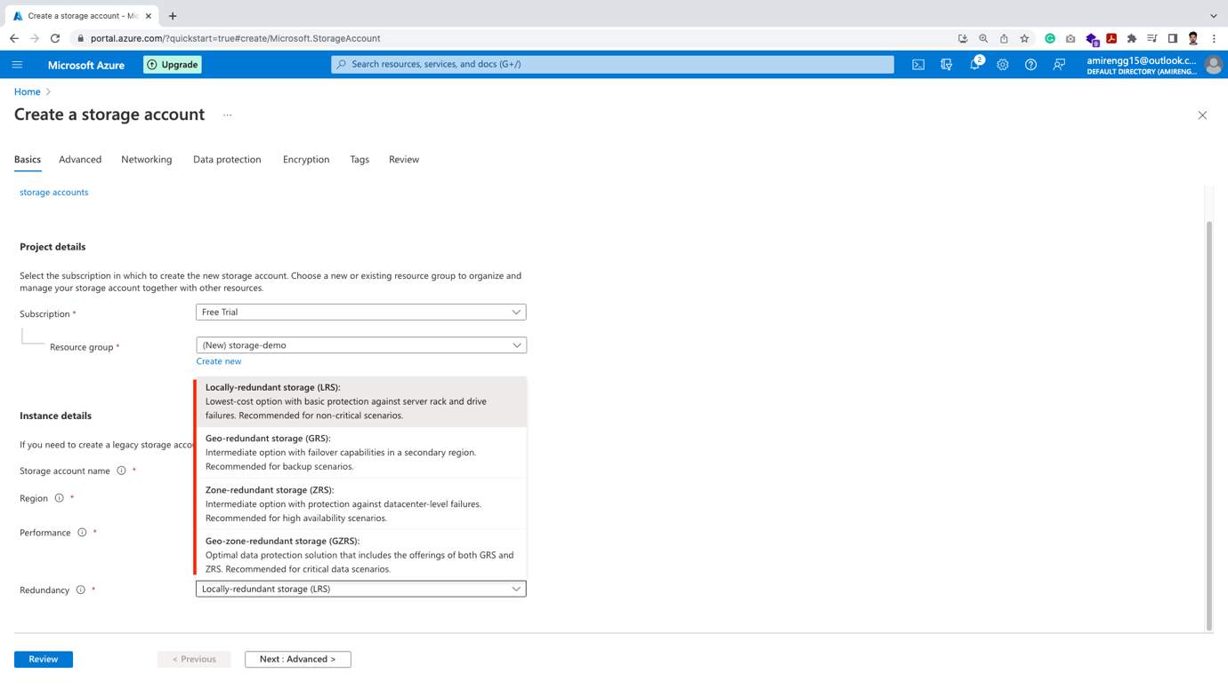

Local Redundant Storage (LRS)

Geo Redundant Storage (GRS) – takes data outside our region

Zone Redundant Storage (ZRS)

Geo Zone Redundant Storage (GRS)

🡪 For now let chose the least paying option i.e. LRS in Standard performance plan. Click Next: Advanced method

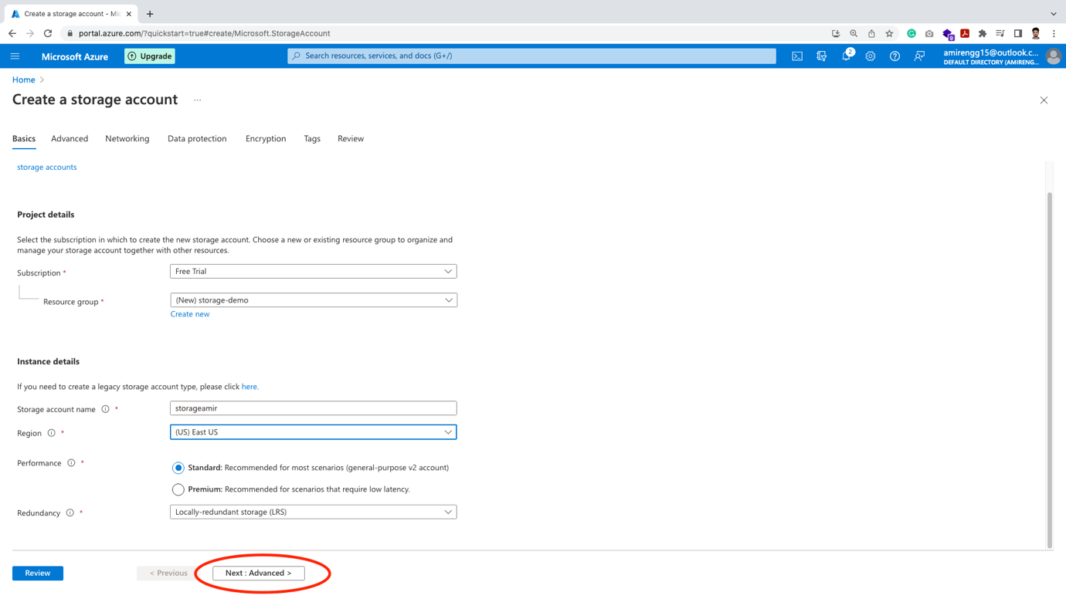

🡪 The next feature is Data Lake. If our application heavy data work load. We can check this feature

NOTE: This feature at present cannot be enabled after storage creation.

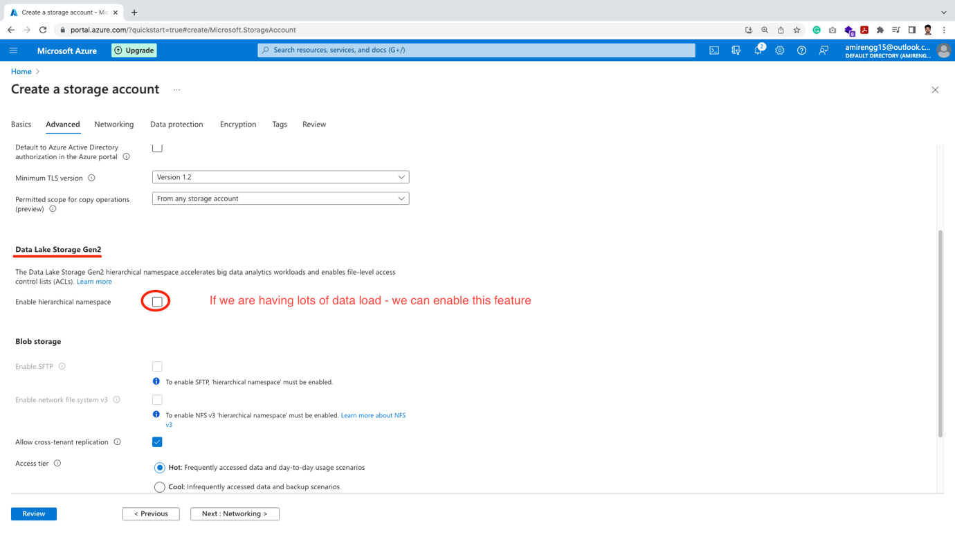

🡪 The next feature we have to chose:

Hot Tier: Frequently accessed data

Access Price: Very Less, Storage Price: More

Cool Tier: Data that are not used frequently eg. backups

Access Price: Little more, Storage Price: Half of Hot tier

Archive Tier: This is not available at the time of creation

Access Price: Save 90% of Hot tier price, Storage Price: Takes hours to access

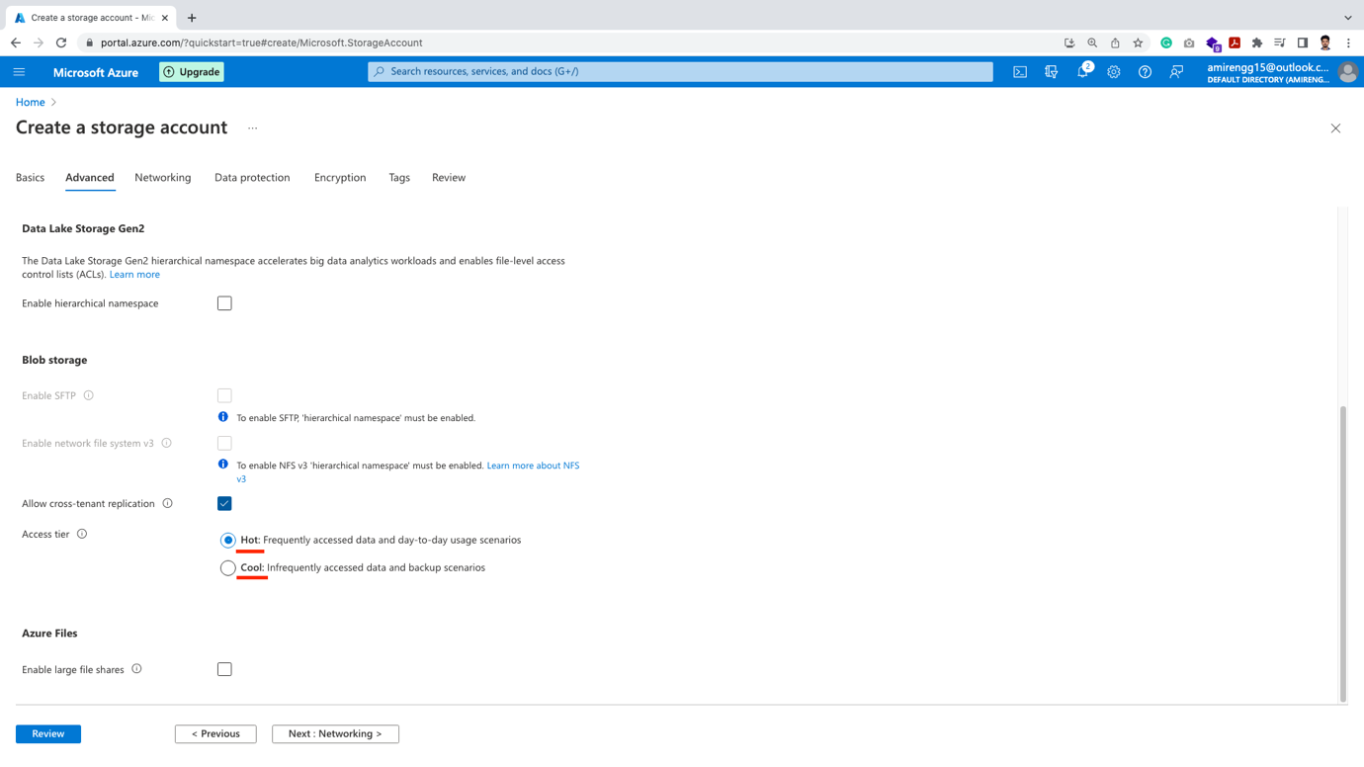

🡪 Click Next:Networking button

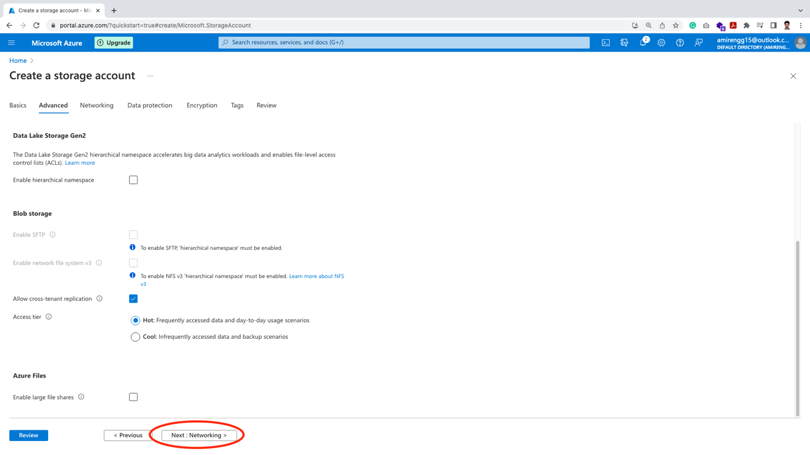

🡪 Three options:

1. Enable public access from all network -This means there is a locked door Anyone with key can access.
2. Enable public access from selected virtual and IP address.

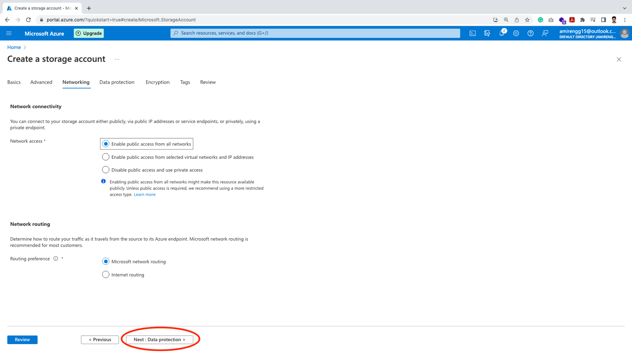

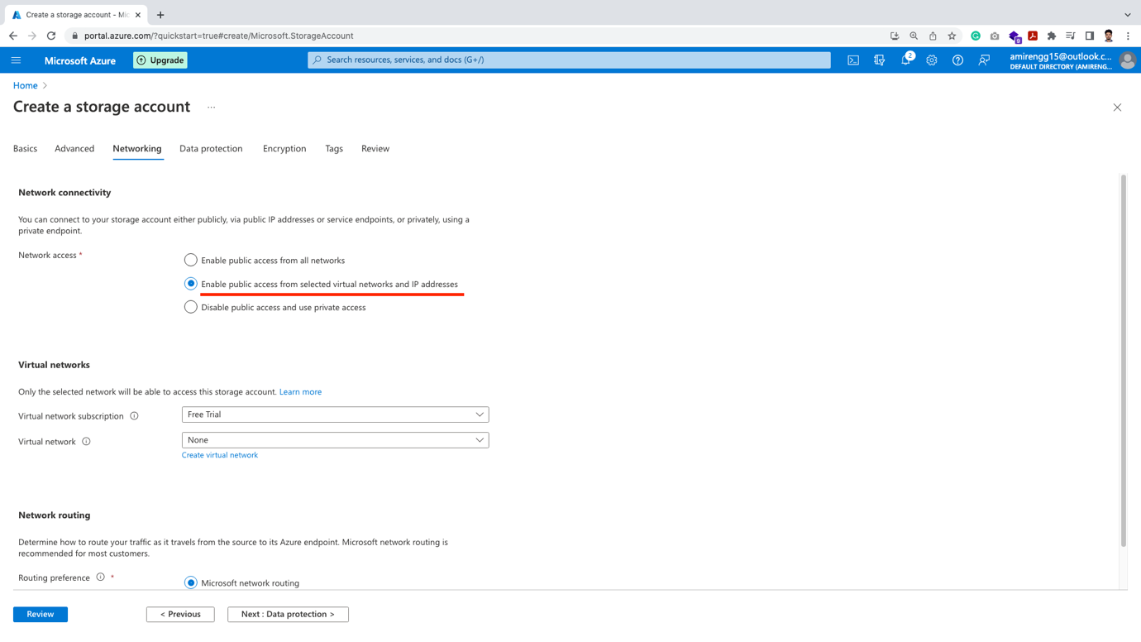

1. Disable public access and private access – This means like remove the door. Only people inside can access

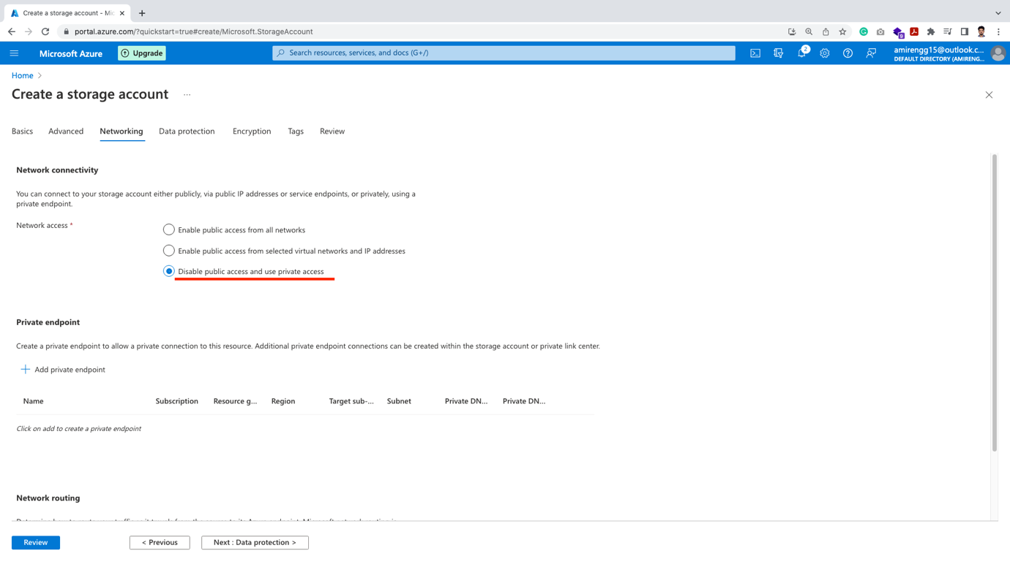

. Click Next: Data protection button

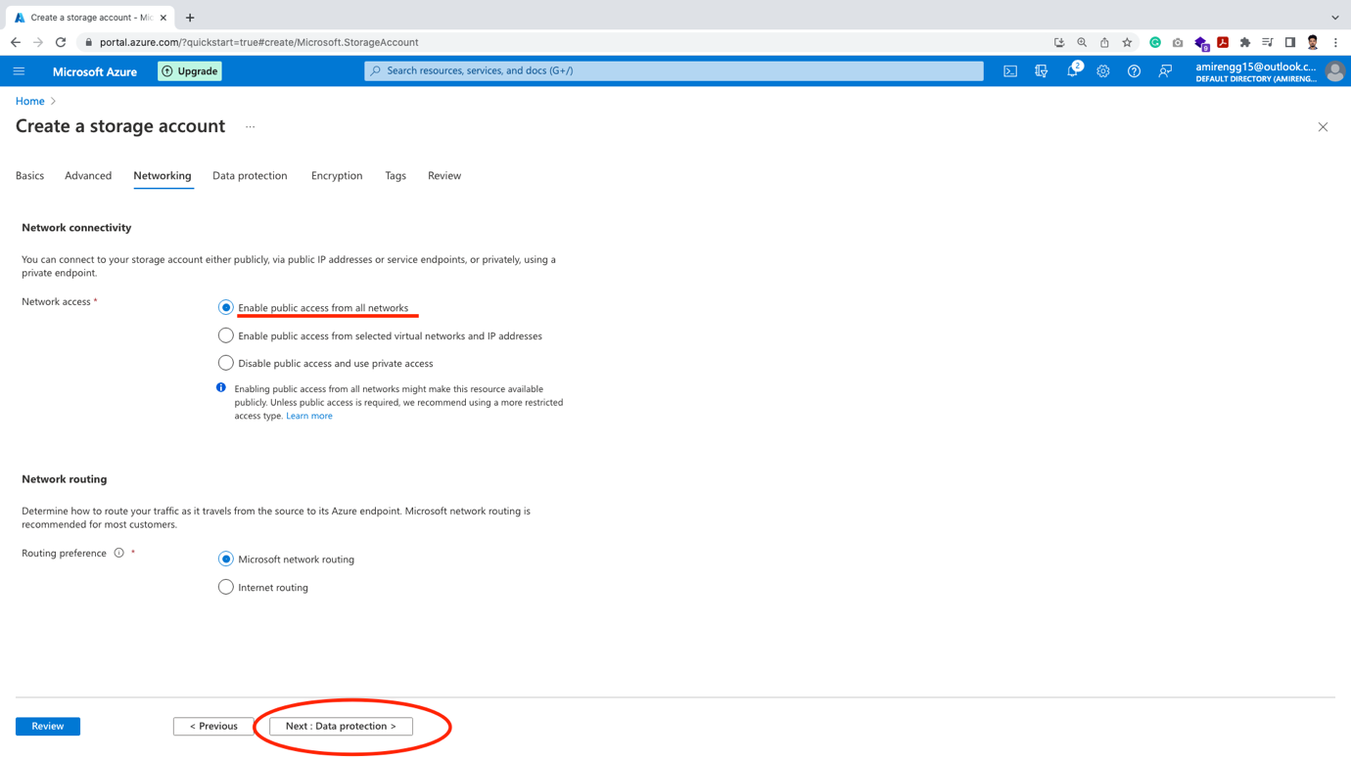

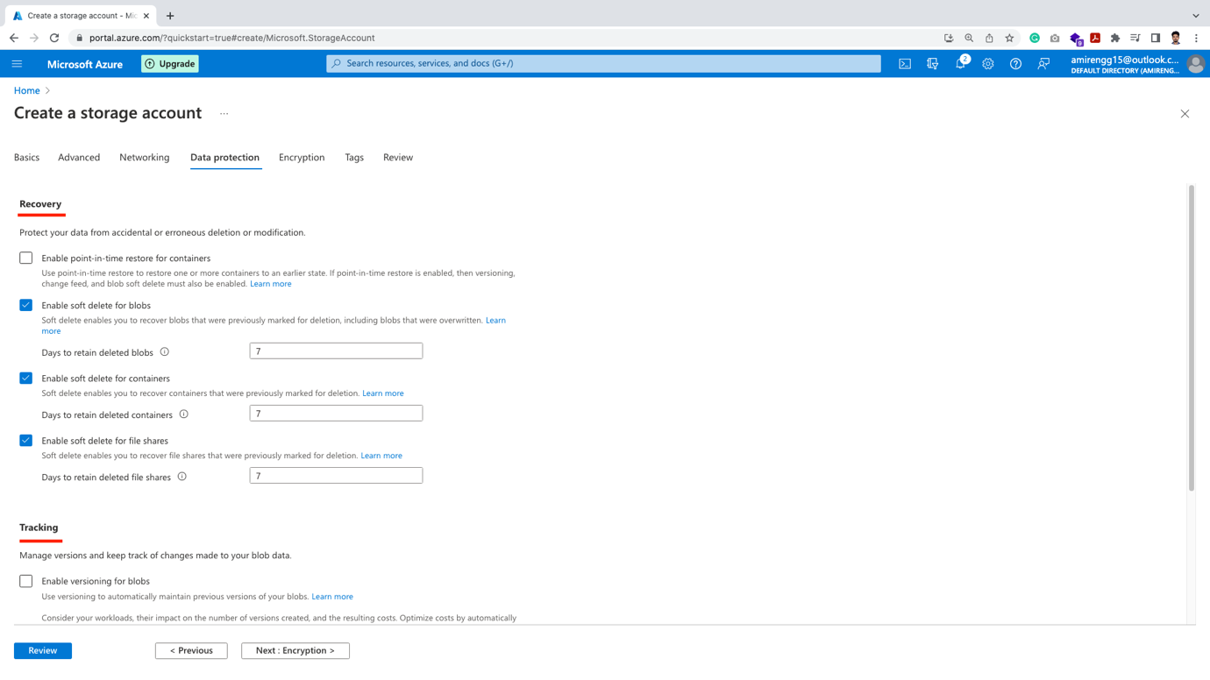

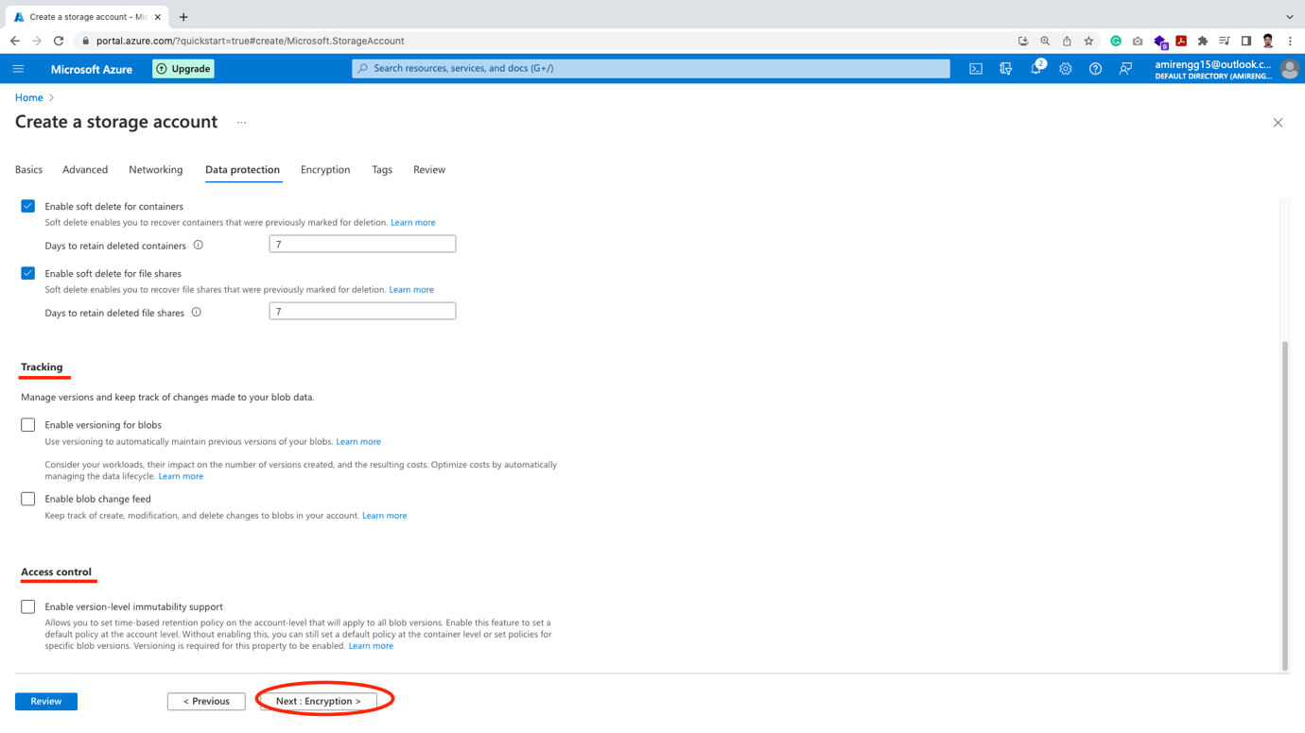

🡪 So lots of feature are available. The last point Access control is great when we freeze changes nor able to delete it. eg. some legal documents, emails

🡪 In Encryption by default there is encryption. We can also add additional layer encryption (Infrastructure level) by check marking.

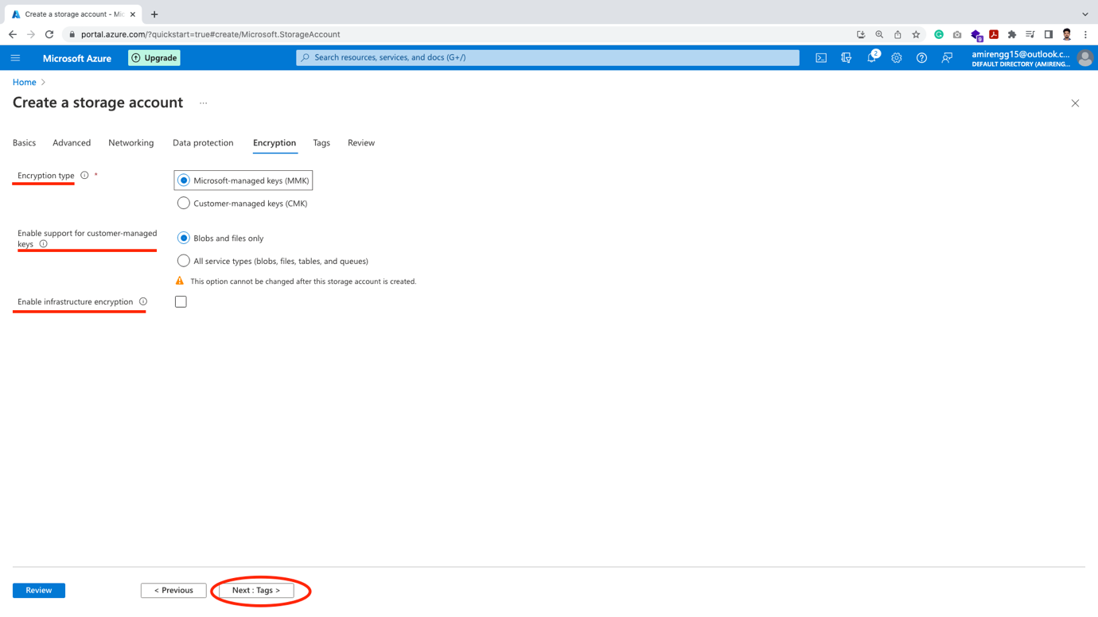

🡪 We can add tags. It is optional feature. Click Next: Review

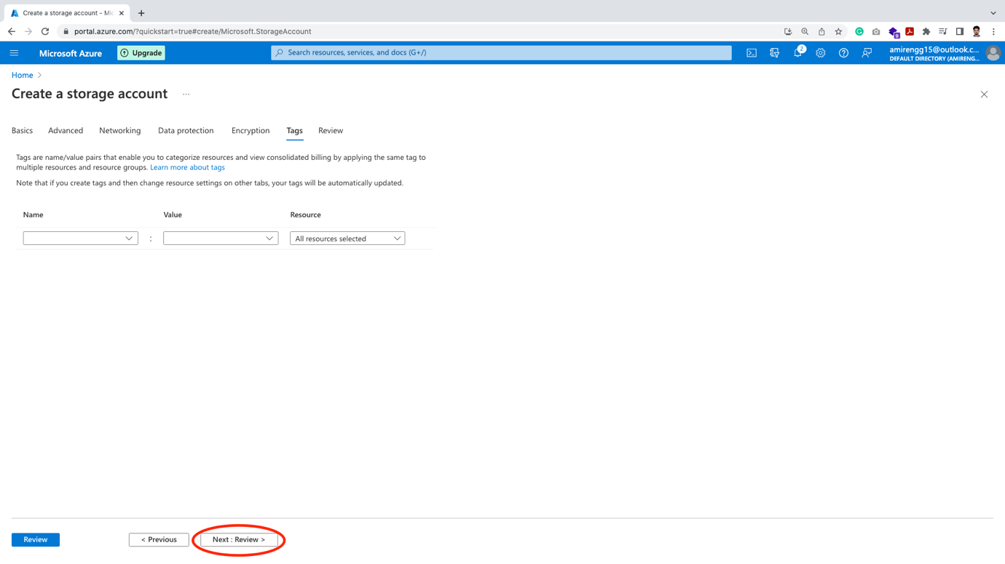

🡪 Reviewing Features:

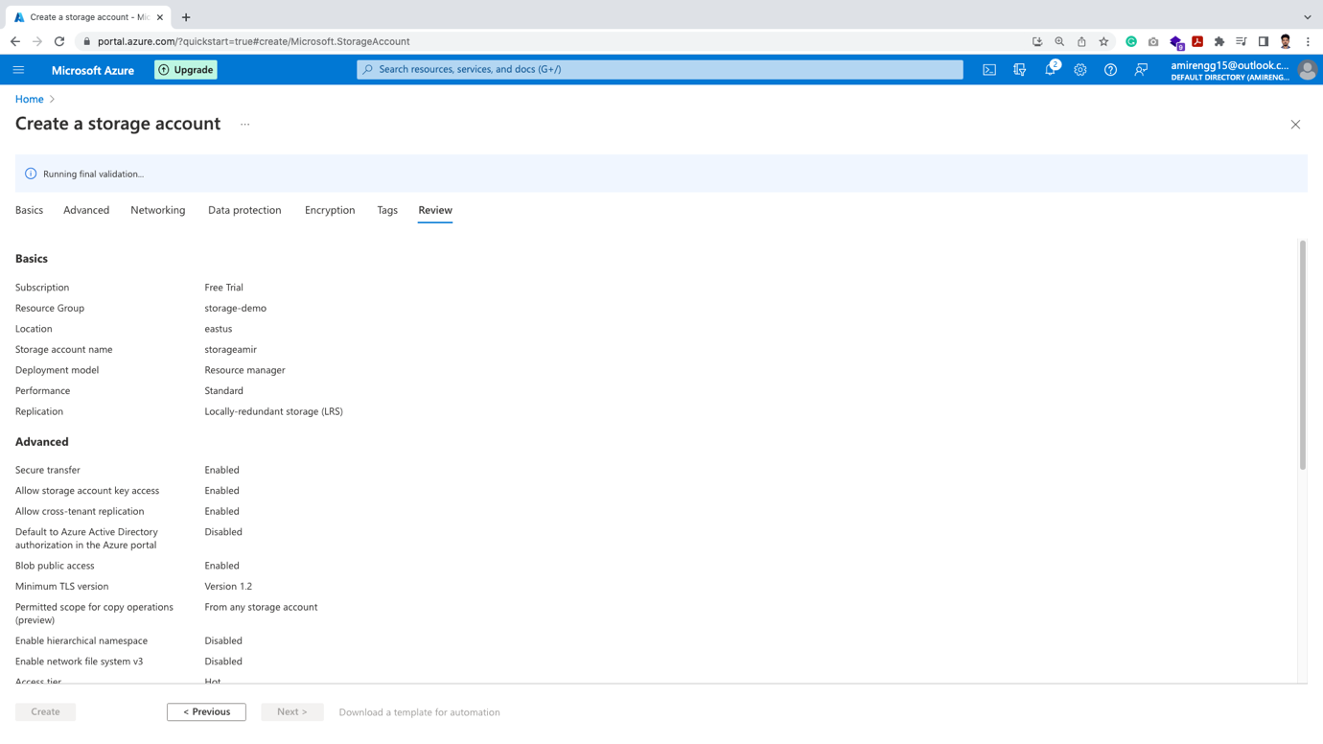

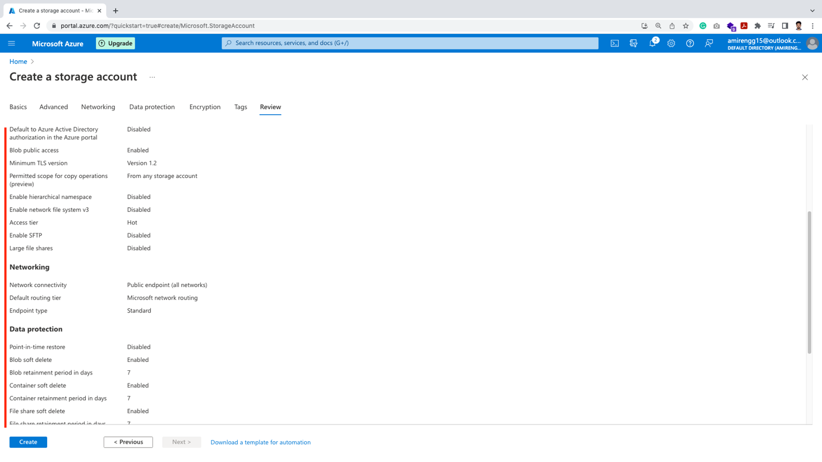

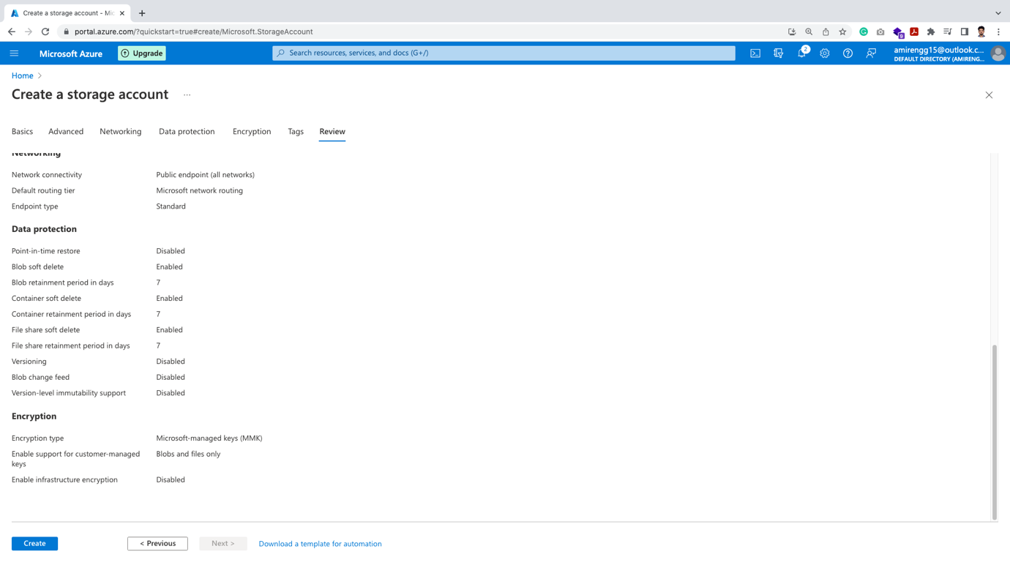

🡪 Click on Create button. Once reviewed

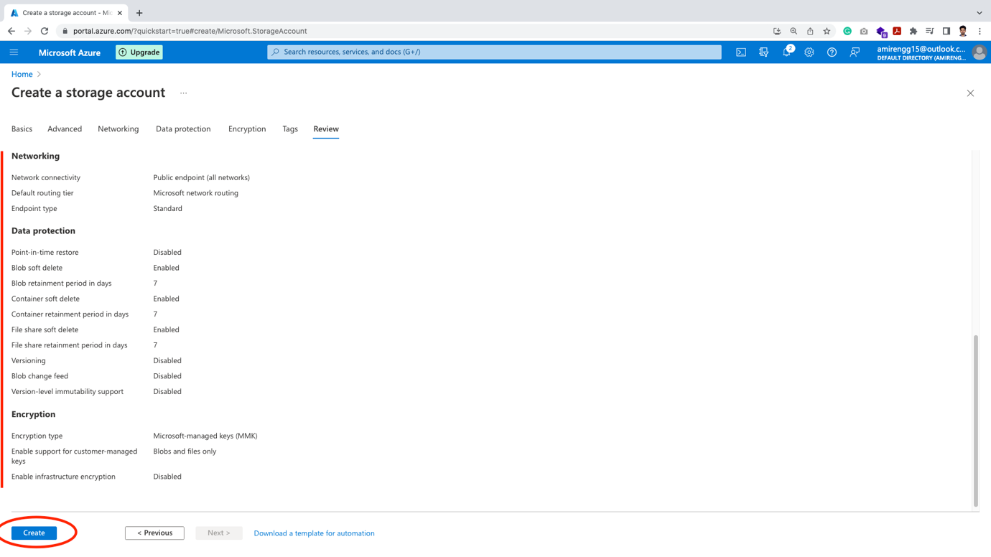

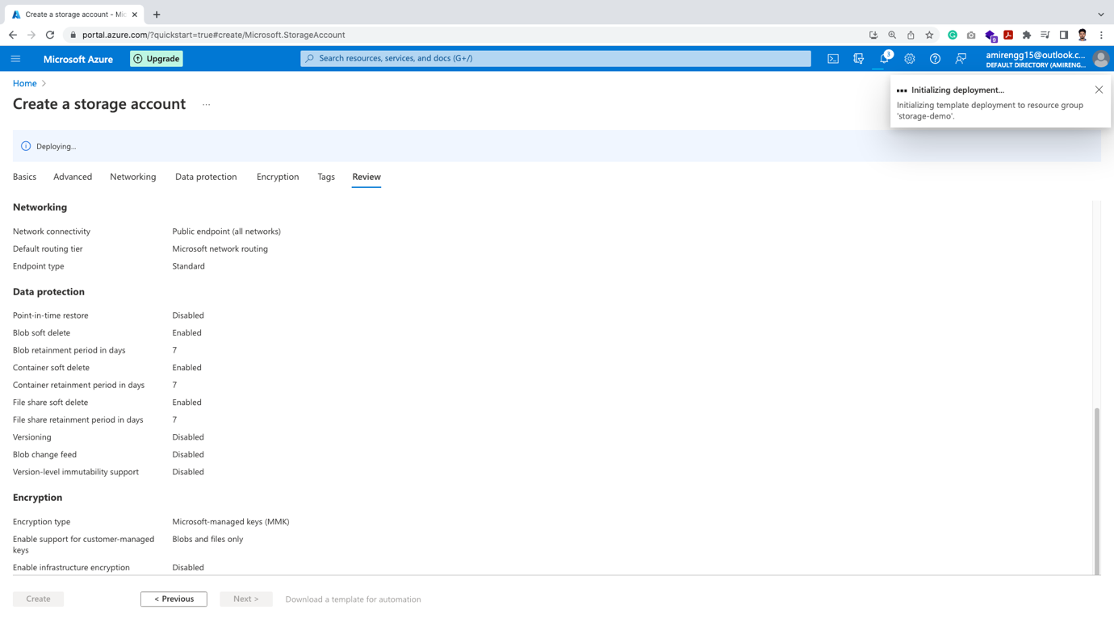

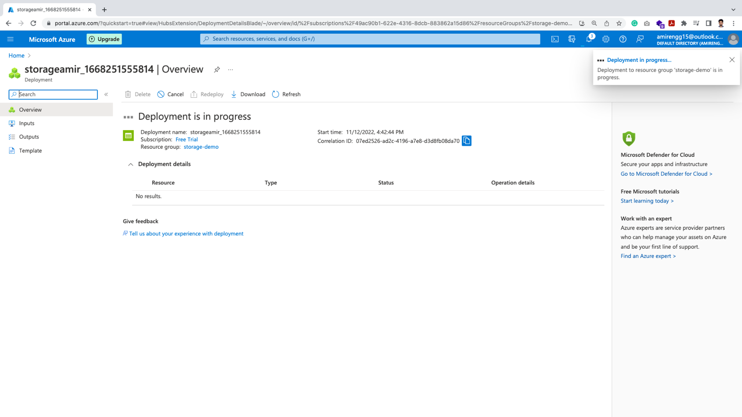

🡪 Finally our deployment is done. Click go to resource button.

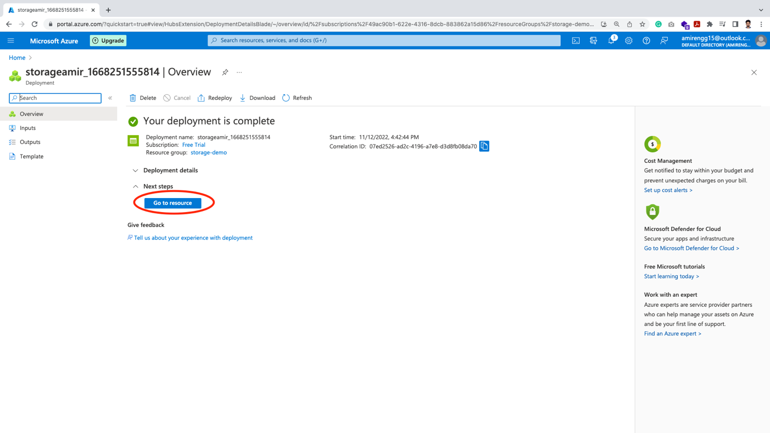

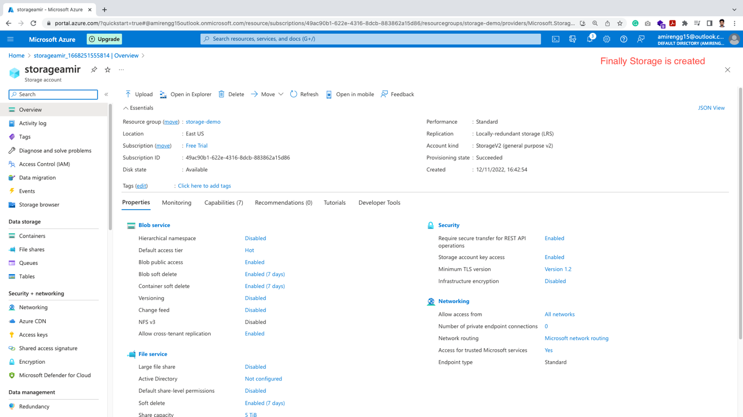

Uploading Files to Storage Account:

🡪 Let us see what we can do with storage account

🡪 Click on the storage we created recently.

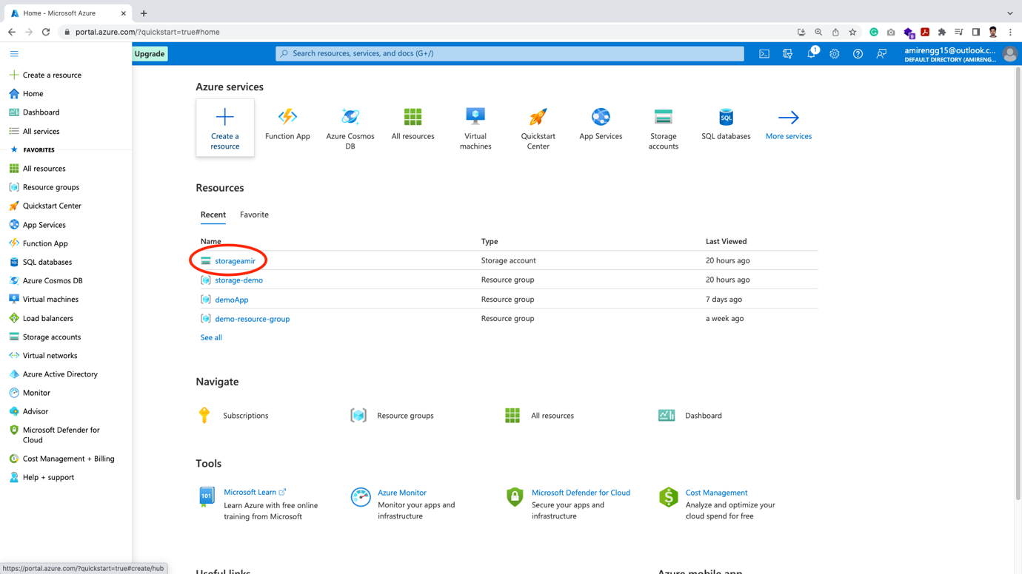

🡪 In the resource page we see there are four types of storages.

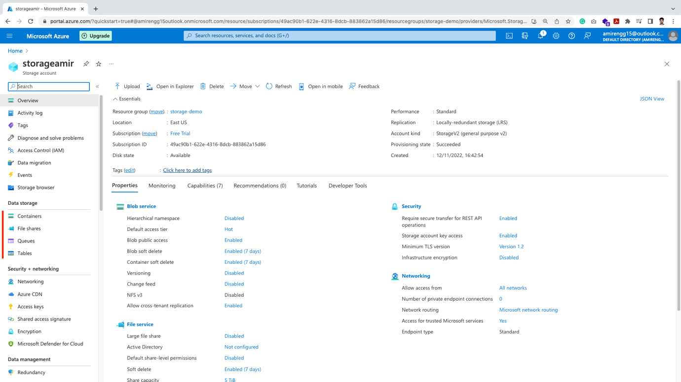

🡪 These storage contains completely separate data:

1. Containers – This contains Blob storage (i.e. binary files eg. PDF, Excel files, etc.)
2. File storage – Contains multiple types of other files
3. Queues –
4. This is like a messaging service.
5. One application can place a message / data in the queue and another application comes and reads the queue.
6. Tables – Here we can keep non-relational data. Pricing is also very less.

🡪 Here we will focus on Containers first.

Creating Containers:

🡪 Let us create our first Azure Storage Containers. Click Containers from left.

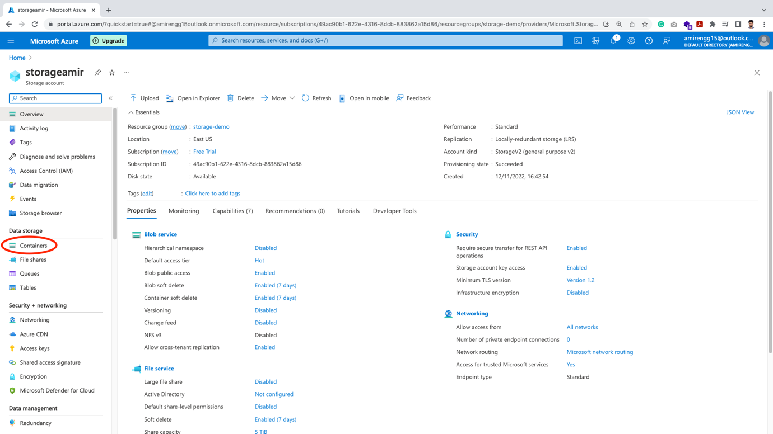

🡪 Click on + Container button

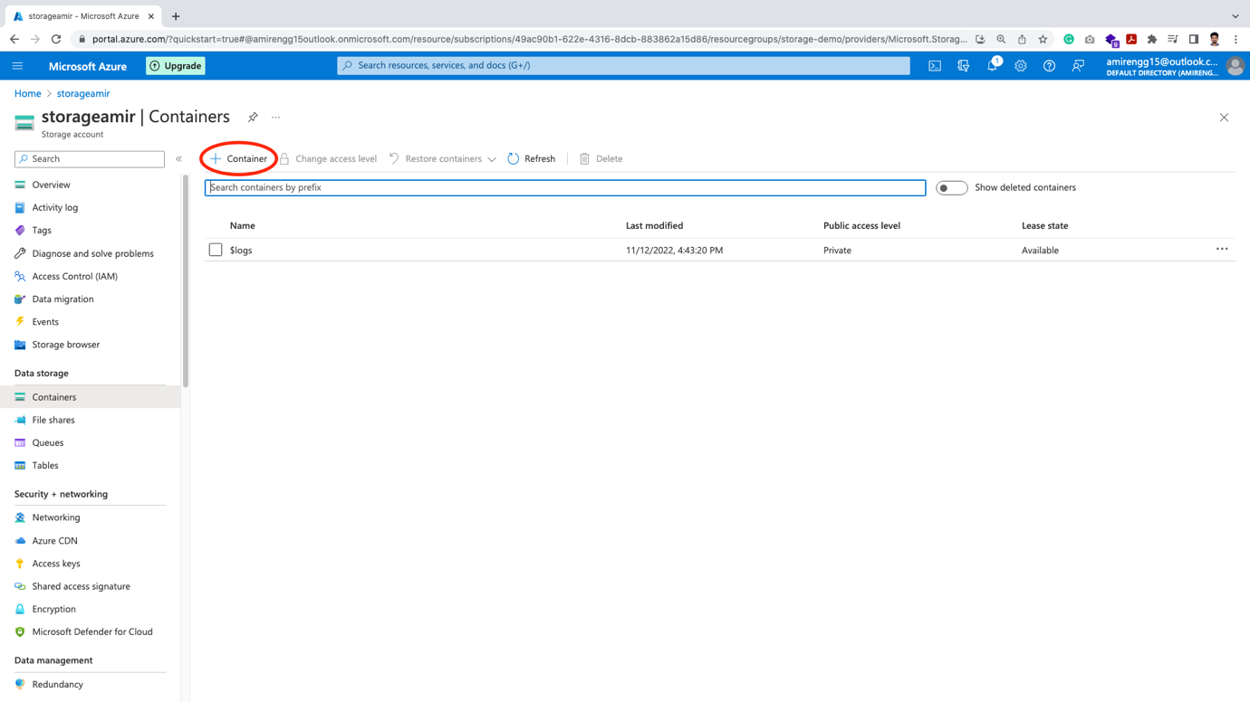

🡪 We have to give container a name

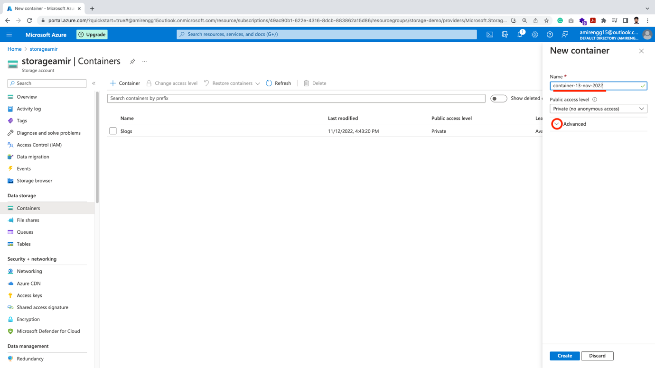

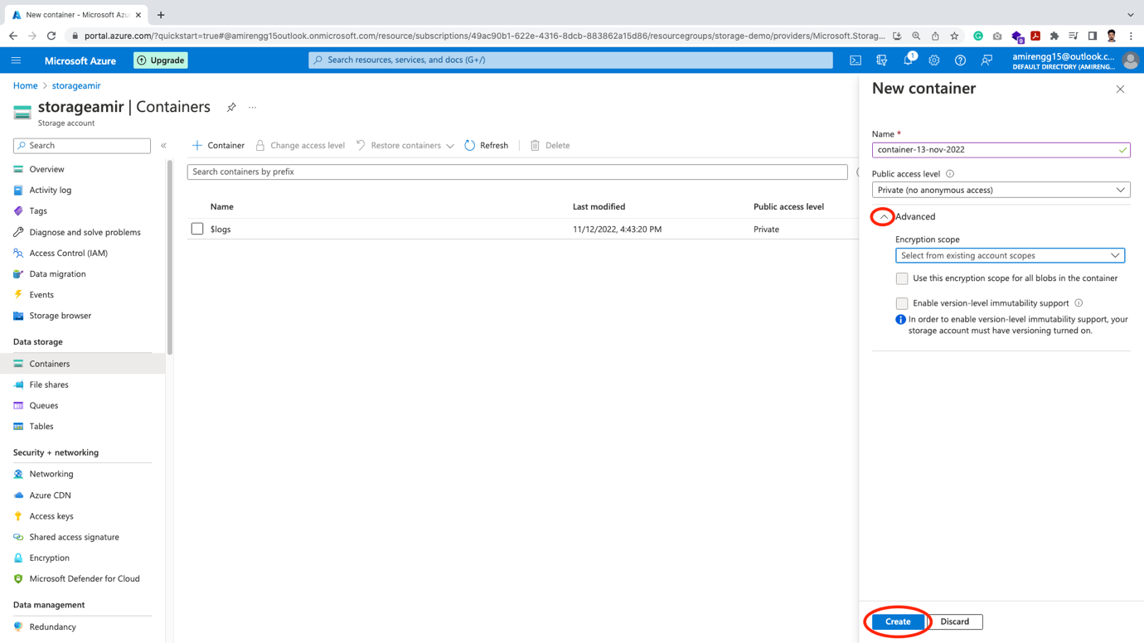

🡪 There are three options for us:

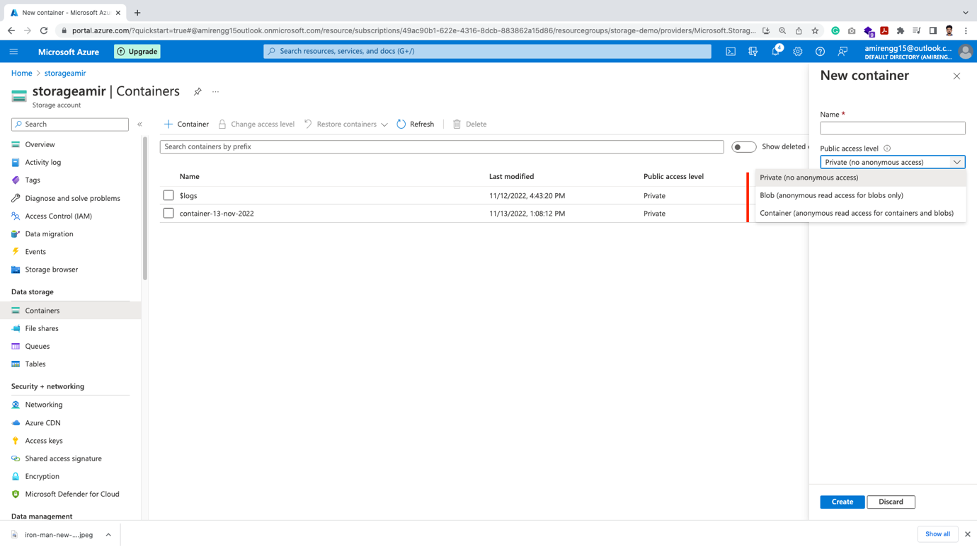

Private: By private we mean – only specific person can access

Anonymous: Anyone with Key can access

🡪 Click Create button



🡪 Our container is created.

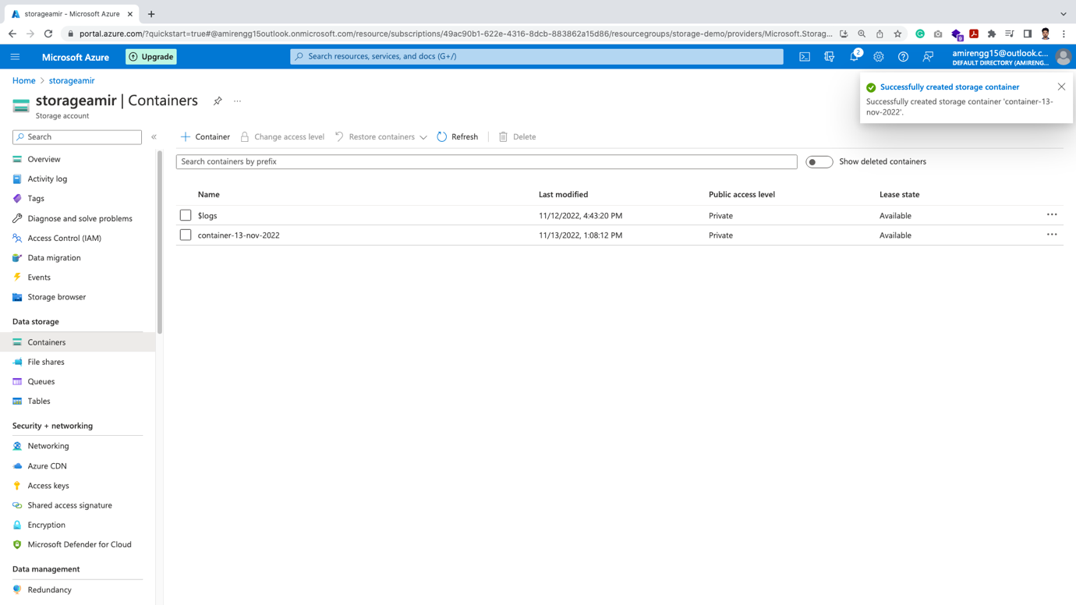

🡪 Now we have to upload the files. Click the newly created container.

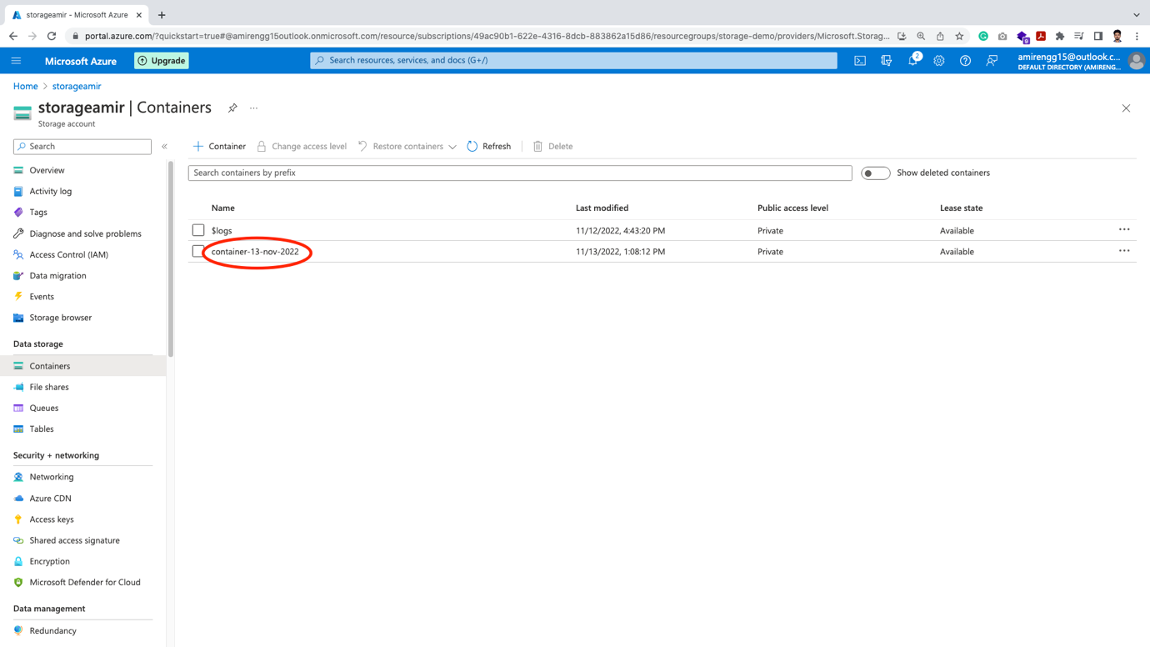

🡪 Click on Upload button:

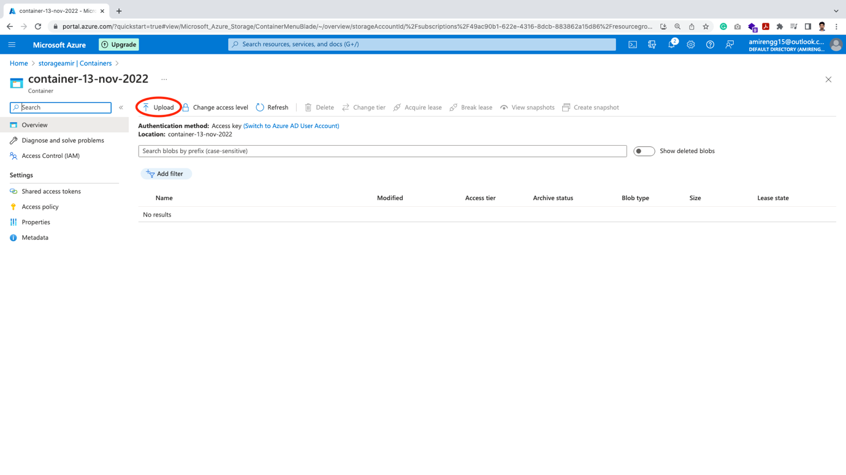

🡪 Click on file explorer – we can select multiple files.

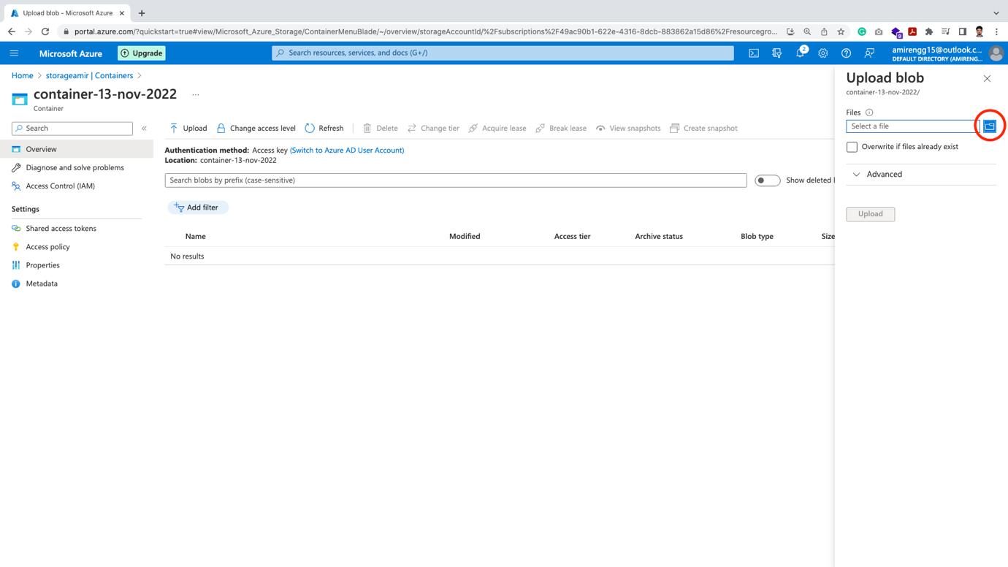

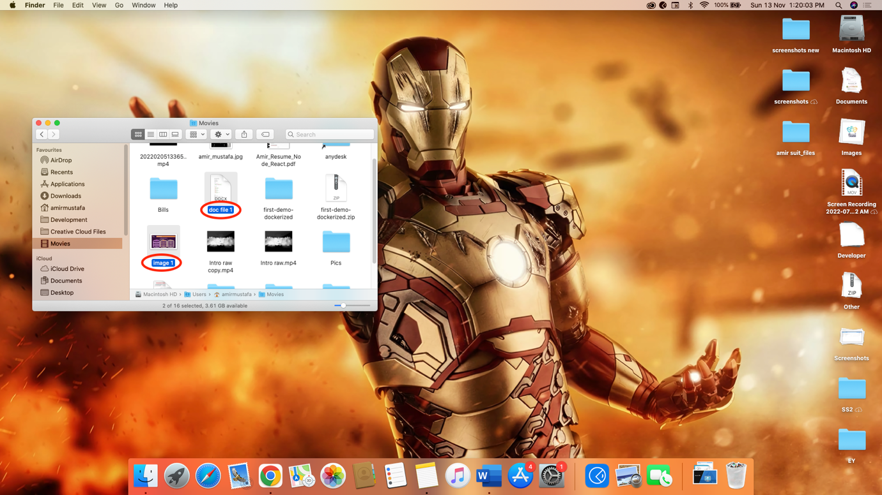

🡪 From the dropdown arrow of Advanced. We have multiple options:

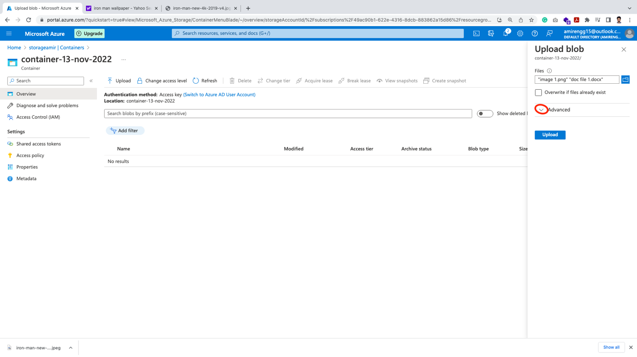

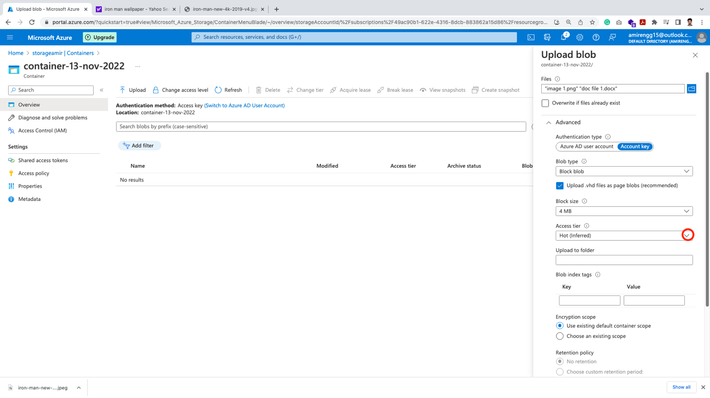

🡪 When we created Storage, we specified Hot tier (i.e. using data regularly). Let us change to Cold Tier (as pricing of this tier is low)

🡪 Here we can also see Archive Tier. This was not available at the time of storage creation.

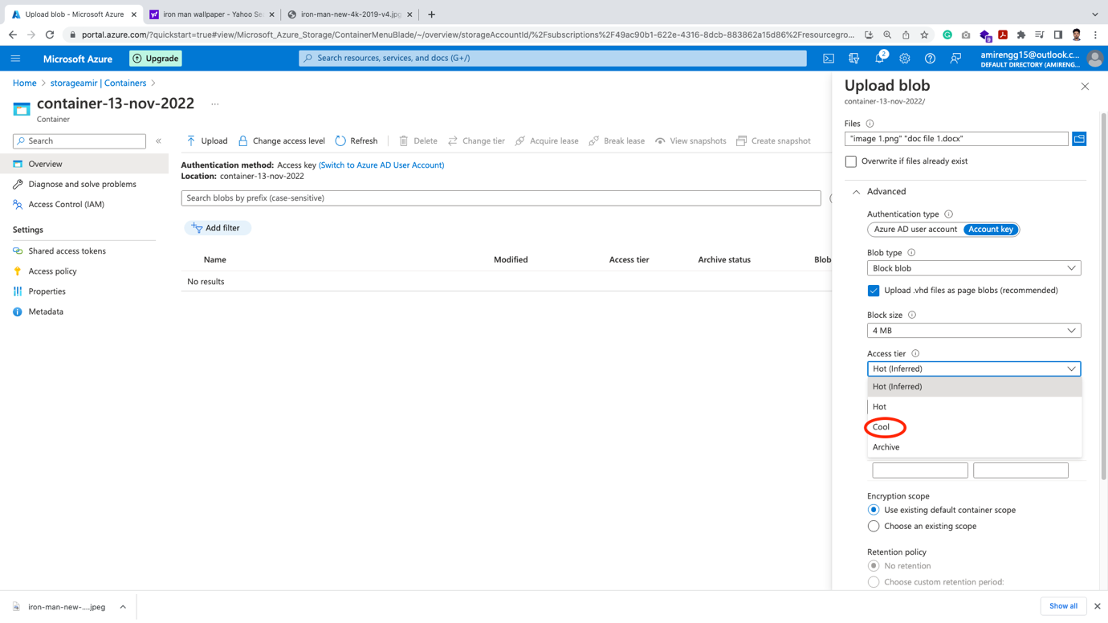

🡪 Keeping every other settings as default, let us click Upload button.

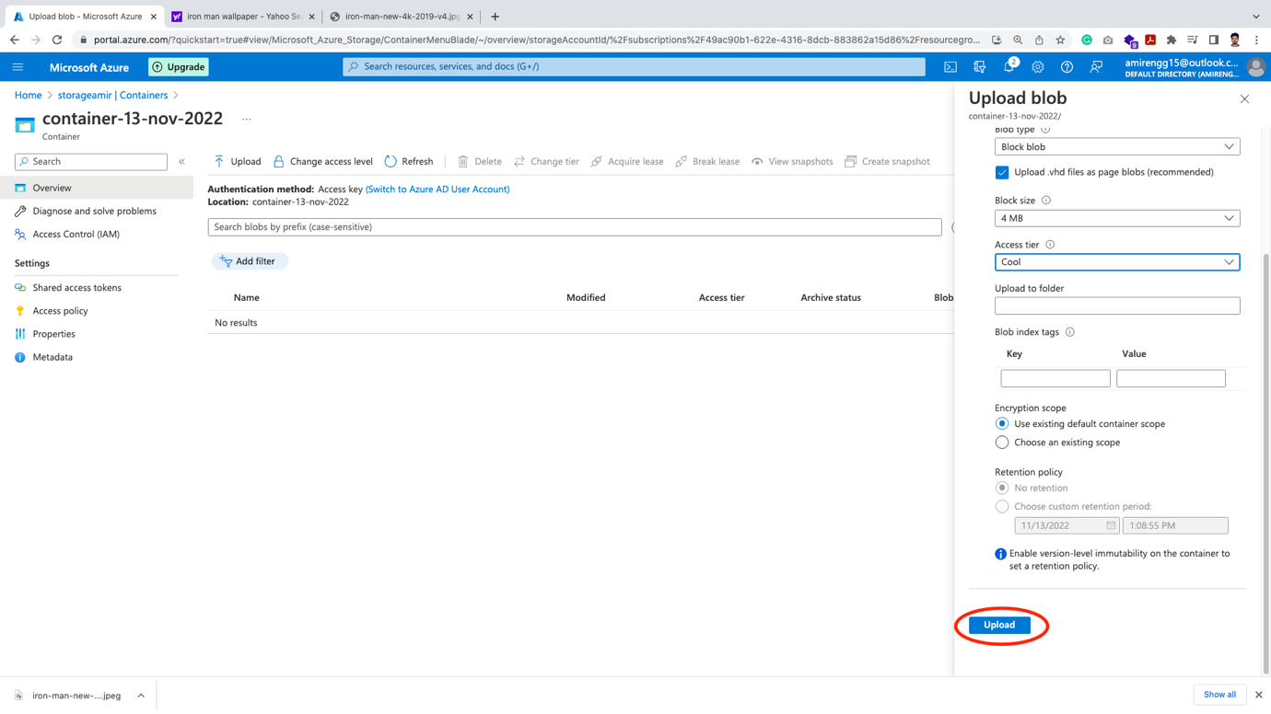

🡪 Finally our files are uploaded in Container storage

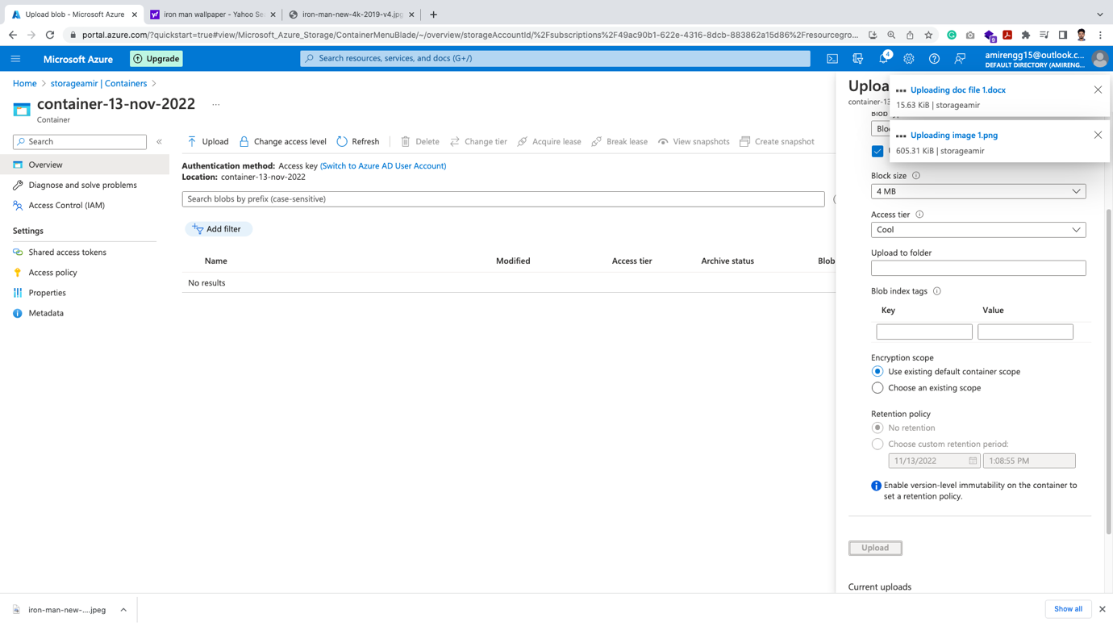

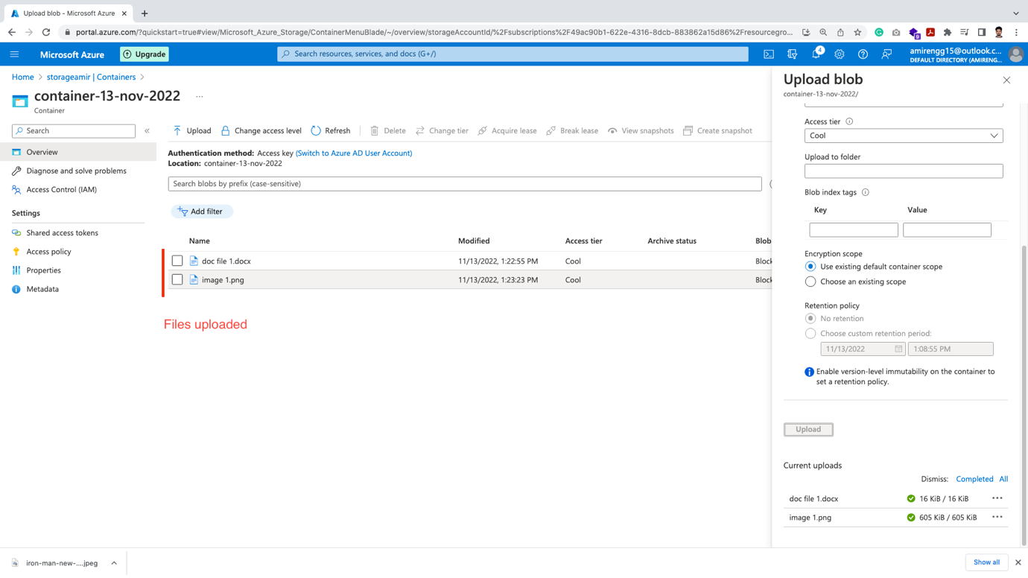

Accessing the Image:

🡪 To the access the image, click on the file to read

Say image1.png

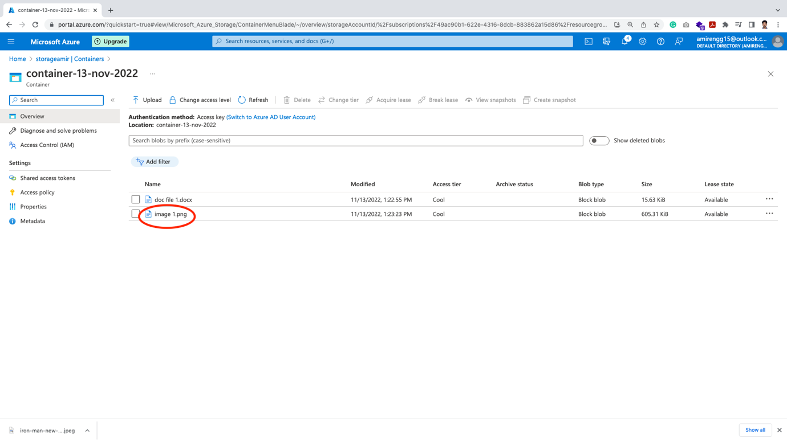

🡪 Copy the URL and open in a browser

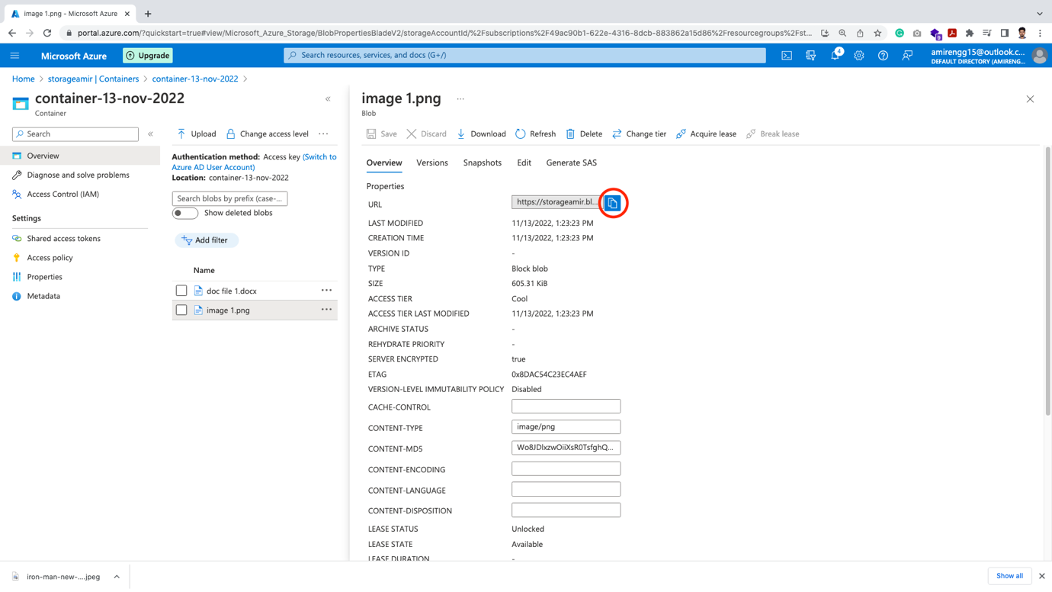

🡪 We get error. This error comes because of access issues.

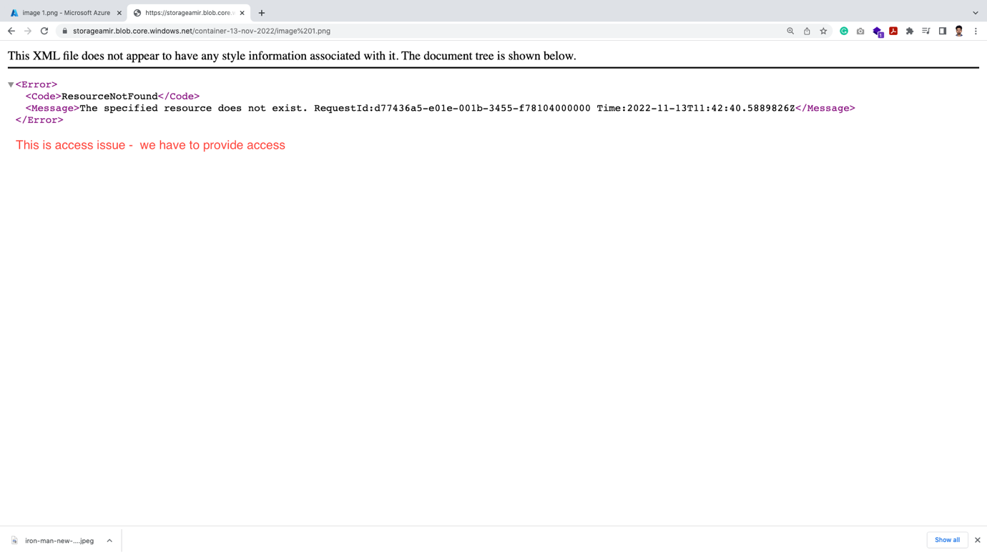

🡪 If you have worked in Amazon Cloud platform. This is something similar to the S3 bucket reading URL access error.

🡪 So let us provide access for getting Fully Qualified URL.

🡪 Click on the three dots of the file

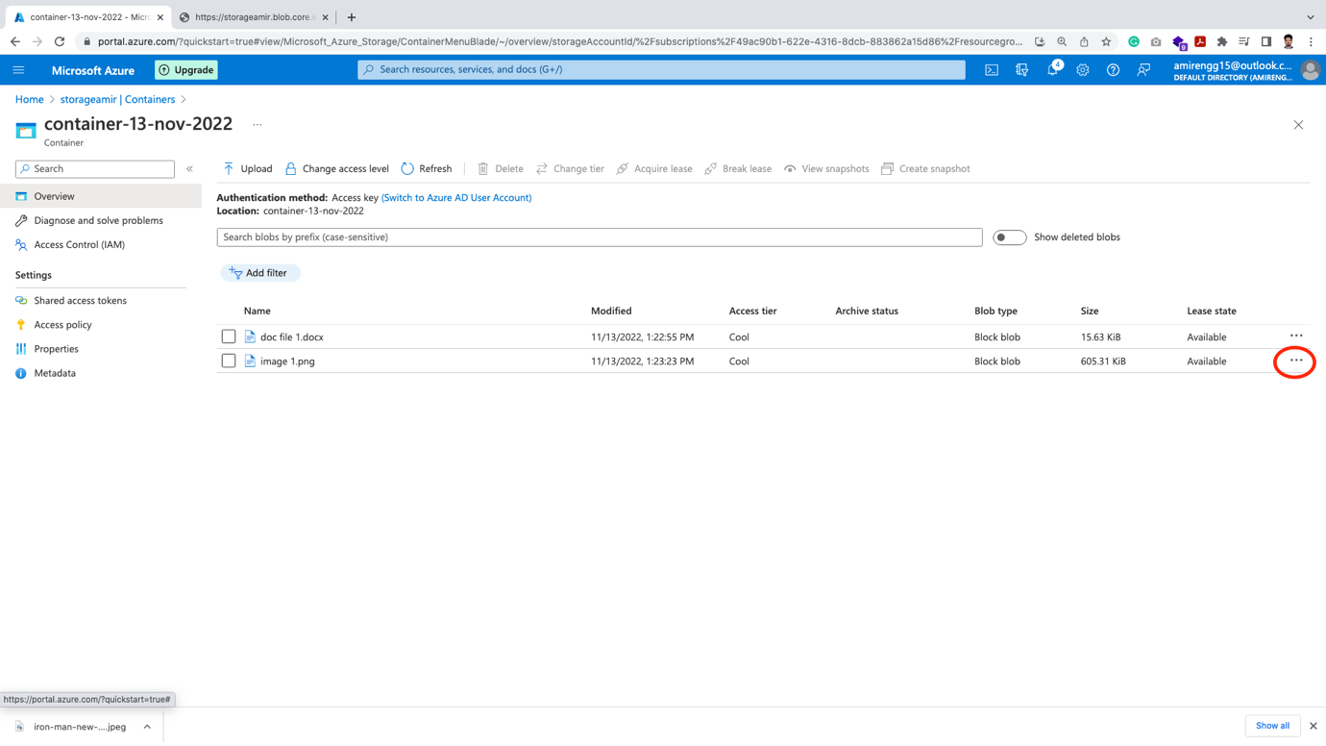

🡪 Click Generate SAH (i.e. Shared Access Token)

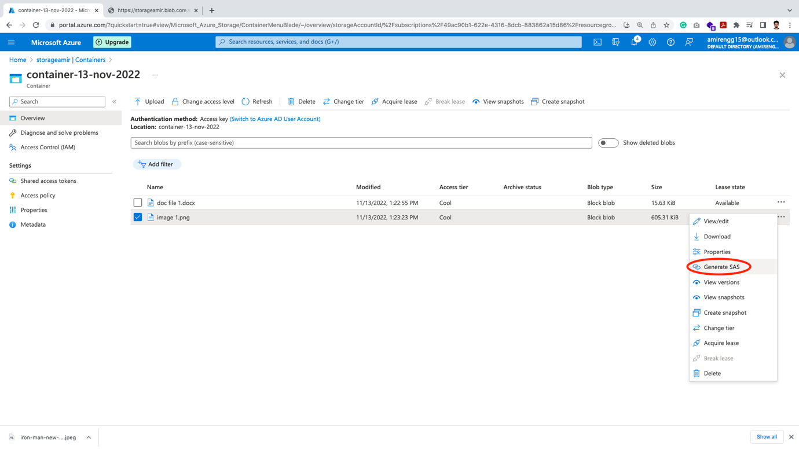

🡪 Finally click Generate Shared Access Token URL button

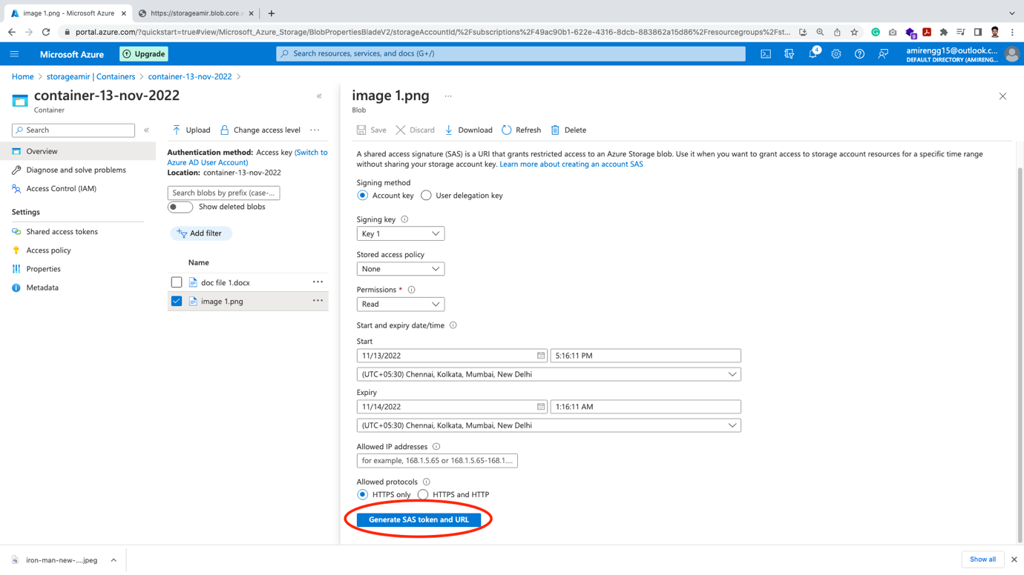

🡪 Let us now copy the generated URL and open in browser

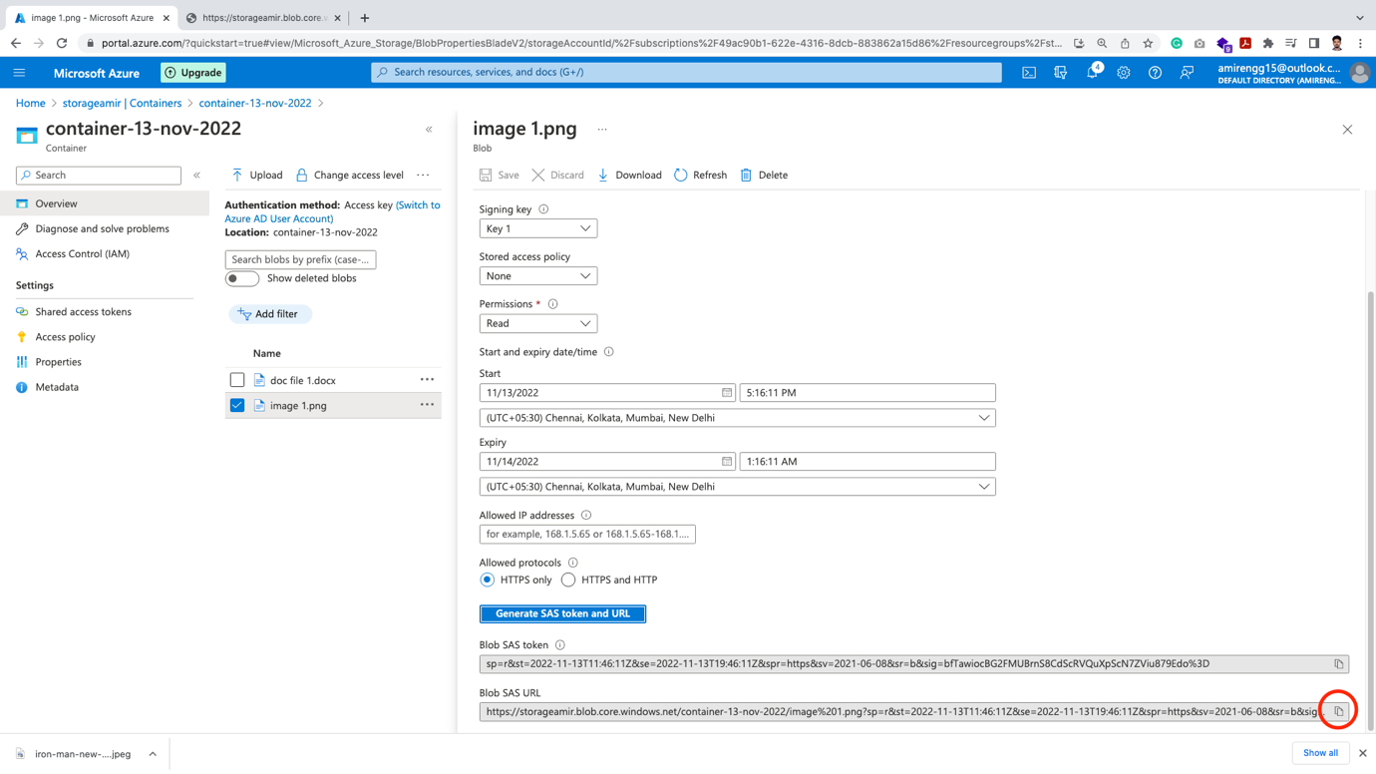

🡪 Our image successfully opened



🡪 So we have successfully read the file with the help of Shared Access key.

🡪 There are couple of more option in storage

Configuring Redundancy:

🡪 If we click Redundancy, we can configure multiple copies in other geographic region.

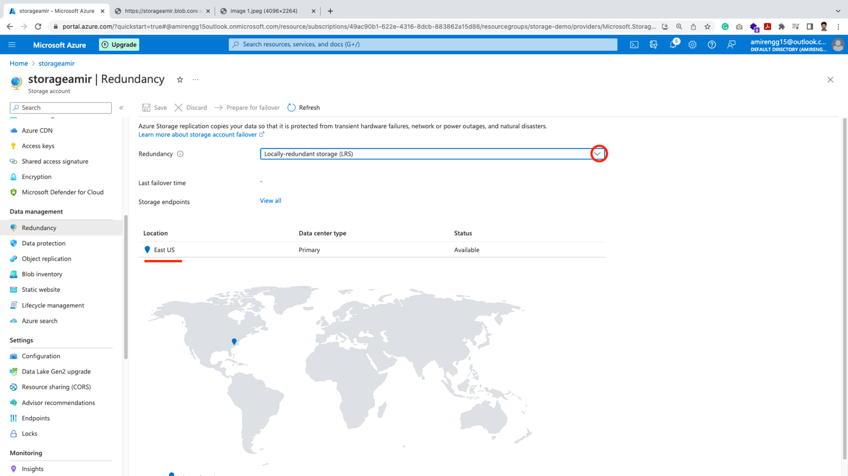

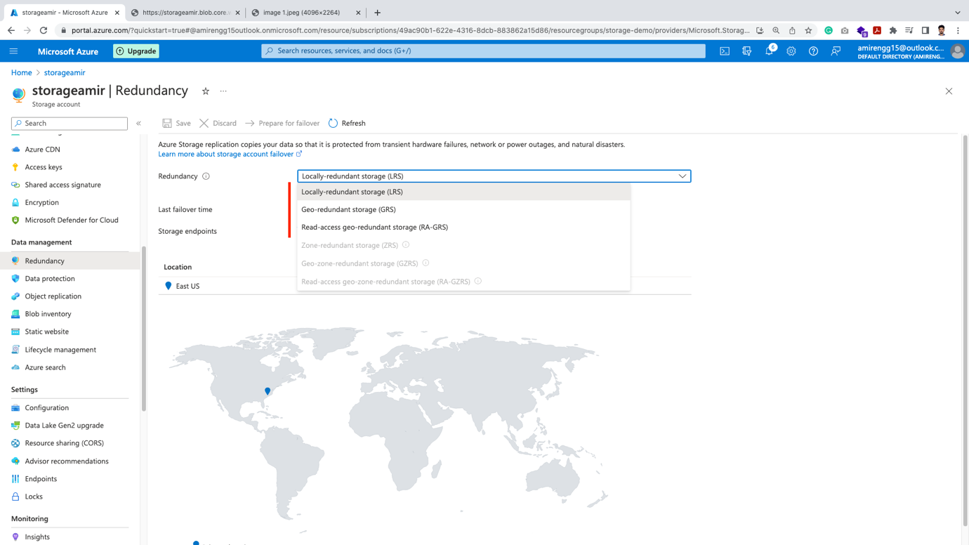

Life Cycle Management:

🡪 We can configure our files based on time period. i.e. move to archive tier or delete in 30 days, etc.

🡪 Click Life cycle management from left explorer. Click Add a rule

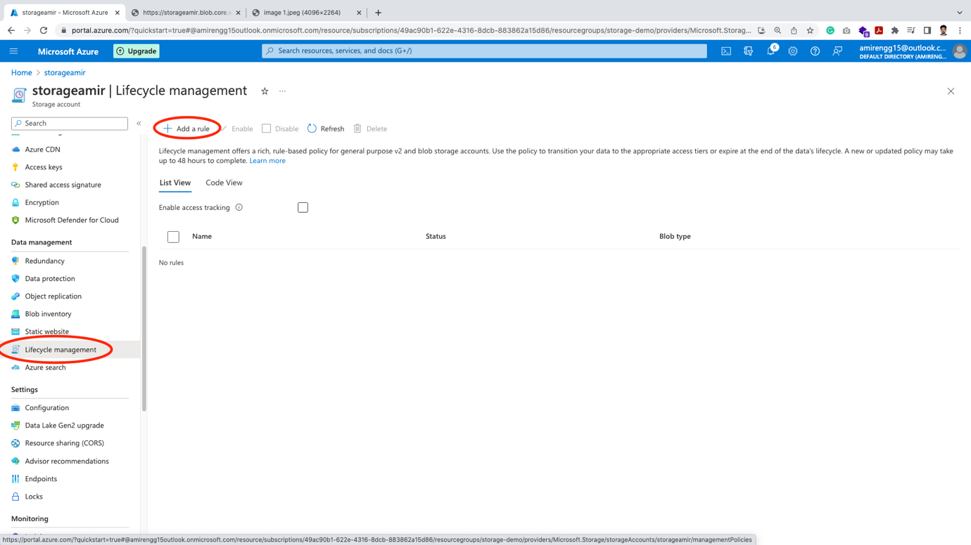

🡪 Enter rule name

Eg. Rule 1 – delete in 30 days. Click Next button.

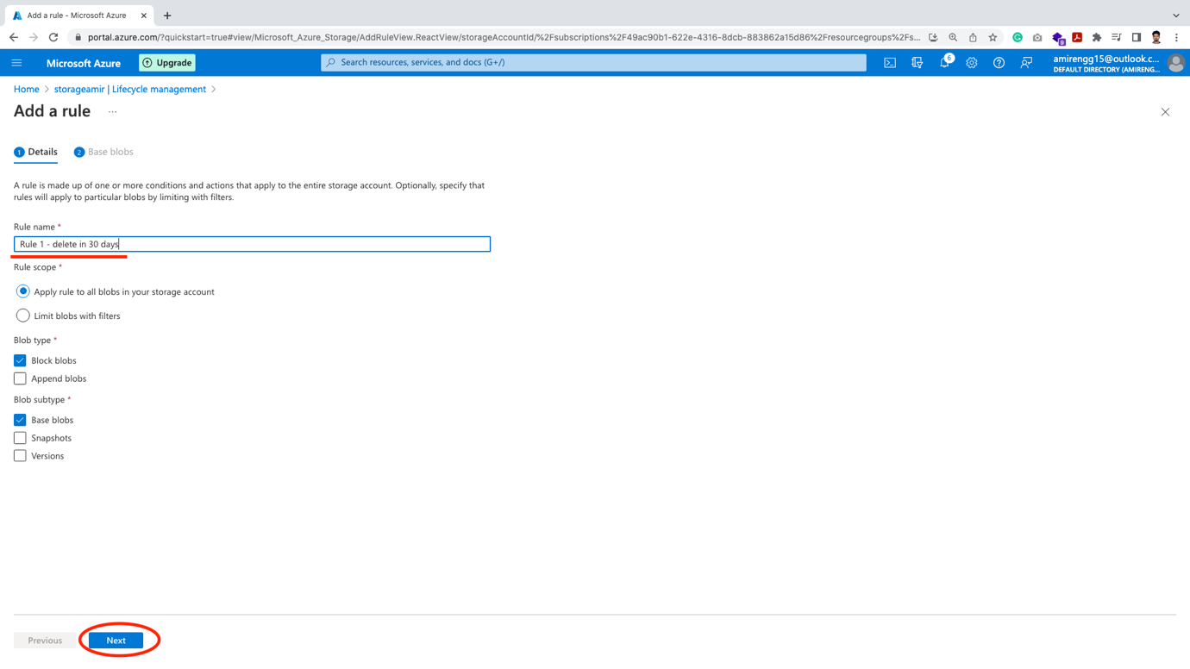

🡪 Based on the action we are trying to do we select eg. Delete for this rule. Click Add button.

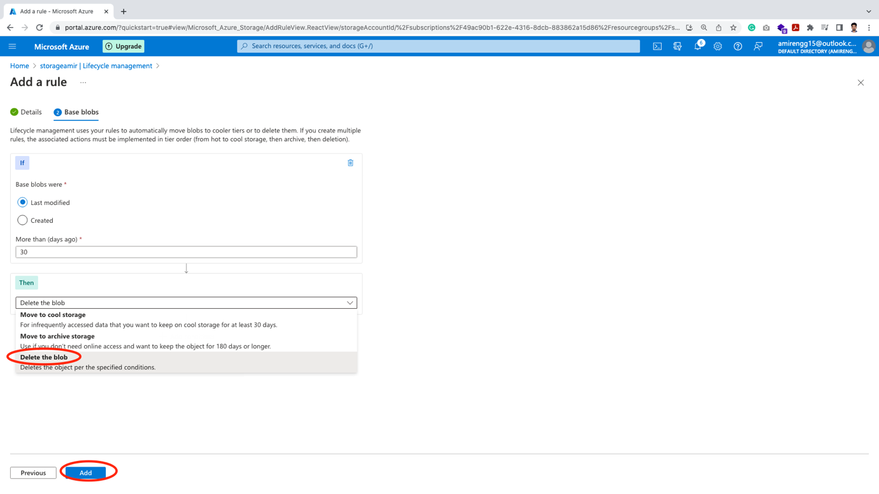

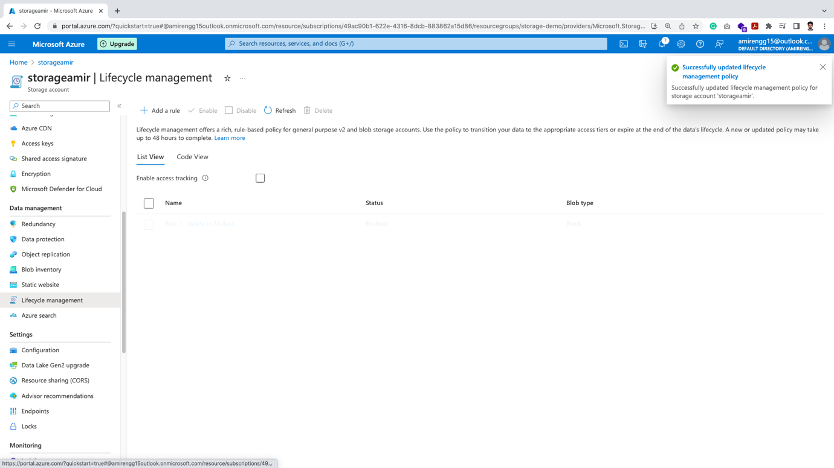

🡪 Azure finally configure this rule for this storage (eg. storageamir )

